When the one stack mode is selected, the trap below can be entered

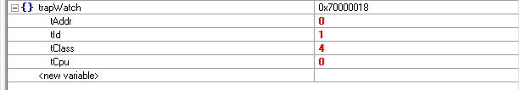

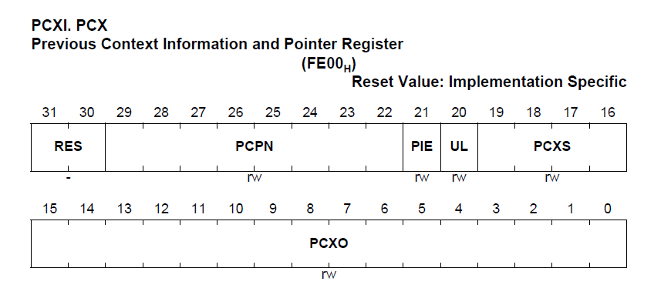

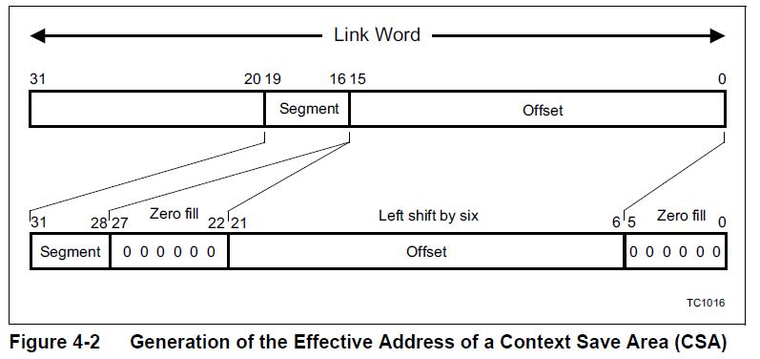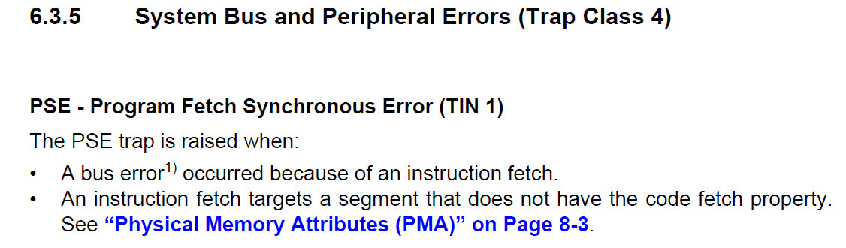

通过观测变量，可以确定在任务一被激活，重新恢复上下文的过程。当上下文在恢复的过程中出现错误

| _lc_ub_csa_tc0 | 0x70019c00 | |

_lc_ue_csa_tc0 | 0x7001bc00 | |

When the csa of task 2 is normal:

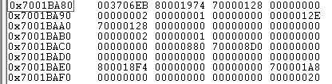

When the bug has occurred

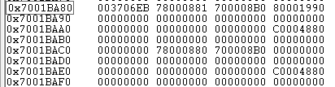

Init csa of thread 1

