JOHNS HOPKINS UNIVERSITY
BLOOMBERG SCHOOL OF PUBLIC HEALTH

340.721.81 Epidemiologic Inference in Public Health I

PROBLEM 0

CDC EXERCISE:

FOODBORNE DISEASE INVESTIGATION: ANALYSIS OF FIELD DATA

JOHNS HOPKINS UNIVERSITY
BLOOMBERG SCHOOL OF PUBLIC HEALTH

Problem 0:
Foodborne Disease Investigation: An Analysis of Field Data

Introduction

This exercise focuses on localized outbreaks of salmonellosis. It was adapted from “Food-borne Disease Investigation: Analysis of Field Data,” Public Health Service Publication No. 1186.

Concepts covered:

  - Attack rate
  - Incubation period and median incubation period
  - Infective food
  - Median
  - Onset and median onset time
  - Suspected eating time
  - Vulnerable food

Learning Objectives:

By the end of this problem, you should be able to:
1. Determine median onset time of symptoms.
2. Calculate median incubation period.
3. Calculate attack rates.
4. Draw an epidemic curve.
5. Determine the probable infective meal or food.

(Adapted from Public Health Service Publication No. 1186, 1964)
FOODBORNE DISEASE INVESTIGATION: ANALYSIS OF FIELD DATA
(Adapted from Public Health Service Publication No. 1186, 1964)

Introduction: Salmonella and Salmonellosis

Diarrhea and abdominal cramps are the dominant symptoms in Salmonella gastroenteritis (salmonellosis). They are usually accompanied by vomiting, chills and fever. Salmonellosis is milder than most forms of bacterial diarrhea, and the stool is usually not bloody. The illness usually runs its course in three days.
The causative agents are several varieties of Salmonella bacteria. They are found in the intestines of almost all poultry and hogs. If the human ingests salmonellae in sufficient quantity, he usually gets sick in about 18 hours (12-24 hours is the range).
Salmonellae are transmitted in animal food products, or by certain other foods that come in contact with them. Salmonellae are also transmitted by infected humans who do not wash their hands well after a bowel movement, and who then handle food. Any food that contains salmonellae is contaminated, but these bacteria grow only in certain vulnerable foods. When salmonellae increase to such quantities as to make people sick, the host food is said to be an infective food.
Salmonellosis is rarely fatal except in elderly people. It is commonly found in homes where food is not handled properly, and Public Health agencies have done very little to prevent these cases. However, by applying proper sanitary operating procedures, an outbreak of salmonellosis can be controlled in a place where food is prepared for public consumption.

Salmonellae are infectious organisms, but they can make food infective only:
IF (1) the food is VULNERABLE Typically, vulnerable foods are moist and have a high protein content. Some vulnerable foods are: cheese, beans, meat, eggs, dairy products.
AND (2) it gets CONTAMINATED Salmonellae must get into it or on it.
AND (3) its TEMPERATURE is right Anywhere between 45°F and 115°F.
FOR (4) adequate TIME Organisms multiply enough in 4 hours.
FOODBORNE DISEASE INVESTIGATION: ANALYSIS OF FIELD DATA
(Adapted from Public Health Service Publication No. 1186, 1964)

Key terms and concepts:

Attack rate: Number of people at risk in whom a certain illness develops
Total number of people at risk

- Useful for comparing the risk of disease in groups with different exposures
- Food-specific attack rate: Number of people who ate a certain food and became ill
Total number of people who ate that food

Incubation period: the interval from receipt of infection to the time of onset of clinical illness
- Median incubation period: in a population, the midpoint of the intervals from receipt of infection to the time of onset of clinical illness; the usual amount of time required to make a person sick.
  - The median incubation period of Salmonella is 18 hours.

Infective food: A food that is contaminated with bacteria (e.g., salmonellae) which have grown to sufficient quantities to make a person sick.

Median: a measure of central tendency; the midpoint of a series of ordered values.
- For example, if there are five people whose heights are 4’, 4’6”, 5’, 6’, and 6’2”, the median height is 5’, as it is the midpoint of the given heights.
4’ 4’6” 5’ 6’ 6’2”

Onset: the beginning of the symptoms of sickness.
- Median onset time: in a population, the midpoint of the intervals of time during which people became sick.
- For example, if there are five people who got sick at 11am, 5pm,
12pm, 11am, 2pm, you first put the series of values in order: 11am, 11am, 12pm, 2pm, 5pm. Then, you find the middle value in the series—the median onset time is the middle value in this series of five: 12pm.

Suspected eating time: The day and hour suspected of being the time that the infective or toxic food was eaten.

Vulnerable food: Moist, high protein food liable to grow salmonellae or staphylococci.
FOODBORNE DISEASE INVESTIGATION: ANALYSIS OF FIELD DATA
(Adapted from Public Health Service Publication No. 1186, 1964)

Situation 1:
A salmonellosis epidemic is first suspected when cases of diarrhea are reported to the local health department by private physicians, institutional authorities, laboratories, and individuals. The symptoms described are frequently typical enough to suggest the presence of a strain of Salmonella. As a public health worker, you interview all suspected cases and seek information to find unreported cases. You ask for the following information and record it in a table:
- Time of onset of the symptoms
- Eating locations in the 24 hours prior to the onset of symptoms
- Suspected eating time and location
- Foods eaten

Based on the median onset time, and knowing that the median incubation is 18 hours, you can calculate the suspected eating time, or time of exposure You know that Salmonella has a median incubation period of about 18 hours. Using this information, you graph your data and determine the median onset time.

Persons 1-5 have been entered in the graph. Please complete the graph (histogram) with the onset times of Persons 6-12.
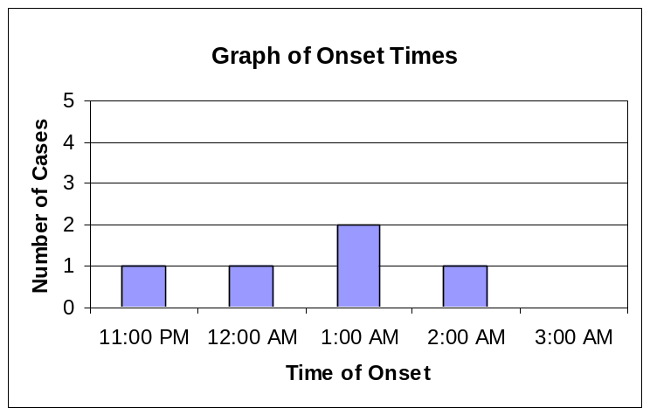
Person | Time of onset
1 | Jan 2, 1am
2 | Jan 2, 1am
3 | Jan 2, 12am
4 | Jan 2, 2am
5 | Jan 1, 11pm
6 | Jan 2, 1am
7 | Jan 2, 2am
8 | Jan 2, 2am
9 | Jan 2, 3am
10 | Jan 2, 2am
11 | Jan 2, 1am
12 | Jan 2, 12am

Answer the following questions according to the graph:

How many persons became sick at 1am? ___________________

The median onset time is shown to be: ___________________

The suspected eating time can be found by subtracting the median incubation period from the median onset time and is __________ AM/PM on January ______

Therefore, the probable infective meal is: breakfast lunch dinner

Upon further probing, you discover that all 12 of your cases attended an all-night New Year’s Eve party that served breakfast on New Year’s Day. You question 8 other people who attended the party, but did not get sick and add their data to the table. You record the foods eaten by all 20 people which may have caused the infection (these foods are called vulnerable). If the person ate the vulnerable food, you mark an “O”; if they did not eat the food, you mark an “X”.

Place of Exposure: New Year’s Eve Party at Club Epi
Person | Sick? | Time of onset | Vulnerable foods
Person | Sick? | Time of onset | Cream pie | Cream cheese bagel
1 | Y | Jan 2, 1pm | X | X
2 | Y | Jan 2, 1pm | O | O
3 | Y | Jan 2, 12pm | O | X
4 | Y | Jan 2, 2pm | O | O
5 | Y | Jan 2, 11am | X | X
6 | Y | Jan 2, 1am | O | O
7 | Y | Jan 2, 2am | O | X
8 | Y | Jan 2, 2am | O | O
9 | Y | Jan 2, 3am | O | O
10 | Y | Jan 2, 2am | O | X
11 | Y | Jan 2, 1am | O | O
12 | Y | Jan 2, 12am | O | O
13 | N |  | X | X
14 | N |  | X | O
15 | N |  | O | O
16 | N |  | X | X
17 | N |  | X | O
18 | N |  | X | X
19 | N |  | X | X
20 | N |  | X | X

To determine the infective food, you create an attack rate table. Complete the table below.
Attack Rate Table
Food | Ate |  |  |  | Did Not Eat
Food | Sick | Well | Total | Attack rate | Sick | Well | Total | Attack rate
Cream pie | 10 | 1 | 11 | 10/11 = 91% | 2 | 7 | 9 | 2/9 =  22%
Cream cheese bagel

The infective food is: __________________________

Explain why eating BOTH vulnerable foods might increase the attack rate:

_____________________________________________________________________
FOODBORNE DISEASE INVESTIGATION: ANALYSIS OF FIELD DATA
(Adapted from Public Health Service Publication No. 1186, 1964)

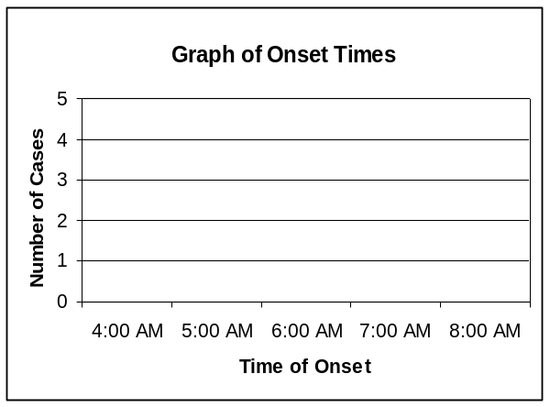
Situation 2: Twelve patrolmen living in a state-police barracks have been reported sick with diarrhea resembling salmonellosis. You get a case history on each patient, as well as other patrolmen in the barracks; plot a graph of onset times; and determine the probable meal and infective food.
Answer the following questions according to the graph of onset times:
Place of Exposure: Kitchen, State Police Barracks
Person | Sick? | Time of onset | Vulnerable foods
Person | Sick? | Time of onset | Corned beef | Pudding
1 | Y | Feb 8, 6 am | X | O
2 | Y | Feb 8, 4 am | X | X
3 | Y | Feb 8, 7 am | X | O
4 | Y | Feb 8, 7 am | X | O
5 | Y | Feb 8, 6 am | O | X
6 | Y | Feb 8, 5 am | X | X
7 | Y | Feb 8, 7 am | X | O
8 | Y | Feb 8, 6 am | X | X
9 | Y | Feb 8, 8 am | O | O
10 | Y | Feb 8, 7 am | X | O
11 | Y | Feb 8, 7 am | O | O
12 | Y | Feb 8, 8 am | X | O
13 | N |  | X | X
14 | N |  | X | X
15 | N |  | O | O
16 | N |  | X | X
17 | N |  | X | X
18 | N |  | O | X
19 | N |  | X | X
20 | N |  | X | X
The median onset time is shown to be: ______________________

The suspected eating time is: ______

The probable meal is: ____________

Complete the attack rate table for the State Police Barracks outbreak:

Attack Rate Table
Food | Ate |  |  |  | Did Not Eat
Food | Sick | Well | Total | Attack rate | Sick | Well | Total | Attack rate
Corned beef
Pudding

The infective food is: __________________________
FOODBORNE DISEASE INVESTIGATION: ANALYSIS OF FIELD DATA
(Adapted from Public Health Service Publication No. 1186, 1964)

ANSWER KEY
Situation 1:
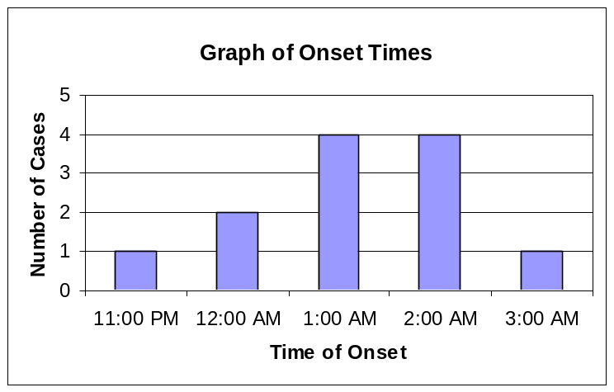
Case # | Time of onset
1 | Jan 2, 1pm
2 | Jan 2, 1pm
3 | Jan 2, 12am
4 | Jan 2, 2pm
5 | Jan 2, 11am
6 | Jan 2, 1am
7 | Jan 2, 2am
8 | Jan 2, 2am
9 | Jan 2, 3am
10 | Jan 2, 2am
11 | Jan 2, 1am
12 | Jan 2, 12am

Answer the following questions according to the graph:

How many persons became sick at 1pm? ____4_______________

The median onset time is shown to be: _1:00 am on January 2__

The suspected eating time can be found by subtracting the median incubation period from the median onset time and is ___7:00 am___ AM/PM on January __1__

Therefore, the probable infective meal is: breakfast lunch dinner

Food | Ate |  |  |  | Did Not Eat
Food | Sick | Well | Total | Attack rate | Sick | Well | Total | Attack rate
Cream pie | 10 | 1 | 11 | 10/11 = 91% | 2 | 7 | 9 | 2/9 =  22%
Cream cheese bagel | 7 | 3 | 10 | 70% | 5 | 5 | 10 | 50%

The infected food is: ____Cream pie______________

Explain why eating BOTH vulnerable foods might increase the attack rate:
If the foods are contaminated, eating both may provide a sufficient quantity of Salmonella to be infective, thereby making people sick and increasing the attack rate.
FOODBORNE DISEASE INVESTIGATION: ANALYSIS OF FIELD DATA
(Adapted from Public Health Service Publication No. 1186, 1964)

ANSWER KEY

Situation 2:

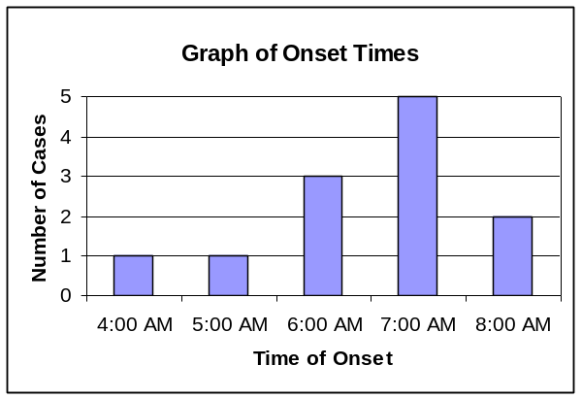Answer the following questions according to the graph of onset times:
Place of Exposure: Kitchen, State Police Barracks
Case # | Sick? | Date and time of onset | Vulnerable foods
Case # | Sick? | Date and time of onset | Corned beef | Pudding | Pork & beans
1 | Y | Feb 8, 6 am | X | O | O
2 | Y | Feb 8, 4 am | X | X | O
3 | Y | Feb 8, 7 am | X | O | O
4 | Y | Feb 8, 7 am | X | O | X
5 | Y | Feb 8, 6 am | O | X | O
6 | Y | Feb 8, 5 am | X | X | O
7 | Y | Feb 8, 7 am | X | O | O
8 | Y | Feb 8, 6 am | X | X | O
9 | Y | Feb 8, 8 am | O | O | O
10 | Y | Feb 8, 7 am | X | O | O
11 | Y | Feb 8, 7 am | O | O | X
12 | Y | Feb 8, 8 am | X | O | O
13 | N |  | X | X | O
14 | N |  | X | X | O
15 | N |  | O | O | X
16 | N |  | X | X | O
17 | N |  | X | X | O
18 | N |  | O | X | O
19 | N |  | X | X | O
20 | N |  | X | X | O
The median onset time is shown to be: 7:00 am on February 8th

The suspected eating time is:
1:00 pm on February 7th

The probable meal is: _Lunch_______

Complete the attack rate table for the State Police Barracks outbreak:

Food | Ate |  |  |  | Did Not Eat
Food | Sick | Well | Total | Attack rate | Sick | Well | Total | Attack rate
Corned beef | 3 | 2 | 5 | 60% | 9 | 6 | 15 | 60%
Pudding | 8 | 1 | 9 | 89% | 4 | 7 | 11 | 36%

The infective food is: __Pudding________________

