**340.721 Epidemiologic Inference in Public Health I**

**ACTIVITY:**

**Measures of Disease Frequency**

Activities provide experience in applying epidemiologic methods, interpreting findings, and drawing inferences. Activities consist of a series of short answer questions and are held on Mondays or Wednesdays (8:30-10:00 am) per the course syllabus. Room and Group assignments are posted in CoursePlus.  Attendance will be taken at the Activities and students are expected to attend and participate in the Activities.

*Expectations for the Activities*

1. *Individually, read the Activity and attempt to answer all the questions.*
2. *“Meet” with your group and discuss challenging concepts, questions and compare answers*
3. *Formulate group consensus of answers if possible (sometimes there is no right or wrong answer!)*
4. *Post questions to the Discussion Forum if there is disagreement in your group or if there is need for a clarification to answer the question.*
5. *If your group is presenting at the LiveTalk, review your answers with a TA by posting to the Discussion Forum in your Group’s Category/Topic by 12PM EST of the Tuesday preceding the LiveTalk*

**I. Comparison of Rates across Populations**

Question 1

The table below summarizes results from the PRE-Activity Questions. Fill in the missing values.

**Crude and Age-Adjusted* Breast Cancer Incidence Rates by Race**

|  |  |  |  |
| --- | --- | --- | --- |
|  | White Females | Black Females | Ratio |
| Crude Rates |  |  |  |
| Age-Adjusted Rates |  |  |  |

*Using direct standardization methods using the total population of white and black females as the standard population.

1. The ratio of crude breast cancer incidence rates comparing white women to black women is called the relative risk. Interpret that relative risk. Discuss possible reasons for the difference in crude breast cancer incidence rates.

1. Interpret the ratio of age-adjusted breast cancer incidence rates comparing white women to black women.

Question 2

How do the crude relative risk and the age-adjusted relative risk compare? Do they differ? If so, how do you explain the difference?

(HINT: Look again at the information in Table 3 from the PRE-Activity Questions.)

**TABLE 3:**

**Invasive Breast Cancer Incidence Rates in White and Black Females by Age,**

**United States, SEER, 1998-2002**

|  |  |  |  |  |  |  |  |  |  |
| --- | --- | --- | --- | --- | --- | --- | --- | --- | --- |
|  | **White Females** | | | |  | **Black Females** | | | |
| Age Group (years) | Average Number of Cases per year[1] | Population (In 1,000's)[2] | Percent of Total Population | Average annual incidence rate per 100,000 women at risk |  | Average Number of Cases per year3 | Population (In 1,000's)4 | Percent of Total Population | Average annual incidence rate per 100,000 women at risk |
|  |  |  |  |  |  |  |  |  |  |
| 0 – 19 | 0 | 30,057 | 26 | 0 |  | 0 | 6,147 | 33 | 0 |
| 20 – 29 | 118 | 14,081 | 12 | 0.8 |  | 30 | 2,722 | 15 | 1.1 |
| 30 – 39 | 1,525 | 16,848 | 15 | 9.0 |  | 281 | 2,917 | 16 | 9.6 |
| 40 – 49 | 5,630 | 17,627 | 15 | 31.9 |  | 795 | 2,737 | 15 | 29.0 |
| 50 – 59 | 8,081 | 13,334 | 12 | 60.6 |  | 872 | 1,740 | 9 | 50.1 |
| 60 – 69 | 5,488 | 9,123 | 8 | 60.2 |  | 792 | 1,156 | 6 | 68.5 |
| 70 – 79 | 8,300 | 8,137 | 7 | 102.0 |  | 615 | 778 | 4 | 79.0 |
| 80+ | 5,023 | 5,527 | 5 | 90.9 |  | 316 | 448 | 2 | 70.5 |
| All ages | 34,165 | 114,734 | 100 |  |  | 3,701 | 18,645 | 100 |  |
|  | | | |  |  |  |  |  |  |
| Average annual incidence rate per 100,000 women at risk (from Table 2): | | | |  |  |  |  |  |  |

Question 3

Why adjust? [HINT: which incidence rates (crude or adjusted) are more appropriate for inter‑population comparisons – why?] Is it ever inappropriate to adjust? In what circumstances, if any, might you choose to present crude (unadjusted) rates?

**II. Choice of Standard Population**

In the Assignment, we created a hypothetical standard population by combining (summing) the populations of white and black females.

Other standard populations can be used for direct adjustment. The choice of a standard population for the age adjustment is somewhat arbitrary, although it is usually based on previous studies and desired comparison groups.

The following table contains standard populations used frequently in computing age-adjusted rates:

|  |  |  |  |  |  |  |  |
| --- | --- | --- | --- | --- | --- | --- | --- |
| **Age Group**  **(years)** | **1940 US  Standard  Million[3] (%)** |  | **1970 US  Standard  Million5 (%)** |  | **2000 US  Standard  Million5 (%)** |  | **WHO World Standard Million[4] (%)** |
| 0 – 19 | 344,086 (34%) |  | 378,769 (38%) |  | 286,869 (29%) |  | 346,150 (34%) |
| 20 – 29 | 172,284 (17%) |  | 146,881 (15%) |  | 131,007 (13%) |  | 161,450 (16%) |
| 30 – 39 | 150,284 (15%) |  | 110,905 (11%) |  | 151,806 (15%) |  | 147,550 (15%) |
| 40 – 49 | 129,439 (13%) |  | 118,580 (12%) |  | 153,969 (15%) |  | 126,250 (13%) |
| 50 – 59 | 99,497 (10%) |  | 103,720 (10%) |  | 111,170 (11%) |  | 99,150 (10%) |
| 60 – 69 | 64,822 (6%) |  | 76,809 (8%) |  | 73,057 (7%) |  | 66,750 (7%) |
| 70 – 79 | 30,937 (3%) |  | 45,660 (5%) |  | 58,772 (6%) |  | 37,250 (4%) |
| 80+ | 8,651 (1%) |  | 18,676 (2%) |  | 33,350 (3%) |  | 15,450 (1%) |
| Total | 1,000,000 |  | 1,000,000 |  | 1,000,000 |  | 1,000,000 |

Question 4

Compare the WHO World Standard Population (last column in Table 4) to the Standard Population in Table 3. How do they compare? Given what you learned about direct standardization in the Assignment, how do you expect the age-adjusted breast cancer incidence rates that were adjusted using the combined population (calculated as part of the Assignment) to compare to the age-adjusted breast cancer incidence rates that are adjusted using the WHO World Standard Population? Why?

(To make the comparison easier, data on the two standard populations is summarized for you in the table below).

|  |  |  |  |  |  |
| --- | --- | --- | --- | --- | --- |
| **Age Group**  **(years)** |  | **Combined Population Standard (In 1,000's) (%)** | |  | **WHO World Standard**  **(Million) (%)** |
| 0 – 19 |  | | 36,204 (27%) |  | 346,150 (34%) |
| 20 – 29 |  | | 16,803 (13%) |  | 161,450 (16%) |
| 30 – 39 |  | | 19,765 (15%) |  | 147,550 (15%) |
| 40 – 49 |  | | 20,364 (15%) |  | 126,250 (13%) |
| 50 – 59 |  | | 15,074 (11%) |  | 99,150 (10%) |
| 60 – 69 |  | | 10,279 (8%) |  | 66,750 (7%) |
| 70 – 79 |  | | 8,915 (7%) |  | 37,250 (4%) |
| 80+ |  | | 5,975 (4%) |  | 15,450 (1%) |
| Total |  | | 133,379 |  | 1,000,000 |

(For more practice calculating rates, or to help better understand how the rates would compare, see Table 5 at the end of this Activity – it’s not required for the Activity but is fun!)

Question 5

What issues should one consider in selecting a standard population?

**III. Indirect Standardization**

Question 6

Suppose that the SMR for mortality from all causes among former mercury miners is 1.40. Interpret this SMR.

Question 7

Why calculate an SMR? When might you choose to calculate an SMR instead of use direct adjustment? (HINT: Consider the real example in the following abstract.)

**Statin drugs and risk of advanced prostate cancer**

Platz, EA, Leitzmann MF, Visvanathan K, et al. J Natl Cancer Inst. 2006 Dec 20;98(24):1819-25.

#### BACKGROUND:

Statins are commonly used cholesterol-lowering drugs that have proapoptotic and antimetastatic activities that could affect cancer risk or progression. Results from previous epidemiologic studies of the association between statin use and cancer have been inconsistent. We investigated the association of statin use with total and advanced prostate cancer, the latter being the most important endpoint to prevent.

#### METHODS:

We analyzed data from an ongoing prospective cohort study of 34,989 US male health professionals who were cancer free in 1990 and were followed to 2002. Participants reported their use of cholesterol-lowering drugs on biennial questionnaires. Prostate cancer diagnosis was confirmed by medical record review. Multivariable-adjusted relative risks (RRs) were estimated from Cox proportional hazards regression models. Statistical tests were two-sided.

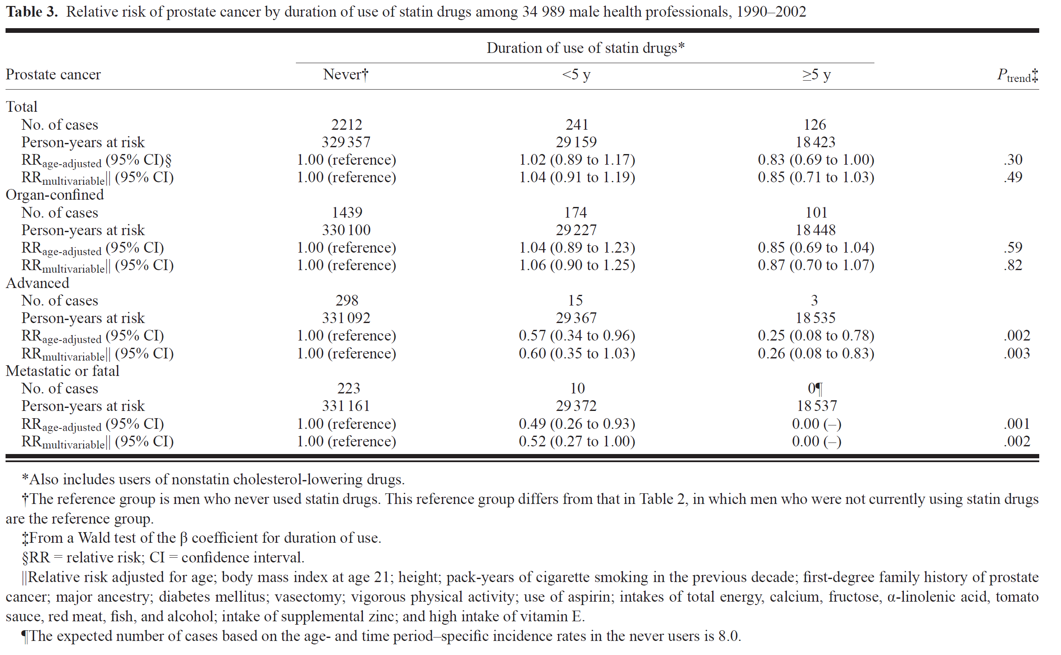

Question 8

Complete the following table, comparing the direct and indirect methods of adjustment.

|  |  |  |
| --- | --- | --- |
|  | Direct Adjustment | Indirect Adjustment |
| From what population are the age-specific incidence rates drawn? |  |  |
| From what population are the age-specific weights drawn? |  |  |
| What useful comparisons can be made with each method of standardization? |  |  |
| Under what circumstances are each method of adjustment applied? |  |  |
| What is an advantage of each method of adjustment? |  |  |
| What is a limitation of each method of adjustment? |  |  |

**III. More Practice! (Optional – not required)**

Isn’t this fun? Want more practice? Need to prove to yourself how the age-adjusted rates compare when using the combined standard population vs. using the WHO standard population? Using the data from Table 5 (below), calculate age-adjusted incidence rates for both racial groups using **the WHO World Standard Population** as the standard population.

**TABLE 5:**

**Age-Adjustment of Invasive Breast Cancer Incidence in White and Black Females,**

**United States, SEER, 1998-2002 Using WHO World Standard Population**

|  |  |  |  |  |  |  |  |  |  |
| --- | --- | --- | --- | --- | --- | --- | --- | --- | --- |
|  |  |  |  |  | **White Females** | |  | **Black Females** | |
|  |  |  |  |  |  |  |  |  |  |
|  |  |  | ***WHO World Standard Population*** |  | Average annual incidence per 100,000 women at risk | Expected Number of Cases for White Females |  | Average annual incidence per 100,000 women at risk | Expected Number of Cases for Black Females |
|  |  |  |  |  |  |  |  |  |  |
| Age Group (years) |  |  |  |  |  |  |  |  |  |
|  |  |  |  |  |  |  |  |  |  |
| 0 – 19 |  |  | 346,150 (34%) |  | 0 |  |  | 0 |  |
| 20 – 29 |  |  | 161,450 (16%) |  | 0.8 | 1.29 |  | 1.1 | 1.78 |
| 30 – 39 |  |  | 147,550 (15%) |  | 9.0 |  |  | 9.6 |  |
| 40 – 49 |  |  | 126,250 (13%) |  | 31.9 |  |  | 29.0 |  |
| 50 – 59 |  |  | 99,150 (10%) |  | 60.6 |  |  | 50.1 |  |
| 60 – 69 |  |  | 66,750 (7%) |  | 60.2 |  |  | 68.5 |  |
| 70 – 79 |  |  | 37,250 (4%) |  | 102.0 |  |  | 79.0 |  |
| 80+ |  |  | 15,450 (1%) |  | 90.9 |  |  | 70.6 |  |
| **Total:** |  | 1,000,000 |  |  |  |  |  |  |
|  |  |  |  |  |  |  |  |  |
| Age-adjusted annual incidence rate per 100,000 population: | | | | | |  |  |  |  |

1. SEER. Cancer Statistics Review 1975-2002: Table IV-3. [Number of cases accumulated over 5 years/5 years]
2. Census P25-1130, Table 2: Projections of the Population by Age, Sex, Race and Hispanic Origin for the United States. As of July 1, 2000. [Midpoint population used to approximate average annual population]
3. http://www.seer.cancer.gov/stdpopulations/stdpop.19ages.html   
   
4. WHO World Standard Population Distribution, based on World Average population between 2000 – 2025. Available at: http://w3.whosea.org/healthreport/pdf/paper31.pdf