Site Setting >Revenue

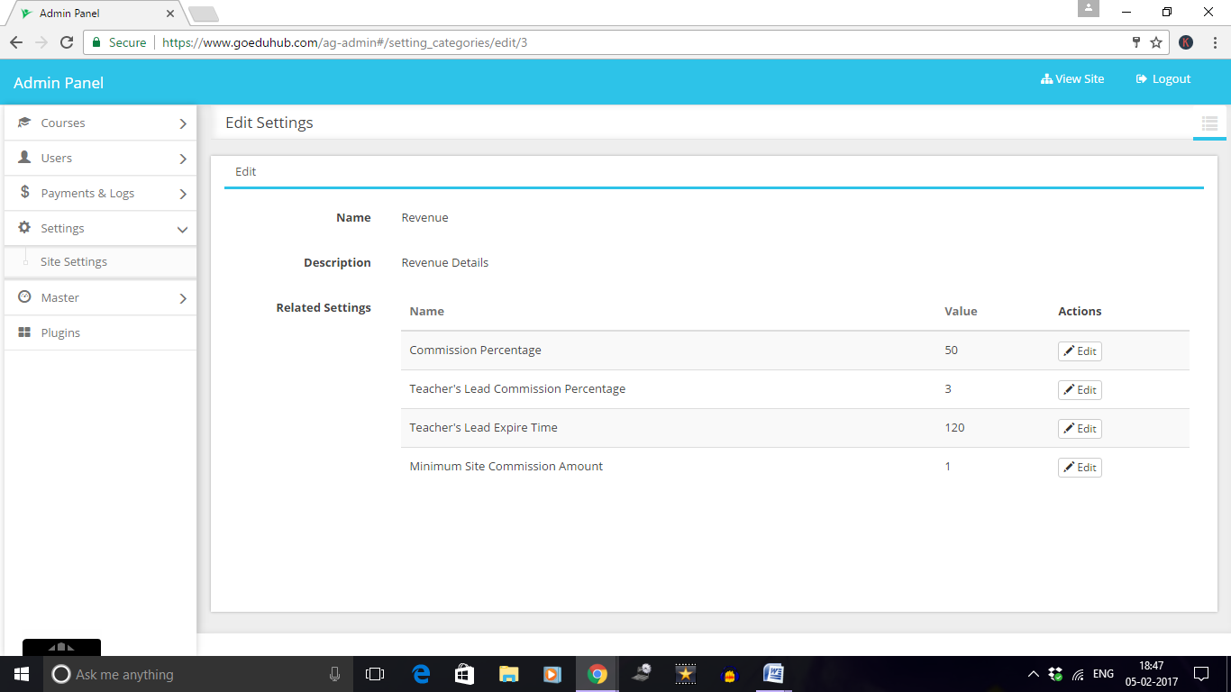

Here Commission Percentage is 50%. (Not working)

Teacher’s Lead Commission Percentage is 3%. (Not Working)

Teacher’s Expire time is 120. (How it works.)

CASE.1 Course (USD 10) is created by user Piyush ([mymail.piyush@gmail.com](mailto:mymail.piyush@gmail.com)) and Purchased by Sharda ([sharda.godara.23@gmail.com](mailto:sharda.godara.23@gmail.com)). Website sharing is 50% (Not Working)

<https://www.goeduhub.com/my-courses/teaching>

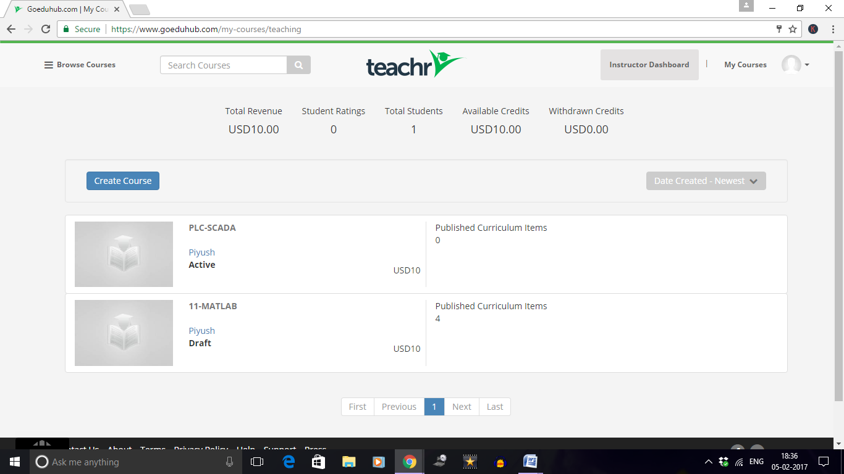

<https://www.goeduhub.com/transactions>

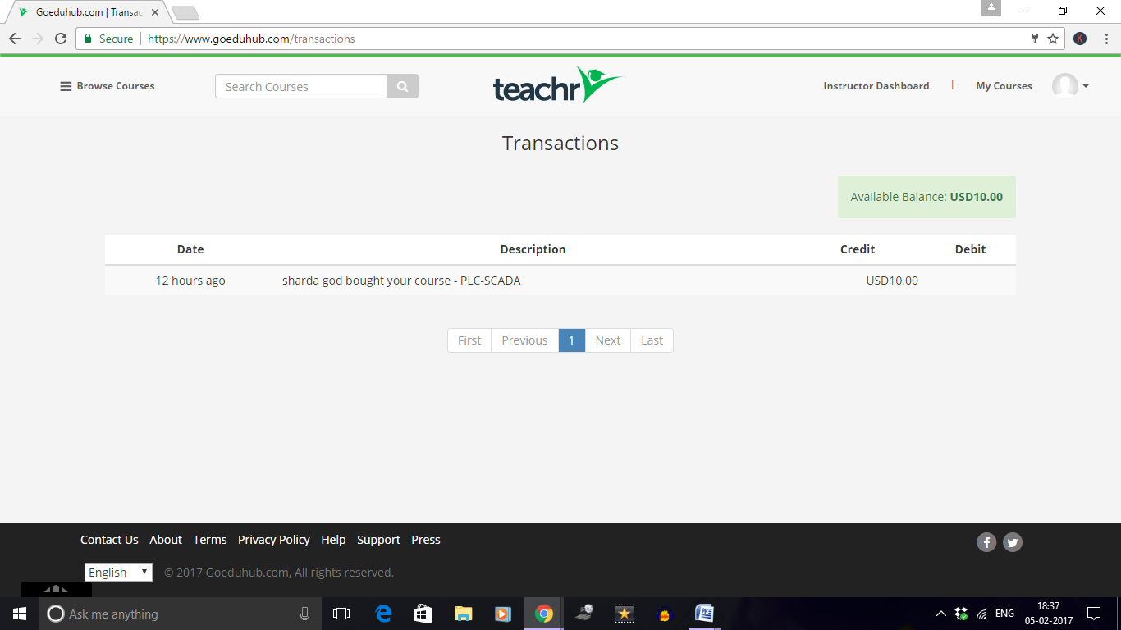

Admin Dashboard: <https://www.goeduhub.com/ag-admin#/transactions/list>

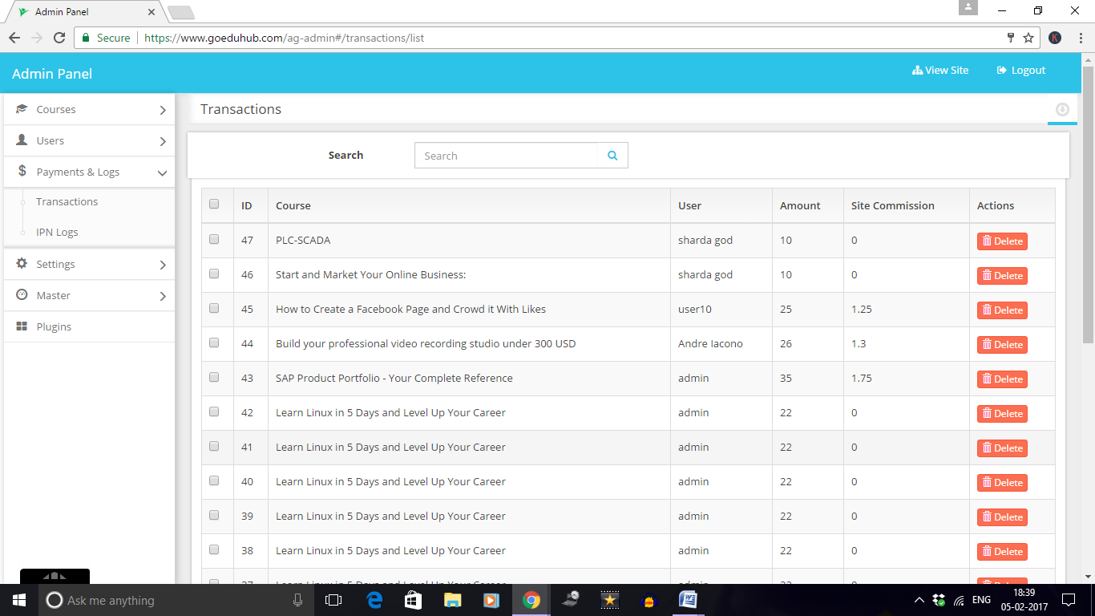

<https://www.goeduhub.com/ag-admin#/course_users/list?search=%7B%22filter%22:%22paid%22%7D>

