MINOR PROJECT REPORT
on

“RETRIVEX- document search engine”

Submitted in partial fulfillment of the requirements for the award of the degree of

BACHELOR OF TECHNOLOGY
in
COMPUTER SCIENCE AND ENGINEERING



Submitted By:
PARTH BHATTAR (23BCON1136)
KUSHAGRA JAIN (23BCON1166)
BADRISH LARGOTRA (23BCON2245)

Under the Supervision of
Mr. Taranjit Singh

Department of Computer Science and Engineering
JECRC University, Jaipur

Session: 2025–26

DECLARATION

We, Parth Bhattar, Kushagra Jain and Badrish Largota certify that my minor project work embodied in this Report entitled “RETRIVEX- document search engine”” is my own Bonafide work carried out by me under the supervision of Mr. Taranjit Singh as Department of Computer Science & Engineering the JECRC University, Jaipur.

The work presented in this report is original and has not been submitted earlier as a whole or in part for the award of any degree or diploma at this or any other Institution or University in India or abroad. The information and data presented in this report are genuine to the best of our knowledge.

Date: _____________
Place: Jaipur

Signature of Students
Parth Bhattar (Team Leader)
Kushagra Jain(Team Member)
Badrish Largota(Team Member)

Counter Signature
Mr. Taranjit Singh
(Project Guide)

CERTIFICATE

This is to certify that the Minor Project titled “RETRIVEX- document search engine” has been successfully completed by Parth Bhattar (Team Leader), Kushagra Jain and Badrish Largota under my supervision during VI Semester of B.Tech. (CSE), JECRC University, Jaipur.

The project work is found to be satisfactory and is recommended for submission to the Department of Computer Science and Engineering, JECRC University, Jaipur in partial fulfillment of the requirements for the award of the degree of Bachelor of Technology in Computer Science and Engineering.

_________________  Mr. Taranjit Singh  (Project Guide) | _________________  HOD Signature  Head, Dept. of CSE  (Mrs. Shashi Sharma) | _________________  Dean Signature  Dean, School of Engg.  (Mr. Naveen Hemrajani)

ACKNOWLEDGEMENT

We would like to express our sincere gratitude to Mr. Taranjit Singh, Assistant Professor, Department of Computer Science and Engineering, JECRC University, Jaipur, for his invaluable guidance, continuous encouragement, and persistent support throughout the course of this project. His expert advice and constructive feedback have been instrumental in shaping this project to its current form.

We are deeply grateful to the Head of Department and the faculty members of the Department of Computer Science and Engineering, JECRC University, Jaipur, for providing us with the necessary resources, infrastructure, and academic environment to carry out this work.

We also extend our thanks to JECRC University, Jaipur, for giving us the opportunity to work on this minor project as part of our curriculum. The knowledge and skills imparted through the academic program have been the foundation upon which this project was built.

A special thanks to our family members, friends, and classmates who supported and motivated us throughout the project. Their encouragement at every step made the journey enjoyable and rewarding.

Parth Bhattar (Team Leader)
Kushagra Jain (Team Member)
Badrish Largota (Team Member)

ABSTRACT
Traditional file searching methods become inefficient and time-consuming when dealing with large collections of documents. Users often struggle to retrieve relevant information quickly across multiple file formats such as TXT, PDF, and DOCX. Existing basic search systems lack proper ranking and contextual result display, reducing search accuracy and usability. Retrivex is a desktop-based document search engine designed to provide fast and relevance-based document retrieval. The system uses an inverted indexing mechanism to enable efficient searching and applies the TF-IDF algorithm to rank documents according to relevance. It also performs text preprocessing operations such as normalization and tokenization for accurate indexing. Additionally, the application provides snippet-based results, keyword highlighting, and an interactive graphical user interface for improved user experience. The project is developed using Java as the core programming language and JavaFX for building the graphical user interface. Apache PDFBox is used for extracting text from PDF files, while Apache POI is used for processing DOCX documents. The project also utilizes data structures such as HashMaps and algorithms like TF-IDF and inverted indexing for efficient information retrieval. IntelliJ IDEA and GitHub are used for development and version control. The project successfully demonstrates an efficient and portable desktop document search engine capable of processing multiple file formats and providing accurate search results. It highlights the practical implementation of information retrieval concepts, data structures, and ranking algorithms in a real-world application.

Keywords:
Information Retrieval, TF-IDF, Inverted Index, JavaFX, Document Search Engine, Text Processing, Ranking Algorithm

TABLE OF CONTENTS

Declaration i
Certificate ii
Acknowledgement iii
Abstract iv
Table of Contents v
List of Figures vi
List of Tables vii
List of Abbreviations viii
Chapter 1: Introduction 1
1.1 Background of the Study 1
1.2 Problem Statement 3
1.3 Objectives of the Project 4
1.4 Scope of the Project 5
Chapter 2: Literature Review 6
2.1 Related Work 6
2.2 Comparative Study 8
2.3 Feasibility Study 9
Chapter 3: System Design 11
3.1 System Architecture 11
3.2 UML Diagrams 12
3.3 Database Design 14
Chapter 4: Implementation 16
4.1 Tools & Technologies Used 16
4.2 System Requirements 17
4.3 Module Description 18
4.4 Algorithms / Logic Used 20
Chapter 5: Testing & Results 22
5.1 Test Plan 22
5.2 Test Cases 23
5.3 Performance Analysis 25
Chapter 6: Conclusion & Future Work 27
References 29
Appendices 30

CHAPTER 1: INTRODUCTION

1.1 Background of the Study
With the rapid growth of digital data, users increasingly store information in various document formats such as TXT, PDF, and DOCX. Retrieving specific information from large collections of files using traditional manual searching methods is often slow, inefficient, and time-consuming. Modern information retrieval systems solve this problem by using indexing and ranking techniques to improve search speed and relevance. Search engines widely used on the internet follow similar principles to efficiently process and retrieve information from large datasets.
Retrivex is developed as a desktop-based document search engine that applies information retrieval concepts such as inverted indexing and TF-IDF ranking to provide fast and accurate document retrieval. The project demonstrates how data structures, algorithms, and text preprocessing techniques can be combined to build an efficient search system capable of handling multiple document formats with a user-friendly graphical interface.
In addition to efficient retrieval, modern search systems are expected to provide relevance-based results and better user interaction. Simple keyword matching alone is often insufficient because it does not consider the importance or context of terms within documents. Therefore, ranking algorithms such as TF-IDF are widely used to prioritize the most relevant results. Retrivex incorporates these concepts along with preprocessing techniques like normalization and tokenization to improve accuracy and consistency. The project also focuses on usability by integrating snippet-based previews, keyword highlighting, and an interactive JavaFX-based graphical interface, making the system practical for educational, organizational, and personal use.

1.2 Problem Statement
Traditional file searching methods rely on manually opening documents or performing simple keyword-based searches, which become inefficient and time-consuming when dealing with large collections of files. Users often face difficulty in retrieving relevant information quickly across multiple document formats such as TXT, PDF, and DOCX. Existing basic search systems do not provide relevance-based ranking, contextual previews, or efficient indexing mechanisms, resulting in slower retrieval and poor user experience.
Additionally, most basic desktop search utilities lack advanced information retrieval techniques that can prioritize documents according to their relevance. As the amount of digital data continues to grow, there is a need for a system that can efficiently process multiple file formats, perform fast searches using indexing techniques, and provide accurate, relevance-based results with improved usability and interaction.

1.3 Objectives of the Project
• To develop a desktop-based document search engine capable of processing TXT, PDF, and DOCX files.
• To implement an inverted indexing mechanism for fast and efficient document retrieval.
• To apply the TF-IDF (Term Frequency–Inverse Document Frequency) algorithm for relevance-based ranking of search results.
• To perform text preprocessing operations such as normalization, tokenization, and cleaning for accurate indexing.
• To provide snippet-based search results and keyword highlighting for improved readability and user experience.
• To design a user-friendly graphical interface using JavaFX for file upload, searching, and preview functionality.
• To demonstrate the practical implementation of information retrieval concepts, data structures, and algorithms in a real-world application.

1.4 Scope of the Project
• To develop a desktop-based document search engine for efficient retrieval of information from TXT, PDF, and DOCX files.
• To implement information retrieval techniques such as inverted indexing and TF-IDF ranking for fast and accurate search results.
• To support text preprocessing operations including normalization, tokenization, and cleaning for improved indexing accuracy.
• To provide features such as snippet-based results, keyword highlighting, and document preview for better user interaction.
• To create a user-friendly graphical interface using JavaFX for file upload, search, and preview operations.
• To enable efficient searching on local systems without requiring internet connectivity or cloud-based services.
• To demonstrate the practical implementation of data structures, algorithms, and software engineering concepts in a real-world application.
• To provide a scalable foundation for future enhancements such as semantic search, database integration, and support for additional file formats.

CHAPTER 2: LITERATURE REVIEW

2.1 Related Work
Information retrieval systems and search engines have become an important part of modern computing due to the rapid growth of digital data. Many existing search systems use indexing and ranking techniques to retrieve relevant information efficiently from large collections of documents. Popular web search engines such as Google use advanced crawling, indexing, and ranking algorithms to provide accurate and relevance-based search results. Similarly, desktop search applications are designed to help users quickly locate files and information stored on local systems.

Several document retrieval systems use keyword matching techniques for searching; however, simple keyword matching often produces less accurate results because it does not consider the importance or frequency of terms within documents. To improve retrieval accuracy, modern systems apply information retrieval algorithms such as TF-IDF and indexing mechanisms like inverted indexing. These techniques help rank documents according to their relevance and significantly reduce search time.

Research in this field has also focused on text preprocessing methods such as normalization, tokenization, stemming, and stop-word removal to improve indexing quality and search efficiency. Various applications additionally provide features such as contextual previews, highlighted keywords, and graphical interfaces to enhance user interaction and usability.

Retrivex is developed based on these existing concepts and techniques. The project integrates inverted indexing, TF-IDF ranking, preprocessing operations, and a JavaFX-based graphical interface to create an efficient desktop document search engine capable of handling multiple file formats including TXT, PDF, and DOCX.

2.2 Comparative Study

Feature / Parameter | Traditional File Search | Basic Keyword Search Systems | Retrivex
Search Method | Manual scanning | Simple keyword matching | Inverted indexing with TF-IDF
Search Speed | Slow | Moderate | Fast
Relevance-Based Ranking | Not available | Limited | Available using TF-IDF
File Format Support | Limited | Mostly single format | TXT, PDF, DOCX
Indexing Mechanism | Not used | Basic indexing | Inverted Index
Search Accuracy | Low | Moderate | High
Snippet-Based Results | Not available | Limited | Available
Keyword Highlighting | Not available | Limited | Available
User Interface | Basic | Simple | Interactive JavaFX GUI
Scalability | Low | Moderate | High
Usability | Time-consuming | Moderate | User-friendly
Retrieval Efficiency | Low | Moderate | High

2.3 Feasibility Study
2.3.1 Technical Feasibility
The technical feasibility of Retrivex is high because the project is developed using widely supported technologies such as Java, JavaFX, Apache PDFBox, and Apache POI. These technologies provide the required functionalities for file processing, text extraction, indexing, ranking, and user interface development.
The project implements information retrieval concepts such as inverted indexing and TF-IDF ranking using efficient data structures like HashMaps and Lists. Text preprocessing techniques such as normalization and tokenization are also used to improve search accuracy and indexing performance.
2.3.2 Economic Feasibility
Retrivex is economically feasible because the project uses free and open-source technologies including Java, JavaFX, Apache PDFBox, Apache POI, and GitHub. Therefore, no additional licensing cost is required for development.
The system also does not require expensive hardware or cloud infrastructure. It can run efficiently on standard computer systems, which keeps the development and maintenance cost very low.
2.3.3 Operational Feasibility
The operational feasibility of Retrivex is high because the system is simple and user-friendly. Users only need to upload files and enter search queries through the graphical interface to retrieve relevant results.
Features such as snippet-based results, keyword highlighting, and document preview improve usability and interaction. The application runs on local systems without requiring internet connectivity or advanced technical knowledge.

CHAPTER 3: SYSTEM DESIGN

3.1 System Architecture
The architecture of Retrivex is designed using a modular approach where each module performs a specific task in the document retrieval process. The system mainly consists of file processing, text preprocessing, indexing, search ranking, and graphical user interface modules. These modules work together to provide efficient and accurate document retrieval.
The file processing module is responsible for reading TXT, PDF, and DOCX files using Java, Apache PDFBox, and Apache POI libraries. After extracting text from the documents, the preprocessing module performs operations such as normalization, tokenization, and cleaning to prepare the data for indexing.
The indexing module creates an inverted index that maps words to the documents in which they appear. This improves search speed by avoiding linear scanning of files. The ranking module then applies the TF-IDF algorithm to calculate the relevance of documents according to the search query.
Finally, the graphical user interface developed using JavaFX allows users to upload files, enter search queries, and view ranked results with snippets and keyword highlighting. The architecture ensures modularity, scalability, and efficient interaction between all system components.

3.2 UML Diagrams
UML (Unified Modeling Language) diagrams are used to visually represent the structure and workflow of the system. These diagrams help in understanding the interaction between users and system components, as well as the sequence of operations performed during document retrieval.
Use Case Diagram:
The use case diagram represents the interaction between the user and the system. The primary functions include uploading files, processing documents, performing search operations, viewing search results, and previewing document content.
Activity Diagram:
The activity diagram illustrates the workflow of the system starting from file upload and preprocessing to indexing, searching, ranking, and displaying results. It shows the sequence of operations and decision-making flow within the application.
Sequence Diagram:
The sequence diagram represents the interaction between different system modules in a time sequence. It shows how user requests are passed from the graphical interface to the processing, indexing, and ranking modules before displaying the final results.

3.3 Data Flow Diagram (DFD)
The Data Flow Diagram (DFD) represents the movement of data within the system. It illustrates how input documents are processed through preprocessing and indexing modules before being stored in the inverted index. When a user enters a search query, the system retrieves relevant documents from the index, applies TF-IDF ranking, and displays the final results through the graphical interface.
The DFD helps in understanding the flow of information between different system components and demonstrates how data is transformed at each stage of the retrieval process.

3.4 ER Diagram
The ER (Entity Relationship) diagram represents the logical structure of data used in the system. Since Retrivex mainly uses in-memory data structures instead of a database, the ER diagram focuses on the relationship between entities such as Documents, Keywords, Search Queries, and Search Results.
Each document contains multiple keywords, while each keyword can appear in multiple documents. The search query entity interacts with the indexing and ranking modules to generate relevant search results for the user.

3.5 Database Design

Data Structure / Entity | Purpose | Description
Documents | Stores document information | Contains uploaded TXT, PDF, and DOCX files processed by the system
Keywords | Stores extracted words | Maintains processed words after normalization and tokenization
Inverted Index | Fast document retrieval | Maps keywords to the list of documents in which they appear
Search Query | User input processing | Stores the keyword or phrase entered by the user for searching
Search Results | Result generation | Contains ranked documents returned after TF-IDF calculation
HashMap | Index storage | Used for implementing inverted indexing efficiently
List / ArrayList | Data collection | Stores documents, keywords, and search results dynamically
TF-IDF Score | Ranking mechanism | Represents the relevance score of documents based on search query

CHAPTER 4: TECHNOLOGY STACK – IN-DEPTH ANALYSIS

4.1 Tools & Technologies Used
Java:
Java is the core programming language used for developing Retrivex. It is an object-oriented, platform-independent, and robust programming language widely used for desktop applications and backend systems. Java provides strong support for file handling, data structures, multithreading, and memory management, making it suitable for implementing information retrieval systems. In this project, Java is used for document processing, indexing, TF-IDF calculation, search operations, and overall system logic.
JavaFX:
JavaFX is used for developing the graphical user interface of the application. It provides modern UI components such as buttons, text fields, list views, layouts, and web views that help create an interactive and user-friendly desktop application. JavaFX also supports animations, styling, and event-driven programming, improving the overall usability and visual appearance of the system.
Apache PDFBox:
Apache PDFBox is an open-source Java library used for extracting text from PDF documents. Since PDF files store content in a complex format, standard file reading methods cannot directly process them. PDFBox enables the system to read PDF content efficiently and convert it into searchable text for preprocessing and indexing.
Apache POI:
Apache POI is used for processing DOCX files in the project. It allows Java applications to read, write, and manipulate Microsoft Office documents. In Retrivex, Apache POI is used to extract textual content from DOCX documents so that the data can be normalized, indexed, and searched efficiently.
IntelliJ IDEA:
IntelliJ IDEA is the Integrated Development Environment (IDE) used for developing and debugging the project. It provides features such as syntax highlighting, code suggestions, debugging tools, project management, and Maven integration, which improve development efficiency and code quality.
Git & GitHub:
Git is used as the version control system for tracking code changes during development, while GitHub is used for project hosting and repository management. These tools help in maintaining project versions, managing updates, and storing the source code in an organized manner.
4.2 System Requirements
Hardware Requirement
Processor:
Intel Core i3 or equivalent processor is required for smooth execution of indexing and search operations.
RAM:
Minimum 4 GB RAM is required for efficient text processing and indexing.
Storage:
At least 256 GB storage is recommended for application files and documents.

Software Requirement
Operating System:
Windows 10 or Windows 11 operating system.
Java Development Kit (JDK):
JDK 21 or above is required for compiling and running the application.
JavaFX SDK:
Used for graphical user interface development and execution.
Apache PDFBox & Apache POI:
Required for processing PDF and DOCX files.
IDE & Build Tool:
IntelliJ IDEA is used for development and Maven is used for dependency management.

4.11 Module Description
File Processing Module:
This module is responsible for reading TXT, PDF, and DOCX files using Java, Apache PDFBox, and Apache POI libraries.
Text Preprocessing Module:
This module performs normalization, tokenization, and cleaning operations to prepare text for indexing and searching.
Indexing Module:
The indexing module creates an inverted index that maps keywords to the documents in which they appear for fast retrieval.
Search Module:
This module processes user queries and retrieves matching documents from the inverted index.
Ranking Module:
The ranking module applies the TF-IDF algorithm to rank documents according to their relevance to the search query.
Snippet & Highlighting Module:
This module generates contextual snippets and highlights searched keywords within the preview content.
User Interface Module:
Developed using JavaFX, this module handles file upload, search operations, result display, and document preview interactions.

4.12 Algorithms / Logic Used
Inverted Indexing:
The system uses an inverted indexing mechanism where each keyword is mapped to the list of documents in which it appears. This reduces search time by avoiding linear scanning of all files during every search operation.
TF-IDF Algorithm:
TF-IDF (Term Frequency–Inverse Document Frequency) is used to rank documents according to their relevance. TF measures how frequently a word appears in a document, while IDF measures the importance of the word across all documents. The combined score helps prioritize the most relevant search results.
Text Normalization:
Normalization converts all text into a consistent format by transforming characters to lowercase and removing special symbols or unnecessary spaces. This improves indexing consistency and search accuracy.
Tokenization:
Tokenization splits textual content into individual words or tokens, which are then used for indexing and searching operations.
Snippet Generation:
The system generates contextual snippets around the searched keyword to help users quickly understand where the term appears within the document.
Keyword Highlighting:
Matched keywords are highlighted in the preview section to improve readability and user interaction.

CHAPTER 5: TESTING & RESULTS

5.1 Test Plan
The testing process of Retrivex was carried out to verify the functionality, accuracy, and performance of the system. Different types of documents including TXT, PDF, and DOCX files were used to test file processing, indexing, and search operations.
The system was tested for correct document retrieval, relevance-based ranking, snippet generation, keyword highlighting, and preview functionality. Various search queries were entered to ensure that the indexing and TF-IDF ranking mechanisms produced accurate and meaningful results.
The application was also tested for user interface functionality such as file upload, search interaction, and result display. Performance testing was performed using multiple documents to evaluate indexing efficiency and search speed.

5.2 Test Cases

5.2 Test Cases
Test Case ID | Test Scenario | Expected Result | Status
TC-01 | Upload TXT file | File should be processed successfully | Passed
TC-02 | Upload PDF file | PDF text should be extracted correctly | Passed
TC-03 | Upload DOCX file | DOCX content should be processed correctly | Passed
TC-04 | Search valid keyword | Relevant documents should be displayed | Passed
TC-05 | Search invalid keyword | “No Results Found” message should appear | Passed
TC-06 | TF-IDF ranking | Most relevant document should appear first | Passed
TC-07 | Snippet generation | Contextual text snippet should be displayed | Passed
TC-08 | Keyword highlighting | Searched keyword should be highlighted | Passed
TC-09 | Preview functionality | Selected document preview should open correctly | Passed
TC-10 | Multiple file handling | System should process multiple files efficiently | Passed

5.3 Performance Analysis
The performance of Retrivex was evaluated on the basis of search speed, indexing efficiency, retrieval accuracy, and user interaction. The implementation of inverted indexing significantly reduced document search time compared to traditional linear scanning methods. The TF-IDF ranking algorithm improved the relevance of search results by prioritizing documents according to keyword importance and frequency. Text preprocessing operations such as normalization and tokenization also enhanced indexing consistency and retrieval accuracy. The system successfully handled multiple TXT, PDF, and DOCX files with stable performance and efficient response time.

Performance Parameter | Observation | Result
File Processing | TXT, PDF, and DOCX files processed successfully | Efficient
Search Speed | Retrieval performed using inverted indexing | Fast
Ranking Accuracy | TF-IDF provided relevance-based results | High Accuracy
Snippet Generation | Contextual snippets displayed correctly | Successful
Keyword Highlighting | Highlighted matched keywords in preview | Successful
Multi-file Handling | Multiple documents processed efficiently | Stable Performance
User Interface Response | Smooth interaction during search and preview | User-Friendly
Memory Utilization | In-memory indexing using HashMaps and Lists | Optimized

5.4 Output Screenshots

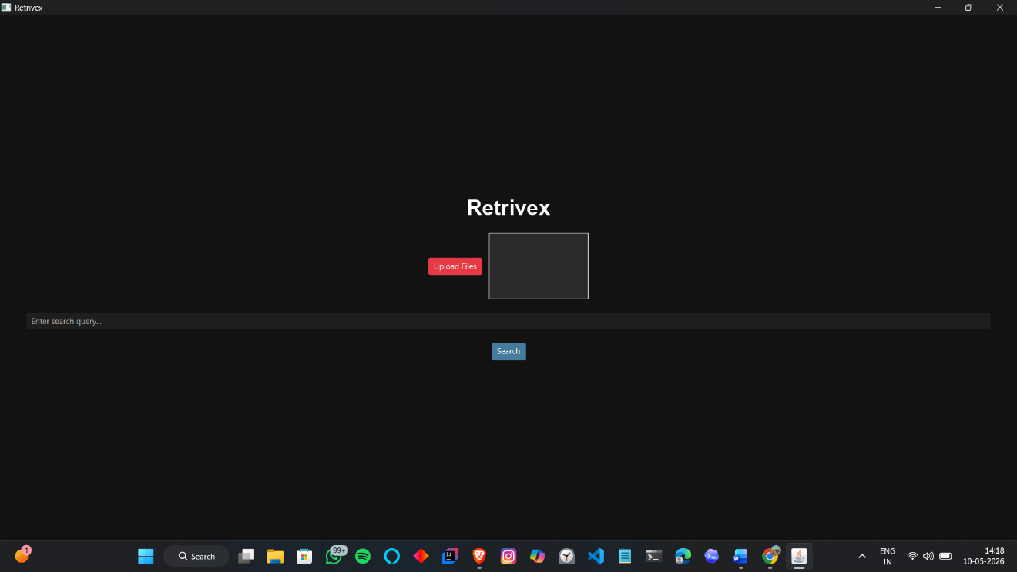

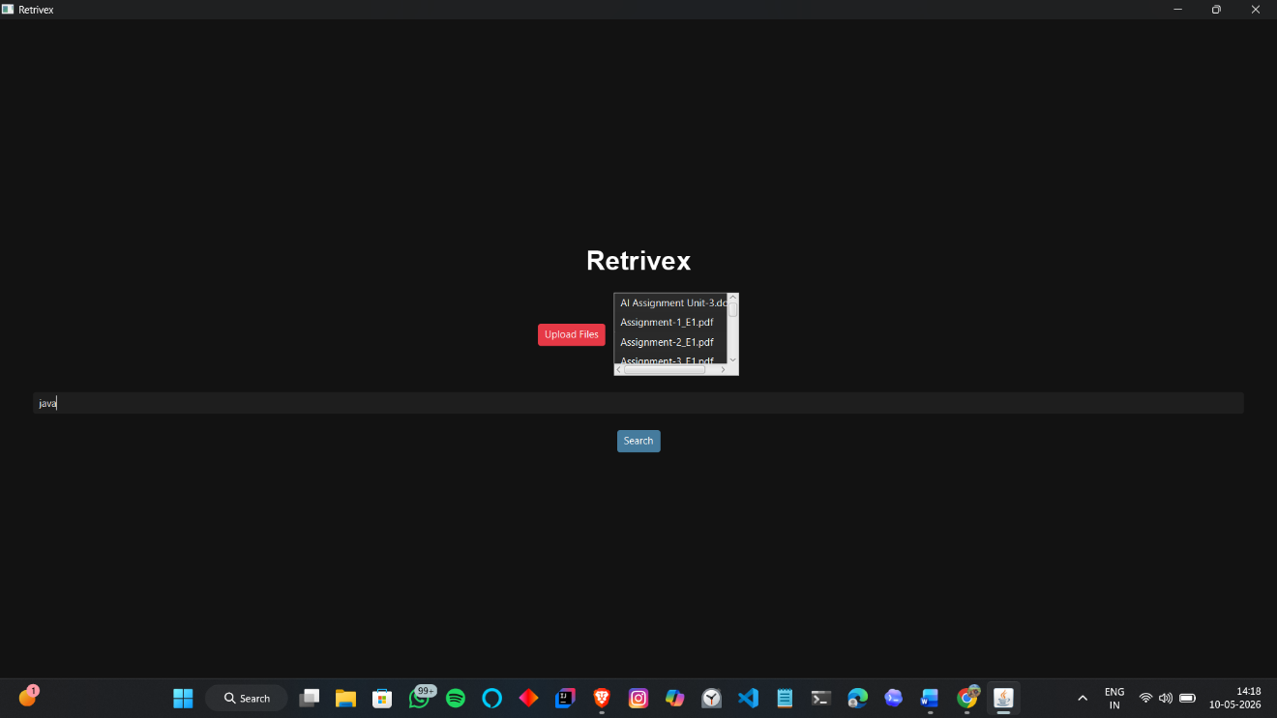

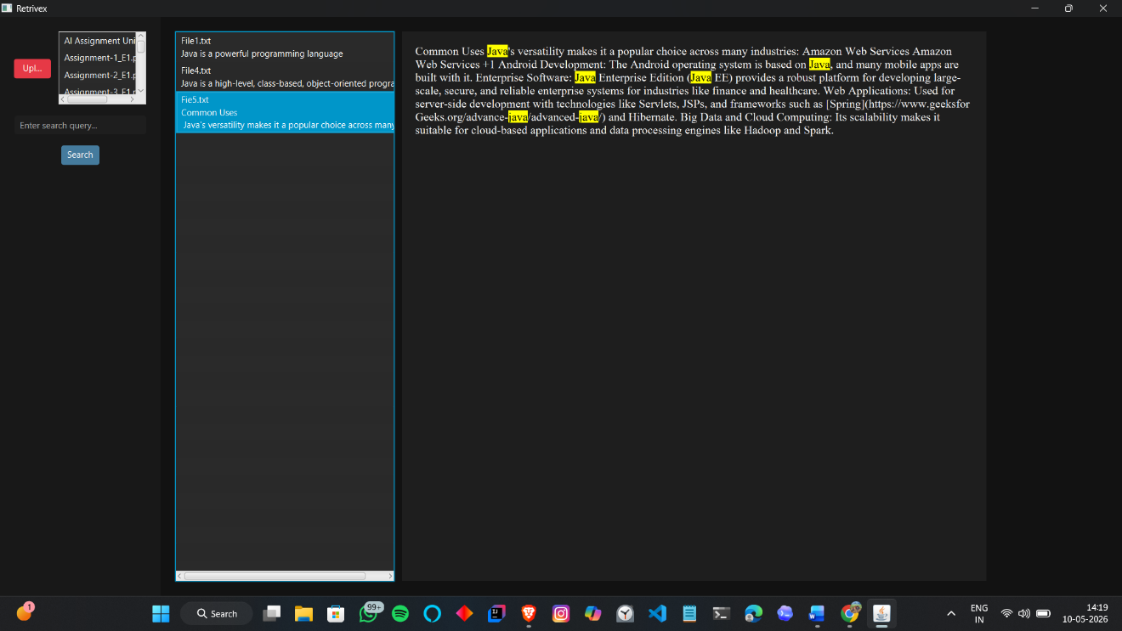

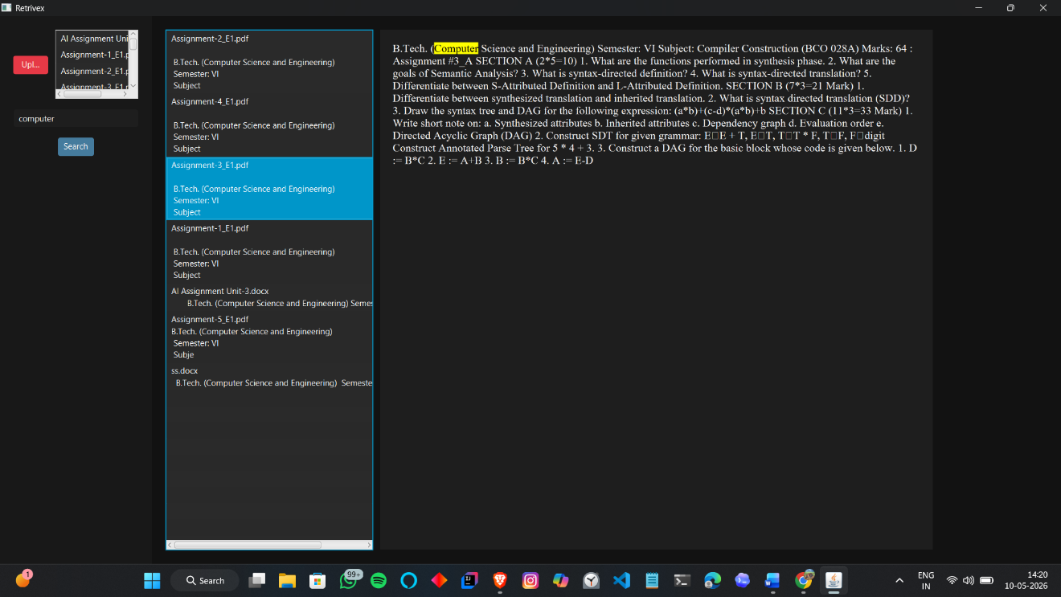

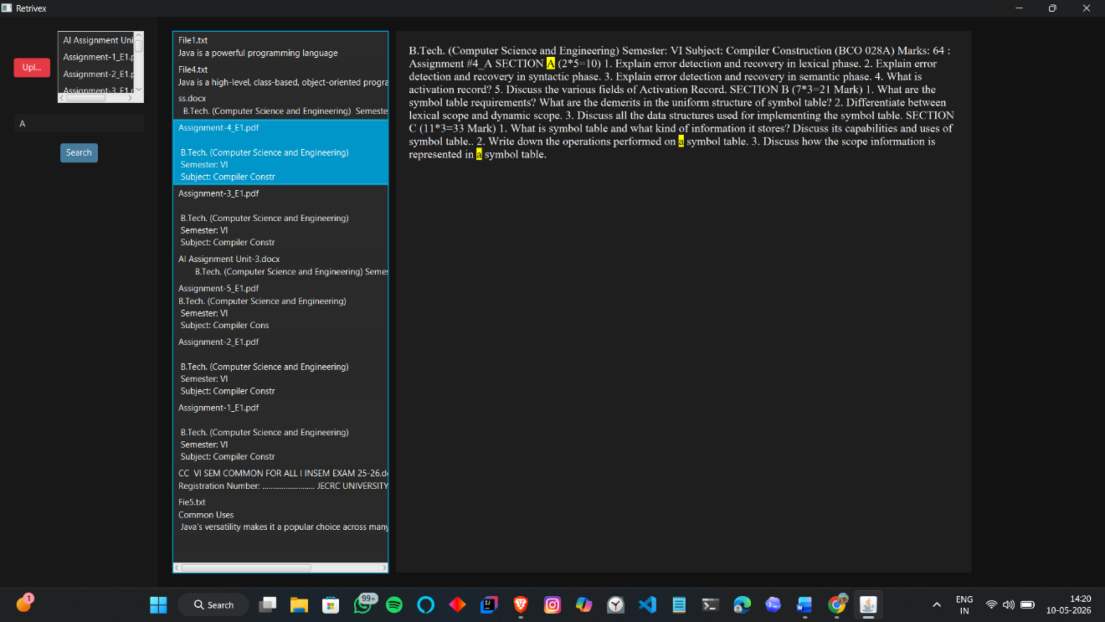

CHAPTER 6: CONCLUSION & FUTURE WORK

6.1 Summary
Retrivex is a desktop-based document search engine designed to retrieve relevant information efficiently from TXT, PDF, and DOCX files. The project implements information retrieval concepts such as inverted indexing, TF-IDF ranking, normalization, and tokenization to improve search speed and accuracy. The system supports multi-format document processing, snippet generation, keyword highlighting, and document preview through a JavaFX-based graphical user interface.
The project demonstrates the practical application of data structures, algorithms, file handling, and GUI development in solving real-world document retrieval problems. By combining efficient indexing and relevance-based ranking techniques, Retrivex provides a fast, lightweight, and user-friendly solution for local document searching.

6.2 Achievements
• Successfully developed a desktop-based document search engine using Java and JavaFX.
• Implemented inverted indexing for fast and efficient document retrieval.
• Applied the TF-IDF algorithm for relevance-based ranking of search results.
• Added support for multiple document formats including TXT, PDF, and DOCX.
• Implemented text preprocessing techniques such as normalization and tokenization.
• Developed snippet generation and keyword highlighting features for improved usability.
• Created an interactive graphical user interface for file upload, search, and document preview.
• Integrated Apache PDFBox and Apache POI libraries for PDF and DOCX processing.
• Improved search efficiency compared to traditional linear scanning methods.
• Successfully demonstrated practical implementation of information retrieval concepts and data structures.
6.3 Future Scope
• Integration of semantic and AI-based search techniques for improved understanding of user queries.
• Support for additional file formats such as PPT, XLSX, HTML, and image-based documents.
• Database integration for persistent storage and large-scale document indexing.
• Automatic folder monitoring and real-time indexing of newly added files.
• Cloud synchronization and online document retrieval support.
• Multi-user access with authentication and role-based security features.
• Advanced filtering and sorting options for improved search customization.
• Performance optimization for handling very large datasets and enterprise-level document collections.
• Development of a web-based or mobile version of the application for cross-platform accessibility.

REFERENCES

- Manning, C. D., Raghavan, P., & Schütze, H., “Introduction to Information Retrieval”, Cambridge University Press, 2008.
- Oracle Java Documentation, Available at: https://docs.oracle.com/javase/
- JavaFX Documentation, Available at: https://openjfx.io/
- Apache PDFBox Documentation, Available at: https://pdfbox.apache.org/
- Apache POI Documentation, Available at: https://poi.apache.org/
- Gamma, E., Helm, R., Johnson, R., & Vlissides, J., “Design Patterns: Elements of Reusable Object-Oriented Software”, Addison-Wesley, 1994.
- Horstmann, C. S., “Core Java Volume I – Fundamentals”, Pearson Education.
- GitHub Documentation, Available at: https://docs.github.com/
- IntelliJ IDEA Documentation, Available at: https://www.jetbrains.com/idea/documentation/
- Salton, G., & McGill, M. J., “Introduction to Modern Information Retrieval”, McGraw-Hill, 1983.

APPENDIX A: HOW TO RUN THE PROJECT

Step 1: Install Java Development Kit (JDK)
Install JDK 21 or above on the system and ensure that Java is properly added to the system PATH.
Step 2: Extract Project Files
Extract the Retrivex project folder containing the application JAR file, JavaFX SDK folder, and run.bat file.
Step 3: Verify Folder Structure
Ensure the project folder contains the following files and folders:
• RetrivexUI.jar
• run.bat
• javafx-sdk folder containing the lib directory
Step 4: Run the Application
Double-click the run.bat file to launch the application. The batch file automatically loads the required JavaFX modules and starts the application.
Step 5: Upload Documents
Use the Upload button in the graphical interface to select TXT, PDF, or DOCX files for processing and indexing.
Step 6: Perform Search Operation
Enter a keyword or query in the search field and press the Search button or Enter key to retrieve relevant documents.
Step 7: View Results
The system displays ranked search results along with snippets and keyword highlighting. Users can preview document content directly within the application.

APPENDIX B: SOURCE CODE
The source code of Retrivex is developed using Java and JavaFX. The project consists of multiple classes and modules responsible for file processing, text preprocessing, indexing, ranking, searching, and graphical user interface management.
Main Components of Source Code:
• Main.java
Handles application startup, user interface initialization, and interaction between different modules.
• SearchEngine.java
Implements indexing, searching, TF-IDF ranking, snippet generation, and keyword highlighting logic.
• File Processing Logic
Processes TXT, PDF, and DOCX files using Java file handling, Apache PDFBox, and Apache POI libraries.
• Text Preprocessing Module
Performs normalization, tokenization, and text cleaning operations before indexing.
• Inverted Index Implementation
Uses HashMaps and Lists to map keywords with corresponding documents for efficient retrieval.
• TF-IDF Ranking Logic
Calculates document relevance scores based on keyword frequency and document importance.
• JavaFX User Interface
Implements file upload, search operations, result display, and preview functionality using JavaFX components.
Technologies Used in Source Code:
• Java
• JavaFX
• Apache PDFBox
• Apache POI
• Maven
• IntelliJ IDEA
The complete source code of the project is attached separately along with the project files and GitHub repository.

