CIMS

Centralized Information Management System
For Cricket

Reports Module
(Captains Login)



User Manual

Captain’s Report:

- To get Captain’s Report click on Captain’s Pitch and Facility
Feedback menu option of the Match Feedback menu. This will present you with
the following captain’s report.

Match Details

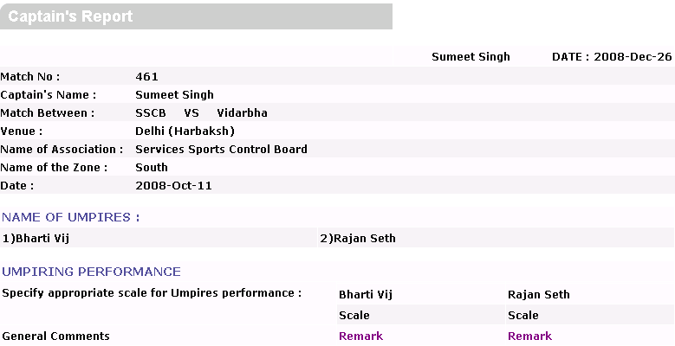
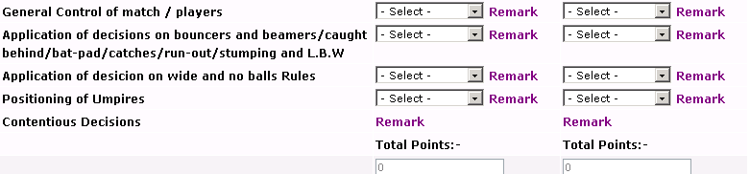

Name of Umpires of Match Umpiring Performance Section

- In this form Captain will be able to view the Umpires of the match and needs to fill information given about the Umpires performances.

- Captain’s Report will be accessed by captain and by admin.
- Captain’s report will contain Match details, Name of umpires and information to scale the umpires.
- Depending upon the information filled by the captain about match umpires, Total Points will be auto calculated in the form.
- You can submit and update data in the same form.

Note: Captain can view all the other reports in Match Details, For Players menu.

