CIMS

Centralized Information Management System

Mobile Module
(Mobile Pages)

For Cricket



User Manual

Viewing CIMS Mobile Pages:

- To get CIMS MobiCast on your phone, just key in this URL into your mobile phone’s WAP browser.

http://www.bccicricket.org/cims/jsp/mobile/login.jsp

Note: Your phone needs to be Internet/GPRS-enabled
GPRS charges as per your tariff plan with your mobile operator apply.

- Click on Login Button to continue.

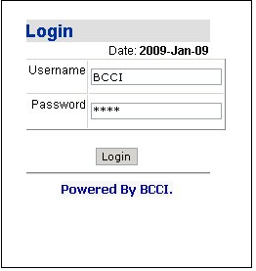

- When you login, you will be presented with following screen.
Select the match to view the details.

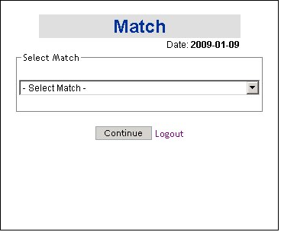

4. On selecting match following screen will be shown.

- Click on Live link to get Live Scorecard.

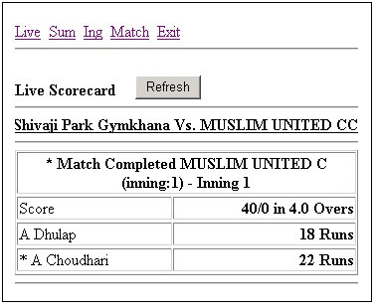

- Click on Sum link to get Innings Summary page.

Click team name Click for selecting batsman/bowler

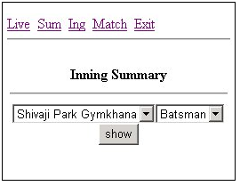

You can select team name and batsman/bowler to see following details.
If batsman is selected user will get batsman statistics i.e. runs, balls and strike rate(S/R).

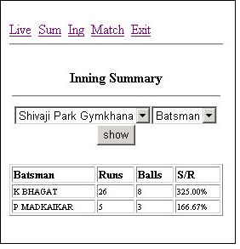

If bowler is selected user will get batsman statistics i.e. overs, wickets, economic rate (Eco.)

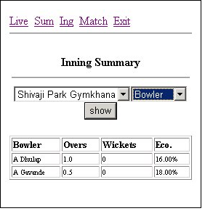

- Click on Ing to get Inning wise detail page.

You can see Innings wise details of team players about batsman and bowler name with runs, balls, overs, and wicket.

Click Inning number to get the result

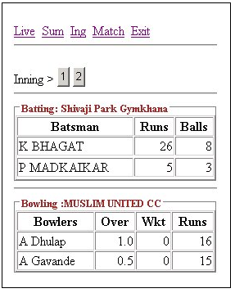

- If you want to see match details of other match click on Match link. You will get the page as in point 3.

- Exit link take you back to login page.

