CIMS

Centralized Information Management System
For Cricket

Reports Module
(Referee Login)



User Manual

Index
Referee’s Feedback Report on Umpire: 3
Pitch and Outfield report (Multiple Days)/One Day: 4
TRDO Report: 5
Over Rate Calculation Report: 6

Referee’s Feedback Report on Umpire:

- To get Referee Feedback report click on menu option of the Match Feedback menu. This will present you with the following captain’s report.

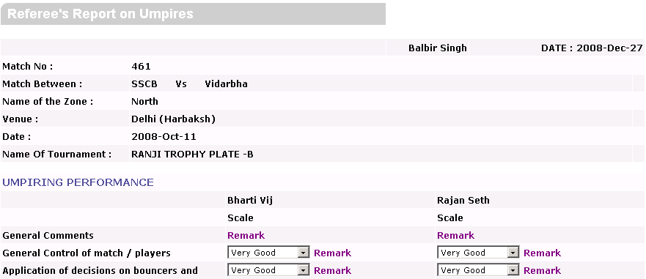
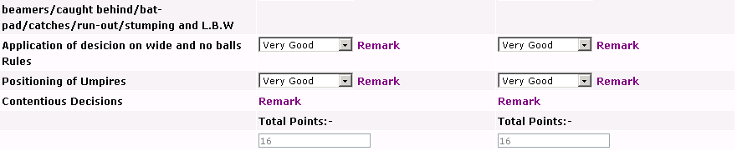
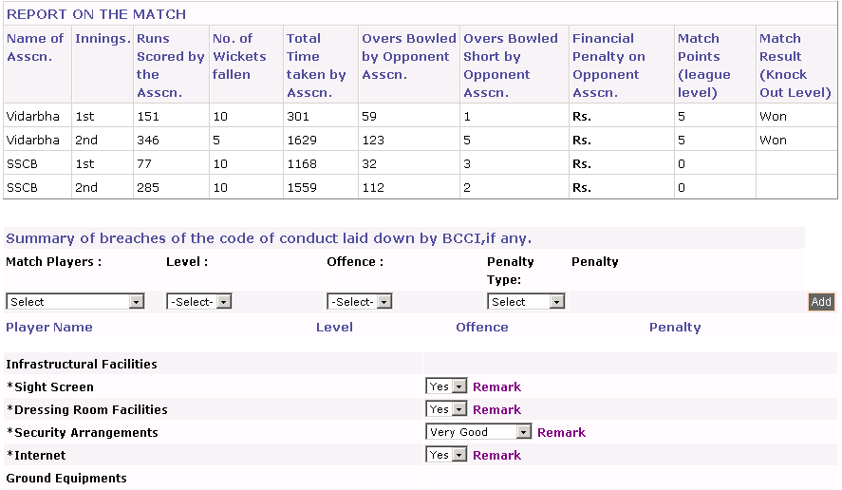
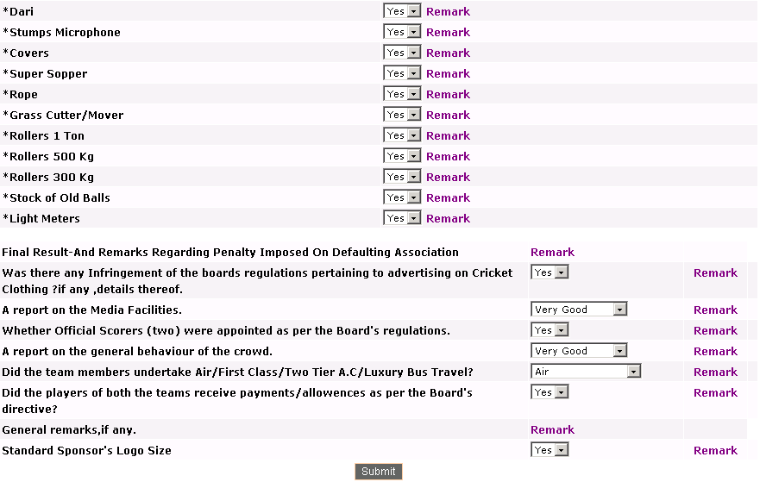

- Referee’s report on umpire basically contain match details, provision for referee to give details about the umpires, Report on match, section to note level of offence committed by the player and the penalty given to him, provision to give
Information about the Infrastructural Facilities and Ground equipment, and
Questions about match.
- You can save and update the data in the same form.

Pitch and Outfield report (Multiple Days)/One Day:

This report is filled by referee of the match. Depending upon the one day or test match selected Pitch Outfield report for multiple days or one day will be displayed. In this report referee gives ratings for pitch conditions before the match .Some of the points in this report are required to rate by referee on each day of match every day depending on number of days of that match.(Day 1, Day 2, Day 3, ….).Click on  icon present next to combo box to add remark.

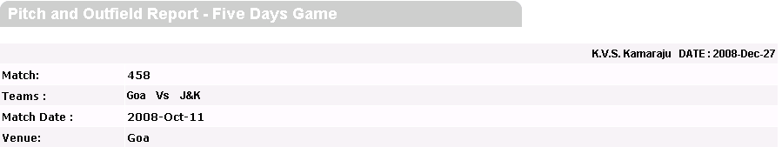
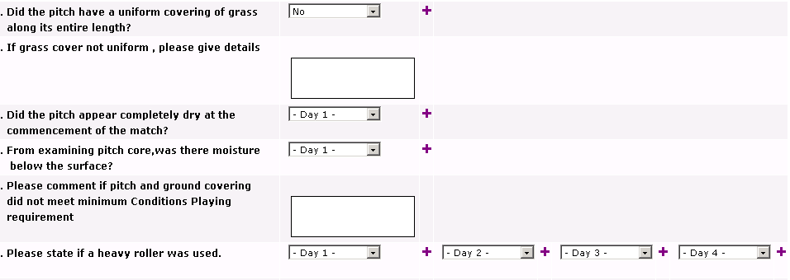
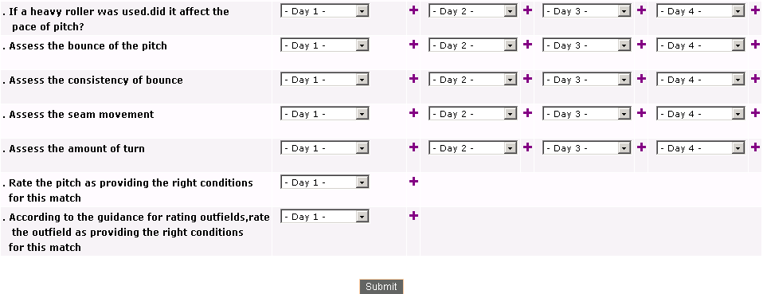

TRDO Report:
- This report is filled by referee of the match. In this report referee will select the player from Match Player field and the Role (Batting, Pacer, Spinner, and Wicket Keeping) and depending upon the points given Referee will rate the selected player’s performance.
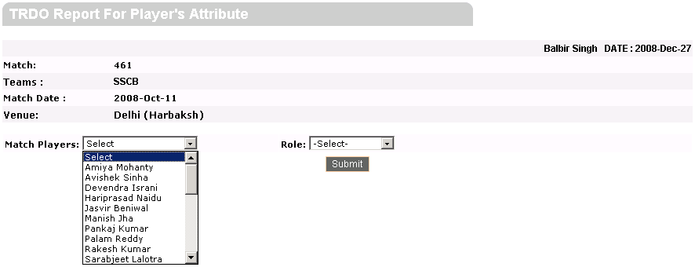

- Depending on selected Player and Role, Performance of selected player and the points to rate player will be presented on the form as following.

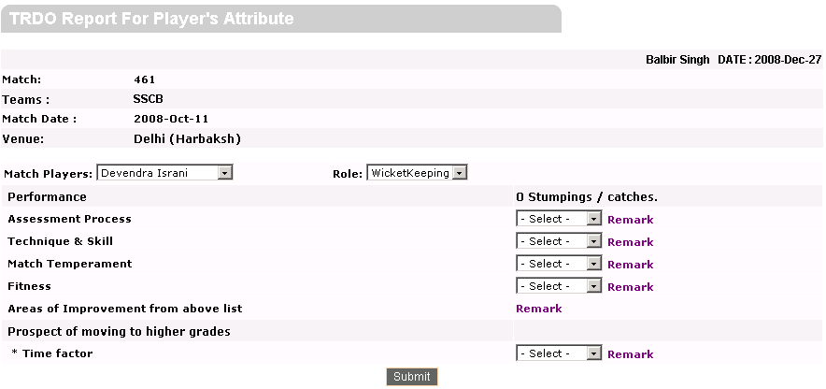

Over Rate Calculation Report:
- Over Rate Calculation Report will be filled by both the umpires of the match
And referee needs to Approve it.
- For referee login, if both the umpires have not sent the Over Rate Calculation form for approval to referee then, Report is Not Approved By Both Umpires message is given.
- For referee login, if either of the umpire(say Bharti Vij) have not sent the Over Rate Calculation form for approval, then Report is pending from Bharti Vij is given.
- For referee login, if both the umpires have set the Over Rate Calculation form for approval then, Report Approved By Both Umpires is given.
- When both the umpires have approved the form, the referee clicks on Approve button to finally approve the report.
- Once the referee approves the report, Report Approved message is given.
- If referee login the Over Rate Calculation form if it is already approved, then
Report Is Already Approved message is given.

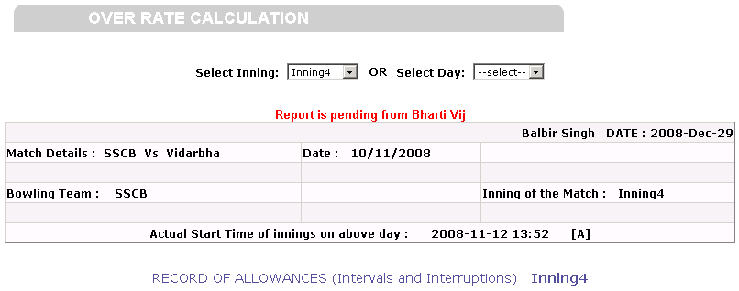

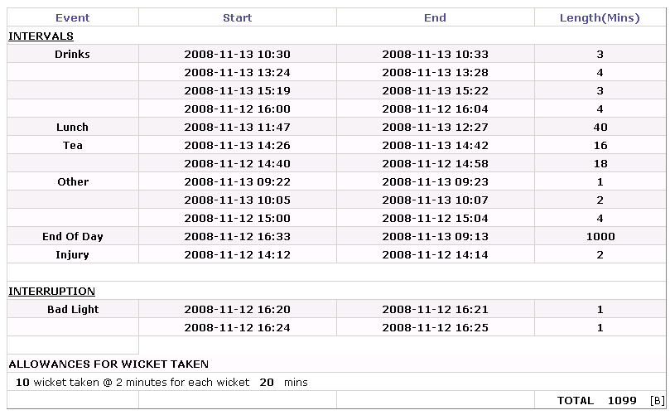
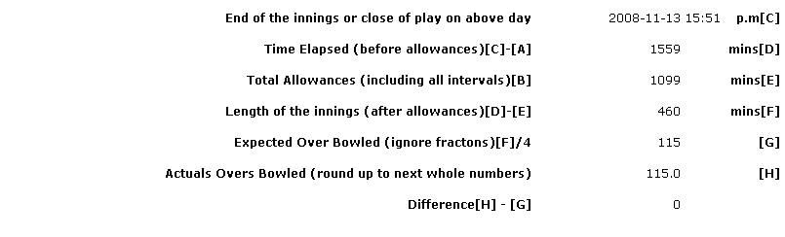

Note: Referee can view all the other reports in Match Details, For Players menu.

