CIMS

Centralized Information Management System

Scoring Application

For Cricket



User Manual

Index
About This Guide 3
About CIMS 3
CIMS – Scoring Application Usage 4
Starting CIMS application 4
Match Selection: 5
Toss Selection: 18
Player Selection: 19
Select Batsman and Bowler: 20
Score Card: 22
Starting Match: 22
Scoring a Match: 22
Wide and Wide + Runs: 23
No Ball: 24
No Ball and No ball + Extra runs: 24
No Ball (Bat Runs): 25
Byes: 27
Leg Byes: 28
Penalty Runs: 29
Wicket: 30
Retires: 31
Forced End Of Over: 32
Pause Innings: 33
Drinks, Lunch, Tea, Rain, Bad Light, Injury and Other: 33
End Innings: 36
End of the day: 36
Declare: 37
Switch Batsman: 38
Change Bowler: 39
New Ball: 40
Extra: 41
1) Undo: 42
2) More Undo 42
3) New Batsman: 43
4) Add Remark: 43
5) Day Max Over: 43
6) Online: 44
7) End Match: 44
8) Previous Innings: 44
9) Edit Interval: 45
10) Exit: 45

About This Guide
This user manual will provide you with the information required for running and using this application.

About CIMS
CIMS (Centralized Information Management System)

CIMS is a total scoring and match analysis application for the game of Cricket.
CIMS software has been designed to allow the user to enter ball-by-ball information for a cricket match just as you would in a traditional cricket scorebook. CIMS software also provides features of capturing ball by ball information of delivery length on pitch pad and shots played by batsman on wagon wheel. The scorer is prompted throughout the scoring of match in accordance with the natural flow of the game. Importantly, all the rules of the game are auto calculated so; you don’t have to know the matches rules for the cricket

CIMS – Scoring Application Usage

Starting CIMS application

- Click on Internet Explorer.
- Type URL – www.bccicricket.org to get the following
Login page
3. Enter valid username and password to log in as a scorer.

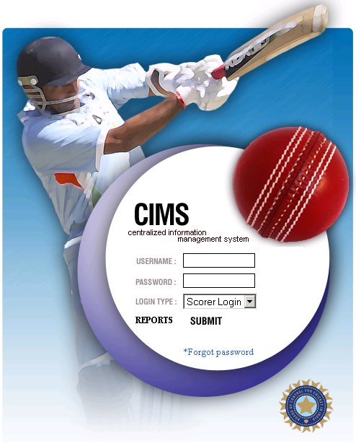


Match Selection:

- Select the current match for which you will do scoring.
Server Time

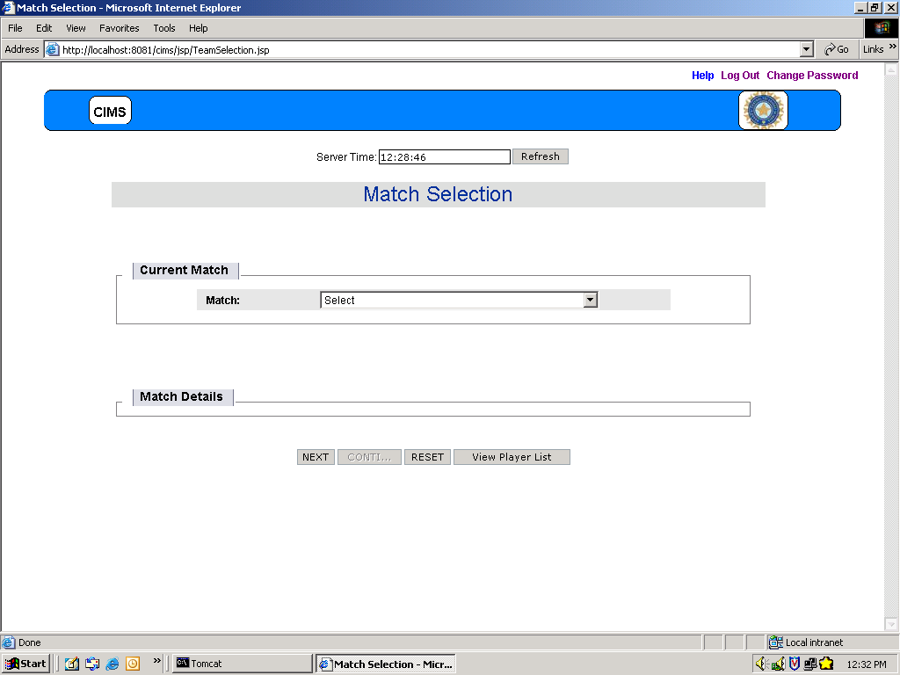

Next Button Continue Button View Player List Button
Will take you will take you to will show you the
next page score card of players list of both the teams
incomplete match

- If correct match is selected, Click NEXT button. It will present you Toss Selection page.

- To clear the data, Click RESET button.

- If selected match is incomplete then, Click CONTI…. button
It will take you to the score card where the match scoring was remained incomplete.

- To view the players list of both the teams, click on View Player List button.

- Selecting required match will present you with the following screen showing the match details with which you can verify the selected match is correct or not.

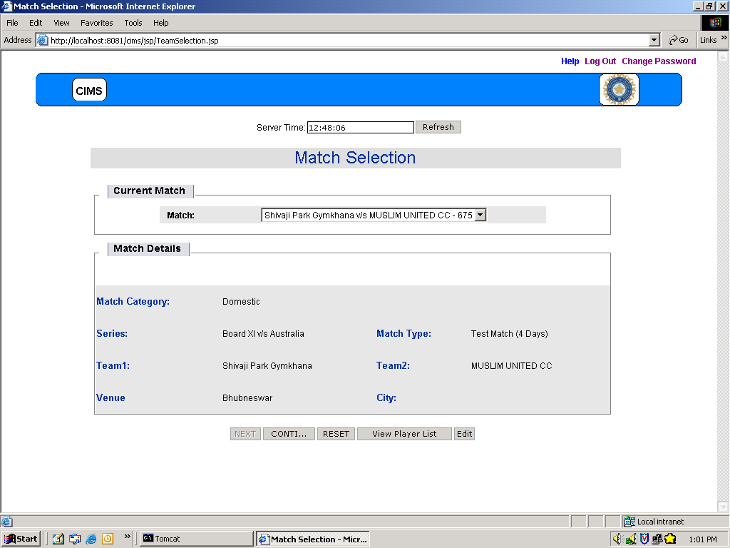

Edit button to edit the selected match.

NOTE: Edit button is visible from start date of match till end date and till 12am.
- Edit:
Clicking on “Edit” button will present you with following Match Innings page.

Match Innings Page:

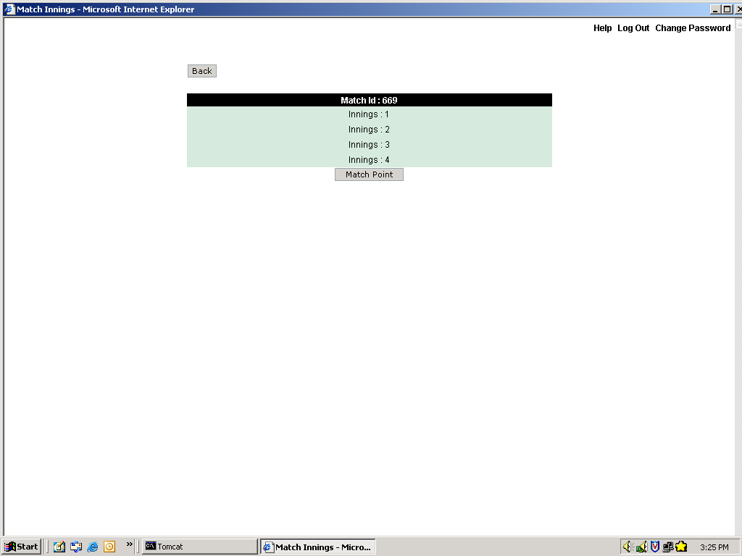

Innings link

- Match Innings page will show you Match Id with match innings. It will show you completed inning and ongoing inning.
i.e. If 10 overs of second inning is completed then, it will present you with
complete first inning and second innings with 10 overs.
- Click on particular inning whose record you want to edit.
Clicking on innings link will present you with following Match Overs page.

Match Overs Page:

Edit Innings Time
Edit Interval View Match Analysis
Edit Wickets

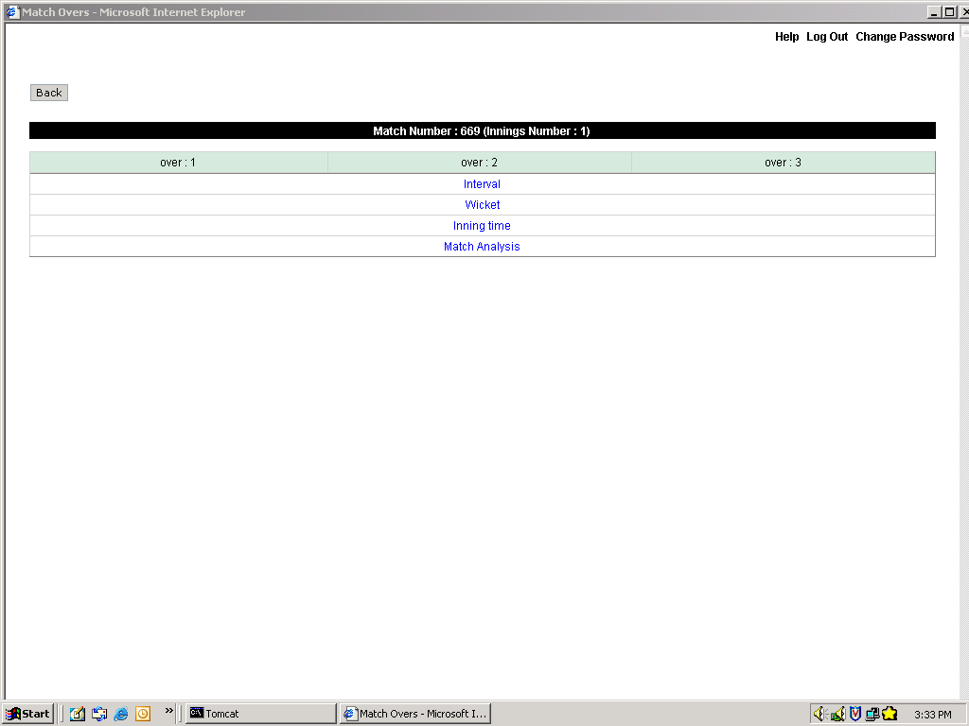

- Click on Interval button to edit the Intervals taken in the innings.
- Click on Wickets button to edit the Wickets taken. It will present you with the
following screen

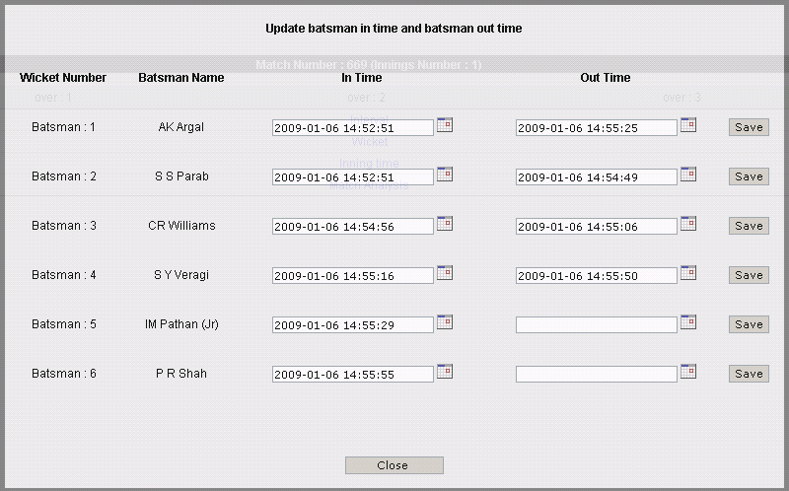

- Click on Innings time to edit the Innings Start Time and End Time.
It will present you with the following screen.

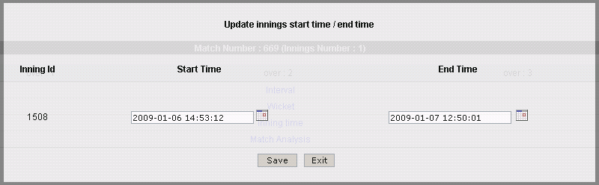

- Click on Match Analysis to get the details of Four/Six, Wickets, Extras, partnership, Innings Time Calculation. It will present you with following window.

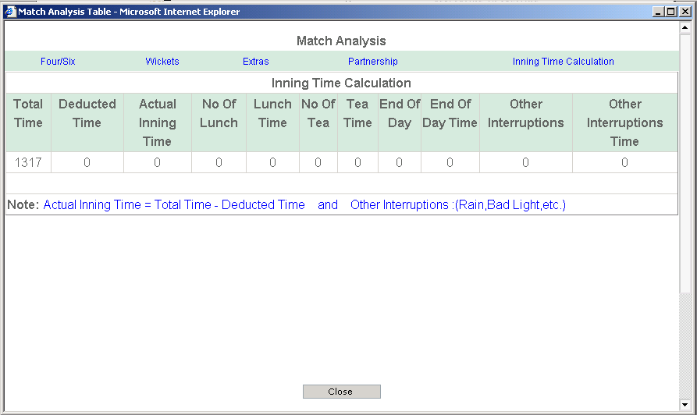

- Click on Four/Six, Wickets, Extras, partnership, Innings Time Calculation
link to get the respective details.

Match Overs Page:

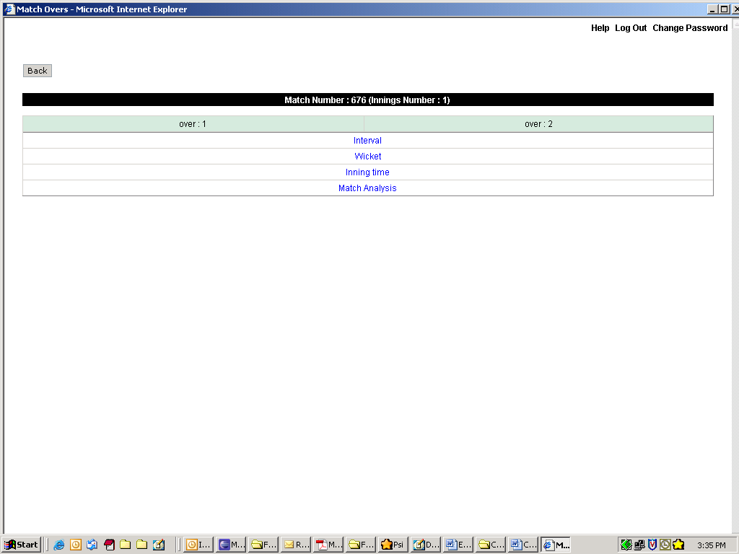
Overs in Innings

- This page will show you all the overs played in the selected inning.
- Click on particular over number (say Over: 63) whose records you want to edit and it will present you with following screen.

Editing particular ball’s record:

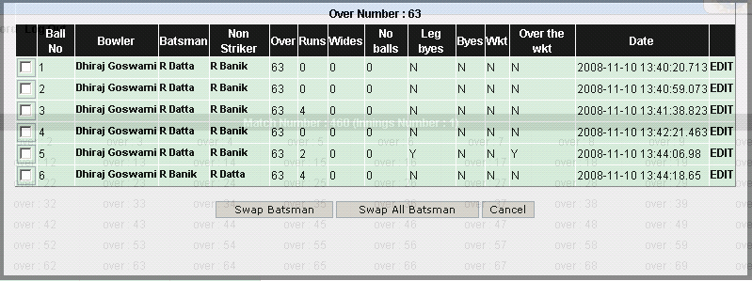

Edit Link
- Click on “EDIT” link of required ball whose record you want to edit.
It will present you with following screen.
For Example 1:
If in 5th ball of 63rd over scorer wants to update 2 Leg Byes with 2
Runs hit by batsman.
Then, S/He can edit this record.
Select Leg byes as “N” and click on “Update” button.
It will transfer these 2 runs to the batsman (Striker)

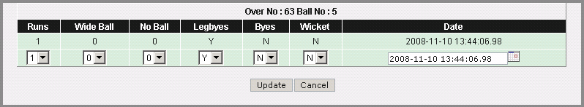

- For Example 2:
If in 3rd ball of 63rd over scorer wants to edit 3 Runs scored by batsman
as No Ball + 3 runs, then S/He can edit this record
Click on “EDIT” link.

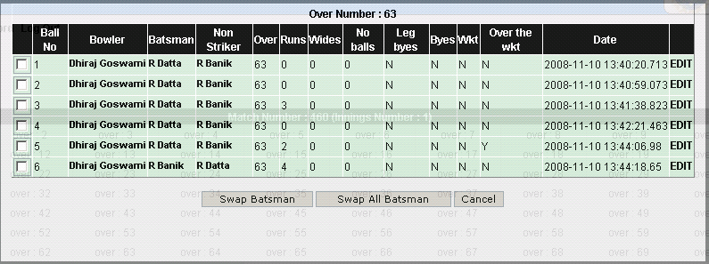

- In the following presented screen Select No Ball as “1” and click on “Update” button

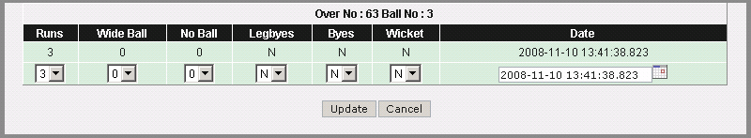

Swapping Batsman:

- For Example 3 – Swapping Batsman for particular ball.
If you want to edit the striker and non-striker of particular ball
played then, select the check box for the ball whose batsman you want
to swap. And click on “Swap Batsman” button. Batsman (Striker and
Non-striker) for selected ball will be swapped.
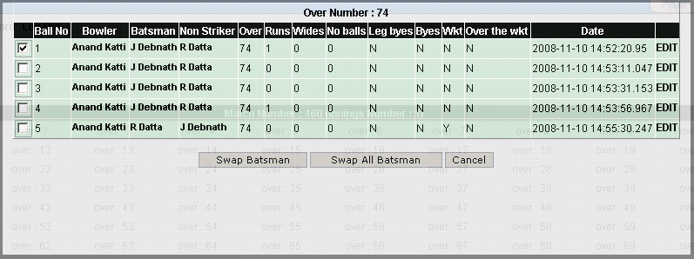

1. Select check box 2. Click Swap Batsman Button

- After swapping particular ball’s batsman you will be presented with following screen.

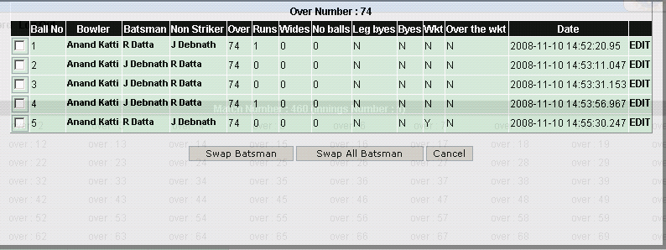

Swapped batsman

- For Example 4 – Swapping All Batsman(of Over)
To swap all the batsman of the over, simply click on “Swap All Batsman”
Button.

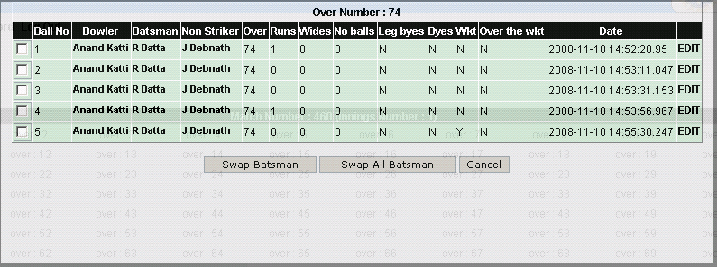

Click Swap All Batsman button
- After clicking “Swap All Batsman” you will be presented with following screen.

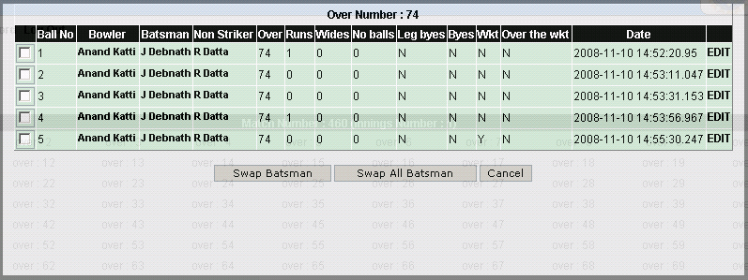

All swapped batsman

Editing time of ball bowled:

- If you want to edit the time of the ball bowled, then click on “EDIT” link of the
Ball whose time needs to update.

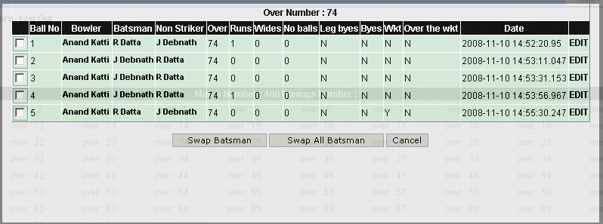

Click EDIT link
- In the following presented screen click on Date icon and you can change the
Time for the ball.
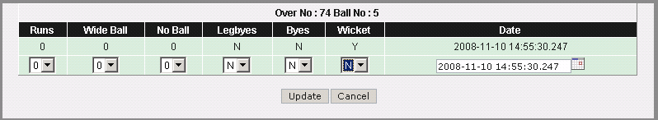
- Click on “Update” button.

Editing the wicket fallen:

- To edit the wicket fallen click on “EDIT” the ball on which wicket has fall.

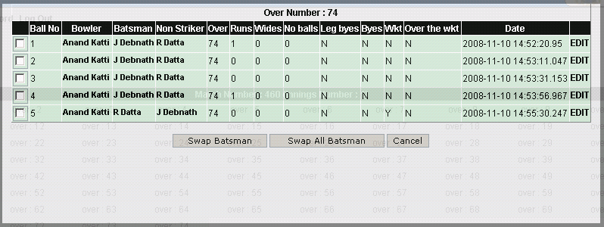

Click EDIT link

- You will get following series of screens to edit score and wicket.

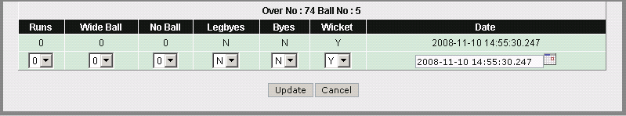

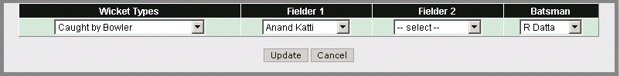

Screen to edit wicket data
- You can change wicket type fielder names and batsman name who was striker in that ball and click “Update” to save the changes.

- Following screen shows entries of records if it is online, offline or modified.

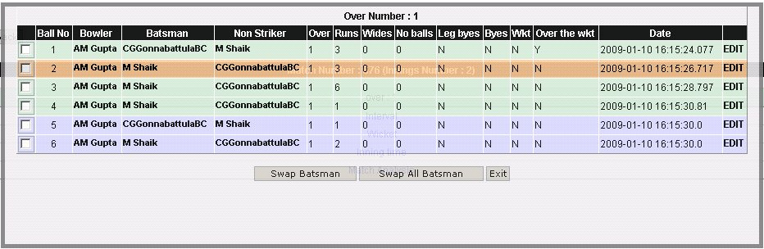

Modified record Record entered offline Record entered online

Toss Selection:

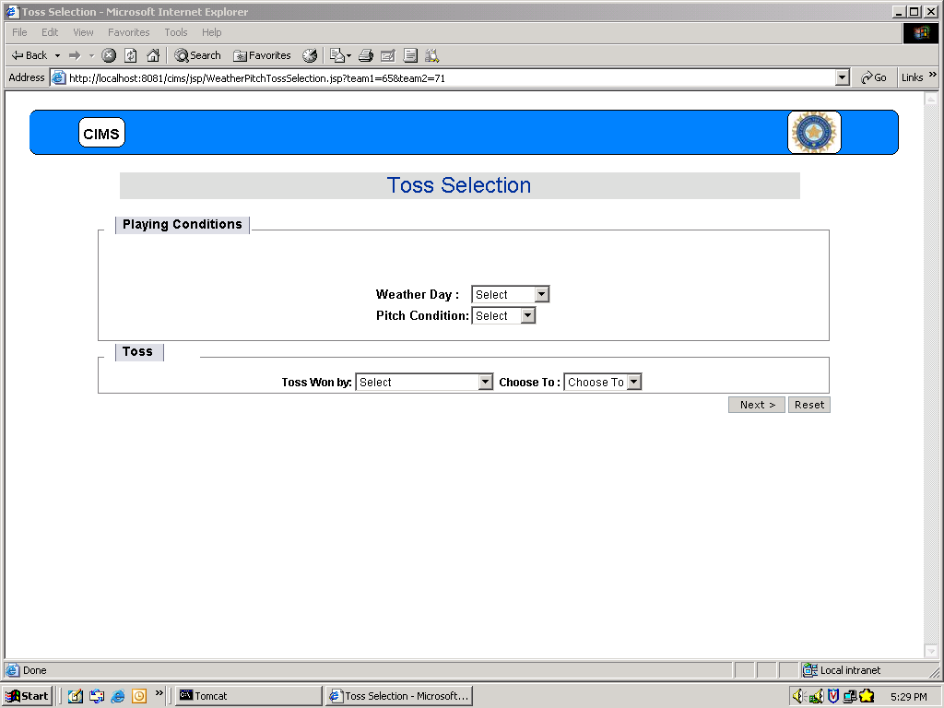

- Select Weather Day and Pitch Condition.
- Select the team who win the toss in Toss Won by and Toss Winning team will bat or field first in Choose To field.
- To clear the data, Click on Reset button
- Click on Next button, and then it will present you following Player Selection form

Player Selection:
Available Players Selected Players

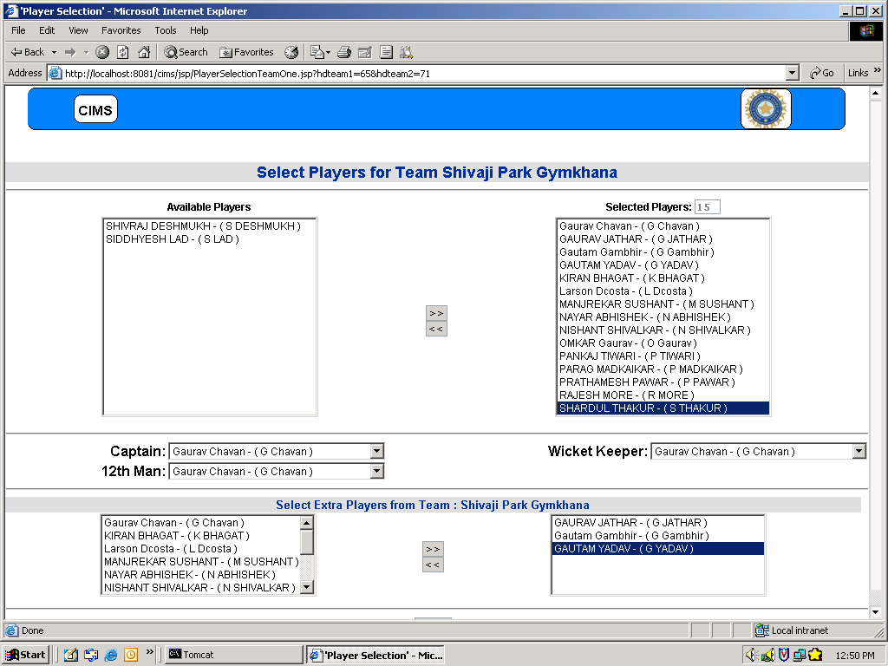

Extra Players Selection List Selected Extra Players

- For the selection of players of team 1 and team 2 Player Selection page for team 1 and team 2 will be presented in sequence.
- From this page you can select minimum 12 and maximum 16 players, Captain, Wicket Keeper, 12th Man and extra players’ selection as per the number of the team selected.
For example:
- If you select 14 players, 2 players will be allowed to select as extra players.
- If you select 16 players, 4 players will be allowed to select as extra players.
- After proper selection of the team, click on NEXT button.
It will present you with following page of SELECT BATSMEN AND BOWLER

Select Batsman and Bowler:

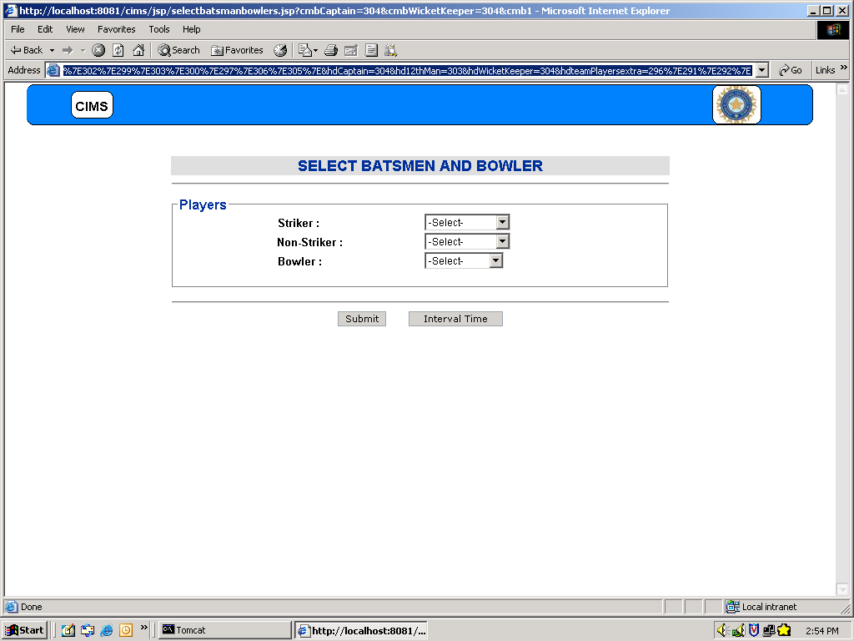

- You can select the Striker , Non-Striker and Bowler for the match
- In case if before any (2nd innings onwards) inning, interval occurs then, you can click
on Interview Time button to take interval. It will present you with following
window.

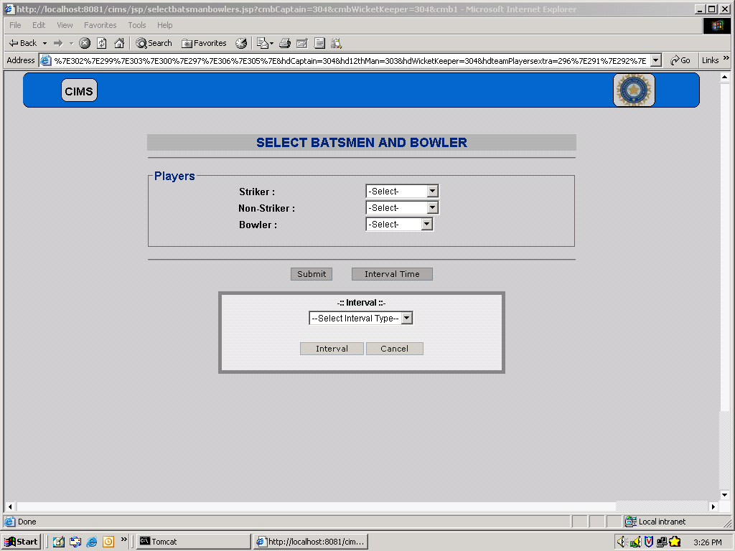

- Click Submit button. It will present you the with following score card screen for
scoring

Score Card:

Starting Match:
- To start match click on Start button

Start match button
Batting Score card
Wagon Wheel

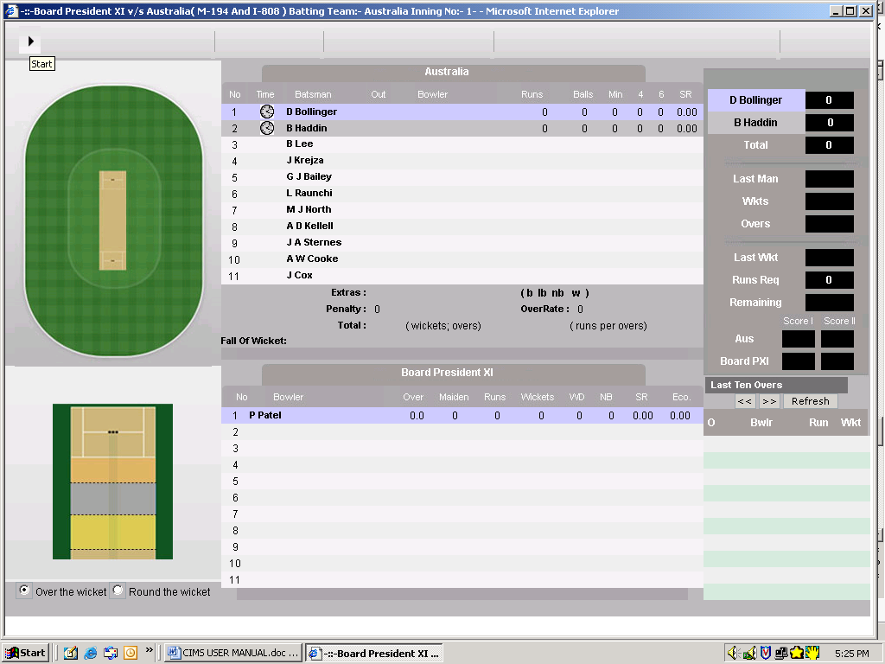

Pitch Pad Batting Score Card Last Ten Overs

Scoring a Match:
Scoring a match is simple as clicking the buttons to reflect the activity in the field.
Each scoring stroke will be followed by confirmation screen for the action.
- To record the delivery position of ball by bowler, click on Pitch Pad.
- To record the position of runs played by batsman, click on Wagon Wheel
- If you click the wrong place on both Pitch Pad and Wagon Wheel, you simply click on the correct place which will replace the previous position with the new one.

Wide and Wide + Runs:

Wide
Wide + Runs

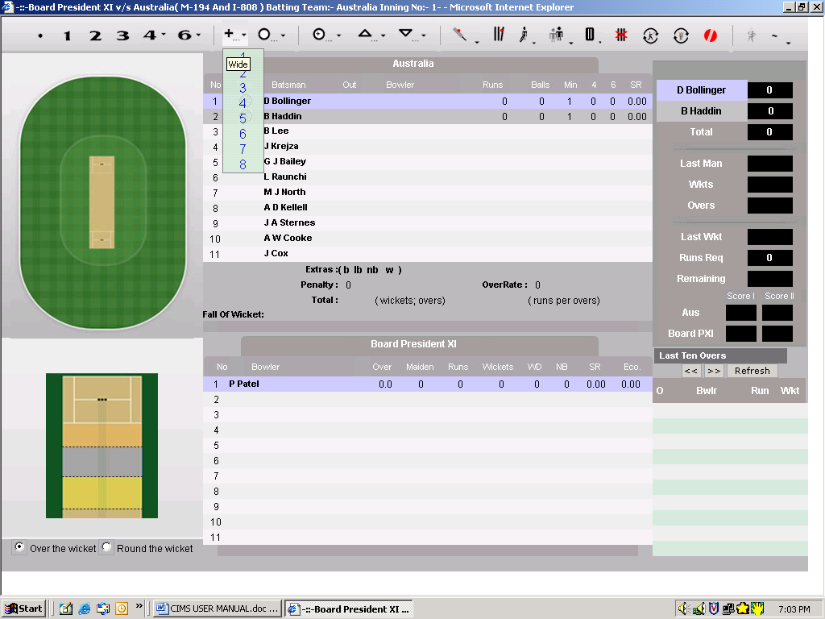

- For Wide run click on icon
- For Wide + Runs take the mouse cursor to the  icon and click on required
runs.

No Ball:

No Ball and No ball + Extra runs:

No Ball

No Ball + Extra Runs

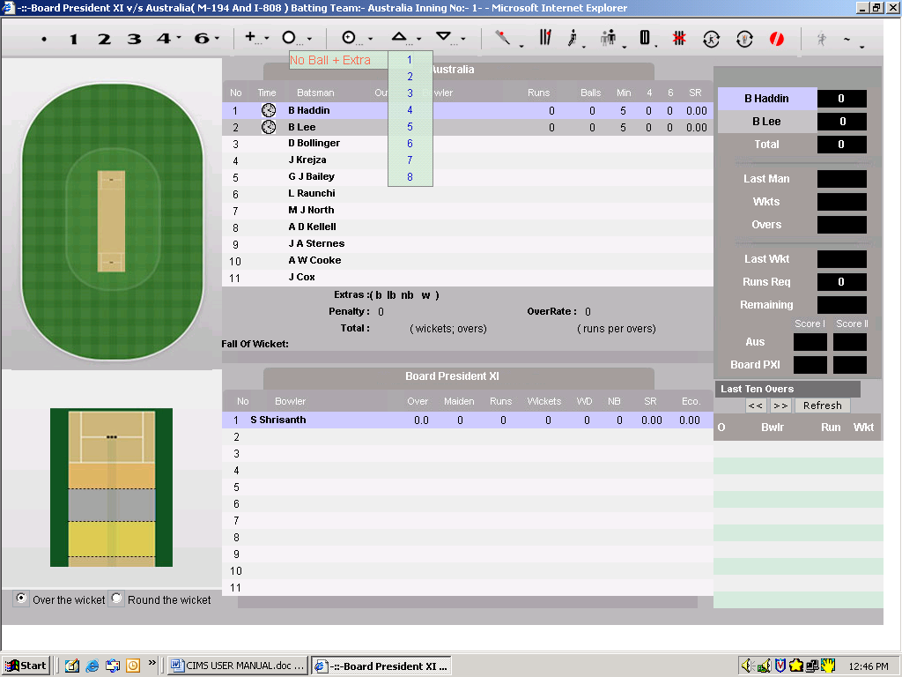

- For No Ball click on icon
- For No Ball + Extra Runs take mouse cursor on and click on required
runs.

No Ball (Bat Runs):

No Ball + Runs

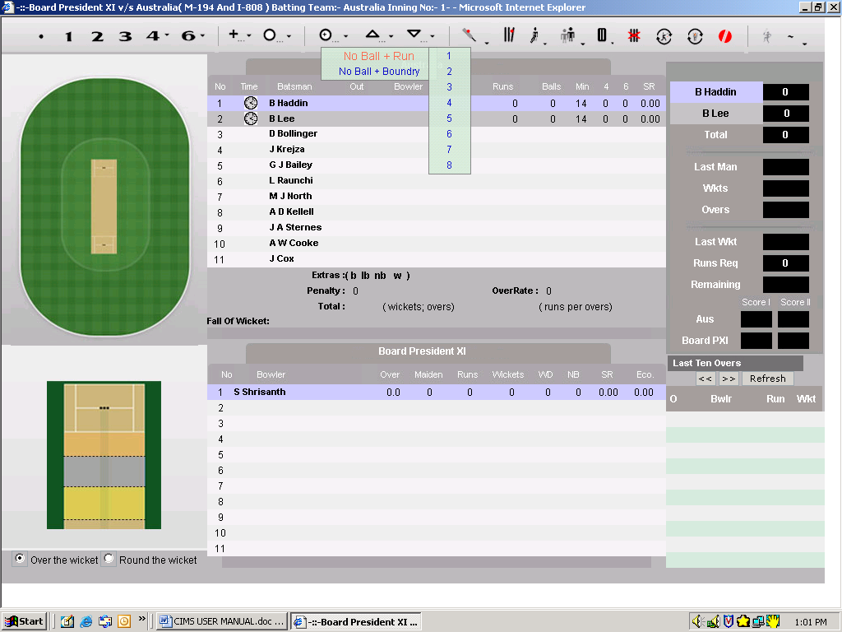

- For No Ball + Runs take mouse cursor on  icon.
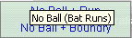
- Click on No Ball + Runs and then click on required runs.

No Ball + Boundary runs

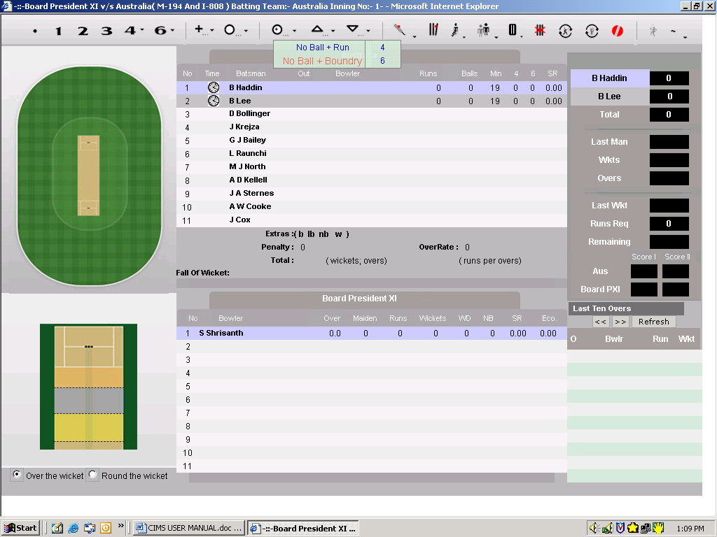

- For No Ball + Runs take mouse cursor on icon.
- Click on No Ball + Boundary and then click on 4 or 6 boundary runs.

Byes:
Byes

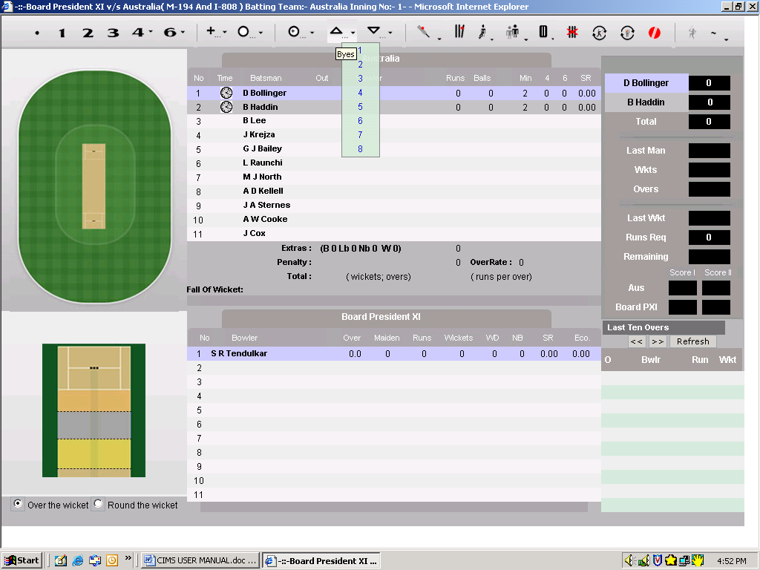

- For Byes take cursor on  icon and click on required runs.
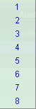

Leg Byes:
Leg Byes

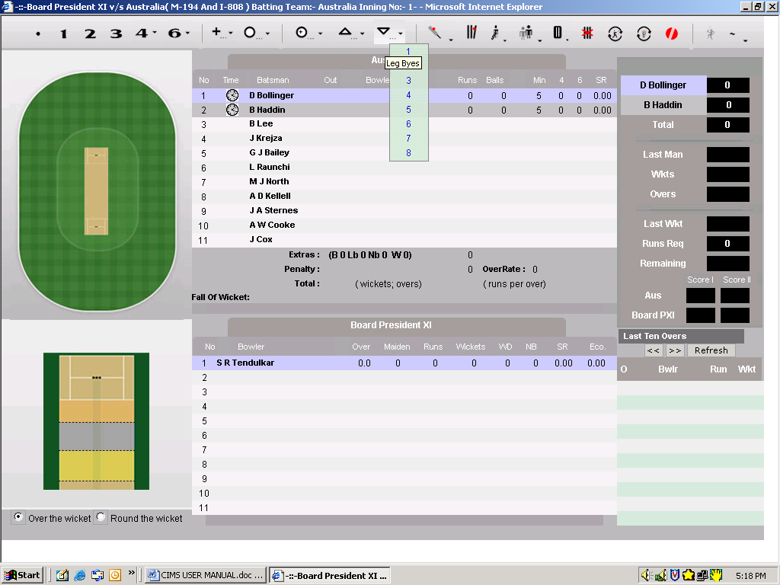

- For Leg Byes take cursor on  icon and click on required runs.

Penalty Runs:

Penalty Runs

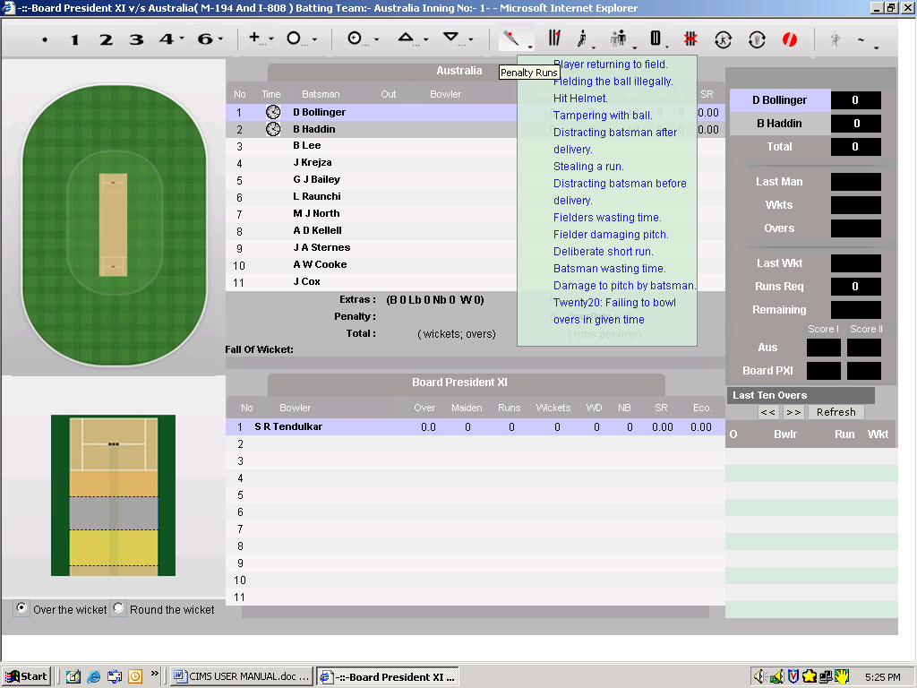

- As per penalty runs rule for batting side and fielding side penalty runs are given.
For Penalty Runs take mouse cursor on the  icon and click on required
Penalty runs option.

Wicket:
Wicket

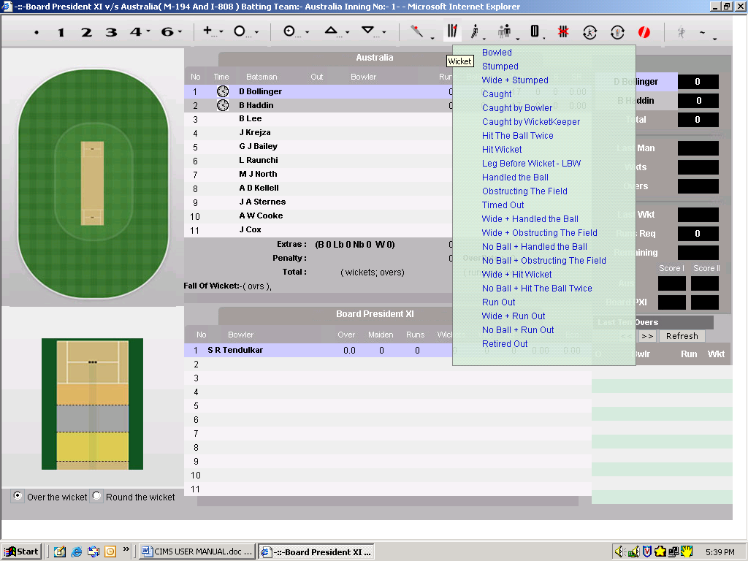

- For all the Wickets options take the mouse on the  icon and click on required
Wicket options. When you click on any wicket option, information required
for that wicket option will be prompted to fill.
For example: If you click on Stumped option, then prompts to select
wicket keeper and to select new batsman will be given.

Retires:
Retires

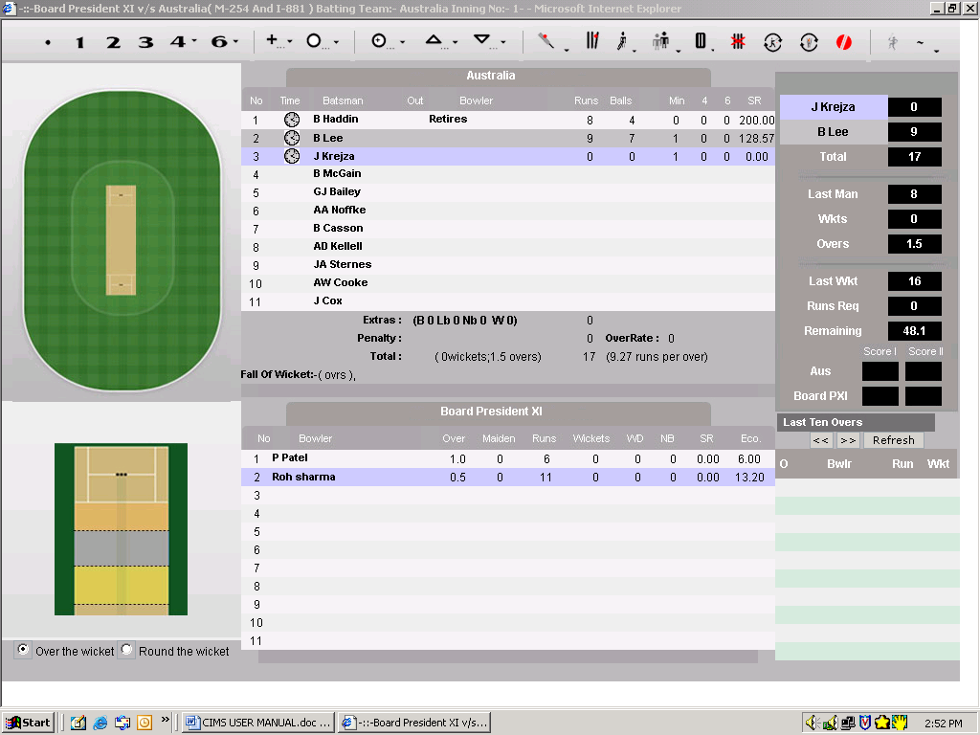

- For Retires, click on icon. It will present you with the following screen to add remark.

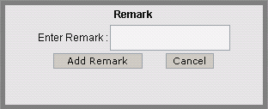

Add remark about the retires
- To add remark, Click on Add Remark button. Added will be displayed in the Score Sheet for that match.
- To abort the action, Click on Cancel

Forced End Of Over:

Forced End Of Over

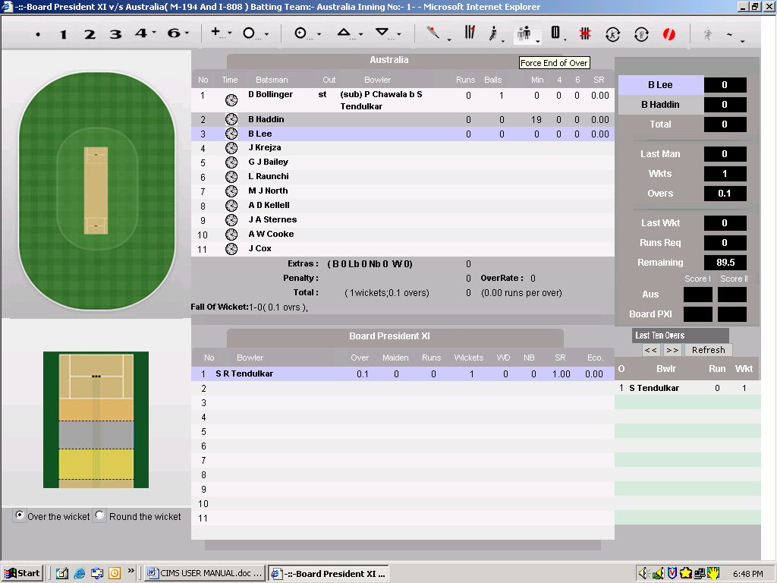

- If over is not complete and you want to end the over then, Click on Forced End Of Over. It will present you with the following screen.

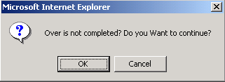

- Click Cancel to abort the action.
- Click OK if you want to end the over. After this new Bowler selection pop – up will be given and current over will be completed.

Pause Innings:
Pause Innings

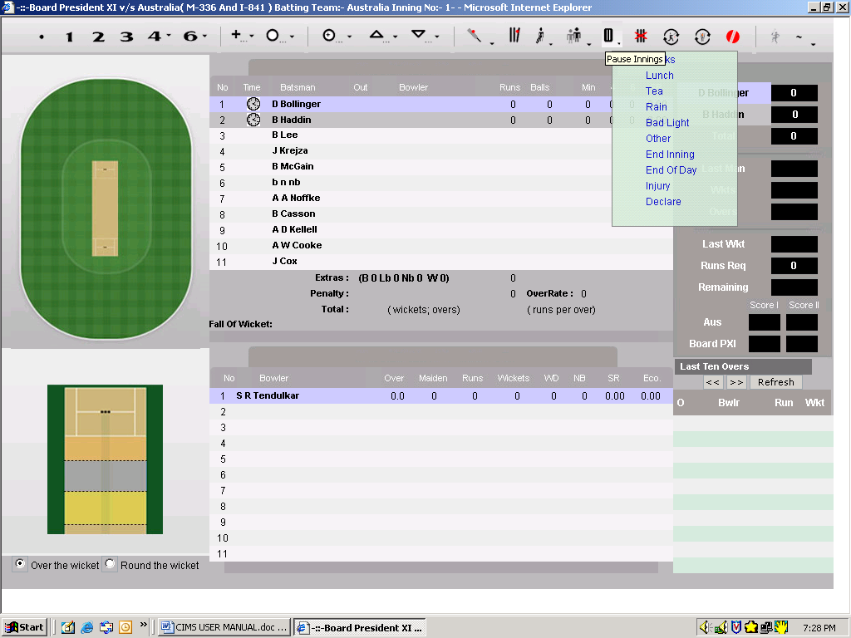

Drinks, Lunch, Tea, Rain, Bad Light, Injury and Other:
- For Drinks, Lunch and Tea take the mouse cursor on icon. And click on either of these three pause innings options. It will present you with the following screens

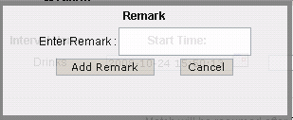

Add remark

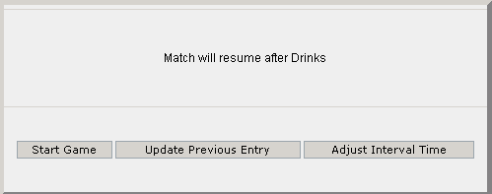

Start Game to Update previous Update Previous and
resume the game entries while pause current interval time
innings options taken

- Click on Start Game button to resume the pause inning option taken.
- Update Previous Entry: This feature allows you to update the score while
Any pause innings option taken.
Steps to update the score while any pause innings option taken are:
- Click on Pause Innings icon to get the above shown window.
- Click on Update Previous Entry button. On clicking this button this window will disappear but the pause innings time will be continued.
- In the Last Ten Overs section click on the O(Over) who’s score you want to
Edit. This will present you with the following window.

Over number whose Edit all the
records needs to update records of
selected record

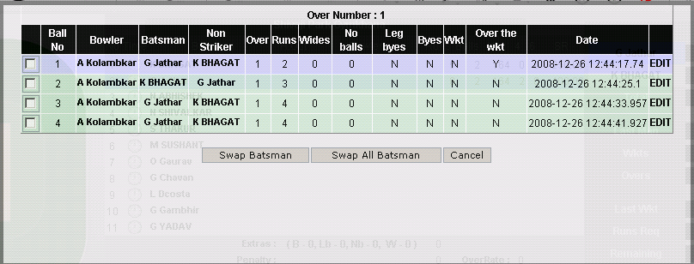

Swaps batsman of selected ball Swaps all the batsman Cancel to abort the
Action

4) After editing to resume the pause innings option, refresh (Press F5 button) the
score card to get the following screen back.

- Click on Start Game button to resume the match again.

- Adjust Interval Time:
- In any case if existing time of any interval needs to change, you can change its time. The edited time will be updated.

- You can also edit the breaks start and end time of previous breaks. If earlier you have taken two breaks say drinks and lunch before tea then, following screen will allow you to edit previous two breaks when you will take tea break.

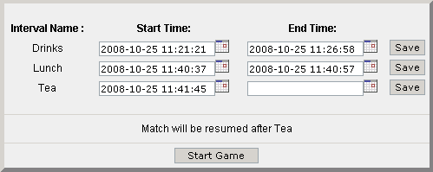

End Innings:
- You can click on End Innings option of Pause Interval to End the match Innings.

End of the day:
- After match end of the day you can click on End of the day option. It will present you with following screen.
- Next day this screen will appear and you can click on Start Game to resume the match

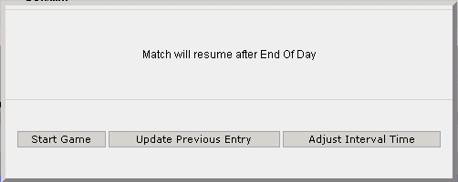

Declare:

- To declare match click Declare option of the Pause Innings.
It will present you with the following screen.

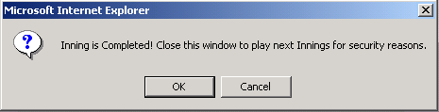

- Click on OK button to get the following screen.

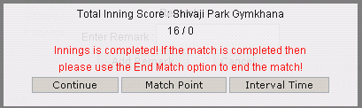

- To get the match declaration result, you have to end the match.
- To end the match, click on Interval Time button and select End of Match
option.
- Finally you will be presented with following result screen.
- Click on continue in the following screen to exit the score card.
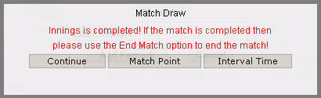

Switch Batsman:
Switch Batsman

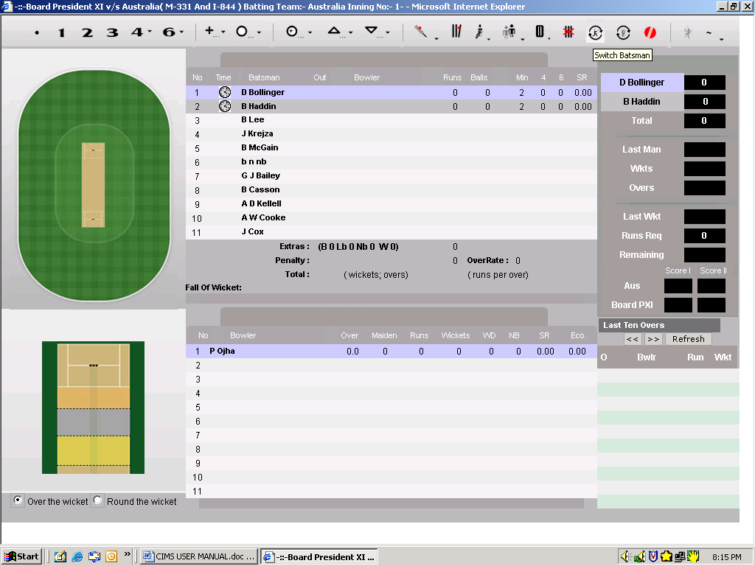

- To switch the batsman’s who are playing as striker and non-striker, click on  icon. On clicking Switch Batsman the striker batsman will switched as
Non-striker and vice versa.

Change Bowler:

Change Bowler

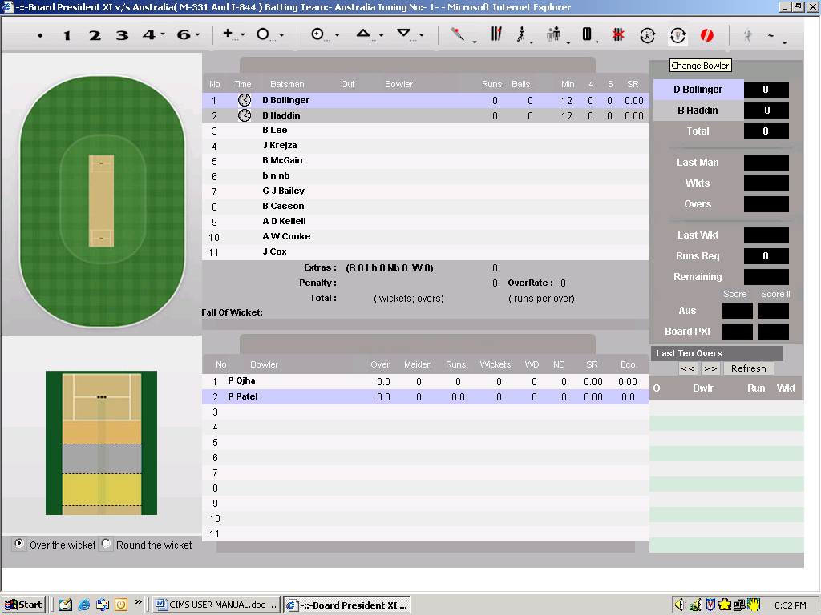

- To change the bowler, click on  icon. When you click change bowler
New bowler will be selected and current bowler’s over will be left at that ball.
For example: If Bowler 1 has played 4 balls and you click Change Bowler
Then, New bowler will be selected and first bowler’s over will be ended at
4 balls played.

New Ball:

New Ball

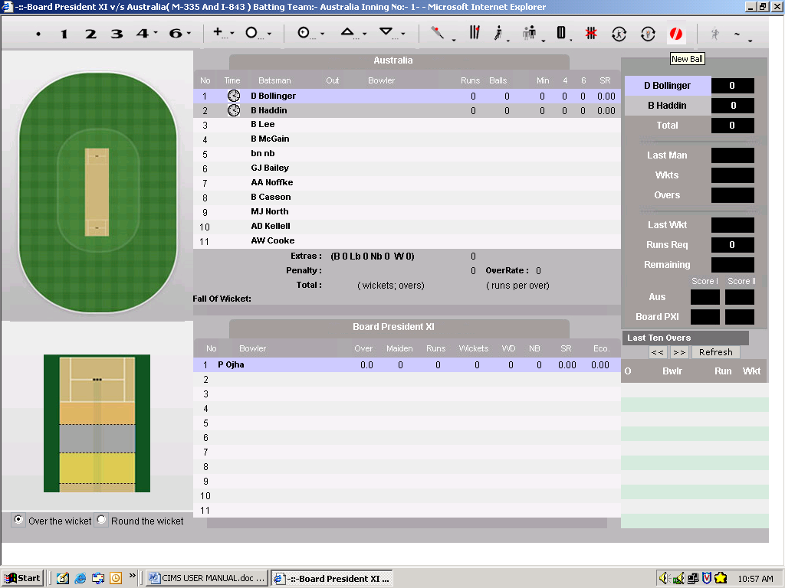

- To note the event of taking new ball in the match, Click on icon. Clicking on New Ball will notify you with the over at which new ball is taken.
For example if new is taken after one over then, following prompt will be given.

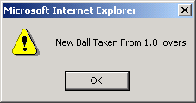

Extra:
Extra

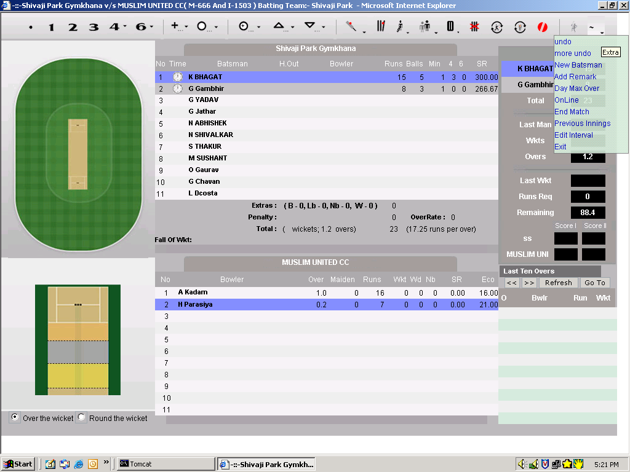

- Extra contains following options:
- Undo
- More Undo
- New Batsman
- Add Remark
- Day Max Over
- Online
- End Match
- Previous Innings
- Edit Interval
- Exit

1) Undo:
  - To delete previous entry click on Undo. It will present you following prompt.
  - Click OK button to delete previous entry.
  - Click Cancel button to abort the action.

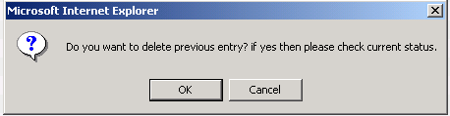

2) More Undo
- To undo the over, click on More Undo.
Example 1: If current over played are 2.3 and you do undo of
1 over then, previous 3 entries will be deleted.

Example 2: If current over played are 2.0 and you do undo of
1 over then, previous 1 over entries will be deleted.

- For More Undo following sequence of screens will be presented

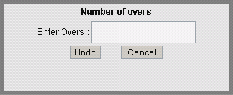 Enter Overs

3) New Batsman:

- If after any dismissal due to any error in new batsman pop – up is not shown.
Then, click on New Batsman option. It will present you with the
following screen to select new batsman.

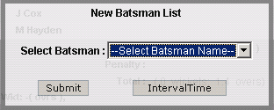

4) Add Remark:
- To add any events in match add remarks click on Add Remarks option in Extras. These remarks added can be viewed in the score sheet.

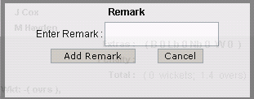

5) Day Max Over:
- If due to any reason for example say rain match’s Max Over’s and Target is reduced in one day match and Max Over’s in Test Match.

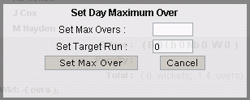

6) Online:
- By default match will be selected as Online. To select match as Offline click on Online option. It will present you with following screen. Uncheck
the Select for Online Entry check box.

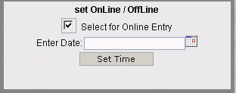

7) End Match:
- To end match click on End Match option of extras. By doing this match will end.

8) Previous Innings:
  - To view the score card of the previous inning and current inning click on Previous Inning option. It will present you with following screen. i.e. It will present you with previous inning and current inning.

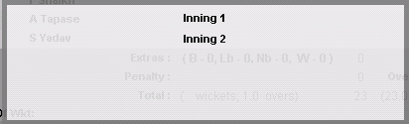

- Click on required inning to view score card. It will present you with
following screen.

9) Edit Interval:
  - You can edit the interval time by clicking the Edit Interval option of Extras

Inning 1 Score Card

Click on required player to get
Pitch Pad and Wagon Wheel details

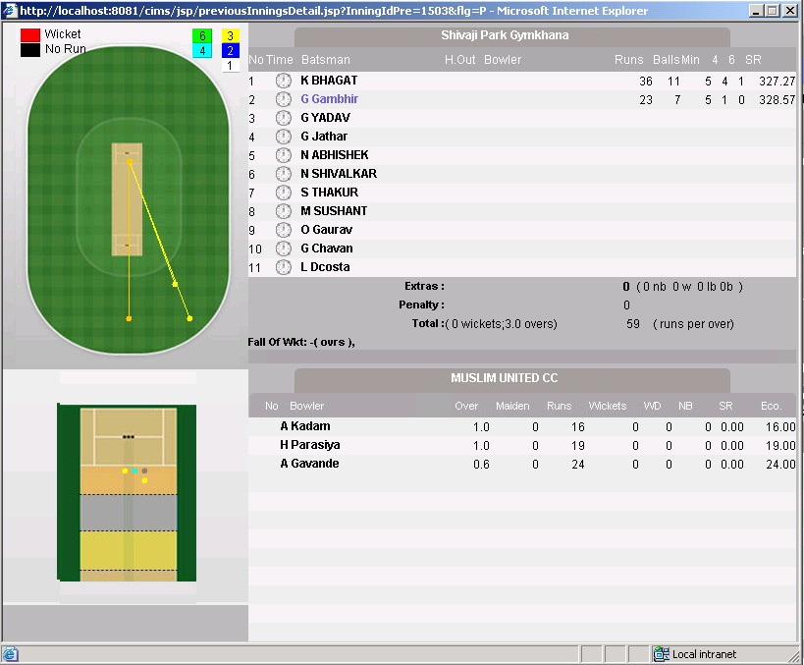

10) Exit:
  - To exit the score card you can click on Exit option of the extras.

