CIMS

Centralized Information Management System

For Cricket

Reports Module
(Umpire Coach Login)



User Manual

Index

Umpiring Decision Log Report: 2
Umpire Coach Match Report: 3

Umpiring Decision Log Report:

- Umpiring Decision Log report is accessed by Umpire Coach to notify the appeal made along with the details like Inning, Over in which appeal is made, Batsman, Bowler, Result, Decision, Reason and Remark against the Umpires of the match.
- You can use Search option to search records.
- You can use Update option to update the records.
You can follow the following steps to update the record.
- Add or Search any record.
- Click on edit link of particular record whose record needs to update.
- Selected record will be obtained in the respective fields.
- Now you can update the data and click on Update button.
  - You can click on Delete option to delete any record.

Record added in Umpiring Decision Log

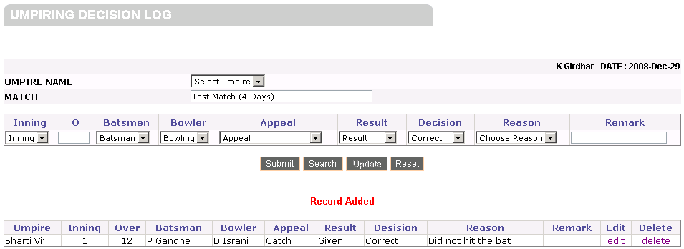

Record added in Umpiring Decision Log

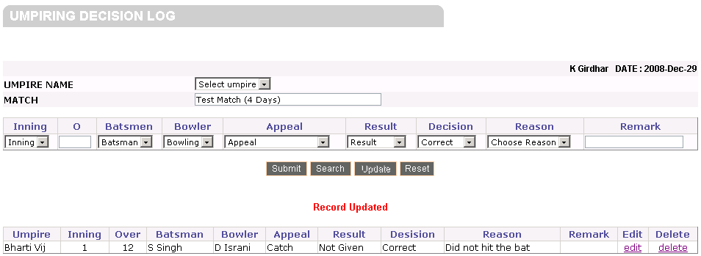

Umpire Coach Match Report:
- Umpire Coach Match Report is filled by Umpire Coach.
- In this report Umpire Coach will rate the points available in the report.
- This form will also view self rating given by the umpires of the match
Given for the available points in the report.

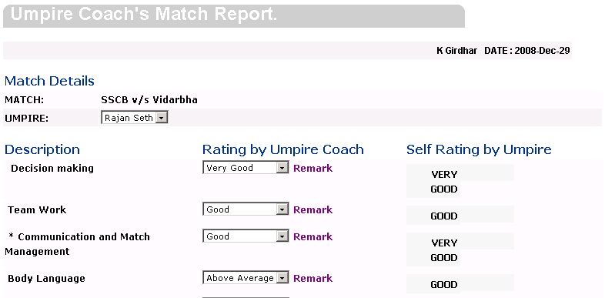
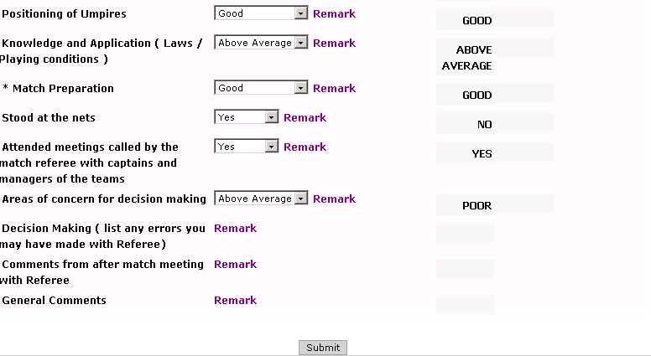

Note: Umpire Coach can view all the other reports in Match Details, For Players
menu.

