CIMS

Centralized Information Management System

For Cricket

Reports Module
(Umpire Login)



User Manual

Index
Umpire’s Self Assessment Report: 3
Over Rate Calculation Report: 5
Umpire’s Feedback Report: 7

Umpire’s Self Assessment Report:

This report is filled by umpires of match. In this report umpires give rating for themselves depending upon the points required to fill in the form to rate themselves.
- Data entered in the form can be saved and updated in the same form.
- Data entered by the Umpires needs to be sent to approval to Umpire Coach.
- Once the data is saved for the first time, Send For Approval button will appear
on the form
- The purpose of the Send For Approval button is to send the data entered by
the umpires to the Umpire Coach
- After sending the data for approval to the Umpire Coach, data cannot be updated and if Umpire attempt to do so, then Data is sent for approval so, can not be updated will be given to indicate that data cannot be updated.

Umpire’s Self Assessment Report

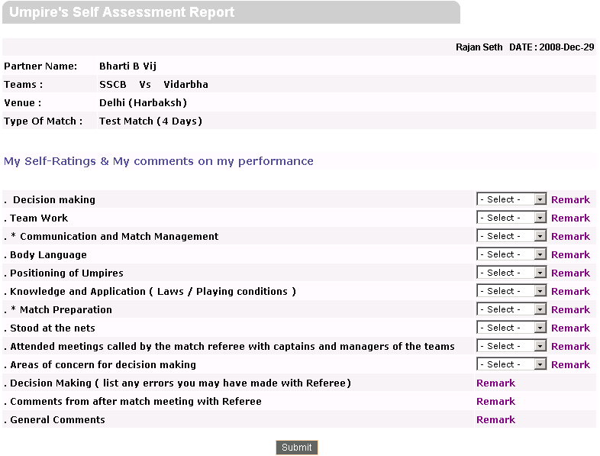

Umpire’s Self Assessment Report with Send for Approval button

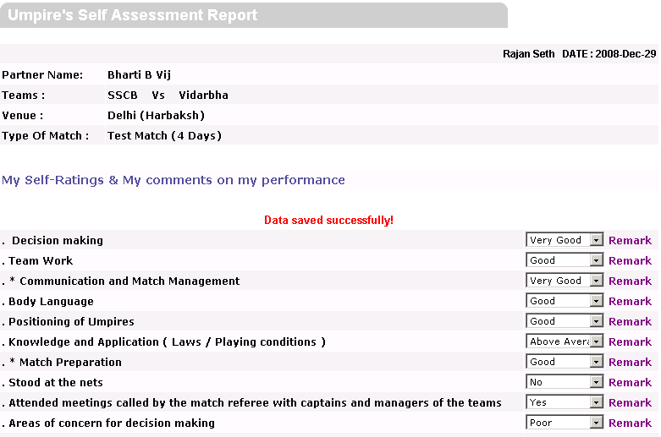
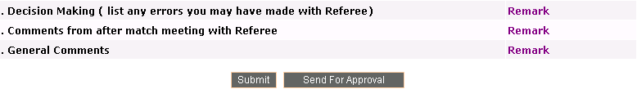

Umpire’s Self Assessment Report with Data cannot be updated message

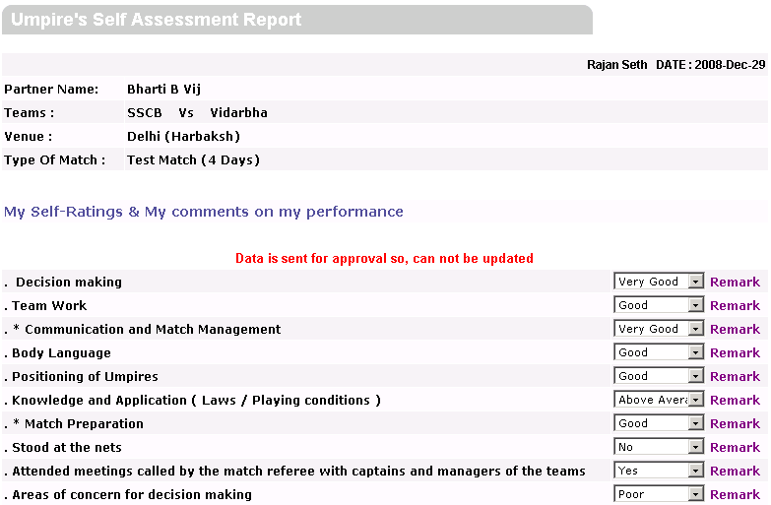
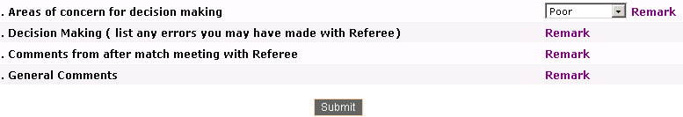

Over Rate Calculation Report:

Over Rate Calculation report can be accessed by admin, umpires and ref ree. This form is accessed by umpires and needs to send for approval to the referee. This report is used to display interval (e.g. Drink, Lunch, Tea etc.) and interruptions (e.g. Bad Light, Rain etc.) during the match. User can check innings wise details or day wise details of interval and interruptions

User will presented with following information in this report.
- Time Elapsed (before allowances)
- Total Allowances (including all intervals)
- Length of the innings (after allowances)
- Expected Over Bowled (ignore fractions)
- Actual Overs Bowled (round up to next whole numbers)
- When umpire login to Over Rate Calculation form, Report Is Pending For Approval is given and umpire needs to click on Send To Referee button.
- When umpire view the form details and sends for approval to referee by clicking
on Send To Referee button, Report Approved message is given.

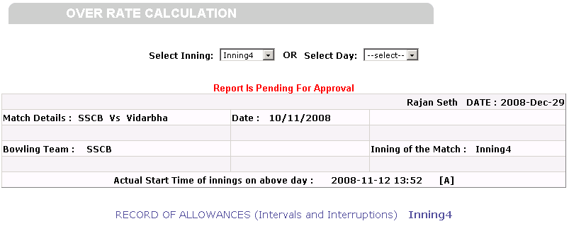
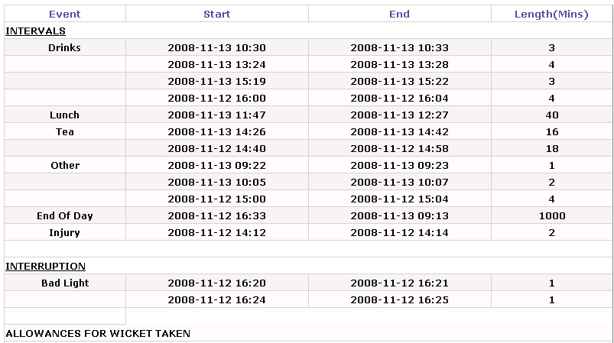
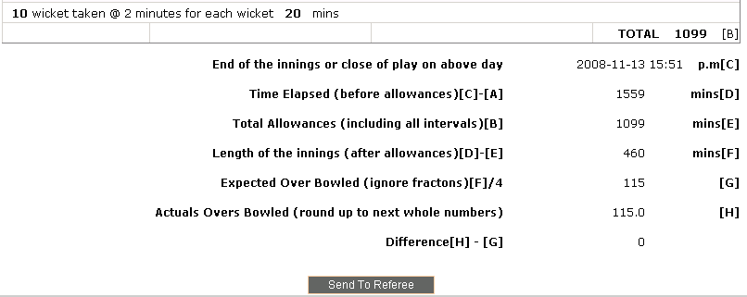

Umpire’s Feedback Report:
- Umpire’s Report is filled by Umpire. In this umpire fill the report regarding the
Conduct of game by teams, ground conditions, and general arrangements made
for game, behavior of crowd etc.

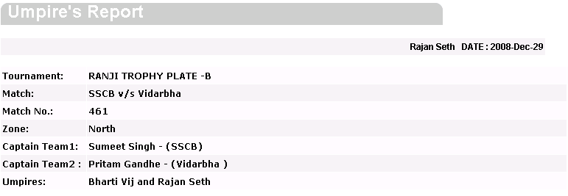

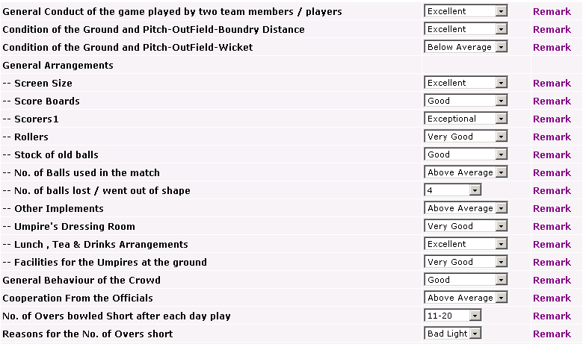
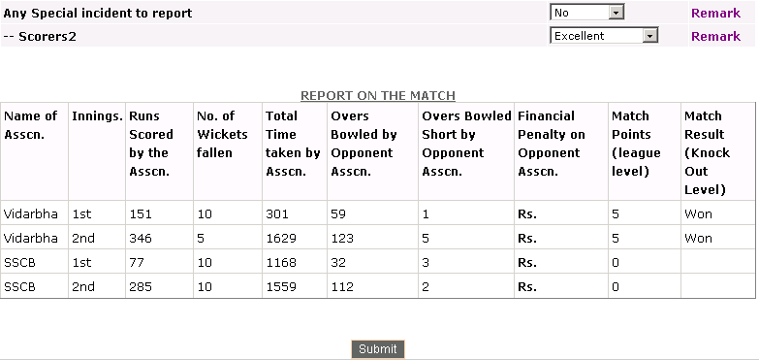

Note: Umpire can view all the other reports in Match Details, For Players menu.

