An intelligent, efficient and low cost Parking Solution

**BITS ZG628T: Dissertation**

by

**Bhuban Mohan Mishra**

Id No. **2013HT13067**

Dissertation work carried out at

Infosys Ltd., Bhubaneswar

Submitted in partial fulfilment of M. Tech. Software Systems degree programme

Under the Supervision of

**Rudra Narayan Rath**

Project Manager

Infosys Ltd., Bhubaneswar

**BIRLA INSTITUTE OF TECHNOLOGY & SCIENCE**

**PILANI (RAJASTHAN)**



**November, 2015**

An intelligent, efficient and low cost Parking Solution

**BITS ZG628T: Dissertation**

by

**Bhuban Mohan Mishra**

Id No. 2013HT13067

Dissertation work carried out at

Infosys Ltd., Bhubaneswar



**BIRLA INSTITUTE OF TECHNOLOGY & SCIENCE**

**PILANI (RAJASTHAN)**

November 2015

**Birla Institute of Technology & Science, Pilani**

**Work-Integrated Learning Programmes Division**

**First Semester 2015-2016**

**BITS ZG628T: Dissertation Mid-Semester Progress Report**

|  |  |  |
| --- | --- | --- |
| ID No. | : | 2013HT13067 |
| NAME OF THE STUDENT | : | Bhuban Mohan Mishra |
| EMAIL ADDRESS | : | Bhuban.Mishra@Outlook.com |
| STUDENT’S EMPLOYING  ORGANIZATION & LOCATION | : | Infosys Ltd., Bhubaneswar |
| SUPERVISOR’S NAME | : | Rudra Narayan Rath |
| SUPERVISOR’S EMPLOYING  ORGANIZATION & LOCATION | : | Infosys Ltd., Bhubaneswar |
| SUPERVISOR’S EMAIL ADDRESS | : | Rudra_Rath@Infosys.com |
| DISSERTATION TITLE | : | An intelligent low cost Parking Solution |
| BROAD AREA OF STUDY | : | Cloud Computing |
| KEYWORDS | : | Internet of Things, Cloud Computing, Image Processing, Raspberry Pi |

# Background

Parking of vehicles has always been a manual and time consuming task. From large retails to corporates that maintain huge parking spaces for their customers and employees find it very hard to provide necessary information to the commuters that would guide them to the available parking space. Commuters usually have to drive through to find the available parking space that is time consuming, costly and tiring. Commuters often miss the nearby parking spot and park at a faraway place that adds to the frustration. Apart from this, people in all major cities face parking problems in crowded and populated areas. Citizens face difficulty in finding a free parking space near places of interest. And on the other hand government, municipal corporations, corporates, retail outlets etc… need to provide manpower to manage the parking spaces and collect the requisite fee from the commuters for the service provided. In the effort of creating Smart Cities in India, we need to find smarter ways to address such problems.

# Objectives

The objective of the study:

* Is to come up with an automated approach to finding free parking places at designated parking areas.
* Is to find a Cost effective solution that can be implemented with minimum/existing infrastructure

The whole purpose of the study is to come up with a cost effective and fully automated solution to ever increasing problem of parking management.

Leveraging the benefits of Devices connected to each other as Internet of Things along with Cloud Computing environment would help in fully automating this process. Cameras with some intelligence to process images and deriving information on the available parking places is a cost effective solution to manage parking places. The data collected by these smart cameras can then be fed into a cloud based system that provides information about available parking spaces to the commuters and users. The objective of this study is to create a prototype of such an intelligent system that uses Image Processing to derive information and Cloud Computing to manage and provide parking information to end users.

# Scope of Work

Scope of work comprise of designing and developing a prototype with Raspberry Pi and a Camera module that will capture the images, process them to derive useful information regarding available parking spaces. The information and the cameras can also be managed remotely from a control centre through a Secured Web application. The information could then be made available to the end users via web application or a mobile app.

Entire Project will be carried out in five phases:

* System study
* Designing
* Coding
* Testing
* Implementation

**System Study**: Identify the requirements for a Parking Management System.

**Designing**: Design the architecture that will implement the intelligent solution and help in managing and displaying data.

**Coding**: Prototyping the system with ASP.Net, C#, Ajax, JQuery, Python, SQL Server 2012.

**Testing**: Software should be tested thoroughly on Browser.

**Implementation**: Final implementation will be on a Cloud environment and access the site and test the prototype.

# Details of work done till date

Following is the plan of work for the project along with the progress of each item.

|  |  |
| --- | --- |
| **Work Item** | **Status** |
| **System Study** | **Completed** |
| * Requirement analysis and elicitation for a Parking System. | **√** |
| * Analysis of device feasibility and procurement. | **√** |
| * Collect various APIs and Libraries that could be used for Image Processing. | **√** |
| * Feasibility study for hosting application on the cloud. | **√** |
| **System Design** | **Completed** |
| * Design the Overall System Architecture. | **√** |
| * Create the Architectural Views. | **√** |
| * Device and Cloud Environment Setup. | **√** |
| * Data Modelling and Setup. | **√** |
| **Prototyping and Coding** | **In Progress** |
| * Implement the Image Processing module through reusable image processing APIs. | In Progress |
| * Implement the Cloud based Data Management Interface. | **√** |
| * Implement User dashboards for data presentation to the end users (commuters). | **√** |

## System Study

Due to the complexity of the project and to help bringing in automation to the organization, a study was conducted at Infosys, Bhubaneswar campus to analyse and find the problems of the daily commuters. Based on the discussions with the employees and feedback received, a problem statement was derived.

*Due to the manual nature of the Parking System, it becomes very difficult for the commuters to find a free Parking space that is located near to their work location. Thus, the commuters have to roam around in search of a free parking place that is time consuming and in the process they waste valuable time.*

After discussion with the Facilities team, it was concluded that, a solution around the above problem statement must cater to the following needs:

* The proposed system should be automated with minimal to no manual intervention.
* The system should be able to provide relevant information to commuters as well as Staff of Facilities on the Parking Areas.
* The investment on the solution should be minimal, along with software and hardware reuse.

Based on the above requirements, a cost effective and fully automated solution has been proposed, that has the following components:

* An intelligent device that makes us of Image Processing from the images received from Cameras placed at designated Parking locations to derive the availability of parking spaces.
* The cameras could send the information processed to a Central Server on Cloud.
* This information could then be presented to End Users through various devices like:
  + Dashboards at designated entry locations
  + Mobile Devices
* The cameras and metadata would be managed through an Administrator interface.

In order to create the intelligent system, following hardware and software were procured.

Hardware:

* Raspberry Pi 2 (Model B, 1GB RAM).
* A MicroSD card to install Operating System for the Pi.
* An old WebCam intended to connect with the Pi for capturing image.
* A WiFi dongle to connect the Pi to a Router.

Software:

* Raspbian: A Debian based Open Source Operating System for Raspberry Pi
* OpenCV for Image Processing with Python
* A cloud environment with Windows 2012 Operating System for hosting Admin Interface, Application Dashboard and Services.

## System Design

The system was designed to cater to the Requirements and 4+1 Architectural Views were created to define the overall functionality of the System. A high level Solution Architecture is provided below.

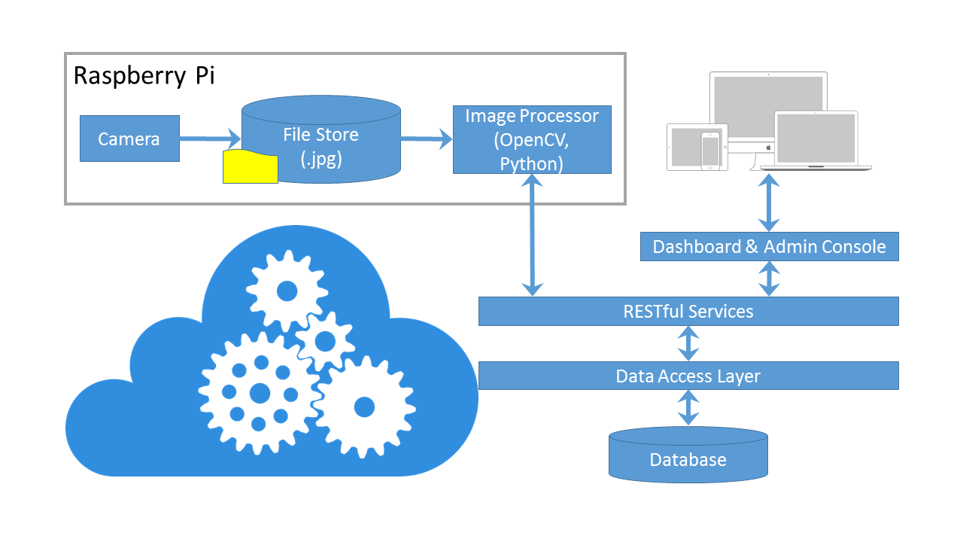

**Fig 1**: Solution Design Diagram

As part of the Design following activities were done:

* Design of Database for the Parking Management System.
* Design of RESTful Services to perform CRUD Operations on the database.
* Design of Admin Console to manage the System.
* Design of Dashboards to provide parking related information to end users.
* Design of the Image Processing System to derive meaningful information from the image received from Camera.

## Prototyping and Coding

As part of the prototype, following setup was considered:

* A router was provisioned to create a network with access to Internet.
* The Camera module was attached to the Raspberry Pi to one of the USB Port.
* The WiFi Module was attached to the Raspberry Pi to enable connection to the internet.

A circuit diagram of the Prototype is provided below:

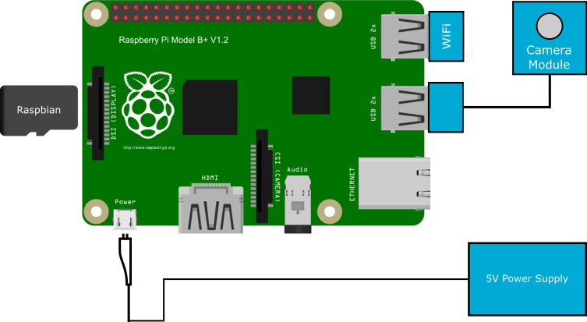

**Fig 2**: Circuit Diagram of Smart Camera

The following modules were considered as part of Coding:

* The designed database schema was created through SQLite.
* Entity framework 6 was used to create the Data Access layer.
* WCF Services were used to create RESTful services.
* The admin console and dashboards were created through HTML5, CSS3 and bootstrap for enabling Responsiveness, thus making it available across devices.
* Currently, the Image processing module is in progress. The Image Processing module is being created with the help of OpenCV and Python.

# Plan of work yet to be done

Following is the plan of work for the project that is yet to be completed.

|  |  |
| --- | --- |
| **Work Item** | **Status** |
| Testing the Prototype | **Yet to Start** |
| * Install the device for testing. | **--** |
| * Host the application on Cloud Environment. | **--** |
| * Test the device and application. | **--** |
| Implementation | **Yet to Start** |
| * Capture the results of the Prototype and System. | **--** |
| * Documenting the final outcome. | **--** |
| * Future scope of Enhancements. | **--** |

# Timelines

|  |  |  |  |  |  |  |  |  |  |  |  |  |  |
| --- | --- | --- | --- | --- | --- | --- | --- | --- | --- | --- | --- | --- | --- |
|  | 10-Aug-15 | 17-Aug-15 | 24-Aug-15 | 31-Aug-15 | 7-Sep-15 | 14-Sep-15 | 21-Sep-15 | 28-Sep-15 | 5-Oct-15 | 12-Oct-15 | 19-Oct-15 | 26-Oct-15 | 2-Nov-15 |
| System Study |  |  |  |  |  |  |  |  |  |  |  |  |  |
| System Design |  |  |  |  |  |  |  |  |  |  |  |  |  |
| Prototyping and Coding |  |  |  |  |  |  |  |  |  |  |  |  |  |
| Testing the Prototype |  |  |  |  |  |  |  |  |  |  |  |  |  |
| Implementation |  |  |  |  |  |  |  |  |  |  |  |  |  |

|  |  |  |  |  |  |  |
| --- | --- | --- | --- | --- | --- | --- |
| Legend: |  | Completed |  | In Progress |  | Yet to Start |

# Literature References

**BOOKS**:

Vijay Madisetti and Arshdeep Bahga. Internet of Things: A Hands-On Approach. VPT. 2014

Adrian McEwen and Hakim Cassimally. Designing the Internet of Things. Wiley. 2013

Geetha Manjunath and Dinkar Sitaram. Moving To the Cloud: Developing Apps in the New World of Cloud Computing. Elsevier Science. 2011

**WEB LINKS**:

Python Language Reference

https://docs.python.org

Microsoft API and reference catalogue.

https://msdn.microsoft.com/library

OpenCV-Python Tutorials

http://opencv-python-tutroals.readthedocs.org/en/latest/py_tutorials/py_tutorials.html

|  |  |  |  |  |
| --- | --- | --- | --- | --- |
|  |  |  |  |  |
| Signature of Student |  | Signature of Supervisor |  | Signature of Additional Examiner |
| **Bhuban Mohan Mishra** |  | **Rudra Narayan Rath** |  | **Prabhat Jana** |