Question 1:

Experiment with Blockchain

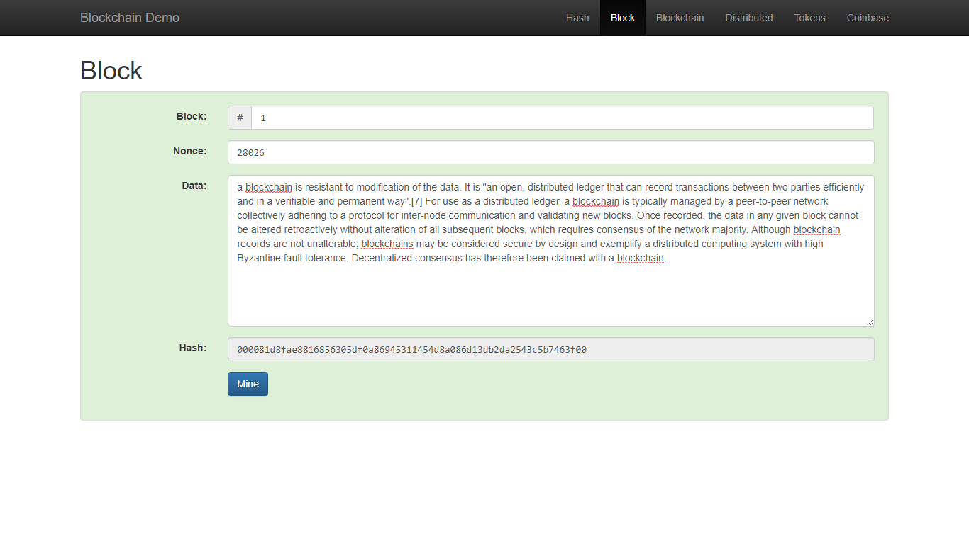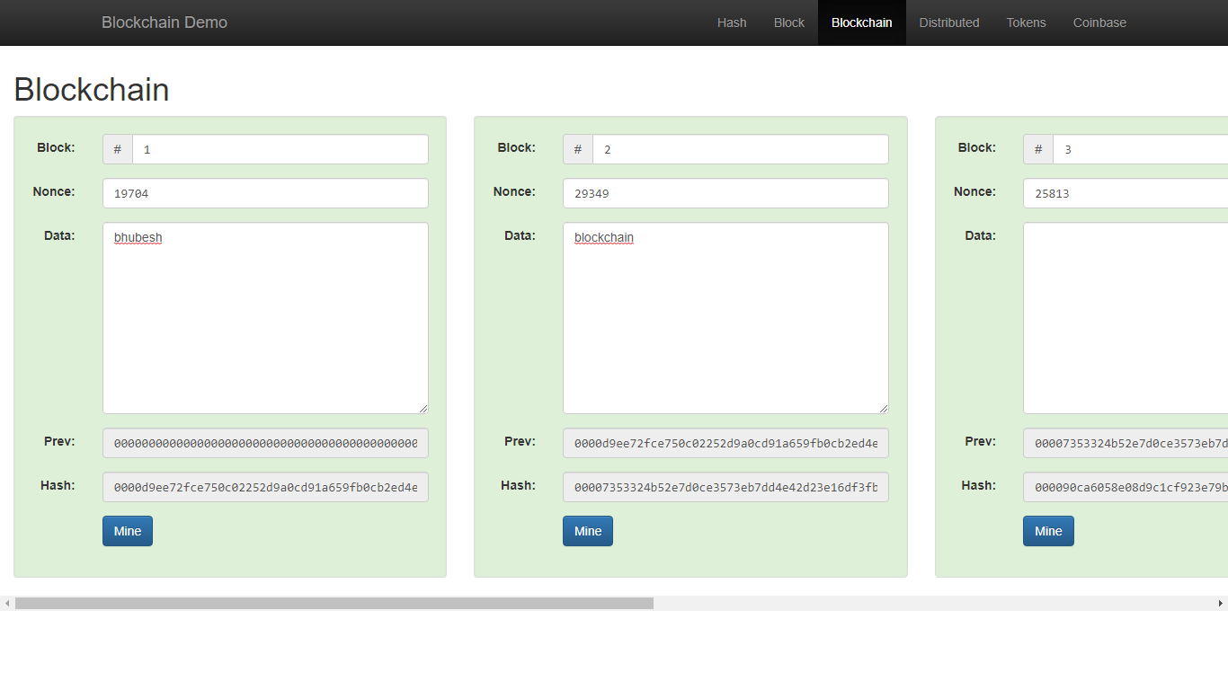

Question 2:

Make a simple contract on remix.ethereum.org and publish it your github profile