RESUME
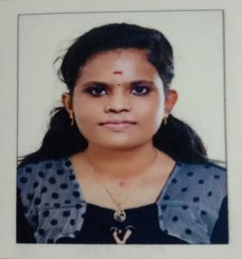
ARYAMOL SURESH MUKALEPARAMBIL (H) MELUKAVU P O MELUKAVU
Email :aryamolsuresh01@gmail.com mob: 9744876901

CAREER OBJECTIVE:

To strive towards achieving organization’s goal is my foremost responsibility and grow with the organization in the right of its success.

ACADEMIC QUALIFICATION:

Course | Institute | Year of Passing | University/Board | Percentage
MSC | College of Applied science,Thodupuzha, Idukki | Pursuing | MG University | Pursuing
BSC | College of Applied  science,Thodupuzha, Idukki | 2021 | MG University | 60
PLUS TWO | CMS Higher secondary  school, Melukavu,Kottayam | 2018 | Kerala Higher  Secondary Board | 70
SSLC | CMS Higher secondary school, Melukavu,Kottayam | 2016 | Kerala State Board | 87

PROGRAMMING SKILLS:

DBMS
- C

C++
- PYTHON

HOBBIES:

. Reading books
- Listening music

Watching Movies

PERSONAL SKILLS:

Leadership
- Communication skill

Assertiveness

PERSONAL PROFILE:

Age, Date of Birth : 21,19-04-2001
Sex, Marital Status : Female,Unmarried
Religion : Hindu
Nationality : Indian
Linguistic ability : English, Malayalam
Conversational Level : Hindi,Thamil,Malayalam Permanent Address : Mukaleparambil (H)
Melukavu P O Kottayam
Kerala 686652

DECLARATION:

I hereby declare that all the information given by me in this are true to the best of my knowledge and belief.

Place : Melukavu ARYAMOL SURESH

30.08.2022

