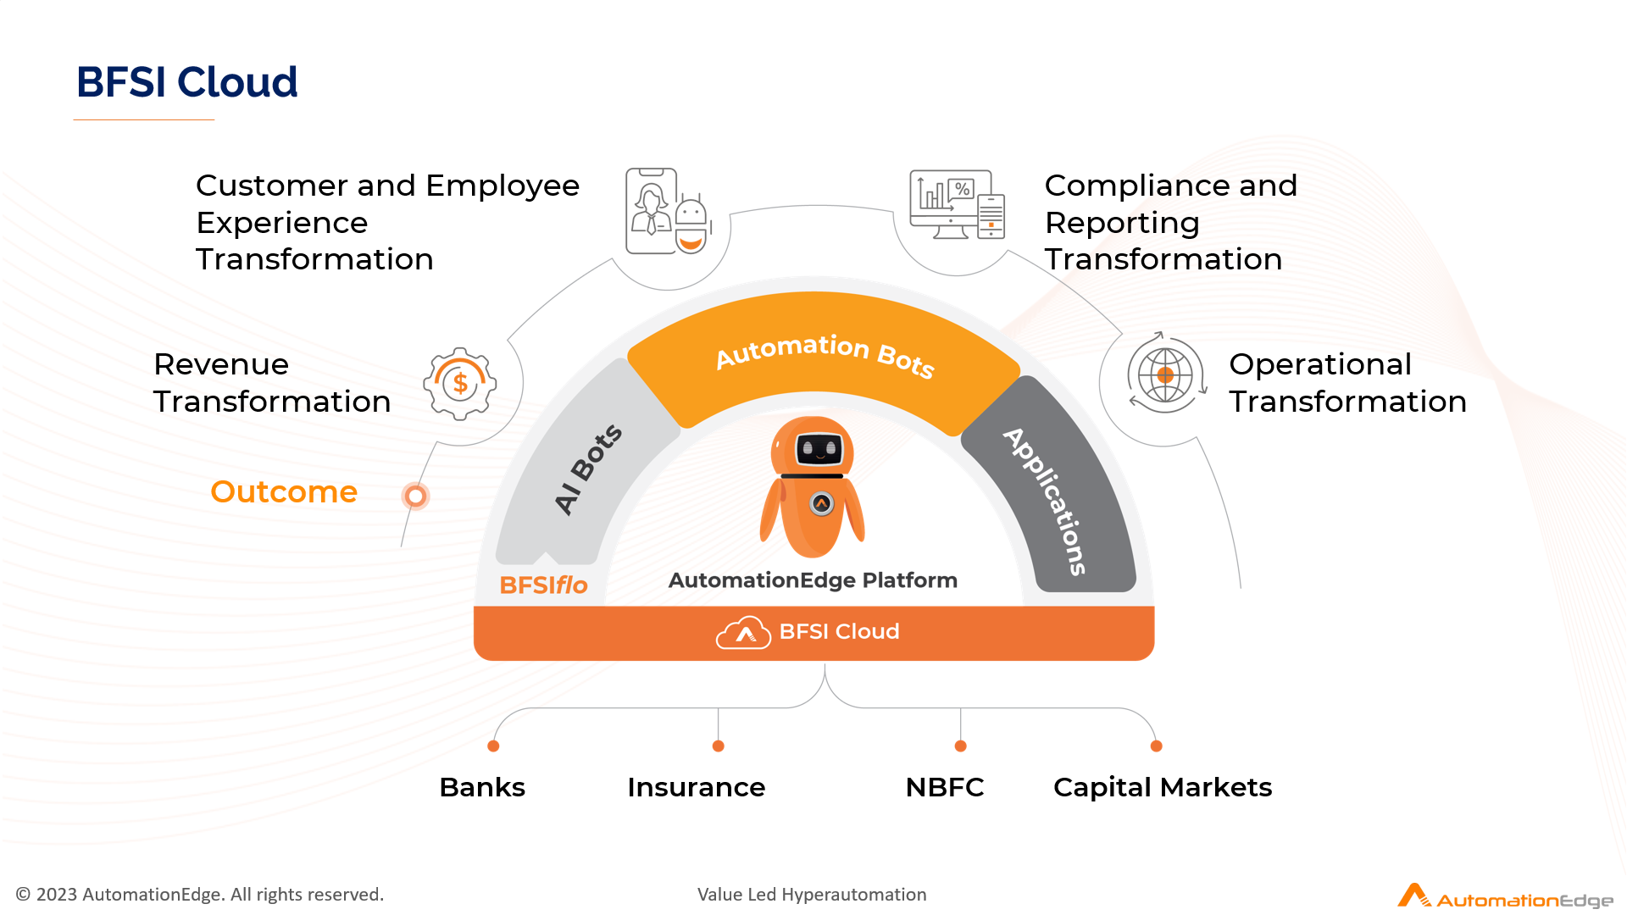
Budgetary Proposal
for
Business Process Automation
By

Submitted To
{{client_name}}
{{proposal_date}}

Table of Content

Confidentiality Statement 3
Contact Information 3
1 Executive Summary 4
2 Scope of Work 6
3 AutomationEdge Deployment 19
4 Post Go Live Support Structure 22
5 Pricing and Payment Terms 23
6 Terms and Conditions 26
7 Automation - A Universal Automation Platform 31

Confidentiality Statement

The information contained in this proposal is of a proprietary nature and is not to be revealed or used except for the evaluation of this proposal and/or in the performance of the services proposed herein. This proposal is strictly meant for the addressee or persons within {{client_name}} (hereinafter referred to as the Client) who are designated to evaluate or consider the proposal.

No part of this work may be reproduced or transmitted in any form or by any means, electronic or mechanical, including photocopying and recording or by any information storage or retrieval system, except as may be permitted by AutomationEdge.

AutomationEdge submits this proposal with the understanding that it will be used only in accordance with the stated intent expressed by the addressee in its solicitation.

Proposal Validity: 30 days from the date of the proposal

Contact Information

Local Contact

Your Point of Contact for this document
Name | {{contact_name}}
Title | {{contact_title}}
Mailing Address | {{contact_address}}
Email | {{contact_email}}
Mobile | {{contact_mobile}}

1 Executive Summary

1.1 Overview of the Project
AutomationEdge is excited to present this proposal to {{client_name}} for the implementation of our Robotic Process HyperAutomation and Intelligent Document Processing (IDP), which is known as the DocEdge solution. Our objective is to revolutionize and automate repetitive business processes, driving efficiency and operational excellence across the workflows.

We are honoured by the opportunity to partner in this transformative journey. With our proven expertise, cutting-edge technology, and industry-leading consulting services, we are confident in our ability to deliver seamless and impactful automation. Together, we aim to ensure the successful completion of these mission-critical HyperAutomation projects, unlocking new levels of productivity and innovation.

We look forward to building a long-lasting, value-driven partnership.

1.2 Business Value
Leveraging RPA and IDP capabilities with AutomationEdge

1. Elevated Operational Efficiency:
With AutomationEdge's RPA and IDP, businesses can automate repetitive tasks such as data extraction, invoice processing, and document management, ensuring employees focus on strategic, high-value activities that foster innovation and growth.
2. Significant Cost Reduction:
By automating high-volume, labor-intensive processes, AutomationEdge's RPA and IDP solutions significantly reduce operational costs and mitigate the risk of costly errors.
3. Accelerated Time to Value:
AutomationEdge's technologies are designed for quick deployment and seamless integration with legacy systems, significantly shortening the time required to achieve operational excellence.
4. Superior Customer Experience:
RPA and IDP ensure faster, more responsive service delivery by automating key touchpoints in the customer journey, enhancing customer satisfaction and building long-term loyalty.

2 Scope of Work

2.1 Business Requirements
{{client_name}} is exploring Robotic Process Automation (RPA) and DocEdge for the processes given in the requirement section as the scope of work for this engagement.

Process Summary
Sr No | Process Name | Summary | Volume | SME | Complexity
{{#processes}}
{{sr_no}} | {{process_name}} | {{summary}} | {{volume}} | {{sme}} | {{complexity}}
{{/processes}}

Notes: Process complexity will be finalised after detailed requirement gathering. Effort estimates may vary.

2.2 Solution Approach
The AutomationEdge RPA and IDP solution offers enhanced accuracy, efficiency and time-saving advantages.

No. | Process Name | Proposed Solution Components
{{#processes}}
{{sr_no}} | {{process_name}} | {{solution_mapping}}
{{/processes}}

2.3 Project Deliverable
AutomationEdge will provide the following deliverables as a part of implementation:

Sr. No. | Project Deliverable
1 | Business Requirement Documentation
2 | Project Plan
3 | Solution Design and Configuration
4 | AutomationEdge Workflows
5 | Training Manual/Guide

2.4 Assumptions
1. A persistent data store like PostgreSQL server will be used for saving application statistics.
2. The implementation will be for English language only.
3. The client will provide VPN access and system connectivity & APIs wherever available.
4. Any delays in provision of hardware, software, requested data, system access, credentials will impact the SOW schedule and cost.
5. Any change in requirement after requirement sign-off will be considered a change request with corresponding commercial implications.

3 AutomationEdge Deployment

3.1 Proposed Software
Below are the proposed software licence requirements for automation deployment.

No. | Line Item | Quantity | Notes
1 | AutomationEdge RPA Unassisted BOT | {{num_bots}} | Unassisted
2 | DocEdge IDP – Per-page Processing / Year | {{idp_pages}} | Annual pages
3 | Agentic AI Plugins | {{num_plugins}} | LLM + Classifier + RAG

3.2 Proposed Infrastructure Sizing
Below are the infrastructure requirements/prerequisites for on-premises deployment.

Production Environment
Qty | Module | Server | vCPU | Core | RAM | HD (GB) | OS | DB | Web Server
{{#prod_servers}}
{{qty}} | {{module}} | {{server}} | {{vcpu}} | {{core}} | {{ram}} | {{hd}} | {{os}} | {{db}} | {{web}}
{{/prod_servers}}

UAT Environment
Qty | Module | Server | vCPU | Core | RAM | HD (GB) | OS | DB | Web Server
{{#uat_servers}}
{{qty}} | {{module}} | {{server}} | {{vcpu}} | {{core}} | {{ram}} | {{hd}} | {{os}} | {{db}} | {{web}}
{{/uat_servers}}

Development Environment
Qty | Module | Server | vCPU | Core | RAM | HD (GB) | OS | DB | Web Server
{{#dev_servers}}
{{qty}} | {{module}} | {{server}} | {{vcpu}} | {{core}} | {{ram}} | {{hd}} | {{os}} | {{db}} | {{web}}
{{/dev_servers}}

4 Post Go Live Support Structure

4.1 Post-production Support
AutomationEdge will provide post-production support for 2 months after go-live.

4.2 Product Support for 1 Year
No. | Support Type | Response Time | Resolution Time
1 | Critical (P1) | 4 hours | 24 hours
2 | High (P2) | 8 hours | 48 hours
3 | Medium (P3) | 24 hours | 72 hours
4 | Low (P4) | 48 hours | 5 working days

5 Pricing and Payment Terms

5.1 AutomationEdge Software Cost
No. | Line Item | Units | Unit Price (INR) | Total (INR)
1 | AutomationEdge RPA Advanced Unassisted Bot | {{num_bots}} | 2,50,000
2 | DocEdge (IDP) – Per-page Processing | {{idp_pages}} | 2
3 | Agentic AI Plugins | {{num_plugins}} | 3,00,000
Total |  |  |  | To be confirmed

5.2 Payment Schedule
No. | Milestone | Payment (%)
1 | On signing of contract / Purchase Order | 30%
2 | On delivery of Development / Configuration | 40%
3 | On Go-Live / Acceptance | 30%

6 Terms and Conditions

- Scope of work for each Use Case mentioned above is tentative and will be finalised after detailed requirement gathering only.
- Effort estimates will vary depending on the actual complexity and deviations from assumptions.
- AutomationEdge is not responsible for third-party product licensing, upgrades, or procurement.
- Any changes to the agreed scope will require a Change Request (CR) with separate commercial approval.
- This proposal is valid for 30 days from the date of issue.
- All intellectual property developed during the project shall be owned by the client upon full payment.
- AutomationEdge reserves the right to assign qualified resources for project execution.
- The client will provide timely access to systems, data, and SMEs as required for the project.
- Data shared with AutomationEdge will be kept confidential and used only for the stated purposes.
- Dispute resolution will follow the mutually agreed contractual terms, under Indian jurisdiction.

7 Automation - A Universal Automation Platform

AutomationEdge is a Universal Automation Platform that combines Robotic Process Automation (RPA), Artificial Intelligence (AI), and Intelligent Document Processing (IDP) into a single unified platform.

7.1 What is a Universal Automation Platform?
A Universal Automation Platform integrates RPA, AI, and IDP to automate end-to-end business processes — structured and unstructured. AutomationEdge provides:
- Robotic Process Automation (RPA) – for UI-based and API-based process automation
- DocEdge (IDP) – for intelligent extraction and processing of documents
- Agentic AI – for autonomous, decision-making bots powered by LLMs
- HyperAutomation – for combining multiple automation technologies

