COMPUTER NETWORKS PROJECT
Private Network Service Platform
Phase 1: Build and Observe - Project Report
Team X
This report documents the design, implementation and verification of a private network service platform built on three laptops sharing one private network. It covers a private DNS server, two backend applications, an nginx reverse proxy and load balancer, HTTPS using our own certificate authority, HTTP caching, packet-level analysis in Wireshark, and a deliberate backend failure demonstration.

Team member | Machine | Main responsibility
Aaditya Yadav | Laptop 1 | Private DNS server (dnsmasq)
Gouri Mishra | Laptop 2 | Edge: nginx reverse proxy, load balancer, HTTPS (TLS)
Bhumi Rastogi | Laptop 3 | Backend A (port 3001), Backend B (port 3002), test client, Wireshark captures, evidence folder

Project at a glance
Team: Team X Private domain: app.teamX.test
Network: one private hotspot / Wi-Fi network shared by all three laptops
Machines: Laptop 1 (DNS) 10.212.31.217, Laptop 2 (edge) 10.212.31.195, Laptop 3 (Backend A and B, client) 10.212.31.163
Services: dnsmasq (UDP 53), nginx (HTTPS, TCP 443), Backend A (TCP 3001), Backend B (TCP 3002)
Report date: 5 October 2026

1. Introduction

1.1 Project overview
We built a small-scale version of how the internet works, running entirely on our own laptops. When a browser opens a website name, many things happen within milliseconds: the name is resolved to an address, a connection is opened, the connection is secured, and a server somewhere produces the answer. In this project we built every piece of that journey ourselves and then proved that it works using standard tools (dig, curl and Wireshark).
The platform has three roles. A private DNS server tells clients where the service lives. An edge server accepts secure connections and decides which application instance handles each request. Two identical backend instances do the actual work. Because every machine is under our control, we could observe each layer on its own, break it on purpose, and see exactly what the failure looks like.
Design principle
The application is simple on purpose. The network is the project. The focus is on name resolution, transport, encryption, proxying, caching and failure behaviour rather than on application features.

Objectives
- Set up a private LAN of three machines with documented addressing and verified connectivity.
- Run our own DNS server that answers for private names under teamX.test.
- Run two identical backend applications that can be told apart by an identity header (X-Backend).
- Place a single edge server (nginx) in front of the backends as a reverse proxy and round-robin load balancer.
- Serve the application over HTTPS using a certificate signed by our own certificate authority (CA).
- Demonstrate HTTP caching with Cache-Control, ETag and 304 Not Modified.
- Capture and analyse real traffic to show DNS, the TCP connection and the TLS handshake, and to prove which machine talks to which.
- Demonstrate a backend failure and show that the service stays available through the other backend.

1.2 The journey of one request
Everything in this project concerns one request travelling from a client to a backend and back:
- The client uses the name app.teamX.test.
- The client asks our DNS server (Laptop 1) for the IP address of this name.
- DNS answers with the IP address of Laptop 2 (10.212.31.195), the edge server.
- The client opens a TCP connection to Laptop 2 on port 443.
- The client and Laptop 2 set up TLS (HTTPS): the server proves its identity with a certificate and both sides agree on encryption keys.
- nginx on Laptop 2 receives the decrypted request and passes it to Backend A or Backend B on Laptop 3.
- The backend replies with its content and an X-Backend header; nginx returns the reply to the client over the encrypted connection.
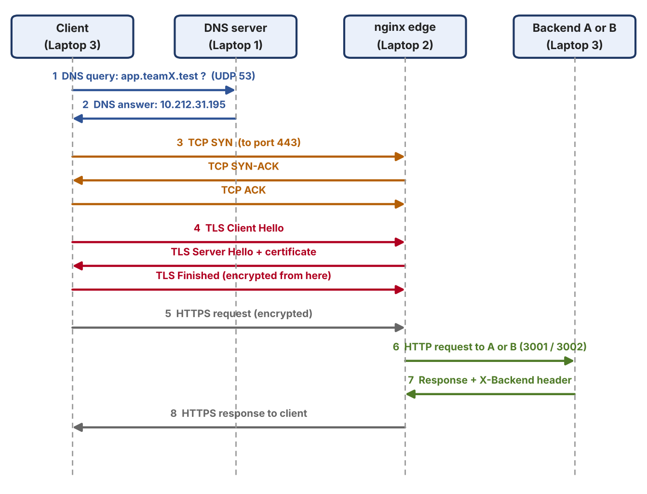
Figure 1: The full journey of one HTTPS request (DNS, then TCP, then TLS, then HTTP through nginx to a backend)

1.3 Analogy: sending a letter
Real-life action | Network step | Tool / machine in our project
Look up a friend's address in a phone book | DNS: turns a name into an IP address | dnsmasq on Laptop 1
Phone them and ask "can you hear me?" | TCP three-way handshake (SYN, SYN-ACK, ACK) | Client to Laptop 2, port 443
Put the letter in a locked box only they can open | TLS / HTTPS encryption | Certificate on nginx, signed by our own CA
A receptionist who passes your request to a free staff member | Reverse proxy and load balancer | nginx on Laptop 2
The staff members who do the work | Backends A and B | Applications on Laptop 3
A note saying "your copy is still up to date" | HTTP caching: ETag and 304 Not Modified | /api/info on the backends

1.4 System topology
All three laptops are connected to the same private network (hotspot / Wi-Fi). Each laptop plays one role, and each role has a cloud equivalent, which makes the small setup resemble a real cloud deployment. Laptop 3 hosts both backends and also acts as the test client and packet-capture machine, so the traffic it sends to the edge can be observed directly.
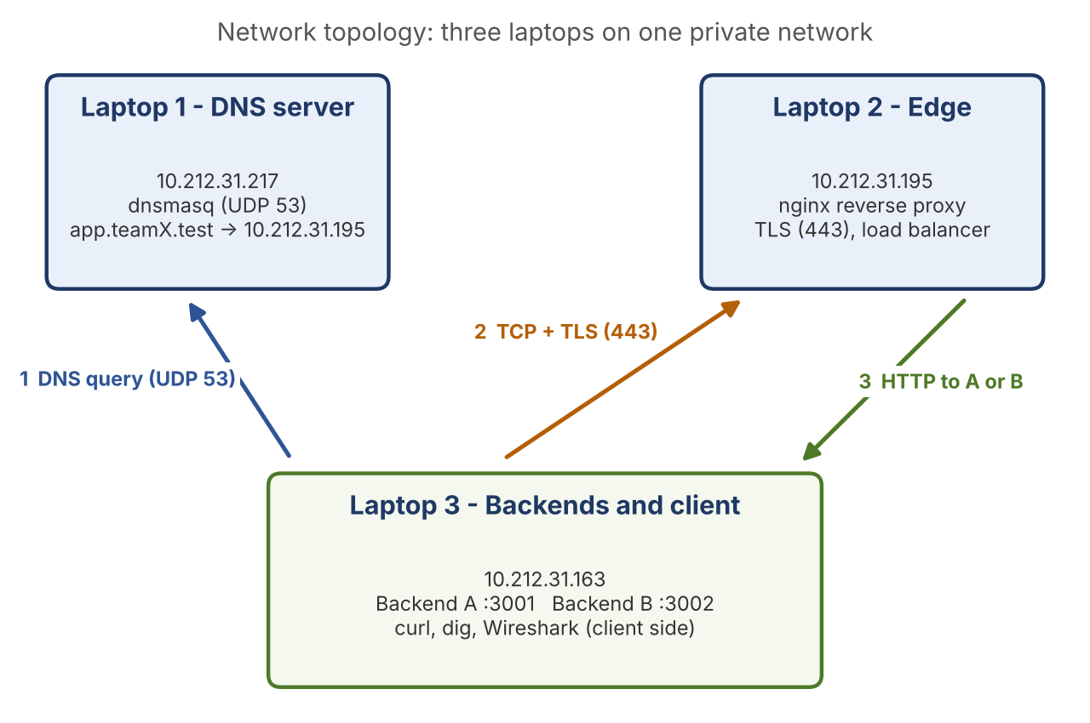
Figure 2: Network topology of Team X: three laptops, with the DNS, TCP/TLS and HTTP exchanges marked
Laptop | Role | IP address | What runs on it | Cloud equivalent
Laptop 1 | DNS server | 10.212.31.217 | dnsmasq (UDP 53), dig | Route 53 (managed DNS)
Laptop 2 | Edge: reverse proxy and load balancer | 10.212.31.195 | nginx, TLS certificate (HTTPS 443) | Cloud load balancer (AWS ALB)
Laptop 3 | Backends A and B, test client | 10.212.31.163 | App on port 3001, app on port 3002, curl, Wireshark | App server instances A and B

1.5 Protocols and ports at a glance
Protocol | Transport | Port | Role in the project
DNS | UDP | 53 | Client asks Laptop 1 for the IP of app.teamX.test
TCP handshake | TCP | 443 | Client opens a reliable connection to the edge (Laptop 2)
TLS (HTTPS) | TCP | 443 | Encrypts and authenticates the connection to nginx
HTTP (plain) | TCP | 3001, 3002 | nginx forwards the request to Backend A or Backend B

1.6 Terminology
Term | Meaning
IP address | The address of a machine on the network.
DNS | A phone book. It turns a name into an IP. It does not connect to anything.
A record | A DNS record that maps a name to an IPv4 address (for example app.teamX.test to 10.212.31.195).
Port | A door number on a machine. One machine can run many services, each on its own port.
TCP | The way two machines agree to talk reliably (three-way handshake: SYN, SYN-ACK, ACK).
TLS / HTTPS | Encryption on top of TCP, so nobody in the middle can read or change the data. HTTPS is HTTP carried inside TLS.
Reverse proxy | One front-door server that takes requests and passes them to hidden servers behind it.
Load balancer | Shares requests between more than one backend so no single one is overloaded.
Upstream | nginx word for the group of backend servers a request can be passed to.
Certificate | An ID card for the server, signed by someone the client trusts.
CA (Certificate Authority) | The trusted signer of certificates. We created our own CA for our private network.
SAN | Subject Alternative Name: the list of host names a certificate is valid for. Modern clients check this field.
Round robin | Taking turns: A, B, A, B ... The default way nginx shares requests.
Failover | Continuing to serve requests from the remaining servers when one server fails.
Cache-Control / max-age | Header telling the client how many seconds it may reuse an answer without asking again.
ETag | A fingerprint of the content, used as a version number for caching.
304 Not Modified | Reply meaning "your cached copy is still good"; no body is sent.
Display filter | A Wireshark expression (for example dns or tcp.port == 443) that shows only matching packets.

2. Team Roles and Responsibilities
Each member took the hands-on lead for one machine and a set of tasks, while all members worked on the shared parts of the project and understand the whole system.
Person | Laptop | Role | Main tasks
Aaditya Yadav | Laptop 1 | Private DNS server | LAN setup, DNS (dnsmasq), client DNS settings
Gouri Mishra | Laptop 2 | Edge: nginx, load balancer, HTTPS | nginx proxy, load balancing, TLS certificate and CA
Bhumi Rastogi | Laptop 3 | Backends A and B, test client | Backend code and ports, caching, Wireshark, failure demo

Detailed responsibilities
Person | Hands-on work | Owns (deliverable)
Gouri Mishra (Laptop 2, the edge) | nginx reverse proxy and load balancing; local CA, server certificate and HTTPS setup; nginx -t validation | Architecture Document (topology, request flow diagram)
Aaditya Yadav (Laptop 1, DNS) | LAN setup and IP table; dnsmasq DNS server; client DNS settings; DNS part of the Wireshark evidence | Configuration Bundle (dnsmasq.conf, nginx.conf, certificate steps)
Bhumi Rastogi (Laptop 3, backends and client) | Backend A (port 3001) and Backend B (port 3002); HTTP caching (Cache-Control, ETag, 304); Wireshark captures (DNS, TCP, TLS); backend failure demonstration | Backend Source Code and Evidence Folder (screenshots, capture files)

Step 1 was shared by all members, each of whom recorded the details of their own laptop. Every member captured the evidence for their own steps and the evidence was consolidated into one Evidence Folder (Section 5).

Order of work
The LAN (Step 1) came first. DNS (Step 2) and the backends (Step 3) were carried out in parallel. nginx and load balancing (Step 4) required both of them to be complete. HTTPS (Step 5) was added on top of Step 4, after which caching (Step 6) and packet capture (Step 7) were done. The failure demonstration (Step 8) was carried out last, once the whole system was working.

3. Implementation
The system was built in eight steps. Each step below states what was done and why, how it was implemented, and how it was verified.
Step | Topic | Owner | Machine
1 | LAN setup | Everyone | All
2 | Private DNS server | Aaditya | Laptop 1
3 | Two backend apps | Bhumi | Laptop 3
4 | nginx edge and load balancer | Gouri | Laptop 2
5 | HTTPS with TLS (local CA) | Gouri | Laptop 2
6 | HTTP caching | Bhumi | Laptop 3 (through Laptop 2)
7 | Packet capture analysis | Bhumi (with Aaditya for DNS) | Laptop 3
8 | Failure demonstration | Shared | All

3.1 Step 1: LAN setup
What | All three laptops were placed on the same private network and each laptop's network details were recorded.
Why | Every other step depends on the machines being able to reach each other directly.
Verification | Connectivity between the three machines was confirmed before any service was configured.

On each Mac the network details were read with the following commands (Wi-Fi is en0):
Terminal
ipconfig getifaddr en0 # IP address
ifconfig en0 | grep -E "inet |ether" # IP and MAC address
route -n get default | grep gateway # default gateway

The details were recorded in an IP inventory table, which is part of the Architecture Document:
Laptop | Person | Role | Interface | IP address
Laptop 1 | Aaditya | DNS server | en0 | 10.212.31.217
Laptop 2 | Gouri | Edge (nginx) | en0 | 10.212.31.195
Laptop 3 | Bhumi | Backends A and B, client | en0 | 10.212.31.163

Connectivity between machines can be checked in both directions with ping -c 4 <other_laptop_ip>. A machine that cannot be pinged usually means the laptops are on different networks, or that the Wi-Fi network isolates clients from each other.
Addressing note
IP addresses can change when a laptop reconnects (DHCP). The DNS record and the nginx upstream list both contain these addresses, so they must be re-checked whenever something stops working; if an address changes, both must be updated.

3.2 Step 2: Private DNS server
What | dnsmasq was installed on Laptop 1 so that it answers queries for our private name. Laptop 2 and Laptop 3 were then configured to use Laptop 1 as their DNS server.
Why | DNS turns app.teamX.test into the IP of Laptop 2. The project required our own DNS rather than the internet DNS.
Why .test? | The .test domain is reserved for testing, so it can never clash with a real website. .local was avoided because macOS uses it for its own mDNS service.
Verification | dig app.teamX.test returned the IP of Laptop 2 (10.212.31.195).

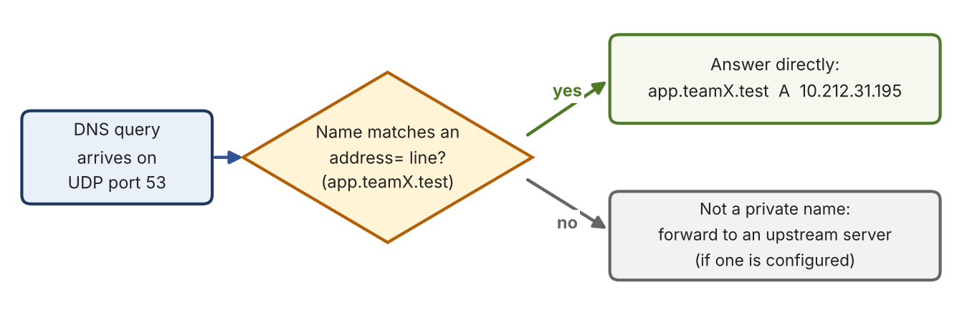
Figure 3: How dnsmasq decides what to answer

Installation and configuration (typical commands on macOS)
Terminal
brew install dnsmasq
# edit the configuration file (Apple Silicon path shown)
nano /opt/homebrew/etc/dnsmasq.conf
sudo brew services start dnsmasq

dnsmasq.conf (representative lines)
listen-address=10.212.31.217,127.0.0.1
bind-interfaces
address=/app.teamX.test/10.212.31.195
server=8.8.8.8 # optional: forward other names to an upstream resolver

Config line | Meaning
listen-address=10.212.31.217,127.0.0.1 | Answer DNS questions arriving on Laptop 1's LAN IP and on localhost.
bind-interfaces | Only bind to the addresses listed above, so dnsmasq does not grab every interface.
address=/app.teamX.test/10.212.31.195 | Always answer app.teamX.test with the IP of Laptop 2 (the edge).
server=8.8.8.8 | Optional. Names that are not private are forwarded to this upstream resolver.

Pointing the clients at our DNS
Laptop 2 and Laptop 3 were set to use Laptop 1 (10.212.31.217) as their DNS server, for example on macOS:
Terminal
networksetup -getdnsservers Wi-Fi # note the current value first
sudo networksetup -setdnsservers Wi-Fi 10.212.31.217
sudo dscacheutil -flushcache; sudo killall -HUP mDNSResponder

Verification
Terminal
dig app.teamX.test
dig @10.212.31.217 app.teamX.test # ask Laptop 1 directly

# answer section:
app.teamX.test. A 10.212.31.195

Key points
DNS only answers "what is the IP for this name?". It does not connect to anything and it does not check that the address is the right server.
The answer points to Laptop 2 (the edge), not to the backends. Clients never need to know where Backend A and B live.
If dig works but the website does not, the problem is not DNS; if ping by IP works but dig fails, the problem is DNS only.

3.3 Step 3: Two backend applications
What | The same small application was run twice on Laptop 3: Backend A on port 3001 and Backend B on port 3002. Both listen on 0.0.0.0, so they accept connections from other machines.
Why | Two identical backends are needed to demonstrate load balancing and failover. The application stays simple on purpose.
Identity header | Each response carries an X-Backend header (A or B) so we can see which instance answered. The page of Backend B reads "Backend B is running on port 3002".
Verification | Each backend started and printed its listening line, and both answered requests that came through nginx.

Terminal
Backend A listening on 0.0.0.0:3001
Backend B listening on 0.0.0.0:3002

The application exposes the endpoints below. Only the identity (name and port) differs between the two instances; the content is identical, which matters for caching in Step 6.
Endpoint | Behaviour | Why it is there
/ | Returns a short page naming the backend, for example "Backend B is running on port 3002" | Shows which instance answered when opened in a browser
/api/info | Returns a small JSON body with Cache-Control: max-age=60 and an ETag; answers 304 to a matching If-None-Match | Used for the HTTP caching demonstration (Step 6)
Every response | Adds the header X-Backend: A or X-Backend: B | Proof of load balancing and failover (Steps 4 and 8)

Key points
Listening on 0.0.0.0 (all interfaces) rather than 127.0.0.1 is essential: nginx on Laptop 2 connects over the network, so a backend bound only to localhost would be unreachable.
Both backends are on one laptop but on different ports, so the nginx upstream list contains the same IP twice with different ports.

3.4 Step 4: nginx edge and load balancer
What | nginx on Laptop 2 was set up as a reverse proxy in front of both backends, using an upstream group.
Why | Clients talk to one address (the edge). nginx decides which backend serves each request, so backends can fail or be added without clients noticing.
Verification | nginx -t reported a valid configuration, and repeated requests returned alternating X-Backend values (A, B).

nginx upstream group
upstream backend {
server 10.212.31.163:3001;
server 10.212.31.163:3002;
}

nginx server block (representative, inside the http block)
server {
listen 443 ssl;
server_name app.teamX.test;
ssl_certificate /path/to/server.crt;
ssl_certificate_key /path/to/server.key;

location / {
proxy_pass http://backend;
proxy_set_header Host $host;
proxy_set_header X-Real-IP $remote_addr;
proxy_set_header X-Forwarded-For $proxy_add_x_forwarded_for;
proxy_set_header X-Forwarded-Proto $scheme;
}
}

Directive | Meaning
upstream backend { ... } | Defines a named group of backend servers. The name is used later in proxy_pass.
server 10.212.31.163:3001; | One member of the group: Backend A.
server 10.212.31.163:3002; | The other member: Backend B.
listen 443 ssl; | Accept HTTPS connections on port 443.
server_name app.teamX.test; | Use this block for requests addressed to this name.
proxy_pass http://backend; | Forward the request to the upstream group over plain HTTP.
proxy_set_header Host $host; | Keep the original host name so the backend sees what the client asked for.
proxy_set_header X-Forwarded-* | Tell the backend the real client address and that the client used HTTPS.

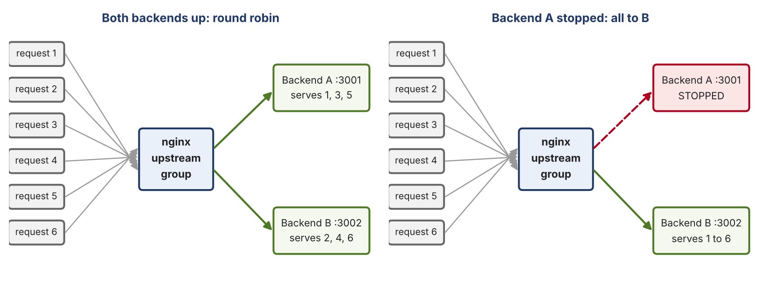
Figure 4: Round-robin load balancing, and what changes when Backend A is stopped
nginx uses round robin by default: requests are handed to the servers in turn. The result was observed with repeated curl requests that print only the X-Backend header, which showed both A and B answering. Other strategies exist if needed:
Method | Effect
round robin (default) | Each request goes to the next server in the list.
weight=N on a server | Gives a server N times its share of requests.
least_conn; | Sends the request to the server with the fewest active connections.
ip_hash; | The same client IP always reaches the same server (sticky sessions).

Validating and applying the configuration
Terminal
nginx -t # test the configuration for syntax errors
sudo nginx -s reload # apply changes without dropping connections

for i in {1..6}; do
curl -s -D - https://app.teamX.test/ -o /dev/null | grep X-Backend
done

3.5 Step 5: HTTPS with TLS
What | nginx was configured to serve https://app.teamX.test/ using a certificate signed by our own local certificate authority (CA). The CA certificate was trusted on the client.
Why | HTTPS encrypts the traffic so nobody between the client and the edge can read it, and the certificate proves that the server really is app.teamX.test.
Verification | curl -s https://app.teamX.test/ succeeded without certificate errors, and Wireshark showed a TLSv1.3 handshake with Laptop 2 on port 443.

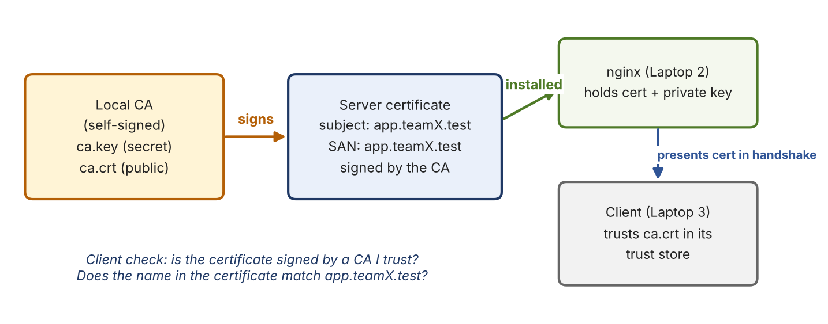
Figure 5: Chain of trust: our own CA signs the server certificate, and the client trusts the CA

Creating the CA and the server certificate (typical openssl steps)
Terminal
# 1. Create our own certificate authority
openssl genrsa -out ca.key 4096
openssl req -x509 -new -key ca.key -sha256 -days 365 -subj "/CN=TeamX Local CA" -out ca.crt

# 2. Create the server key and a certificate signing request
openssl genrsa -out server.key 2048
openssl req -new -key server.key -subj "/CN=app.teamX.test" -out server.csr

# 3. Name the host in the SAN field, then sign with the CA
printf "subjectAltName=DNS:app.teamX.test\n" > san.ext
openssl x509 -req -in server.csr -CA ca.crt -CAkey ca.key -CAcreateserial \
-out server.crt -days 365 -sha256 -extfile san.ext

# 4. Trust the CA on the client (macOS)
sudo security add-trusted-cert -d -r trustRoot -k /Library/Keychains/System.keychain ca.crt

File | Secret? | Purpose
ca.key | Yes, keep private | The CA's private key. Anyone who has it can create certificates the clients will trust.
ca.crt | No | The CA's public certificate. Installed on every client that should trust our certificates.
server.key | Yes, keep private | The server's private key. Stays on Laptop 2 and is used by nginx.
server.crt | No | The server certificate presented to clients; signed by the CA, valid for app.teamX.test.
san.ext | No | Small file that adds the SAN (host name) to the certificate.

What happens in the TLS 1.3 handshake
Message | What it does
Client Hello | The client says which TLS versions and ciphers it supports, sends its key share, and names the host it wants (SNI: app.teamX.test).
Server Hello | The server picks the TLS version and cipher and sends its own key share. Both sides can now derive the same session keys.
Certificate (encrypted in TLS 1.3) | The server shows its certificate. The client checks that a trusted CA signed it and that the name matches.
Finished | Both sides confirm the handshake was not tampered with. From here on, all data is encrypted.

Check the certificate from the client
curl -v https://app.teamX.test/ 2>&1 | grep -E "SSL connection|subject|issuer|expire"
openssl s_client -connect app.teamX.test:443 -servername app.teamX.test </dev/null | head -20

Key points
The certificate must contain the host name in its SAN field; modern clients ignore the older Common Name field.
The client trusts the certificate only because it trusts our CA. Without installing ca.crt, curl reports an unknown-issuer error.
TLS ends at nginx: the hop from nginx to the backends is plain HTTP on the private network.

3.6 Step 6: HTTP caching
What | We showed that the application can tell clients "you can reuse this answer" and that clients can ask "has it changed?" The /api/info endpoint implements this.
Why | Caching saves time and bandwidth, and CDNs work on this idea.
Verification | The response headers showed Cache-Control and ETag, and a conditional request returned 304 Not Modified.

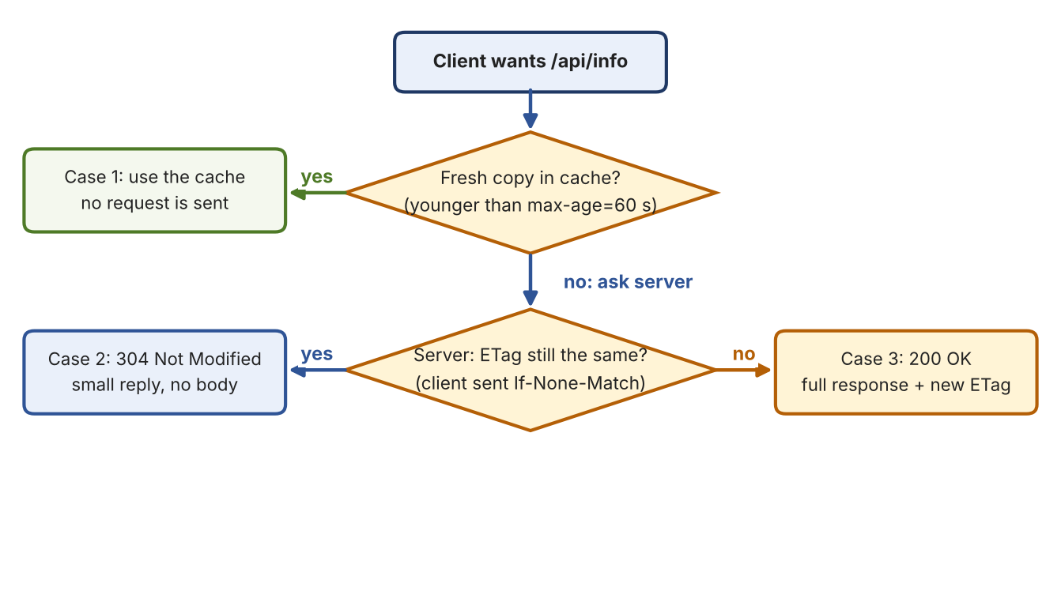
Figure 6: What happens when a client asks for /api/info: the three cases
Case | Condition | What happens
1. Fresh cache hit | Answer is still within max-age | Client does not even contact the server.
2. Conditional request | max-age ran out and the client has an ETag | Client asks "I have version X, is it still good?" Server says 304, no data sent again.
3. Full new request | Nothing in cache, or the content changed | Full 200 response is sent with a new ETag.

Header / status | Sent by | Meaning
Cache-Control: max-age=60 | Server | You may reuse this answer for 60 seconds without asking.
ETag: "..." | Server | A fingerprint (hash) of the content: the "version number".
If-None-Match: "..." | Client | Sends the ETag back: "only send data if it differs from this version".
304 Not Modified | Server | Your copy is still good. No body is sent.

Observed results
Request | Observed response
Normal GET (answered by Backend A) | HTTP/1.1 200 OK, Cache-Control: max-age=60, ETag: "3092ff7e802a9e35a7a613446a9585de"
Conditional GET with If-None-Match (answered by Backend B) | HTTP/1.1 304 Not Modified, same ETag returned

Terminal
curl -i https://app.teamX.test/api/info
curl -i -H 'If-None-Match: "3092ff7e802a9e35a7a613446a9585de"' https://app.teamX.test/api/info

Key points
The two requests were handled by different backends, yet the ETag was identical. Both backends compute the fingerprint from the same content, so a validator issued by A is accepted by B. This is what makes conditional requests work correctly behind a load balancer.
A browser reload within 60 seconds is normally served from its own cache (case 1); a forced reload sends If-None-Match and receives 304 (case 2).

3.7 Step 7: Packet capture analysis
What | The network traffic of one client request was recorded with Wireshark on Laptop 3, on the interface carrying 10.212.31.163 (en0).
Why | Packets prove what the architecture claims: DNS goes to Laptop 1, HTTPS goes to Laptop 2, and the HTTPS payload is encrypted.
Verification | The DNS query and response, the TCP connection to port 443, and the TLS Client Hello and Server Hello were all found in the capture.

Capture procedure
- Find the interface that carries the laptop's IP: ifconfig en0 | grep -E "inet |ether" (it showed 10.212.31.163).
- Open Wireshark and start capturing on that interface (double-click it).
- Generate DNS traffic with dig app.teamX.test and filter with dns.
- Generate HTTPS traffic with curl -s https://app.teamX.test/ and filter with tcp.port == 443.
- Find the TLSv1.3 Client Hello (client to Laptop 2) and the Server Hello (Laptop 2 to client).
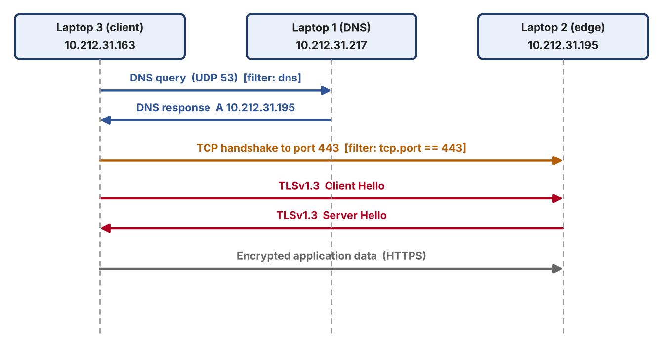
Figure 7: What the capture shows: DNS to Laptop 1, TCP and TLS to Laptop 2

Wireshark display filters used
What we looked for | Filter | What it shows
DNS | dns | Query from 10.212.31.163 to 10.212.31.217 over UDP 53, and the response with 10.212.31.195
TCP and TLS to the edge | tcp.port == 443 | TCP connection from 10.212.31.163 to 10.212.31.195:443, then the TLS handshake and encrypted data
Client Hello only | tls.handshake.type == 1 | The first TLS message, sent by the client
Server Hello only | tls.handshake.type == 2 | The server's answer, sent by Laptop 2

Protocols mapped to layers
Layer | Protocols in our project | Where it shows up in Wireshark
Application | DNS, HTTP | dig output and curl headers; HTTP is visible only inside the encrypted TLS data
Session / Security | TLS 1.3 | Client Hello, Server Hello, then "Application Data"
Transport | UDP (DNS), TCP (HTTPS) | UDP port 53 to Laptop 1; TCP port 443 to Laptop 2
Network | IP | Source and destination addresses (10.212.31.x)
Link | Wi-Fi / Ethernet | MAC addresses and frames on en0

Key takeaway
DNS goes to Laptop 1 (UDP 53). HTTPS goes to Laptop 2 (TCP 443). The client never sends HTTPS to the DNS server and never talks to the backends directly: the TLS handshake ends at nginx.
After the handshake, Wireshark shows only encrypted "Application Data". The request and response bodies cannot be read from the capture, which is exactly what HTTPS is meant to guarantee.

3.8 Step 8: Failure demonstration
What | The setup was broken on purpose by stopping Backend A, the behaviour was observed and explained.
Why | It shows understanding of the system and not only the setup steps.

The failure demonstration followed the same method as the rest of the project:
- A "before" check showing that the service works and is shared between A and B.
- The failure was triggered.
- An "after" check showing the effect on clients.
- The layer that was affected, and why, was explained.
- Everything was restored and shown working again.
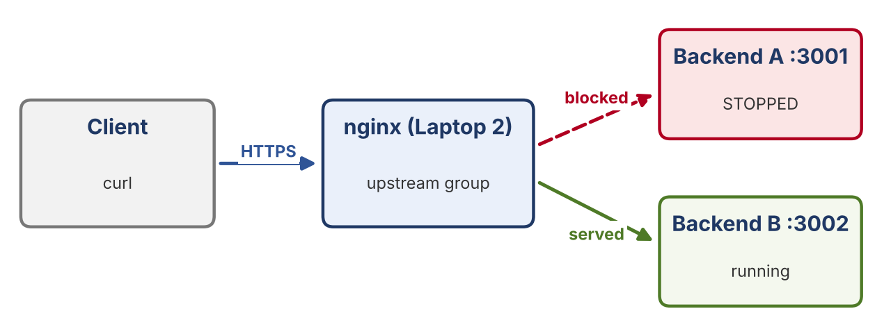
Figure 8: With Backend A stopped, nginx serves every request from Backend B

Failure 1: One backend stopped
Trigger | On Laptop 3, Backend A was stopped with Ctrl+C. Backend B was left running.
Observation | Six consecutive requests all succeeded and all were answered by Backend B (X-Backend: B). No request failed.
Explanation | nginx sees that Backend A is unreachable and sends the request to the other server in the upstream group. Clients keep using the same URL and never notice the failure.
Layer | Application / proxy layer (backend availability)

Terminal
# on Laptop 3: stop Backend A with Ctrl+C in its terminal, then on the client:
for i in {1..6}; do
curl -s -D - https://app.teamX.test/ -o /dev/null | grep X-Backend
done

X-Backend: B
X-Backend: B
X-Backend: B
X-Backend: B
X-Backend: B
X-Backend: B

Restore: restart Backend A on port 3001 and send several requests again; the X-Backend header returns to alternating A and B.
How nginx detects the failure
nginx detects a failed upstream passively. When a connection attempt to a server fails, nginx tries the next server for that request and treats the failed one as unavailable for a short time (by default max_fails=1 and fail_timeout=10s). This lab did not tune these settings, so the first request after a failure may be slightly slower while nginx discovers that the server is down.

Further failure scenarios (planned, not performed in Phase 1)
The same method can be applied to other layers. These scenarios were not run in this phase; they are listed with the behaviour expected from the architecture so the project can be extended.
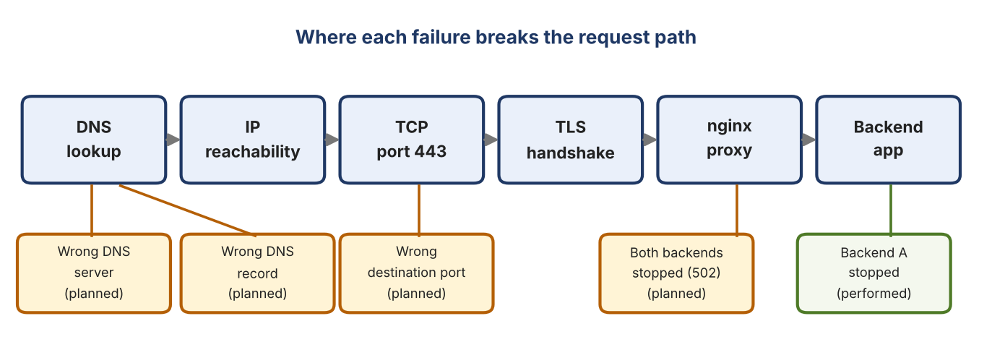
Figure 9: Where each failure breaks the request path (green: performed, orange: planned)
Scenario | How to trigger it | Expected observation | Layer
Wrong DNS server on a client | Point the client at a DNS server that does not exist | dig fails, but ping by IP still works | DNS
Wrong DNS record | Change address=/app.teamX.test/ to an IP that does not run nginx | DNS answers, but the connection fails or reaches the wrong machine | DNS (wrong data)
Wrong destination port | curl https://app.teamX.test:9999/ | Connection refused: nothing listens on that port | TCP
Both backends stopped | Stop Backend A and Backend B | nginx answers 502 Bad Gateway; the TLS handshake still completes | Proxy / backend

4. Verification Summary
The completed system satisfies the following requirements.
Requirement | How it was verified | Status
Three-machine network connectivity | Machines reachable by IP before services were configured | Verified
Private DNS with dnsmasq | dig app.teamX.test returns the edge IP, 10.212.31.195 | Verified
Clients use our DNS | Laptop 2 and Laptop 3 resolve through Laptop 1 (10.212.31.217) | Verified
Backend A on 3001, Backend B on 3002 | Start-up lines printed; X-Backend: A and X-Backend: B seen | Verified
nginx reverse proxy | nginx -t passes; requests reach the backends through the edge | Verified
HTTPS with a local CA | curl https://app.teamX.test/ succeeds without certificate errors | Verified
Load balancing between A and B | Alternating X-Backend values over repeated requests | Verified
HTTP caching | 200 with Cache-Control and ETag; 304 for If-None-Match | Verified
Packet capture | DNS query to Laptop 1; TCP/TLS Client Hello and Server Hello with Laptop 2 | Verified
Backend failure and failover | Backend A stopped; six requests all served by Backend B | Verified

5. Evidence and Deliverables

5.1 Evidence folder structure
All proof of the work should be kept in one folder so that every claim in this report can be checked quickly:
teamx-phase1-evidence/
01-lan/ IP addresses of the three laptops
02-dns/ dig output, dnsmasq.conf
03-backends/ Backend A and B start-up lines, X-Backend responses
04-nginx/ nginx -t output, nginx.conf, load-balancing output
05-tls/ CA and certificate commands, curl over HTTPS
06-caching/ 200 with ETag, 304 conditional request
07-wireshark/ DNS and TLS screenshots, capture file (.pcapng)
08-failures/ Backend A stopped, six X-Backend: B responses
README.md short description of each file

5.2 Evidence index
No. | Evidence | Task | Taken on
1 | dig @10.212.31.217 app.teamX.test | B - DNS | Laptop 1
2 | nginx -t | D - nginx | Laptop 2
3 | Successful curl showing X-Backend: A | C - Backends | Laptop 3
4 | Load-balancing output showing both A and B | D - Load balancing | Laptop 3
5 | curl -i /api/info showing ETag and Cache-Control | F - Caching | Laptop 3
6 | Conditional request returning 304 Not Modified | F - Caching | Laptop 3
7 | Wireshark: DNS query and response (filter: dns) | G - Capture | Laptop 3
8 | Wireshark: TLS Client Hello and Server Hello (tcp.port == 443) | G - Capture | Laptop 3
9 | Failure test showing six X-Backend: B responses | Failure demo | Laptop 3

5.3 Deliverables
Deliverable | Owner | Contents
Architecture Document | Gouri | Topology diagram, IP table, request-flow diagram with protocol labels
Configuration Bundle | Aaditya, Gouri | dnsmasq.conf, nginx.conf, TLS setup notes (openssl steps), backend launch commands
Backend Source Code | Bhumi | The backend application file and any helper scripts
Evidence Folder | Bhumi | Screenshots, curl outputs and Wireshark captures (Section 5.1)
Phase 1 Report | Everyone | This document

6. Troubleshooting Approach and Issues Resolved
When something stopped working, the layers were checked from the bottom up: IP first, then DNS, then TCP, then TLS, then the application. The flowchart shows which check matches which symptom.
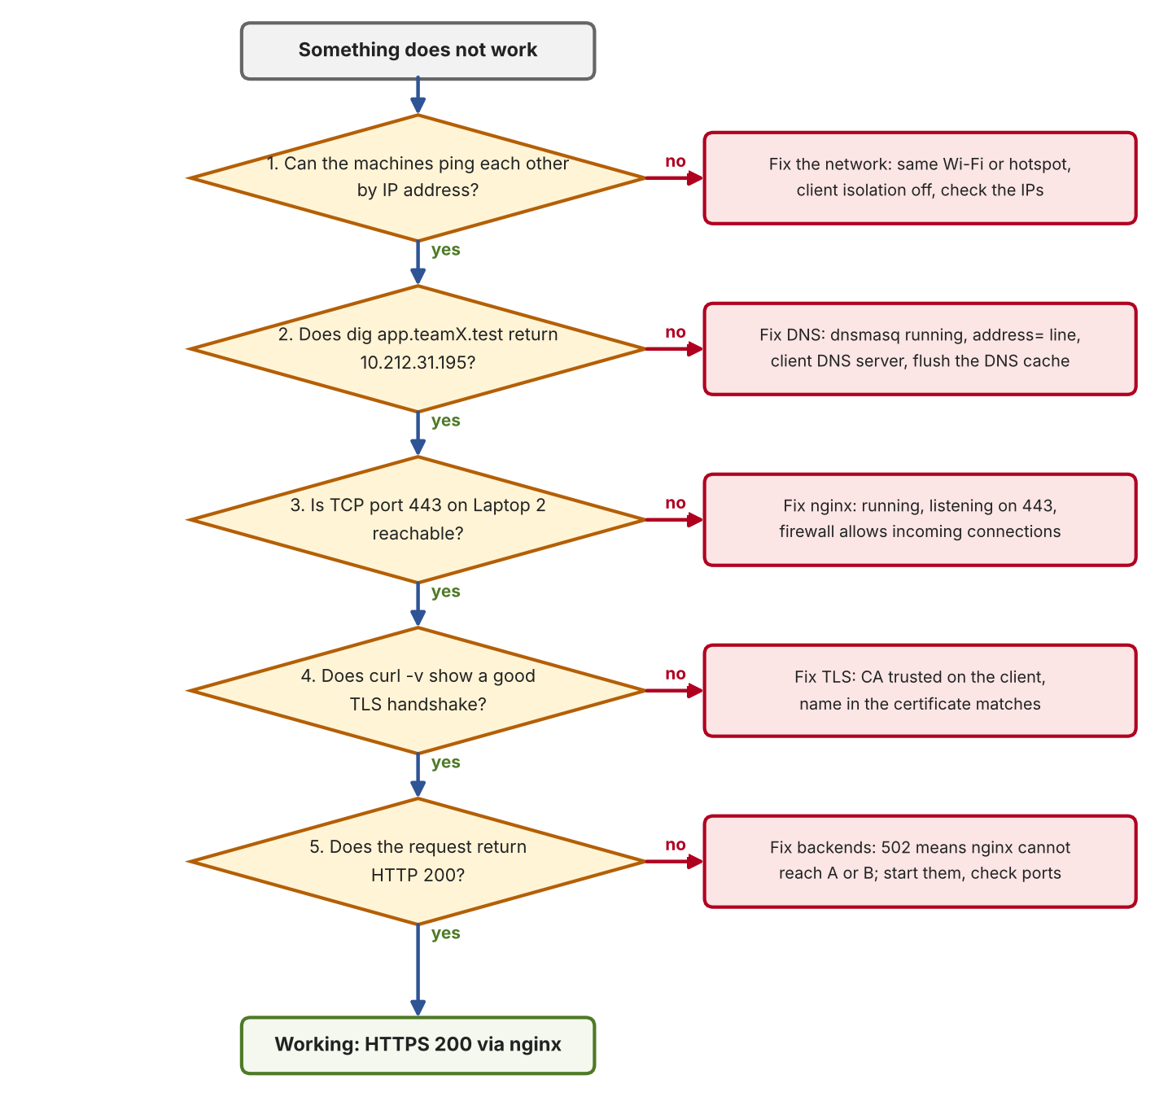
Figure 10: Troubleshooting flowchart: IP first, then DNS, TCP, TLS, then the application
Problem | Likely cause | Fix
Ping between laptops fails | Wi-Fi client isolation, or the laptops are on different networks | Use the same hotspot or network that allows device-to-device traffic
dig gives no answer or the wrong answer | DNS cache, or the client is not using Laptop 1 | Flush the cache and check the SERVER: line in the dig output
dnsmasq will not start | Something already uses port 53 | Run sudo lsof -i :53 to see what, then stop it or change its port
Name resolves but the page does not open | Wrong IP in the DNS record, or nginx is not running | Compare the record with Laptop 2's current IP; start nginx
Backends unreachable from Laptop 2 | Backend bound to 127.0.0.1 or blocked by the firewall | Bind to 0.0.0.0 and allow incoming connections
Certificate warning or curl error 60 | CA is not trusted, or the SAN does not match the name | Install ca.crt on the client; recreate the certificate with the right SAN
nginx will not start or reload | Syntax error, or port 443 already in use | Run nginx -t and read the error; check what uses port 443
502 Bad Gateway | nginx cannot reach any backend | Start the backends; check the ports in the upstream list
Wireshark shows no relevant packets | Capture started on the wrong interface | Select the interface that carries the laptop's IP (en0)
Everything broke suddenly | A laptop got a new IP from DHCP | Re-check the IP table and update the DNS record and nginx upstream

7. Conclusion
Phase 1 produced a working private network service platform on three laptops. A client can use a name, resolve it through our own DNS server, open a reliable TCP connection to the edge, establish a TLS session secured by our own certificate authority, and have its request forwarded to one of two backends that are shared in round-robin fashion. Caching was demonstrated with Cache-Control, ETag and 304 responses. Wireshark captures confirmed each protocol at the packet level, and stopping one backend showed that the service stays available through the other.

7.1 What we learned
- DNS, IP, TCP, TLS and HTTP are separate layers; each can be tested and can fail on its own, and a symptom usually points to one layer.
- A reverse proxy hides the backends from clients, which is what makes load balancing and failover possible without any change on the client side.
- HTTPS needs more than encryption: the client must trust the CA and the certificate must name the host, otherwise the connection is rejected.
- Caching works best when all backends produce the same validator (ETag) for the same content.
- Packet captures turn architecture diagrams into evidence: the DNS path and the HTTPS path really do go to different machines.

7.2 Possible extensions
- Tune nginx failover with max_fails, fail_timeout and proxy_next_upstream, and measure the delay of the first request after a failure.
- Run the backends on separate machines from the client so that Wireshark traffic is easier to separate.
- Add an nginx proxy cache so repeated requests are answered at the edge without reaching a backend.
- Run the additional failure scenarios listed in Section 3.8 and add a "before" and "after" capture for each.

Appendix A: backend.py (representative code)
Note
The code below is a representative backend whose behaviour matches what was observed in the lab: an X-Backend header, a / page naming the instance, and /api/info with Cache-Control, ETag and 304 handling. If the file used in the lab differs, replace this listing with the exact file.

Python, no extra libraries. Run as Backend A with BACKEND=A PORT=3001 and as Backend B with BACKEND=B PORT=3002.
backend.py
import json, hashlib, os
from http.server import BaseHTTPRequestHandler, HTTPServer

NAME = os.environ.get("BACKEND", "A")
PORT = int(os.environ.get("PORT", "3001"))

class Handler(BaseHTTPRequestHandler):
def send_it(self, code, body, ctype="application/json", extra=None):
data = body.encode()
self.send_response(code)
self.send_header("Content-Type", ctype)
self.send_header("Content-Length", str(len(data)))
self.send_header("X-Backend", NAME)
for k, v in (extra or {}).items():
self.send_header(k, v)
self.end_headers()
if self.command != "HEAD": # HEAD (curl -I) gets headers only
self.wfile.write(data)

def do_HEAD(self):
self.do_GET()

def do_GET(self):
if self.path == "/":
page = f"<h1>Backend {NAME} is running on port {PORT}</h1>"
self.send_it(200, page, "text/html")
elif self.path == "/api/info":
body = json.dumps({"message": "this content rarely changes"})
etag = '"' + hashlib.md5(body.encode()).hexdigest() + '"'
hdrs = {"ETag": etag, "Cache-Control": "max-age=60"}
if self.headers.get("If-None-Match") == etag:
self.send_it(304, "", extra=hdrs)
else:
self.send_it(200, body, extra=hdrs)
else:
self.send_it(404, json.dumps({"error": "not found"}))

HTTPServer(("0.0.0.0", PORT), Handler).serve_forever()

Terminal
BACKEND=A PORT=3001 python3 backend.py # terminal 1: Backend A
BACKEND=B PORT=3002 python3 backend.py # terminal 2: Backend B

How the code maps to the requirements
Part of the code | Why it is there
NAME and PORT from environment variables | One file serves as both A and B; only these two variables differ.
send_header("X-Backend", NAME) | Shows which backend answered: the proof of load balancing and failover.
HTTPServer(("0.0.0.0", PORT), ...) | Listens on all interfaces so nginx on Laptop 2 can reach it.
/api/info with Cache-Control and ETag | Caching demonstration: clients may reuse the answer for 60 seconds.
ETag = hash of the body | Identical content gives an identical ETag on A and B, so a 304 works across backends.
If-None-Match comparison | Returns 304 Not Modified when the client already has the current version.
do_HEAD calls do_GET | curl -I sends HEAD; headers are returned without a body.

Appendix B: Complete Configuration at a Glance
Note
These are representative configurations built from the addresses used in the lab. Replace the file paths and any values that differ from the files actually used.

dnsmasq.conf (Laptop 1)
Laptop 1
listen-address=10.212.31.217,127.0.0.1
bind-interfaces
address=/app.teamX.test/10.212.31.195
server=8.8.8.8

nginx.conf, inside http { } (Laptop 2)
Laptop 2
upstream backend {
server 10.212.31.163:3001;
server 10.212.31.163:3002;
}

server {
listen 443 ssl;
server_name app.teamX.test;
ssl_certificate /path/to/server.crt;
ssl_certificate_key /path/to/server.key;
ssl_protocols TLSv1.2 TLSv1.3;

location / {
proxy_pass http://backend;
proxy_set_header Host $host;
proxy_set_header X-Real-IP $remote_addr;
proxy_set_header X-Forwarded-For $proxy_add_x_forwarded_for;
proxy_set_header X-Forwarded-Proto $scheme;
}
}

Port and service summary
Service | Machine | IP address | Port / protocol
DNS (dnsmasq) | Laptop 1 | 10.212.31.217 | 53 / UDP
nginx HTTPS (edge) | Laptop 2 | 10.212.31.195 | 443 / TCP
Backend A | Laptop 3 | 10.212.31.163 | 3001 / TCP
Backend B | Laptop 3 | 10.212.31.163 | 3002 / TCP

Appendix C: Command Quick Reference
Command | What it shows
ipconfig getifaddr en0 | The laptop's IP address on Wi-Fi
ping -c 4 <ip> | Basic IP reachability between two machines
dig app.teamX.test | Name resolution through the configured DNS server
dig @10.212.31.217 app.teamX.test | Ask Laptop 1 directly, ignoring the system DNS setting
networksetup -getdnsservers Wi-Fi | Which DNS server the Mac is using
curl -i https://app.teamX.test/ | Response headers and body, including X-Backend
curl -I https://app.teamX.test/api/info | Headers only: Cache-Control and ETag
curl -i -H 'If-None-Match: "<etag>"' <url> | Conditional request; expect 304 Not Modified
curl -v https://app.teamX.test/ | TLS handshake details, certificate and negotiated protocol
nginx -t | Checks the nginx configuration for errors
sudo nginx -s reload | Applies a changed nginx configuration
sudo lsof -i :53 | Which process is using port 53 (DNS)
nc -vz 10.212.31.195 443 | Whether TCP port 443 on the edge is reachable

