Task Report

# 1.Task Description

Build a Post api which also returns the serialized data with count of data saved.

The task is to build a **Django REST API** that allows users to **send a POST request to save a new user** with name and age.

# 2. Task Output Screenshot

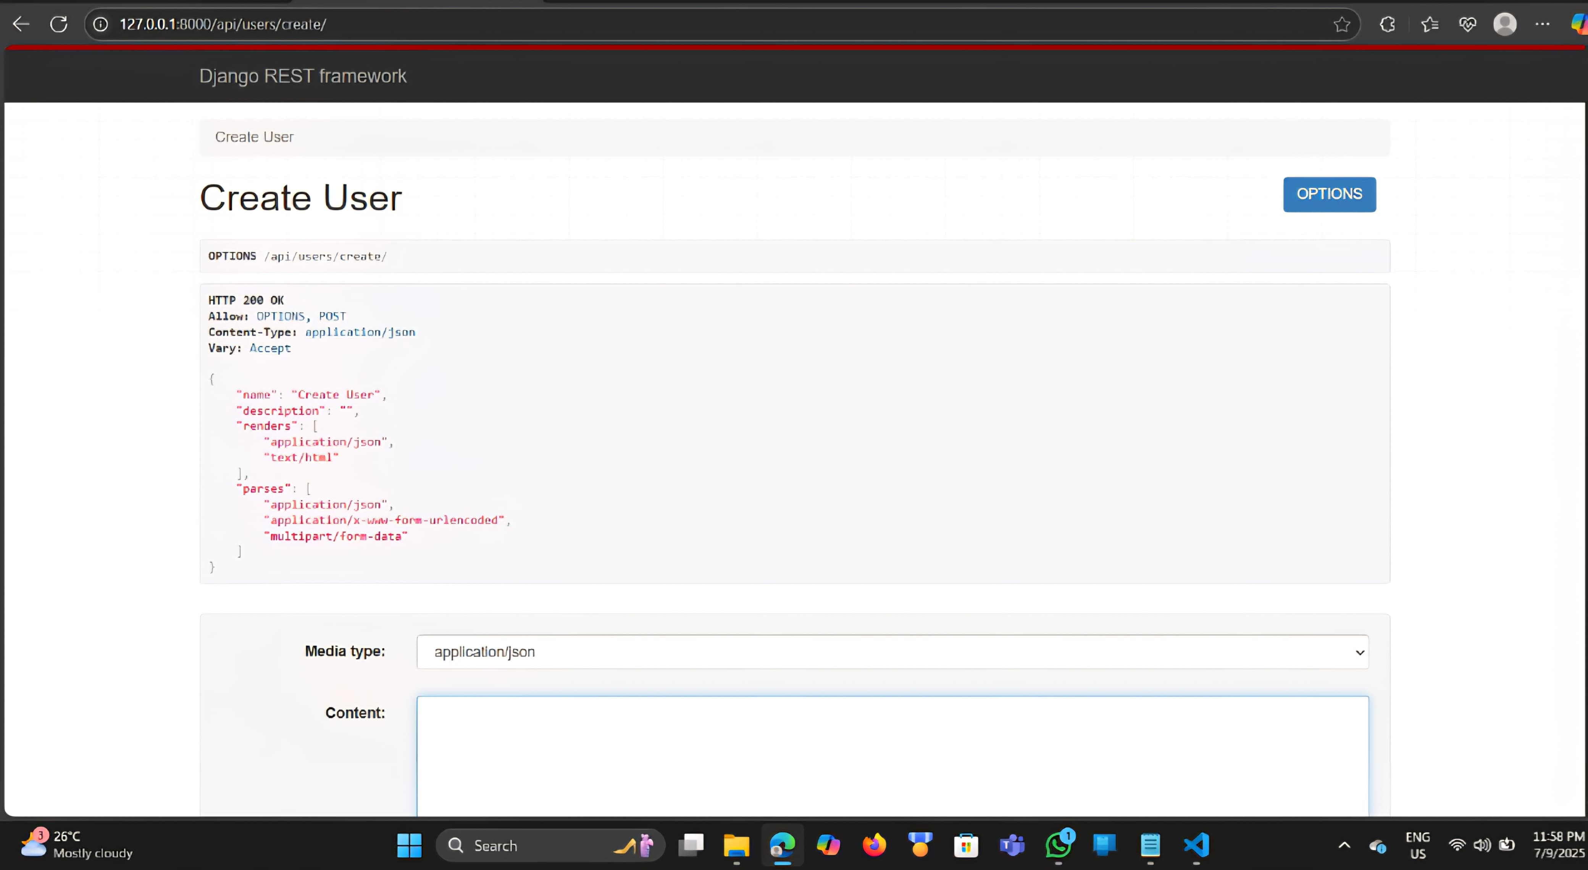

# 3. Widget/Algorithm Used In Task

**Widgets / Tools Used**

1. **Django** – Main web framework to build the project.
2. **Django REST Framework (DRF)** – To create REST APIs.
3. **SQLite** – Default database used via Django ORM.

**Algorithm / Logic Used**

1. **Input Validation & Saving**
   * Input is received via a POST request.
   * UserSerializer is used to validate and save the incoming data.
2. **Data Retrieval**
   * After saving the user, the API fetches **all existing users** from the database.
3. **Response Construction**
   * Serialized data of all users is returned.
   * count of total users is calculated using .count().