
VIT BHOPAL UNIVERSITY

School of Computing Science and Engineering

Bhopal-Indore Highway, Kothrikalan, Sehore
Madhya Pradesh - 466114

CSA1021 INTRODUCTION TO PROBLEM SOLVING AND PROGRAMMING

PERSONAL EXPENSE TRACKER

REG.NO : 26BCE10934
NAME : Bhumi
BRANCH : Cse core
YEAR : 2026
SEMESTER: Fall Semester 2026-27

Table of Contents

1. Introduction
1.1 Purpose
1.2 Scope
1.3 Intended Users
2. Problem Statement
3. Functional Requirements
3.1 Detailed Description of Requirements
4. Non-Functional Requirements
5. System Architecture
5.1 Assumptions and Constraints
6. Design Diagrams
6.1 Use Case Diagram
6.2 Workflow Diagram
6.3 Sequence Diagram
6.4 Class / Component Diagram
6.5 Data Record Diagram (ER-style)
7. Design Decisions and Rationale
8. Implementation Details
8.1 Tools I Used
8.2 - 8.11 Feature Walkthroughs with Code
9. Screenshots / Results
10. Testing Approach
10.1 Test Environment
10.2 Test Cases
10.3 How I Actually Worked Through This
11. Challenges Faced
12. Learnings and Key Takeaways
13. Future Enhancements
14. References
Appendix A: Complete Source Code Listing
Appendix B: User Manual
Appendix C: Glossary of Terms
1. Introduction
I don't really keep track of where my money goes. A few rupees here for chai, a bit more for the
auto, then some random shopping I forget about by the end of the week - and by the time the
month is over I have no real idea what I spent it on. That's basically the reason I picked this
project. I wanted something small and simple where I could just type in an expense the moment I
spend it, and later ask it questions like "how much did I spend on food this month" instead of trying
to remember or scroll through fifteen different UPI notifications.
So this is a Personal Expense Tracker, written in Python and built entirely in the terminal - no
app, no website, just a menu you type numbers into. I built it in VS Code, mainly because that's
the editor I'm most comfortable in and it made testing and re-running the script quick while I was
fixing bugs. I kept it deliberately simple under the hood: no external libraries, no database, just
lists, dictionaries, loops and plain text files. Partly that's because this is a beginner-level project
and I wanted to actually understand every line of it, and partly because I didn't want to depend on
anything that might not be installed on whichever computer runs it.
The program itself works in a loop: it prints a menu, waits for you to type a number, does whatever
that option is supposed to do, and then shows the menu again. Every expense you add gets
stored as a dictionary (with a date, a category, a short description, and an amount) inside one big
list while the program is running. Whenever something changes - a new expense, an edit, a
deletion - the whole list gets written out to a plain text file so nothing is lost if I close the terminal.
There's also an optional monthly budget you can set, and the program will nudge you once you're
close to it or tell you off once you've gone over.
This report walks through why I built it, what it's supposed to do, how it's put together, the
diagrams I made for it, some screenshots of it actually running, how I tested it, and finally what I
struggled with and what I'd add if I kept working on it.

1.1 Purpose
Honestly, the main purpose of this report is to explain the project properly - not just hand in code
with no context. I wanted a document that walks through the reasoning behind the project the
same way I'd explain it out loud if someone asked "why did you build it like this?" It's also useful
for me personally, because in a few months I'll probably forget half the decisions I made here, and
this way I have something to look back at.

1.2 Scope
I kept the scope small on purpose. This is built for one person, running it on their own computer,
with their own local files - nothing about multiple accounts, no internet connection, no syncing
across devices. It covers the full life of an expense: you can add it, view it, search it, edit it, delete
it, sort it, and get summaries and statistics out of it, plus a basic budget warning. Things like bank
integration, a mobile app, or automatically importing transactions are out of scope for now - I've
listed a few of those ideas later on in the Future Enhancements section instead of trying to cram
them in.

1.3 Intended Users
Really, the main user is someone like me - a student who wants a quick way to log expenses
without opening a banking app or a spreadsheet every time. You don't need to know how to code
to use the finished program; it just asks you questions and you type answers. You'd only need to
know Python if you wanted to open the file and change something, which is why I tried to keep the
code readable and commented rather than clever.

2. Problem Statement
Most people, myself included, don't track spending in any structured way. Money moves around
all day through cash and UPI payments, but there's rarely one place where it's all written down
with a category and a date attached. So by the time the month ends, it's genuinely hard to answer
basic questions like:
• How much have I actually spent so far this month?
• Which category - food, travel, shopping, whatever - is eating up most of my money?
• Did I stay under the budget I told myself I'd stick to?
• What was my single biggest expense, and when did that happen?
• How much did I spend between two dates, say during a trip?
The goal here was to build something lightweight that runs offline, doesn't need an account or any
payment, and lets one person log expenses as they happen and get straight answers to questions
like the ones above. I also wanted it to be something I could realistically build and fully understand
at my current level, rather than something that looks impressive on paper but is really just copied
from a tutorial.

3. Functional Requirements
These are the things the program actually needs to do. I wrote this list out before I started coding
properly, and used it as a kind of checklist while building - anytime I finished one, I mentally ticked
it off.

ID | Requirement | Description
FR-1 | Add Expense | User can add a new expense with date, category, description and amount.
FR-2 | View All Expenses | User can view every recorded expense in a numbered table with a running total.
FR-3 | View Total Spending | System calculates and displays the sum of all recorded expenses.
FR-4 | Search by Category | User can view only the expenses that belong to a chosen category.
FR-5 | Search by Date | User can view expenses for one exact date or between a start and end date.
FR-6 | Monthly Summary | System groups expenses by month and shows the total spent in each month.
FR-7 | Category-wise Summary | System groups expenses by category and shows totals with percentage share.
FR-8 | ID | User can select an existing expense by its number and change any of its fields.
FR-9 | Delete Expense | User can remove an expense after confirming the action (yes/no).
FR-10 | Sort Expenses | User can view expenses sorted by amount or by date, ascending or descending.
FR-11 | Statistics | System reports the highest, lowest and average expense, and the costliest day.
FR-12 | Monthly budget | User can set a monthly budget; system warns at 80% usage and on crossing it.
FR-13 | Clear all expenses | User can erase every stored expense after a confirmation prompt.
FR-14 | Persistent Storage | All expenses and the budget are saved to disk and reloaded automatically.
FR-15 | Input Validation | Every user input (date, amount, menu choice, yes/no) is validated before use.

3.1 Detailed Description of Requirements

A few of these need a bit more explaining than the table gives, so here's a more detailed look at
the ones I spent the most time getting right.
• FR-1 Add Expense: I ask for the date, category, description and amount in that order. If any of
them is invalid - a badly formatted date, letters where a number should be - I don't throw the
whole entry away, I just re-ask that one field until it's right.
• FR-4 / FR-5 Search by Category and by Date: Category search isn't case-sensitive, so
"Food" and "food" match the same thing. Date search works for a single day or a range
between two dates, and if you accidentally type the end date before the start date, it just swaps
them for you instead of returning nothing.
• FR-6 / FR-7 Monthly and Category Summaries: Both of these recalculate everything fresh
each time you ask, rather than keeping some separate running total that could quietly go
wrong. The category summary also shows what percentage of your total spending each
category takes up.
• FR-8 / FR-9 Edit and Delete: Both show you the full table first so you can see the number of
the row you want. Editing lets you skip any field by just pressing Enter, and deleting always
asks "are you sure?" before actually removing anything - I added that after accidentally deleting
a test entry I actually wanted to keep.
• FR-10 Sort Expenses: You can sort by amount or by date, in either direction. This only
changes what you see on screen for that one moment - it doesn't reorder the actual saved file.
• FR-12 Monthly Budget: Once you've set a budget, every new expense triggers a quick check
of that month's total against it. At 80% it gives a gentle warning, and past 100% it tells you
exactly how much over you are.
• FR-14 Persistent Storage: Nothing is only kept in memory. Every action that changes data
immediately writes to the file, so even if the terminal is closed unexpectedly, the last saved
state is still there next time.

4. Non-Functional Requirements
These are less about specific features and more about how the program should feel and behave overall.
QUALITY | HOW I HANDLED IT
Usability | The menu reappears after every single action, so you're never stuck  wondering what to do next. Prompts tell you the format expected.
Reliability | Every input is checked in a loop until it's valid, so a typo can't crash the  whole program halfway through.
Data Persistence | Data is written to disk after every change, not just when you exit, so  closing the terminal by accident doesn't lose anything.
Performance | Plain Python lists are more than fast enough here - this isn't handling  thousands of transactions a second, just a personal expense log.
Maintainability | I split everything into small functions with comments, so if I come back  to this in six months I can actually follow what I was doing.
Portability | Only the standard library is used, so it runs anywhere Python 3 is  installed - no extra installs, no setup steps.
Readability | I tried to keep naming and spacing consistent throughout, since I was  also going to have to explain this code to my teacher line by line.

5. System Architecture

There's no client-server setup here and no external database - it's a single Python script that runs top to bottom in one process. Even so, I organised the code into layers that each do one job, which made it much easier to keep track of while I was building it feature by feature.

Layer | Responsibility | Key functions
Presentation Layer | Displays the menu, headings and  results on the screen. | show_menu(), print_heading(),  show_expenses()
Input Validation  Layer | Collects and validates every value  typed by the user. | ask_date(), ask_amount(),  ask_text(),  ask_number_in_range(),  ask_yes_no()
Business Logic  Layer | Implements each feature: adding,  searching, summarising, etc. | add_expense(),  search_by_category(),  monthly_summary(),  sort_expenses()
Data Layer | Holds the expenses and budget while  the program runs. | expenseslist (list of dict),  monthly_budget (number)
Persistence Layer | Reads and writes the data to text files  on disk. | save_data(), load_data()

Keeping these separate meant the feature functions never touch the file system directly - they only ever go through save_data() and load_data(). If I ever wanted to swap the plain text file for something like SQLite later, I'd only have to rewrite those two functions and nothing else would need to change. I didn't plan this out perfectly from day one, to be honest - it's more that I noticed the pattern once I had four or five features working, and then kept it consistent from there.

5.1 Assumptions and Constraints

A few assumptions shaped how I built this, and it's worth being upfront about them:
• It's built for one person on one computer at a time - I didn't design for multiple people sharing
the same data file.
• I'm assuming a fairly normal amount of data - hundreds of expenses, not tens of thousands - so
a simple list scan is more than fast enough.
• You need Python 3 installed and you need to be okay typing into a terminal - there's no GUI.
• Every date follows the same DD-MM-YYYY format and everything is in one currency - I didn't
add any currency conversion.
• I'm assuming the computer itself is trusted - the files aren't encrypted, since this is meant for
personal use, not for protecting data from someone else with access to the same machine.

6. Design Diagrams
Here are the diagrams I put together for this project: a use case diagram for what a user can
actually do, a workflow diagram for the main loop, a sequence diagram for what happens when
you add an expense, a class/component diagram for how the code is grouped, and a simple
record diagram instead of a full ER diagram, since I'm using text files rather than a real database.

6.1 Use Case Diagram
Since this only has one type of user, the diagram is fairly simple - just the User and every action
they can take with the system.
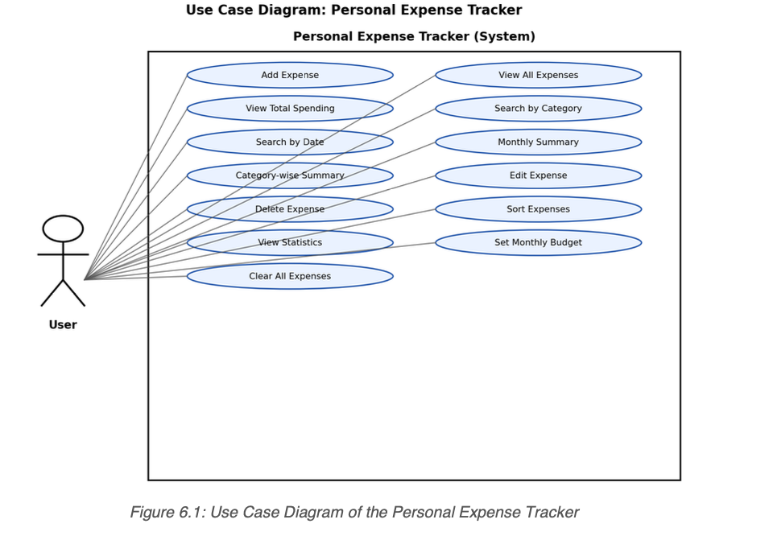

6.2 Workflow Diagram

This flowchart shows the main loop: load whatever was saved before, show the menu, wait for a choice, run that feature, save again, and either go back to the menu or stop if the user picked exit.
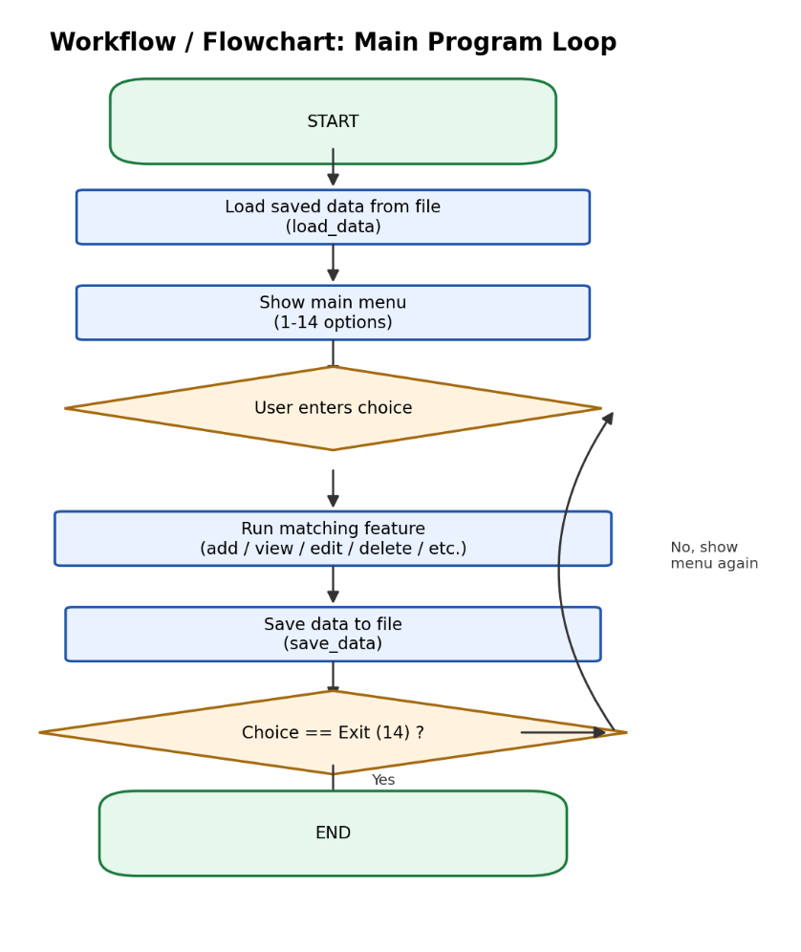
6.3 Sequence Diagram

This one shows what happens step by step when you add a new expense - who talks to who, in
what order. The same rough pattern (validate, update the list, then save) repeats for editing,
deleting and clearing expenses too.
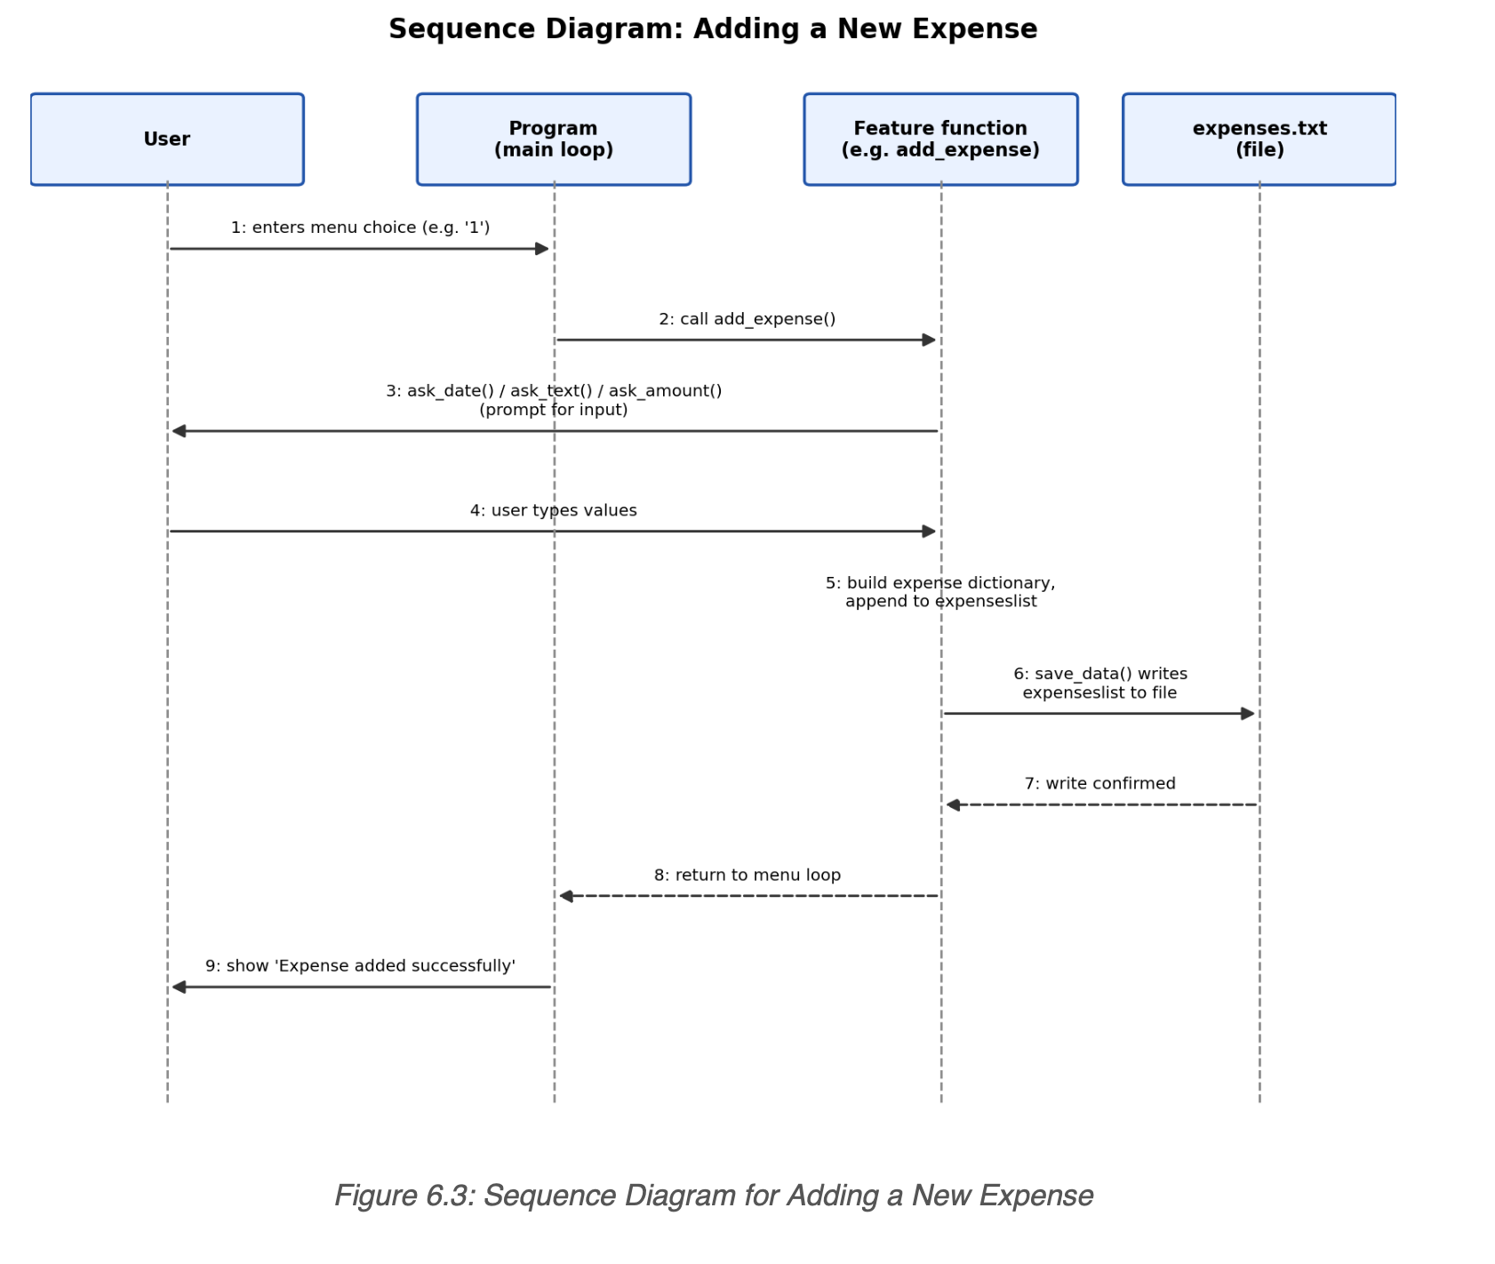

6.4 Class / Component Diagram

I didn't use actual Python classes anywhere in this project - it's all plain functions - but the code
still naturally grouped itself into components, so I drew it the same way a class diagram would be drawn: input helpers, display helpers, storage, the feature functions, and the shared data they all work on.

Figure 6.4: Class / Component Diagram of the Program's Modules
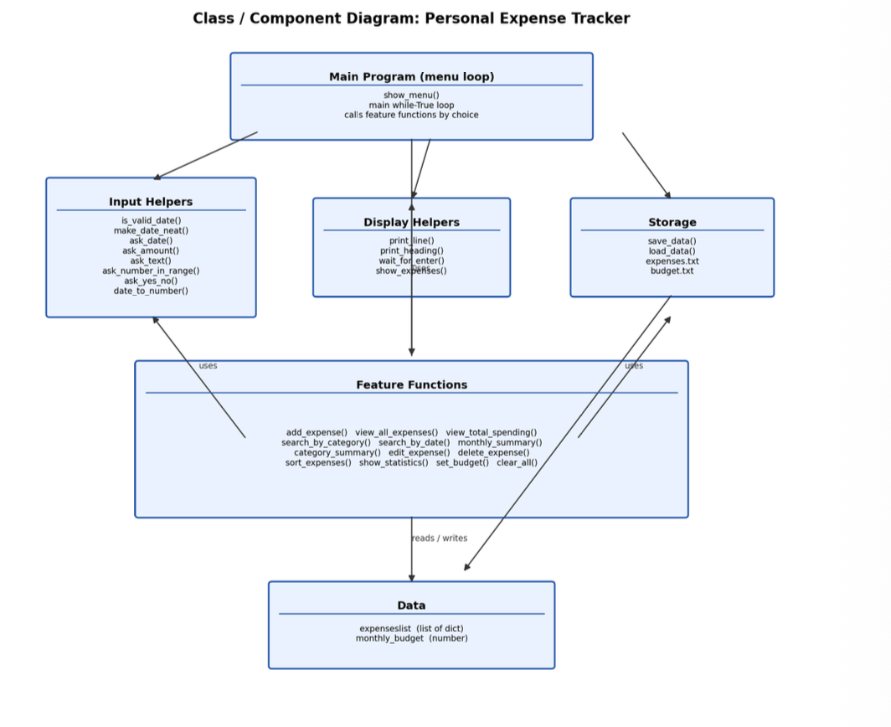

6.5 Data Record Diagram (ER-style)

I'm not using a database, so a real ER diagram with foreign keys between tables doesn't really
apply here. Instead this shows the two records I actually store: one Expense (a single line in
expenses.txt) and one Budget value (in budget.txt), along with the exact text format each line is
saved in.
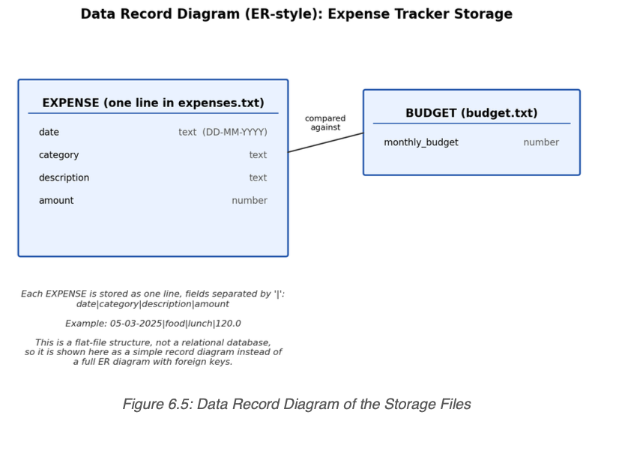
7. Design Decisions and Rationale

A few choices in this project were deliberate trade-offs - I picked simplicity over doing things the "correct" professional way in a few places, and I want to explain why.

7.1 Dictionaries and a list, instead of a class
Each expense is just a plain dictionary with date, category, description and amount as keys - not a proper Expense class. I went with dictionaries mainly because that's what I know best right now, and this project is really about showing I can use lists, dictionaries, loops and functions properly. If I revisit this later, turning each expense into a class would probably be one of the first things I'd
change.

7.2 Plain text file instead of a database
I chose a simple pipe-separated text format (date|category|description|amount) over something
like SQLite. It means I can literally open the file in Notepad and see exactly what's stored, which made debugging so much easier while I was building this. The downside is it's not very robust-I had to specifically handle the case where a description itself contains a "|" character - and it wouldn't scale well to a huge amount of data. For one person's personal expenses though, that’s not really a problem.

7.3 Validation loops instead of letting the program crash
Every input goes through a small "ask" function that keeps looping until it gets something valid. Early on, before I added this, the program would just crash the second you typed a letter where it expected a number, which felt like a really bad experience for something meant to be used daily.

7.4 Bubble sort for the sorting feature
I used a manual bubble sort instead of Python's built-in sorted() function for the sort feature. I
know sorted() would be the better real-world choice, but I wanted to actually write out a sorting algorithm myself with nested loops rather than just calling one line and hoping it's understood.

7.5 Referring to expenses by table position, not a hidden ID
When editing or deleting, you just type the row number you see printed in the table (1, 2, 3...)
rather than some ID you'd have to look up separately. It felt more natural since the number is right there on screen. Behind the scenes I just subtract 1 from whatever number you type, since Python lists start counting from 0 and that tripped me up more than once while testing.
Page 14
8. Implementation Details
The whole thing is one Python script using only the standard library - nothing installed from pip. Here's a look at the tools I used and some of the more important pieces of code.
Aspect | Choice
Programming language | Python 3
Code editor / IDE | Visual Studio Code (VS Code)
Interface | Command-line / console (text-based menu)
Data storage | Plain text files (expenses.txt, budget.txt)
Libraries used | Python standard library only (no external packages)
Core data structures | List of dictionaries (expenseslist), plain variables  (monthly_budget)

8.1 Tools I Used

I did everything in VS Code, mostly because I like being able to run the script straight from the
built-in terminal without switching windows, and the Python extension flags obvious mistakes (like a missing colon) before I even run the file. There's nothing VS Code-specific in the code itself, though - it would run exactly the same way from any other editor or straight from a plain terminal.

8.2 Adding an Expense (Core Logic)
This is the pattern I ended up reusing everywhere: collect validated input, build a dictionary, add it to the list, then save.
def add_expense():
date = ask_date("Enter the date (DD-MM-YYYY): ")
category = ask_text("Enter the category: ").lower()
description = ask_text("Add details: ")
amount = ask_amount("How much did you spend?: ")
expense = {"date": date,
"category": category,
"description": description,
"amount": amount,} expenseslist.append(expense)
save_data()
print("Expense added successfully!")
check_budget(date)

8.3 Saving Data to a Text File
Each expense gets written out as one line, with its four fields joined by a "|" character, which I later split on again when reading the file back in.
def save_data():
file = open(DATA_FILE, "w")
for item in expenseslist:
clean_description = item["description"].replace("|", "-")
line = (item["date"] + "|" + item["category"] + "|" +
clean_description + "|" + str(item["amount"]))
file.write(line + "\n")
file.close()

8.4 Validating a Date

I validated dates manually using string splitting and isdigit(), instead of pulling in the datetime
module, just so the logic stayed visible rather than hidden behind a library call.

def is_valid_date(text):
parts = text.split("-")
if len(parts) != 3:
return False
day, month, year = parts[0], parts[1], parts[2]
if not (day.isdigit() and month.isdigit() and year.isdigit()):
return False
if len(year) != 4:
return False
if int(day) < 1 or int(day) > 31:
return False
if int(month) < 1 or int(month) > 12:
return False
return True

8.5 Viewing All Expenses

This show_expenses() helper gets reused in a few places - viewing everything, search results, sort results - so I only had to write the table-printing logic once.

def show_expenses(list_to_show):
if len(list_to_show) == 0:
print("No expenses to show.")
return
print(“No.".l just(5) + “Date".l just(13) + “Category".l just(13)
+ “Details".l just(20) + "Amount")
total = 0
count = 1
for item in list_to_show:
print(str(count).l just(5) + item[“date"].ljust(13)
+ item[“category"].l just(13) + item["description"].ljust(20)
+ str(item["amount"]))
total = total + item["amount"]
count = count + 1
print("Total of these expenses =", round(total, 2))

8.6 Searching by Category

Nothing fancy here - just a fresh empty list, and a loop that copies over anything whose category matches what was typed.

def search_by_category():
name = ask_text("Which category do you want to see? ").lower()
found = []
for item in expenseslist:
if item["category"] == name:
found.append(item)
if len(found) == 0:
print("No expenses found in category:", name)
else:
show_expenses(found)

8.7 Monthly and Category Summaries

I used two lists side by side here (one for the group name, one for its running total) instead of
anything fancier, just to keep the logic something I could explain out loud without hesitating.

def monthly_summary():
months = []
month_totals = []
for item in expenseslist:
month = item["date"][3:] # "MM-YYYY" part of the date
if month in months:
position = months.index(month)
month_totals[position] += item["amount"]
else:
months.append(month)
month_totals.append(item["amount"])
for i in range(len(months)):
print(months[i], ":", round(month_totals[i], 2))

8.8 Editing an Expense

Editing shows the table first so you can pick a row number, then re-asks each field, keeping the
old value if you just hit Enter without typing anything.

def edit_expense():
show_expenses(expenseslist)
number = ask_number_in_range("Which number to edit? ", 1, len(expenseslist))
item = expenseslist[number - 1]
new_amount = input("Amount [" + str(item["amount"]) + "]: ")
if new_amount != "":
item["amount"] = float(new_amount)
# ... the same pattern repeats for date, category and description
save_data()

8.9 Deleting an Expense (with Confirmation)

I added the yes/no confirmation here after almost losing a test entry by accident while debugging -
it just felt safer to double-check before actually removing anything.

def delete_expense():
show_expenses(expenseslist)
number = ask_number_in_range("Which number to delete? ", 1, len(expenseslist))
item = expenseslist[number - 1]
if ask_yes_no("Are you sure you want to delete it?"):
expenseslist.pop(number - 1)
save_data()
print("Expense deleted.")
else:
print("Okay, nothing was deleted.”)

8.10 Sorting with Bubble Sort

I copy the list first so the original order (the one that actually gets saved) doesn't get disturbed,
then compare neighbours and swap them if they're in the wrong order.

sorted_list = expenseslist[:]
size = len(sorted_list)
for i in range(size):
for j in range(size - 1 - i):
first = sorted_list[j]
second = sorted_list[j + 1]
if first["amount"] > second["amount"]: # ascending by amount
sorted_list[j] = second
sorted_list[j + 1] = first

8.11 Budget Warning Check

This runs right after adding a new expense - it adds up that month's spending again and compares it to the budget I set.

def check_budget(date):
if monthly_budget == 0:
return
month = date[3:]
month_total = 0
for item in expenseslist:
if item["date"][3:] == month:
month_total += item["amount"]
if month_total > monthly_budget:
print("WARNING: You crossed your budget for", month,
"by", round(month_total - monthly_budget, 2))
elif month_total >= monthly_budget * 0.8:
print("Careful! You used 80% or more of your budget for", month)

9. Screenshots / Results

These are actual screenshots from running the program on my machine - the main menu, the full expense table, and the category summary together with the statistics screen.
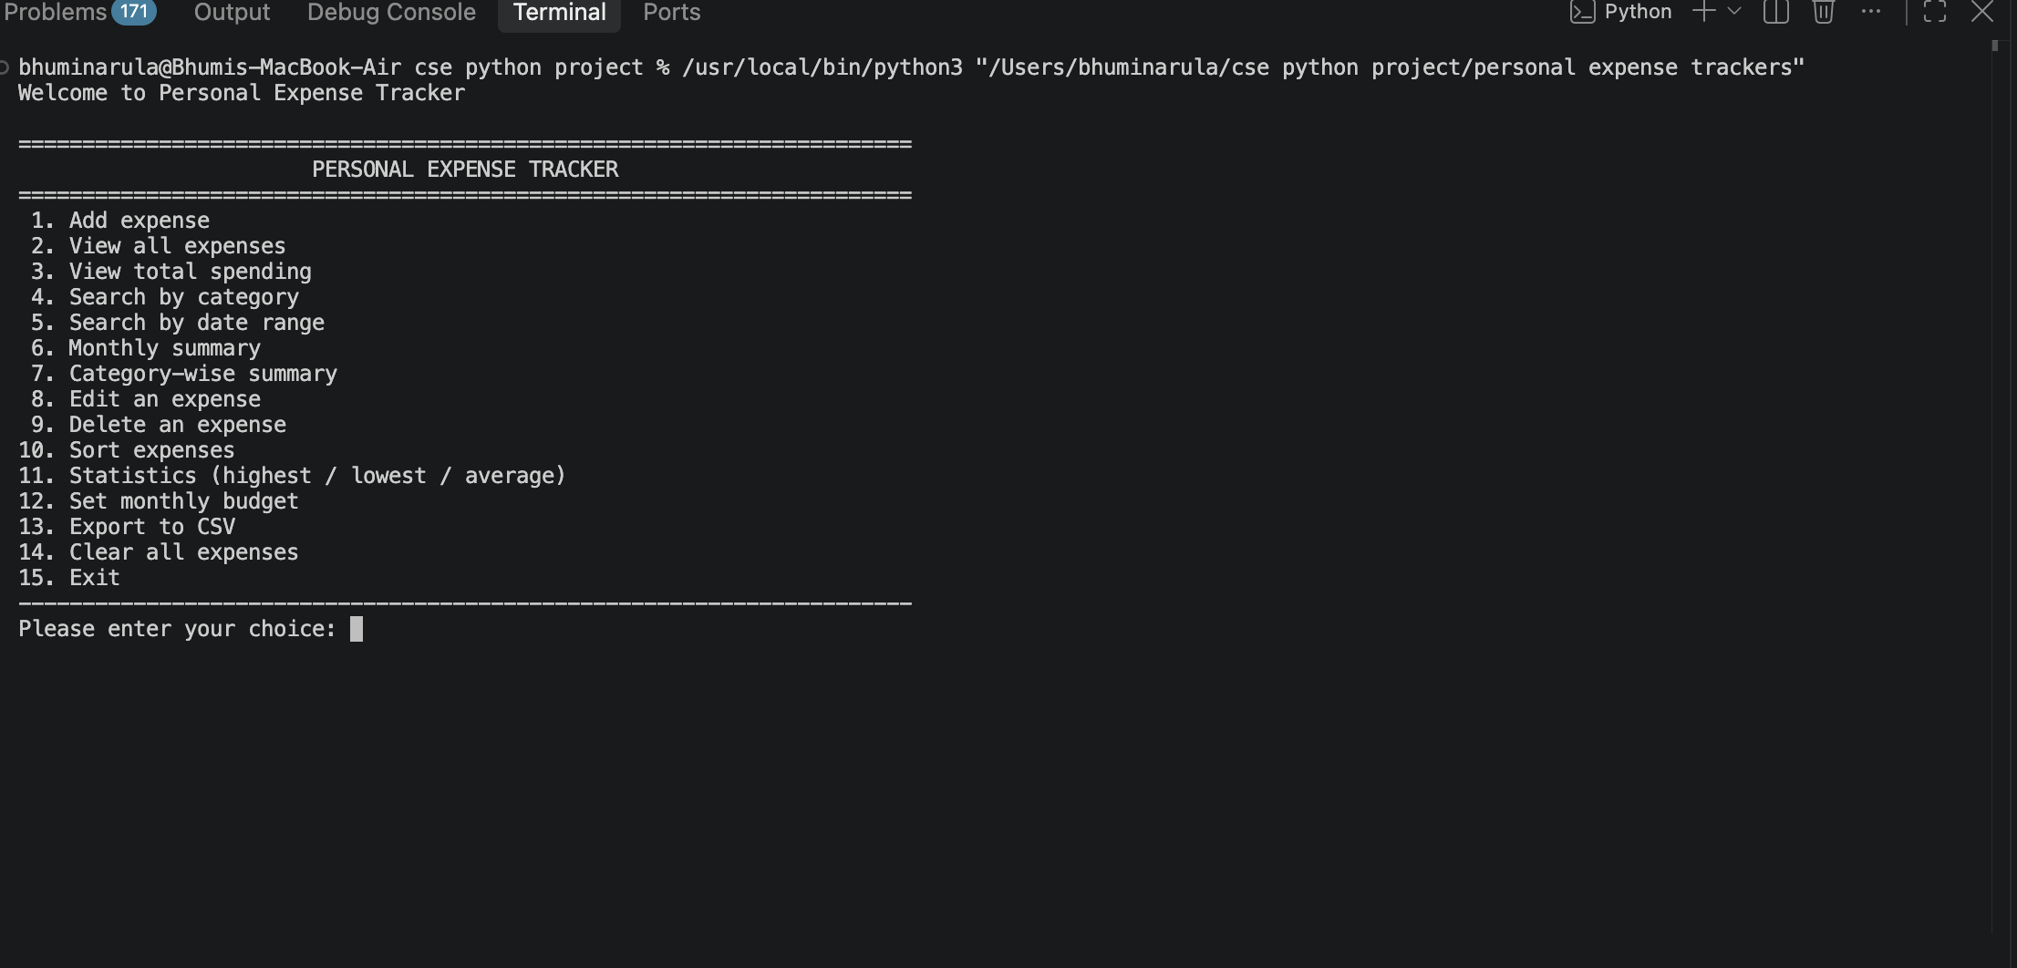
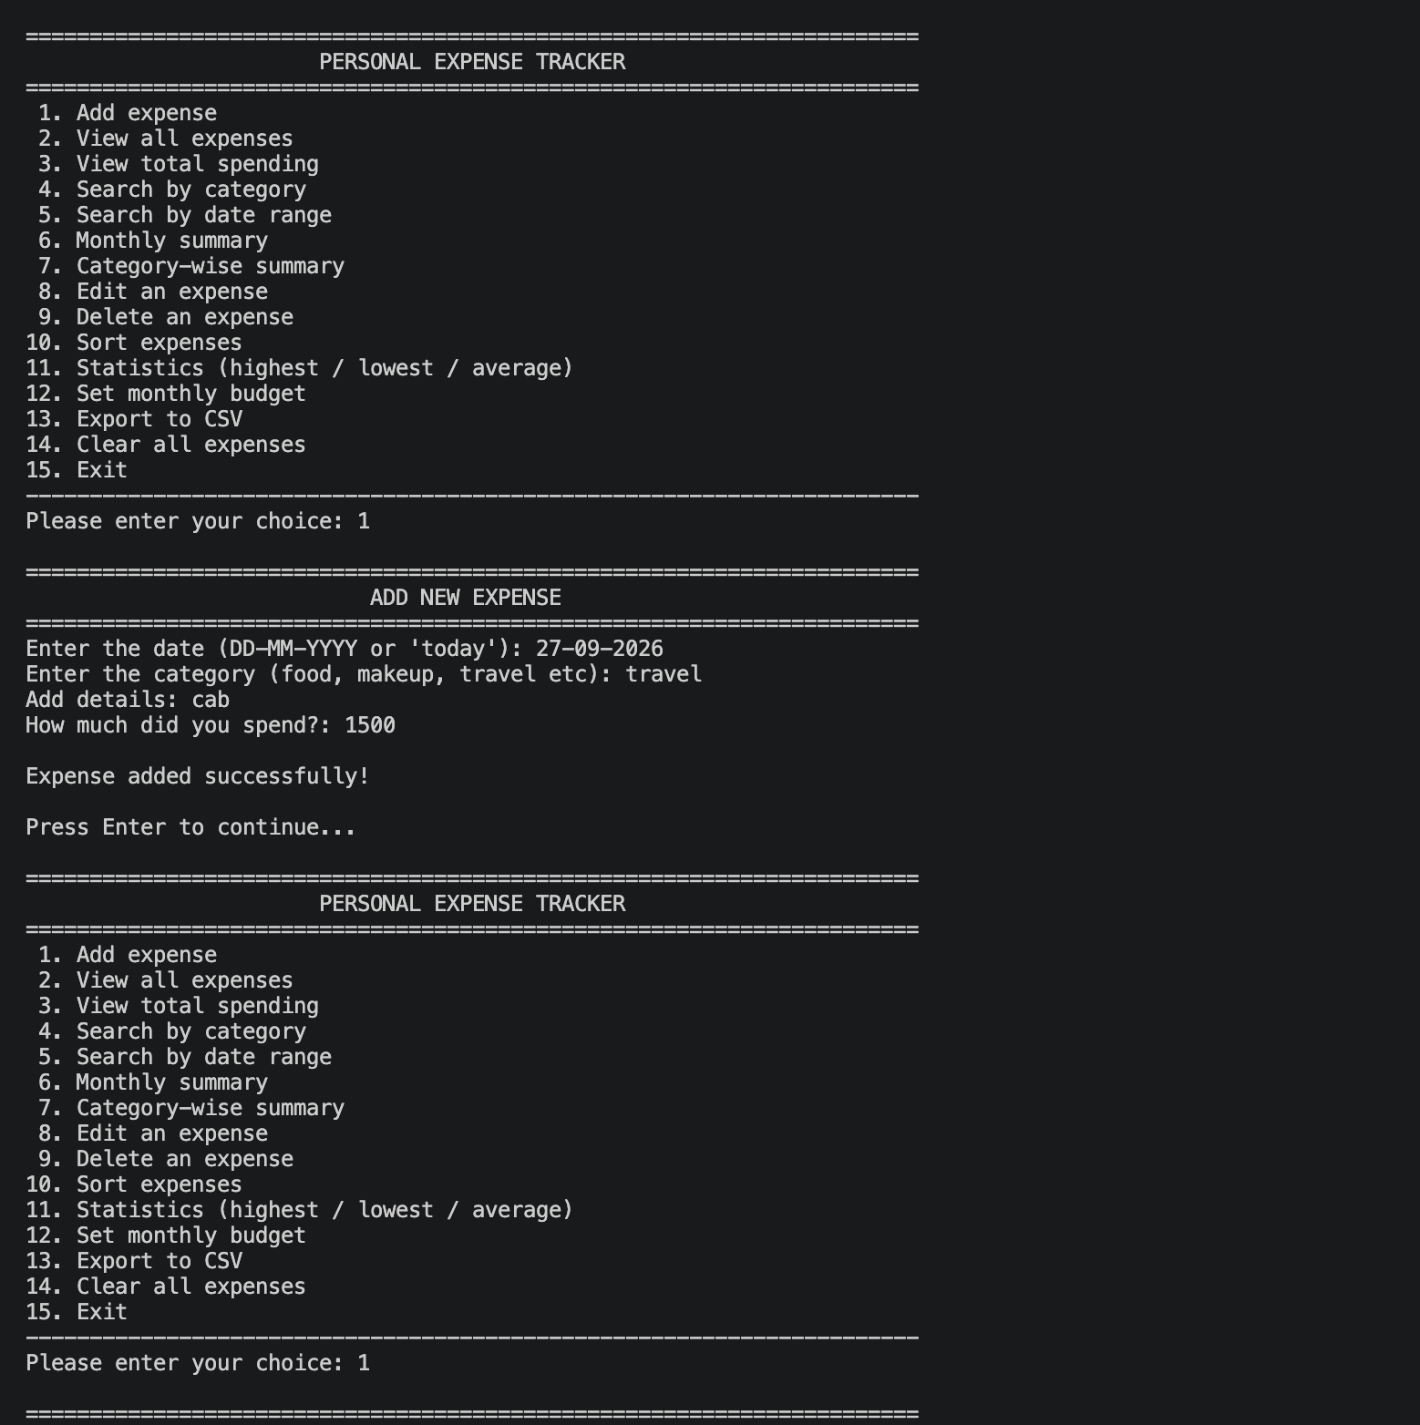
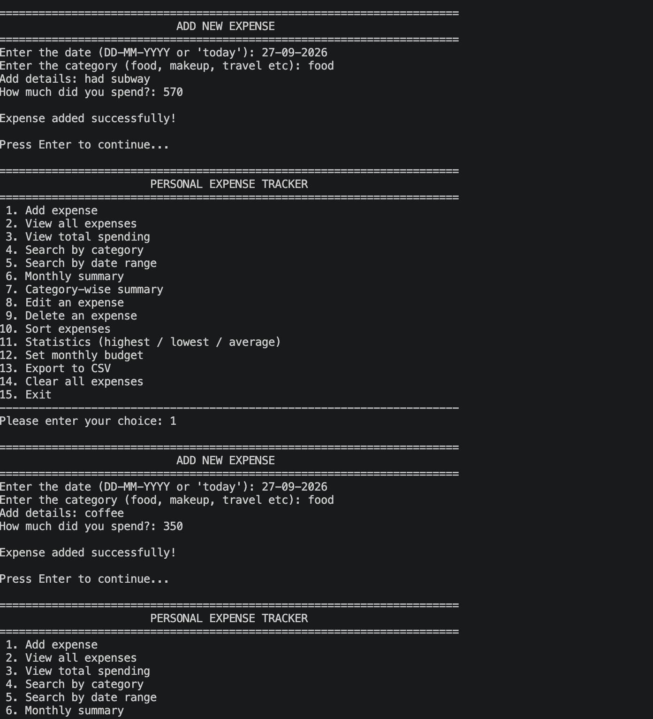
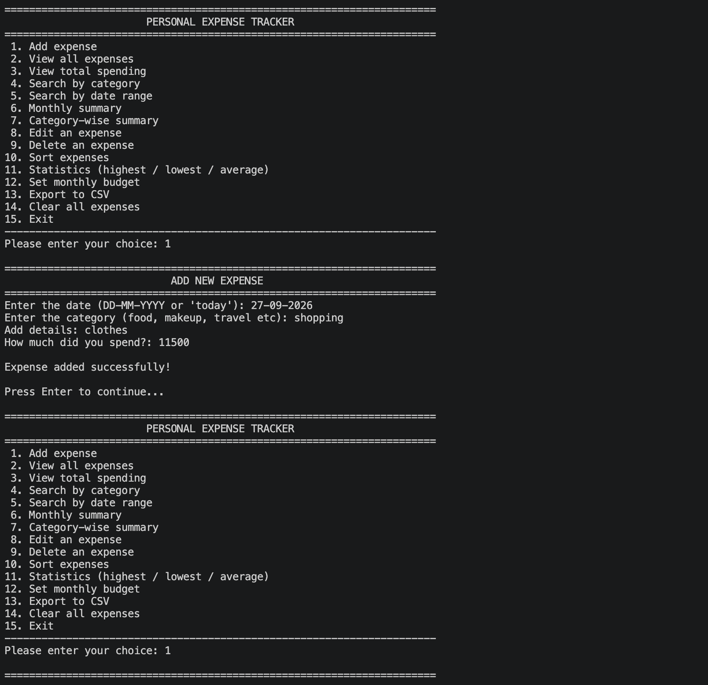
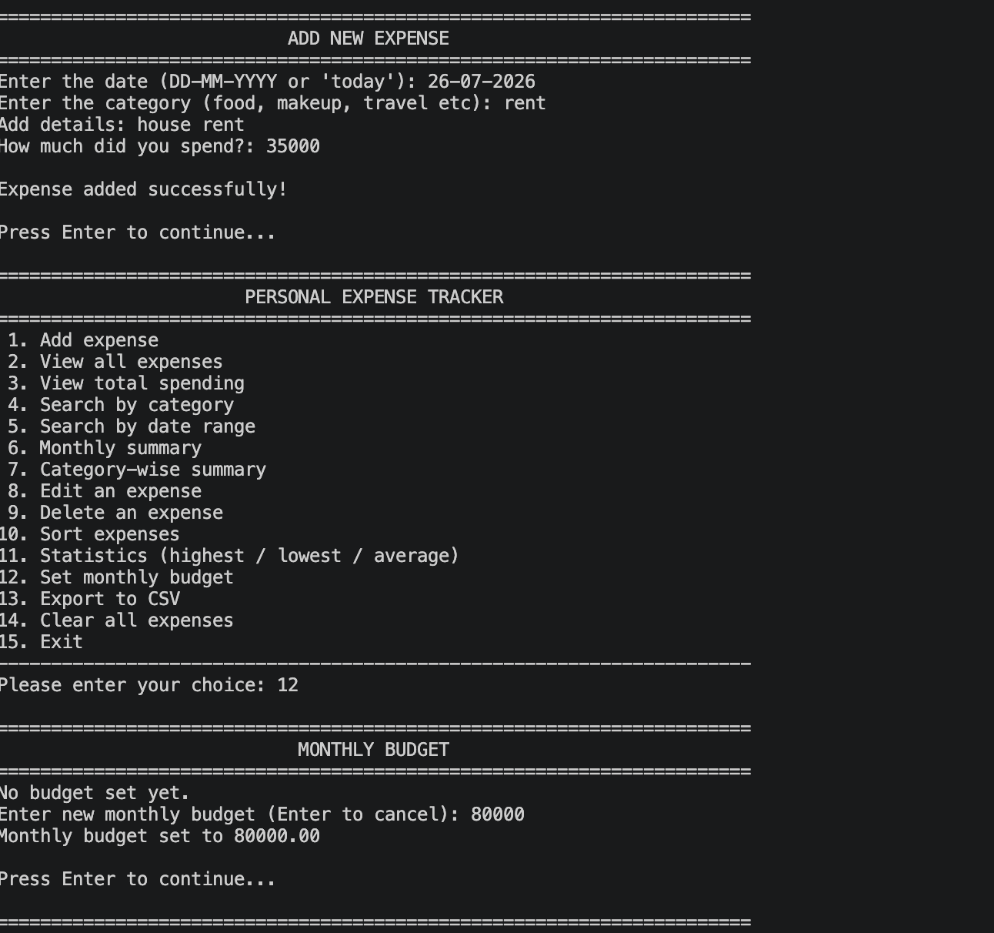
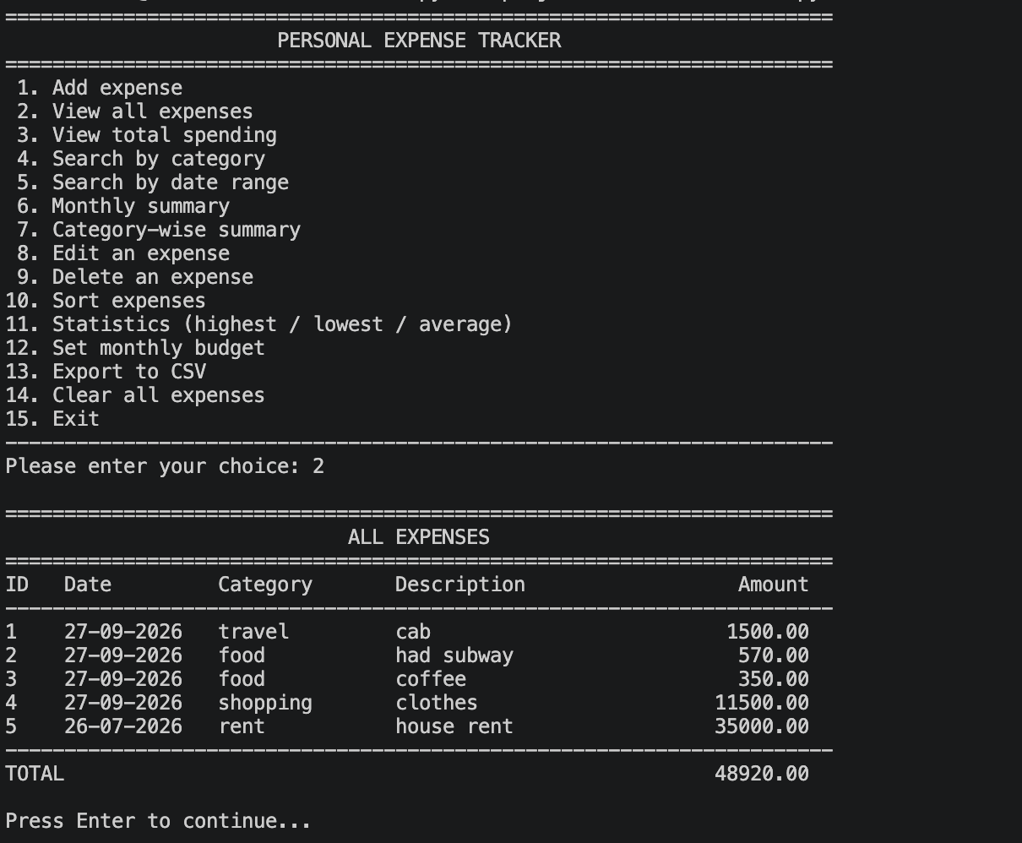
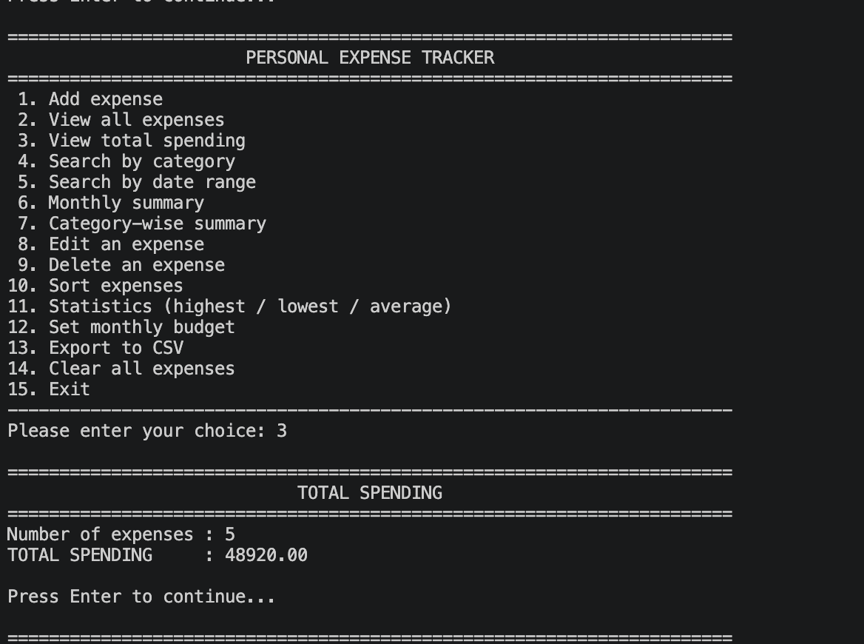
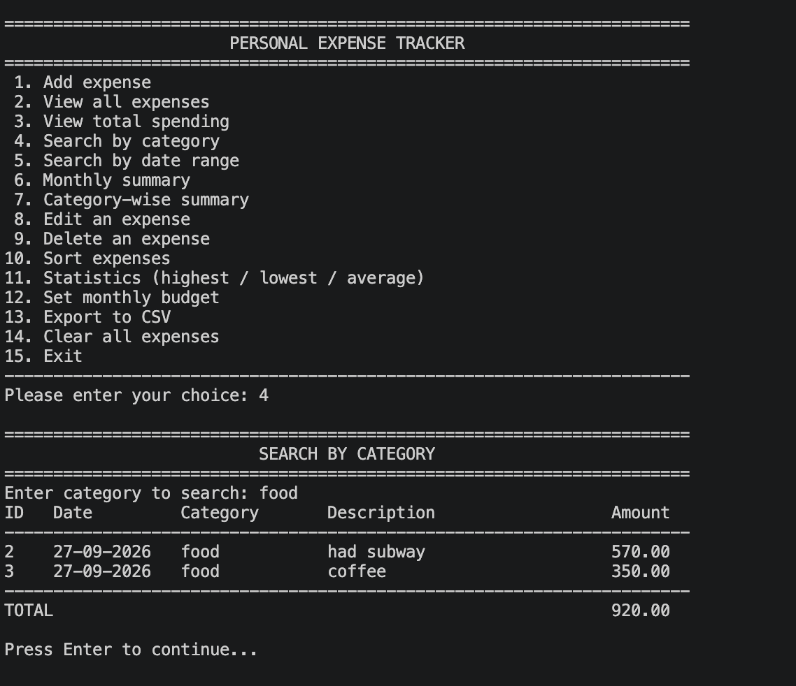
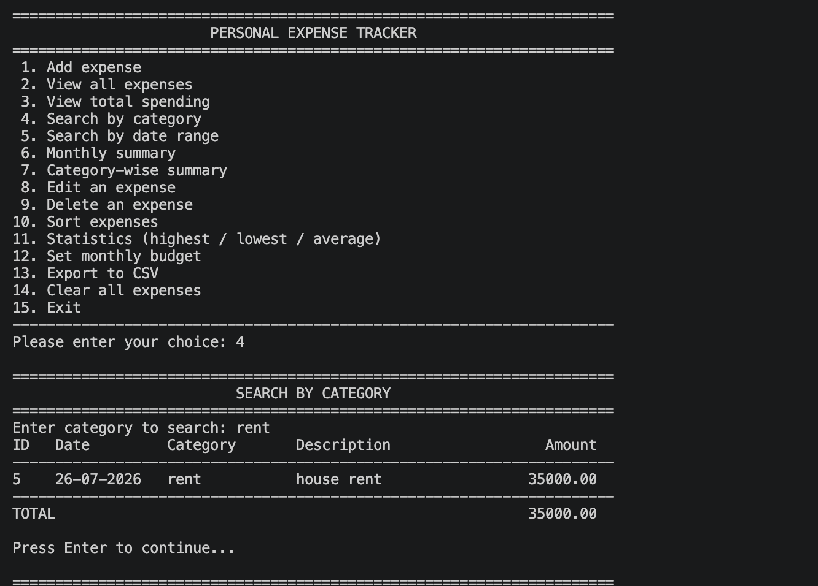
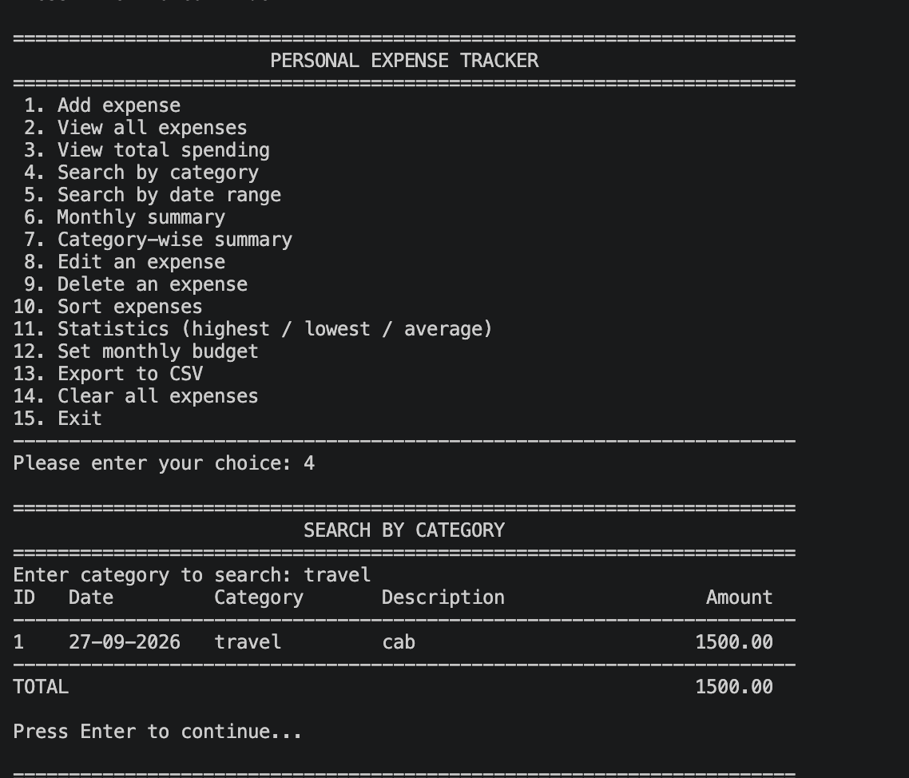
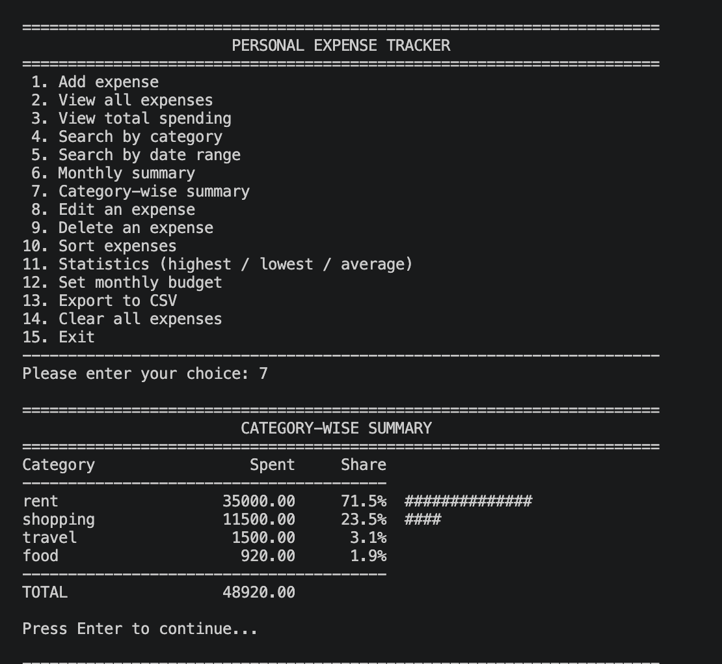
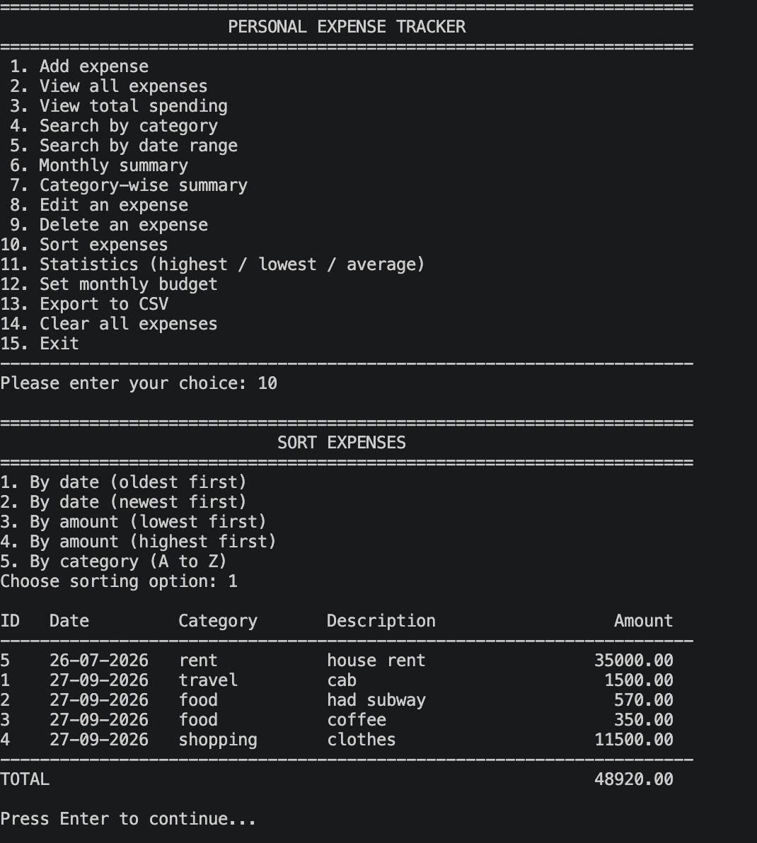
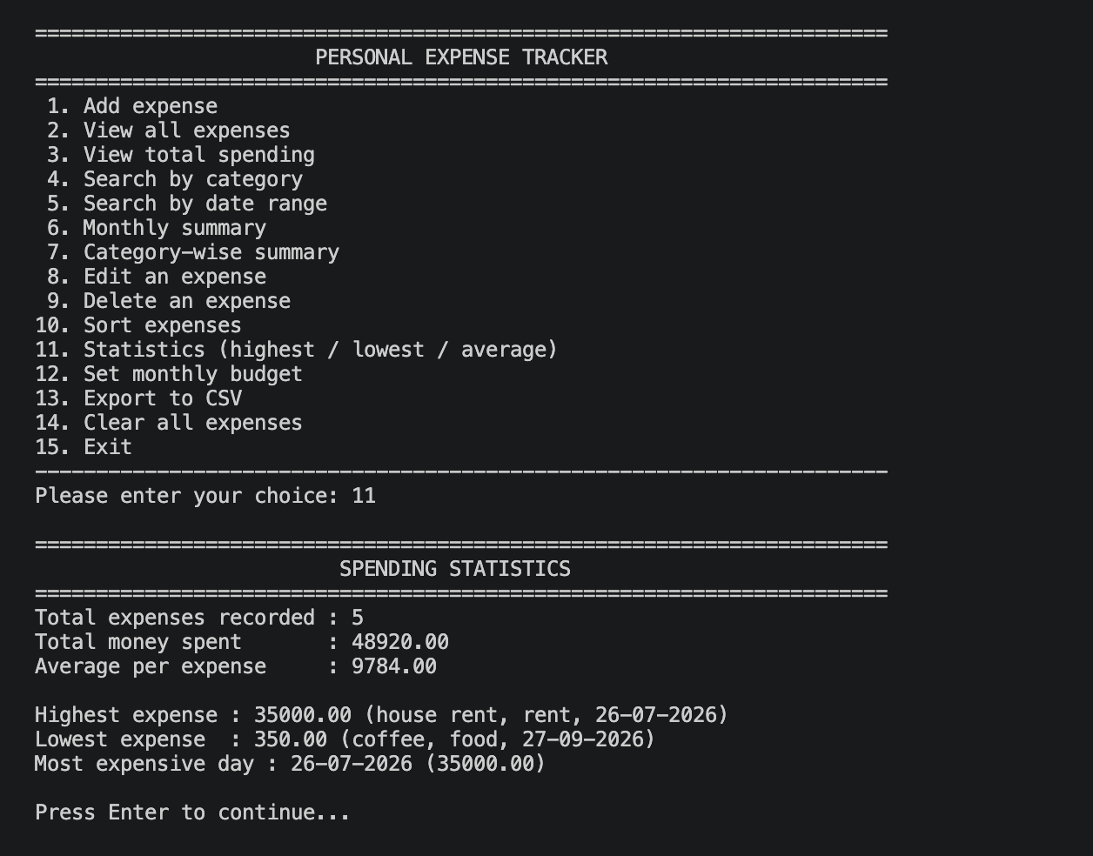
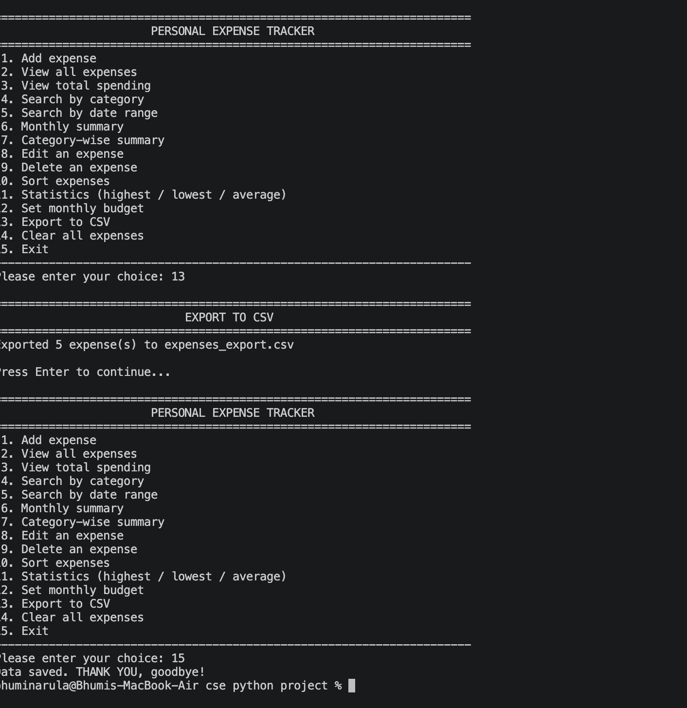
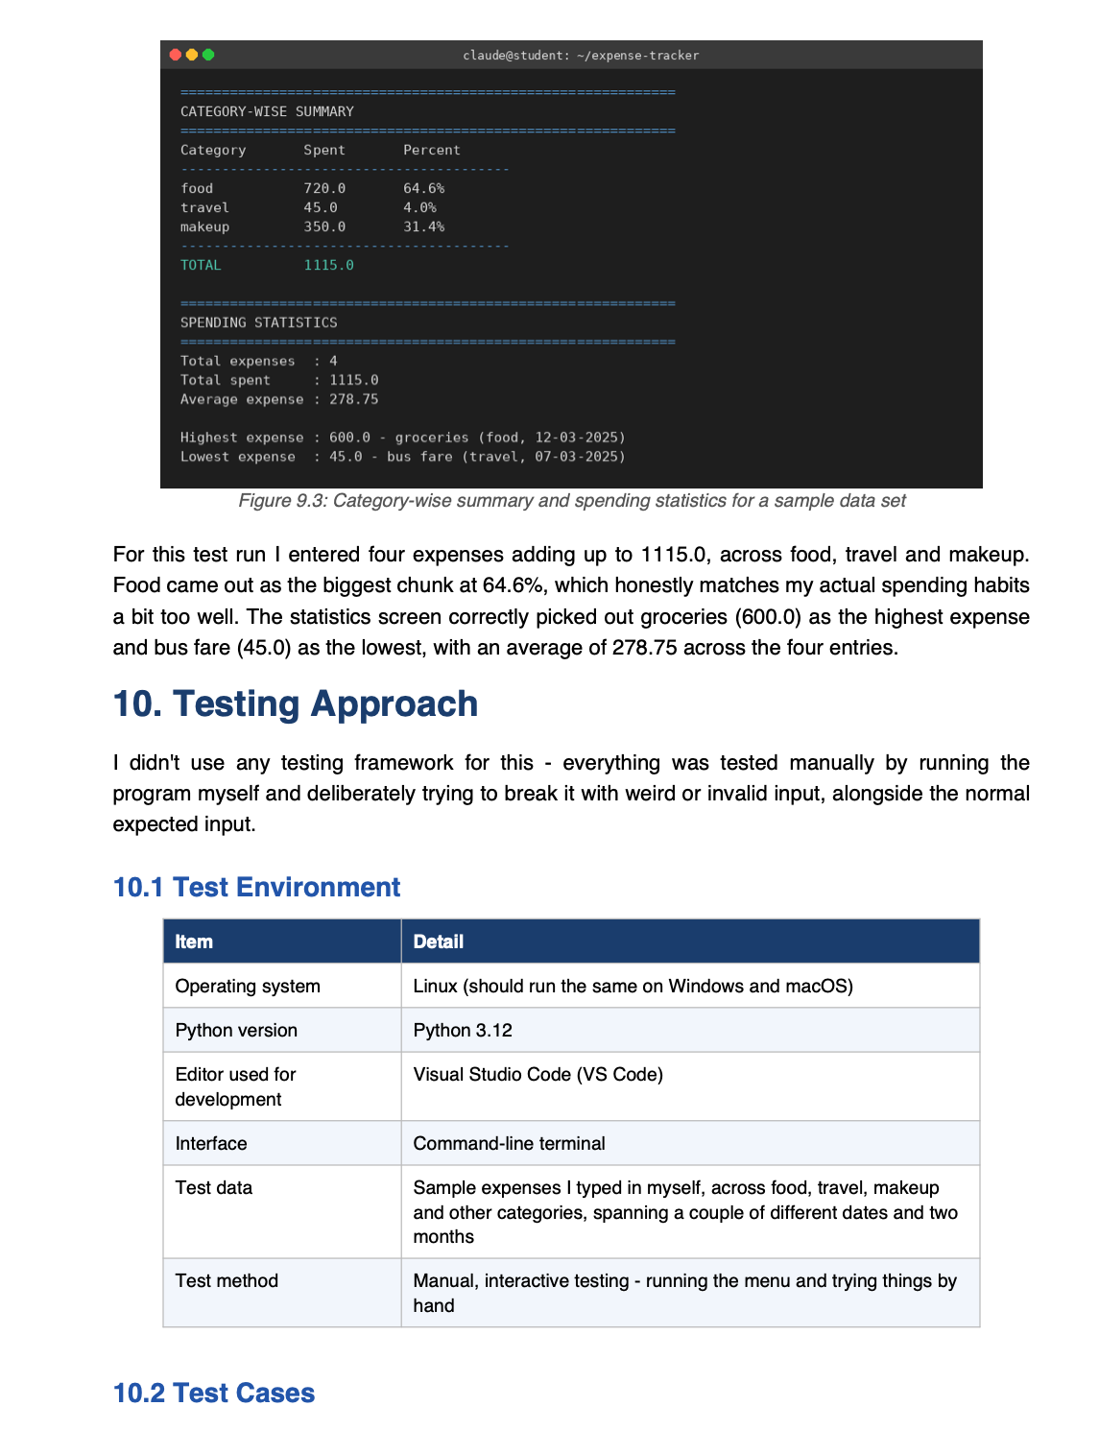
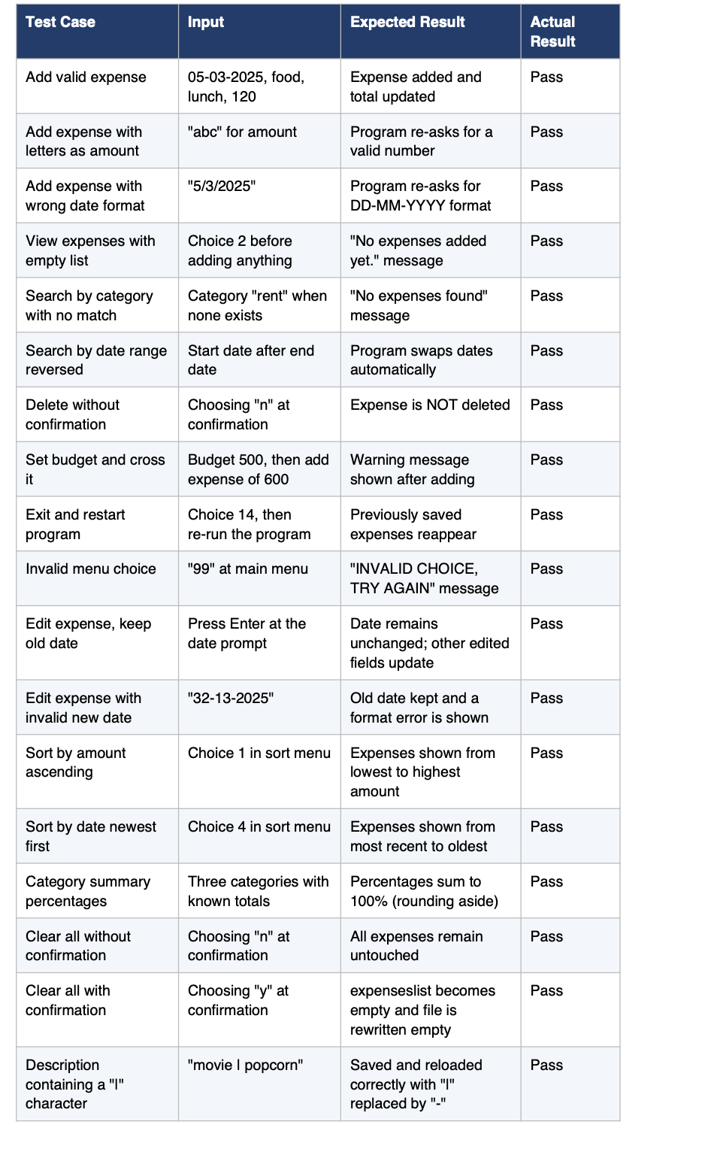
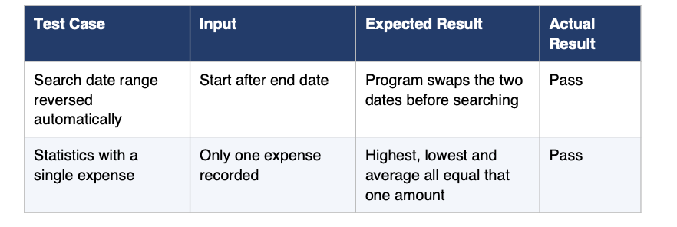
Everyone of these passed, though it wasn't first try for all of them - a few (especially the date
range swap and the "|" character in the description) only worked properly after I found the bug through testing and went back to fix it. That's honestly the biggest reason I'd recommend testing this deliberately with bad input, not just the normal expected stuff.

10.3 How I Actually Worked Through This

I didn't build this in one sitting or in the neat order the sections above suggest - it was more back-and-forth than that. Still, roughly, this is how it went:
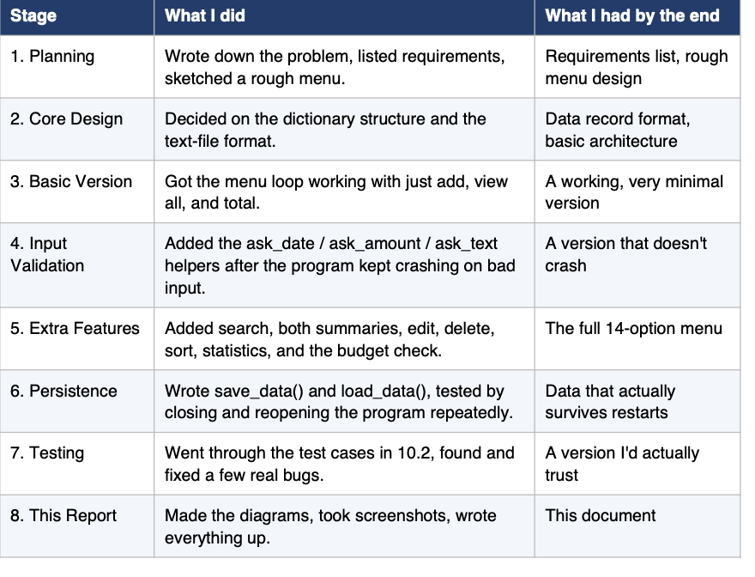

11. Challenges Faced

- Validating dates without a library: Doing this by hand with string splitting and isdigit() meant I had to think carefully about single-digit days and months (like "5-3-2025") so they'd still be accepted and then shown consistently as “05-03-2025”.

- Comparing dates for sorting and range search: Since dates are just text, I couldn't compare them directly with < or >. I had to write a small function that turns a date into one sortable number (like 20250305) before comparing.

• Keeping the file format from breaking: Because I separate fields with "|", a description that
itself contains a "|" would mess up the whole line when reading it back. I only caught this by
accident while testing, and fixed it by swapping any "|" in the description for a "-" before saving.

• Stopping the program from crashing on bad input: Earlier versions of this crashed the
instant you typed a letter where a number was expected. Wrapping every input request in a
validation loop fixed that, but it took a few rounds of testing to catch every spot this could
happen.

• Writing bubble sort correctly: Getting the swap condition right for all four sort options
(ascending/descending, amount/date) took more attempts than I'd like to admit - it's an easy
algorithm to get almost right and still wrong.

• Keeping the menu readable: With 14 options, fitting everything on a plain console screen
without it looking cluttered took a few rounds of just tweaking spacing and wording.

12. Learnings and Key Takeaways

- Got a lot more comfortable using lists of dictionaries to model structured records - it clicked for me here in a way it hadn't in smaller practice exercises.

- Understood, properly, why input validation loops matter in anything interactive - not just as a rule I was told, but because I watched my own program crash without them.

- Learned to work with plain text files for saving data, including the annoying edge case of a separator character showing up inside the data itself.

- Got better at breaking a growing program into small, single-purpose functions - this project would have been unmanageable as one giant block of code by the end.

• Actually implemented bubble sort myself instead of just reading about it, which made the
nested-loop logic finally make sense.

• Learned that thinking through requirements and diagrams before coding saves a lot of
backtracking later - I skipped this at first and regretted it a little.

- Realised how much testing with bad input on purpose actually matters, since almost every bug I found came from typing something weird rather than the normal expected case.

13. Future Enhancements

This version covers everything I set out to build, but there's a fair bit I'd add if I kept working on it.
• Charts: Bar or pie charts (probably with matplotlib) instead of just text tables for monthly and category spending.
• A real database: Swapping the text files for something like SQLite, which would make
searching faster and the storage more robust.
• Recurring expenses: Being able to mark something like rent as recurring so I don't have to
type it in every single month.
• Multiple users: A basic login system so more than one person could use it with separate
histories.
• Multiple currencies or accounts: Tracking cash, card, and wallet spending separately, or in
different currencies.
• An actual interface: Rebuilding the front end with something like Tkinter, or even a small web app, so it's not just a terminal tool.
• Automated tests: Using something like pytest instead of manually running through my
test-case list every time I change something.
- Export and import: Exporting to CSV or PDF to share, and maybe importing a bank statement CSV so I don't have to type everything by hand.

14. References

1 Python Software Foundation. The Python Standard Library. https://docs.python.org/3/library/
2 Python Software Foundation. Built-in Types - Python 3 Documentation (lists, dictionaries,
strings). https://docs.python.org/3/library/stdtypes.html
3 Python Software Foundation. Input and Output - Python Tutorial (reading and writing files). https://docs.python.org/3/tutorial/inputoutput.html
4 GeeksforGeeks. Bubble Sort Algorithm. https://www.geeksforgeeks.org/bubble-sort/
5 GeeksforGeeks. Python Dictionary. https://www.geeksforgeeks.org/python-dictionary/
6 W3Schools. Python File Handling.
https://www.w3schools.com/python/python_file_handling.asp
7 Visual Studio Code Docs. Python in Visual Studio Code.
https://code.visualstudio.com/docs/languages/python
8 Class lecture notes and lab exercises on Python fundamentals, from my course.

Appendix A: Complete Source Code Listing

This is the full source code exactly as I wrote it, split into labelled parts matching the components I described back in Section 5.
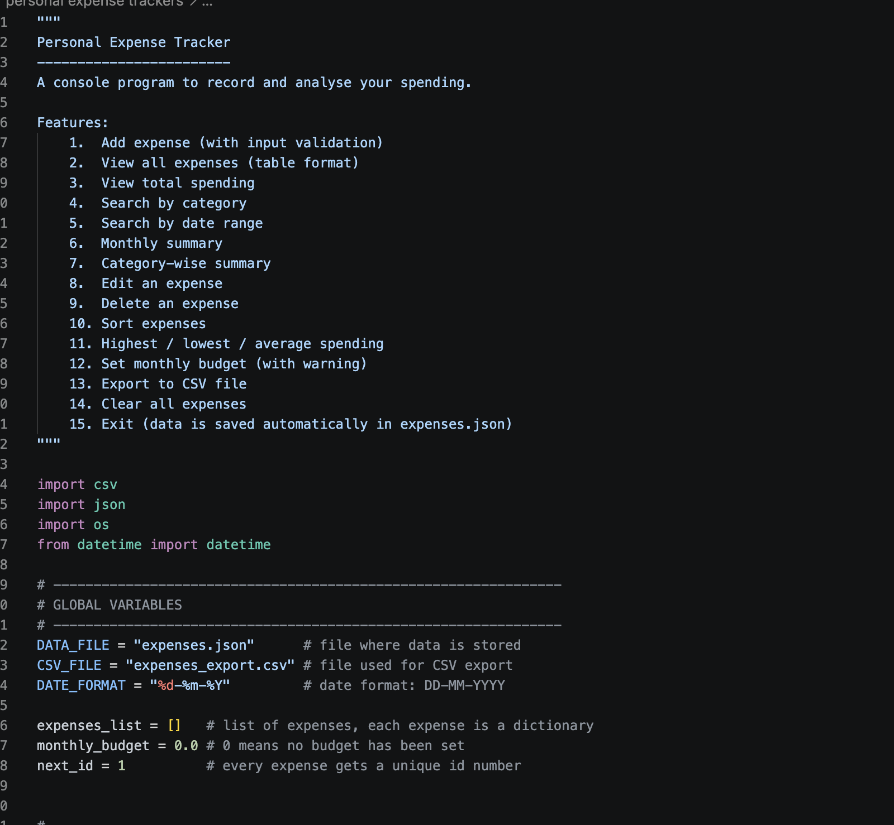
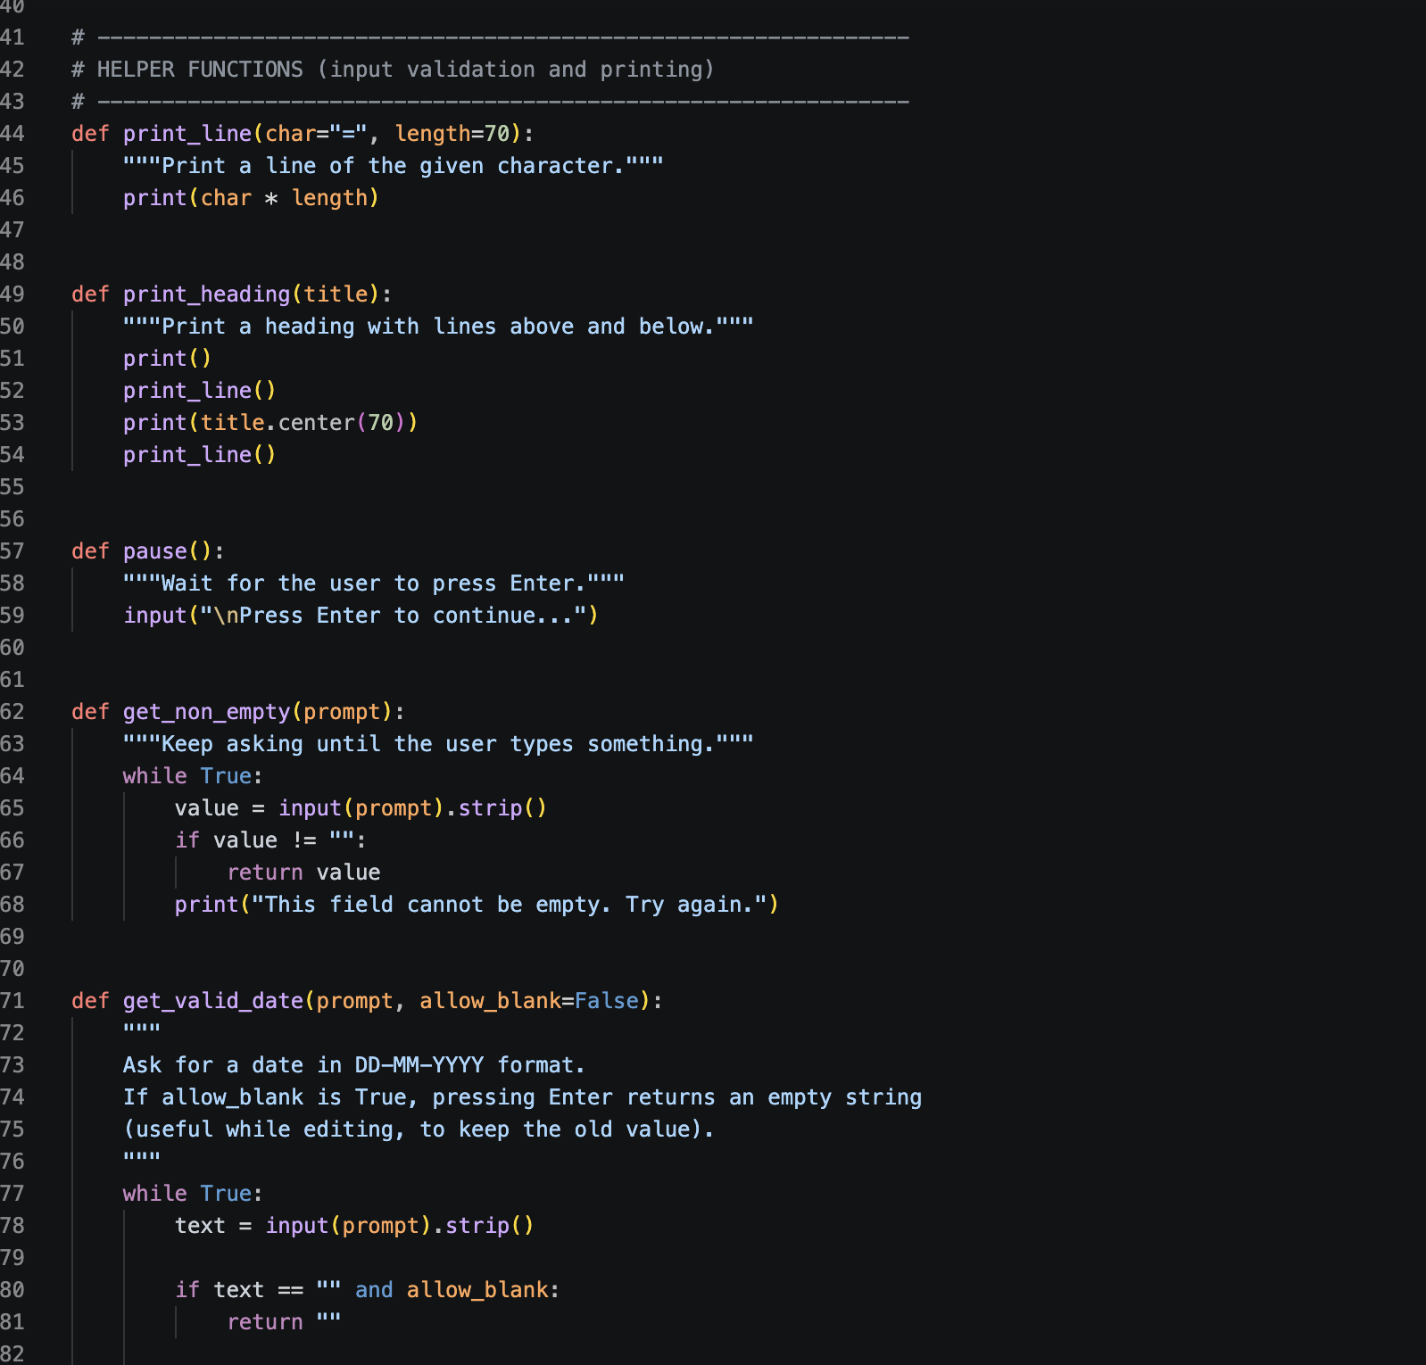
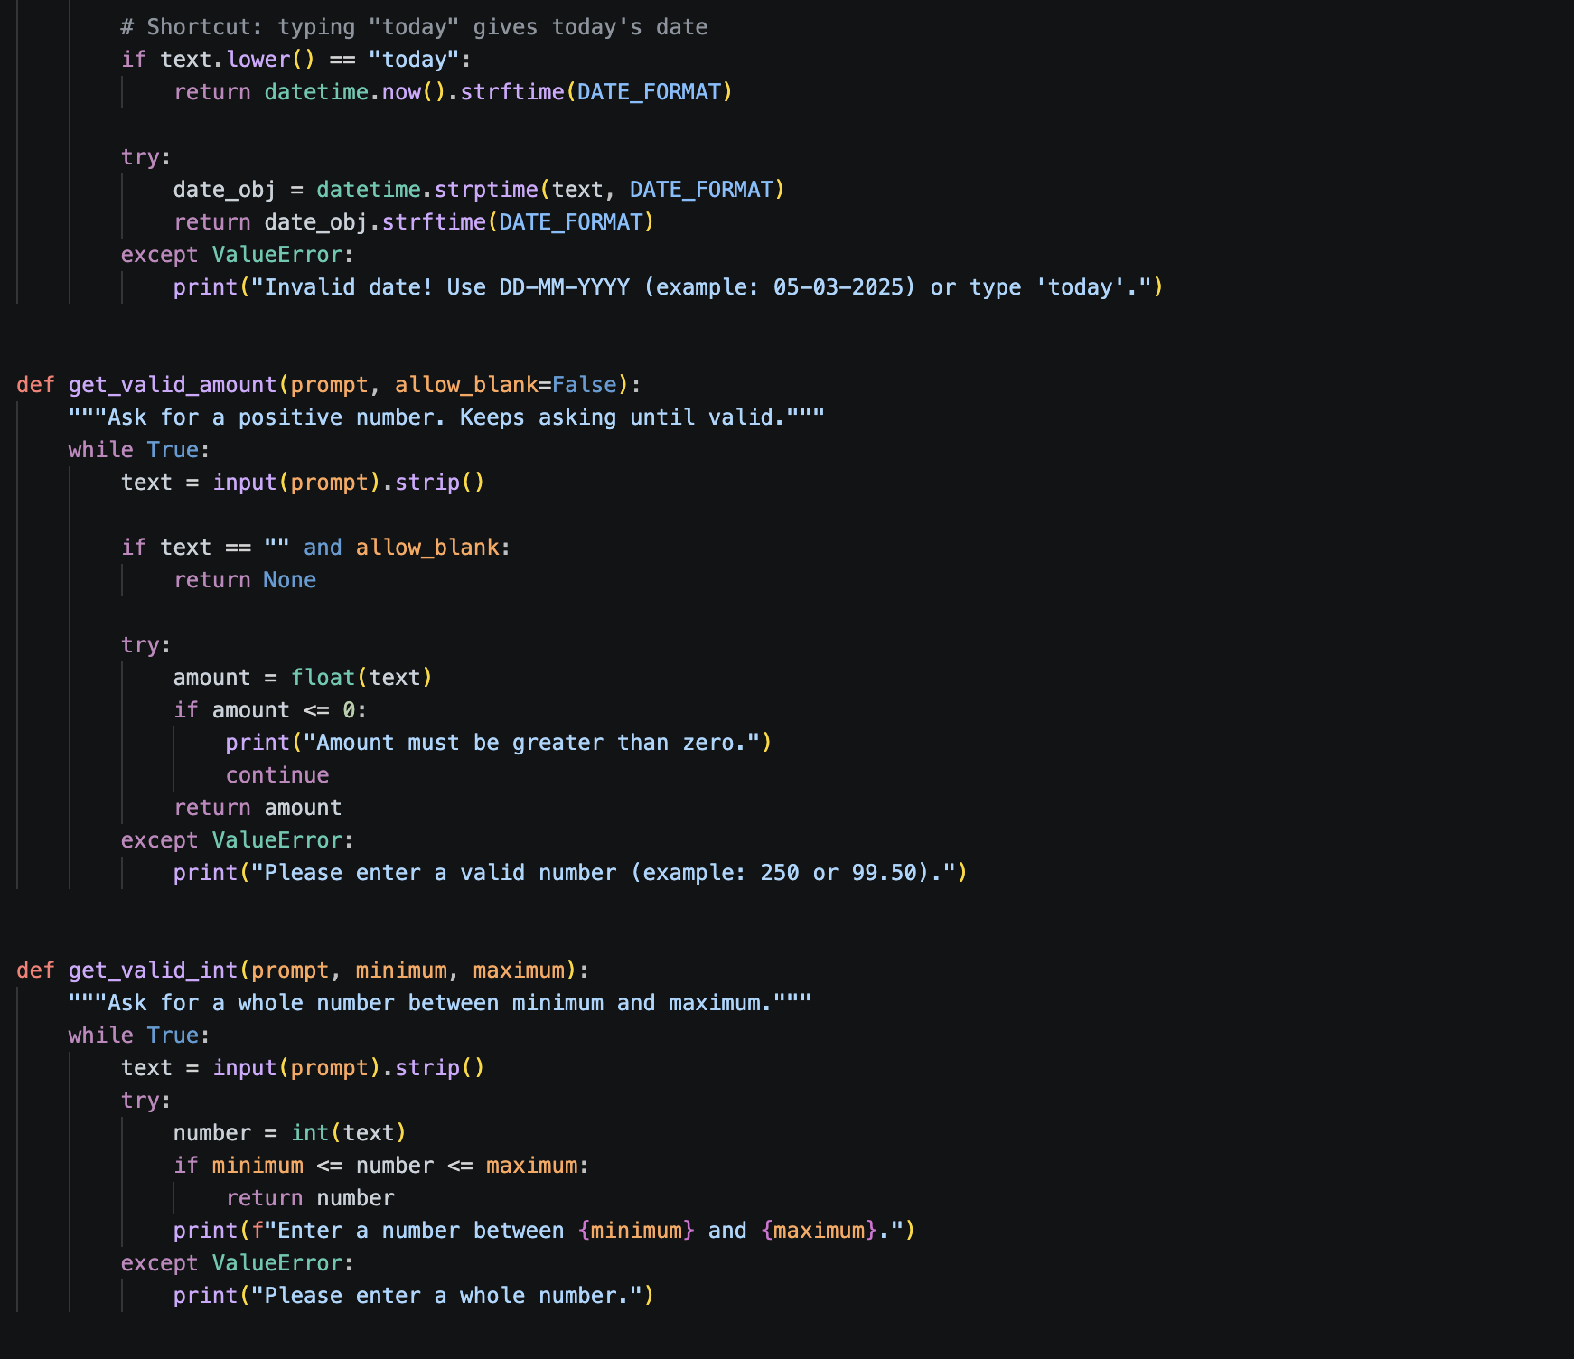
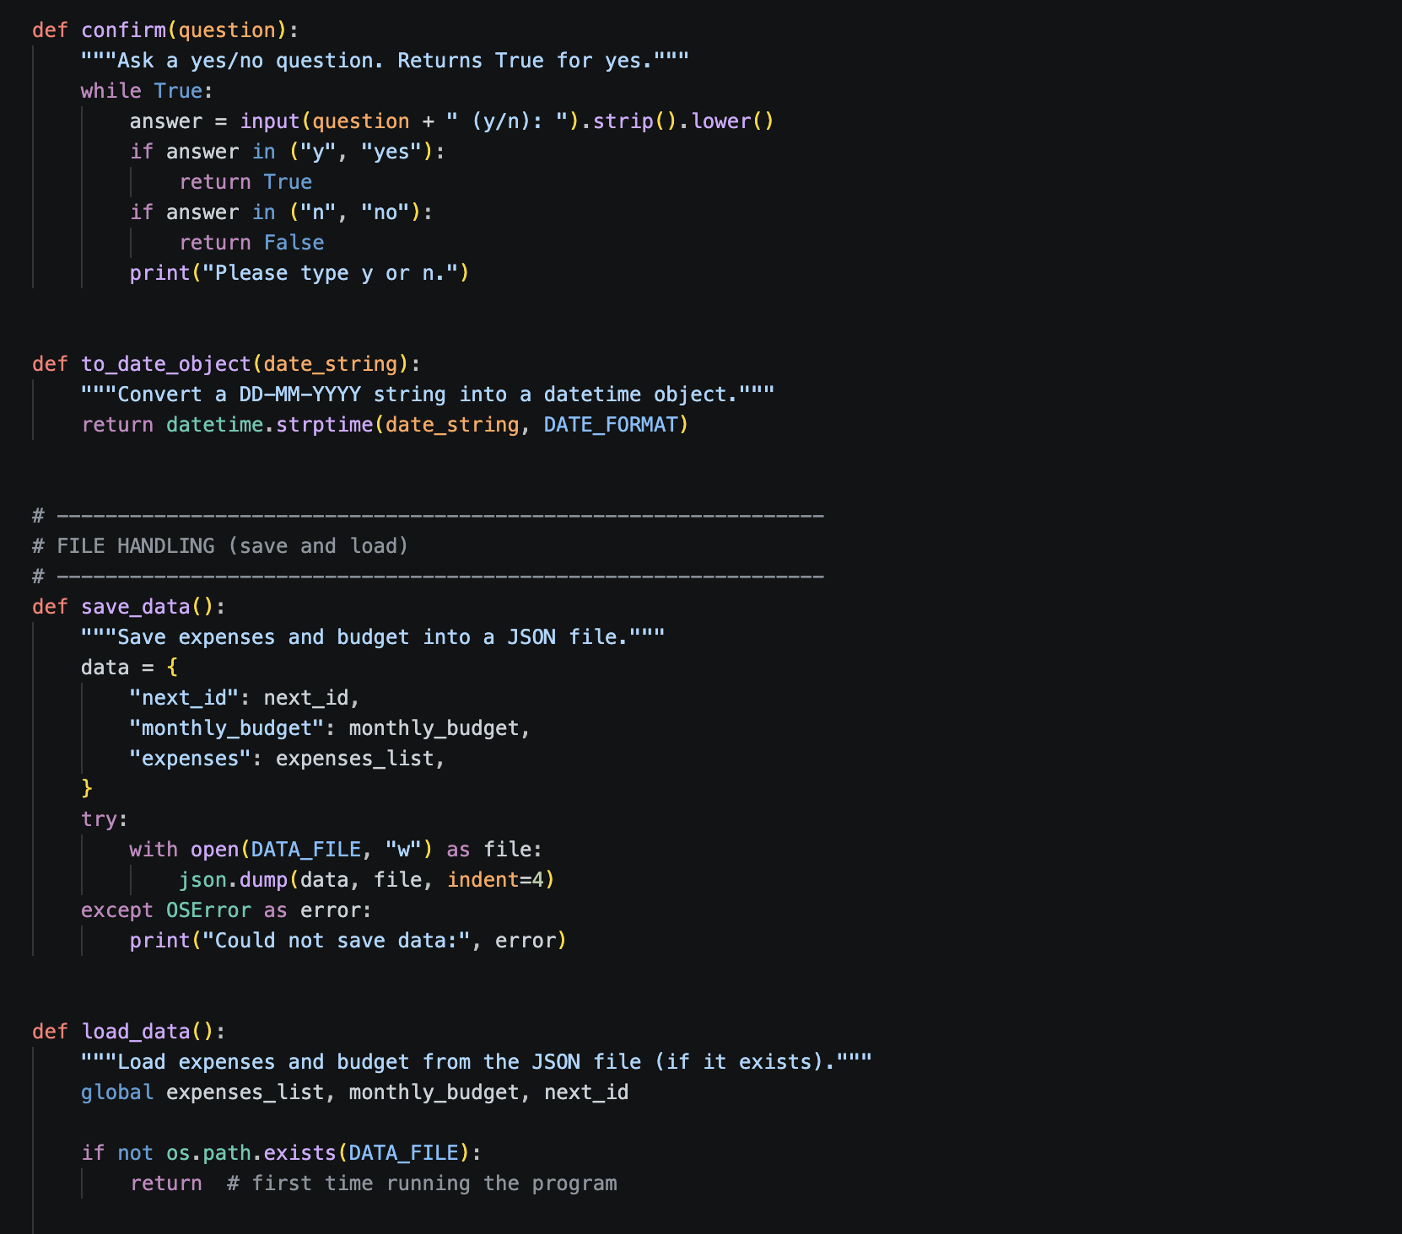
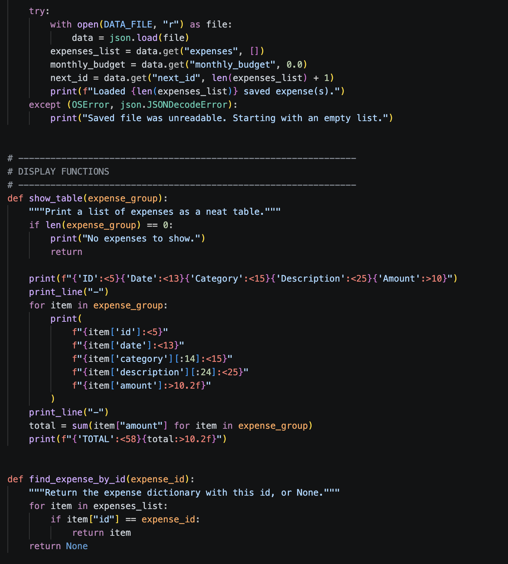
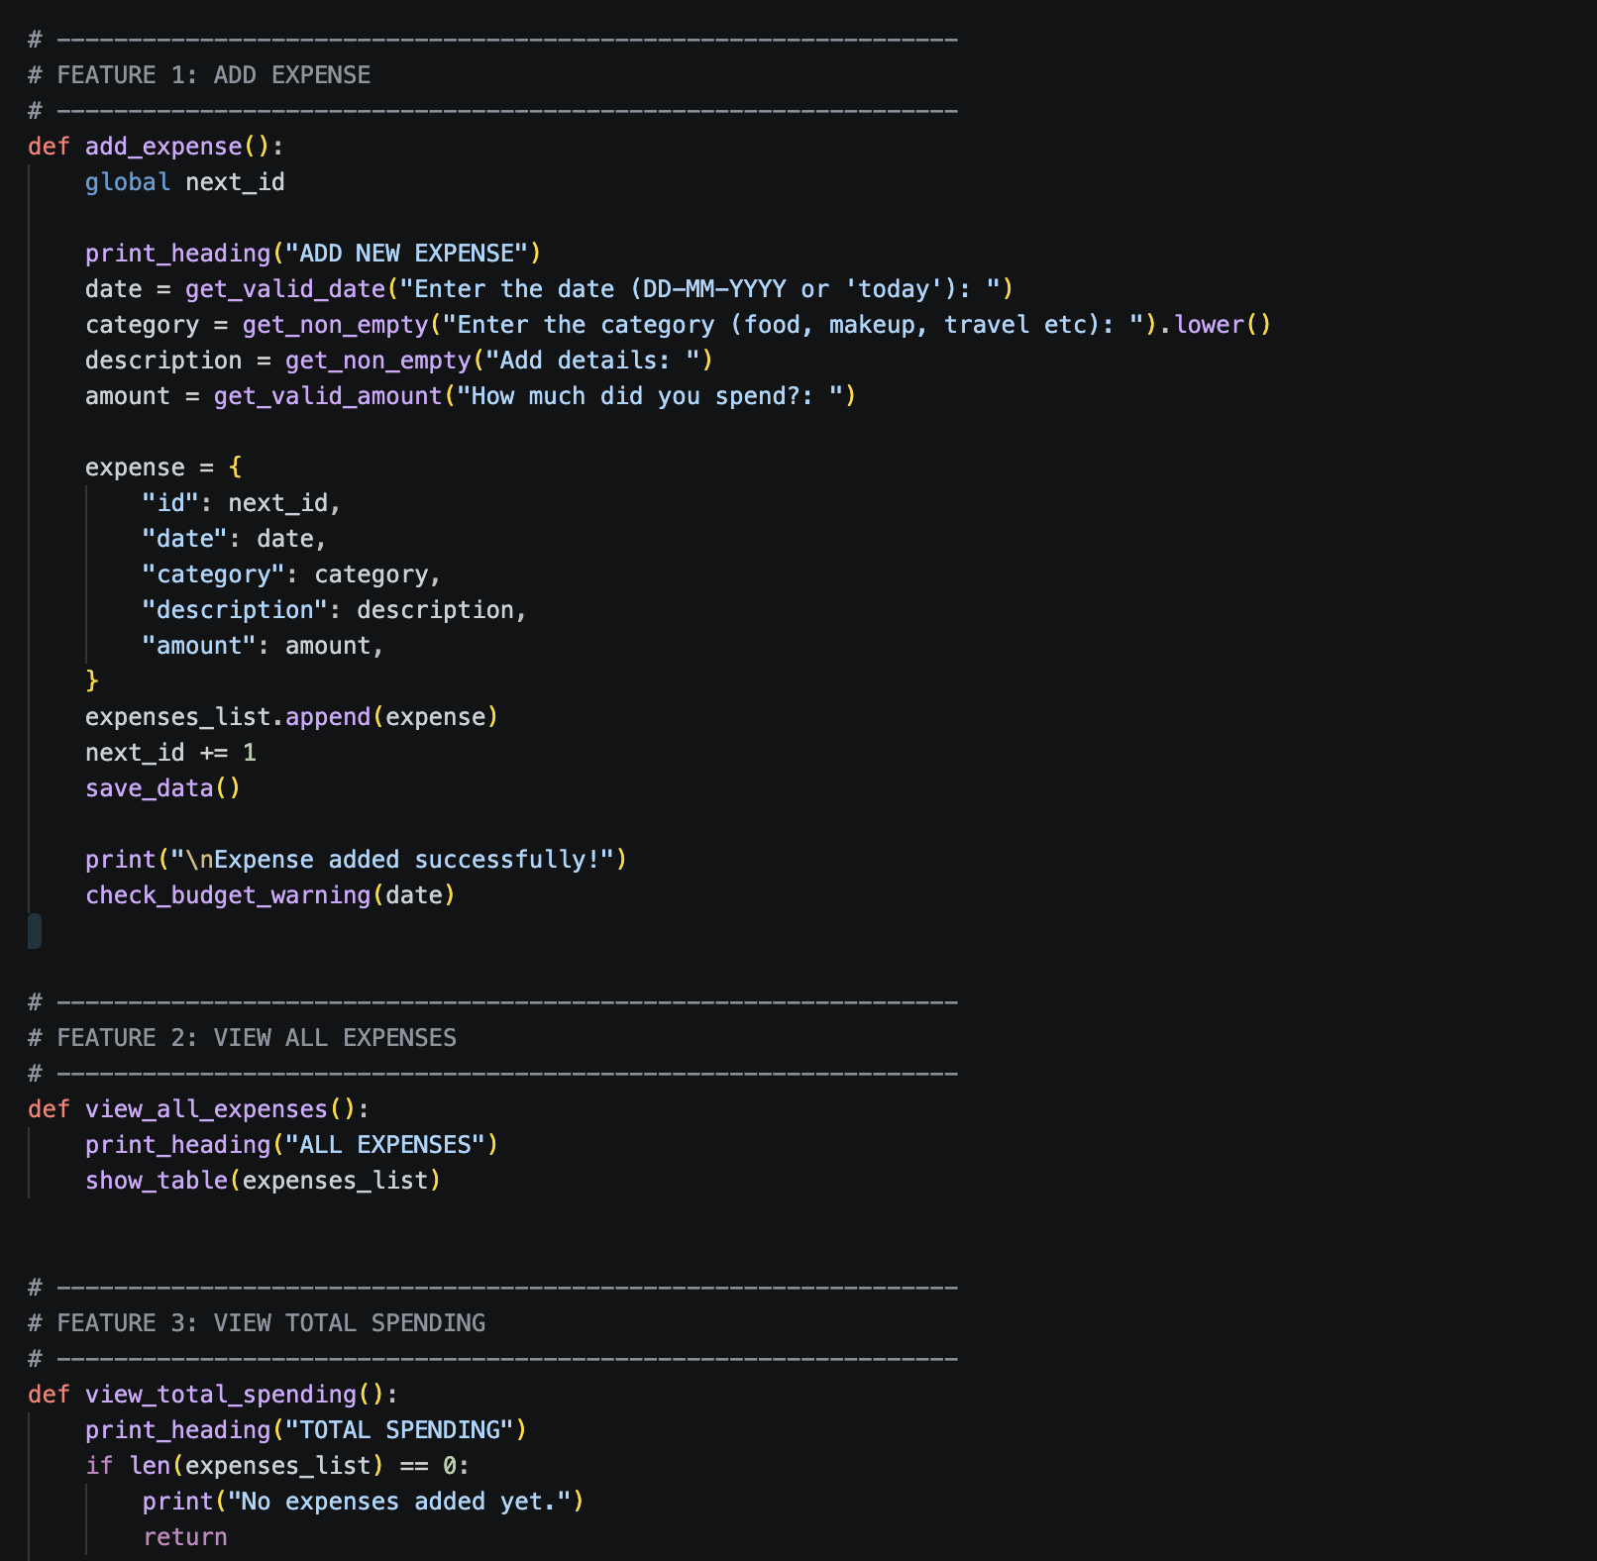
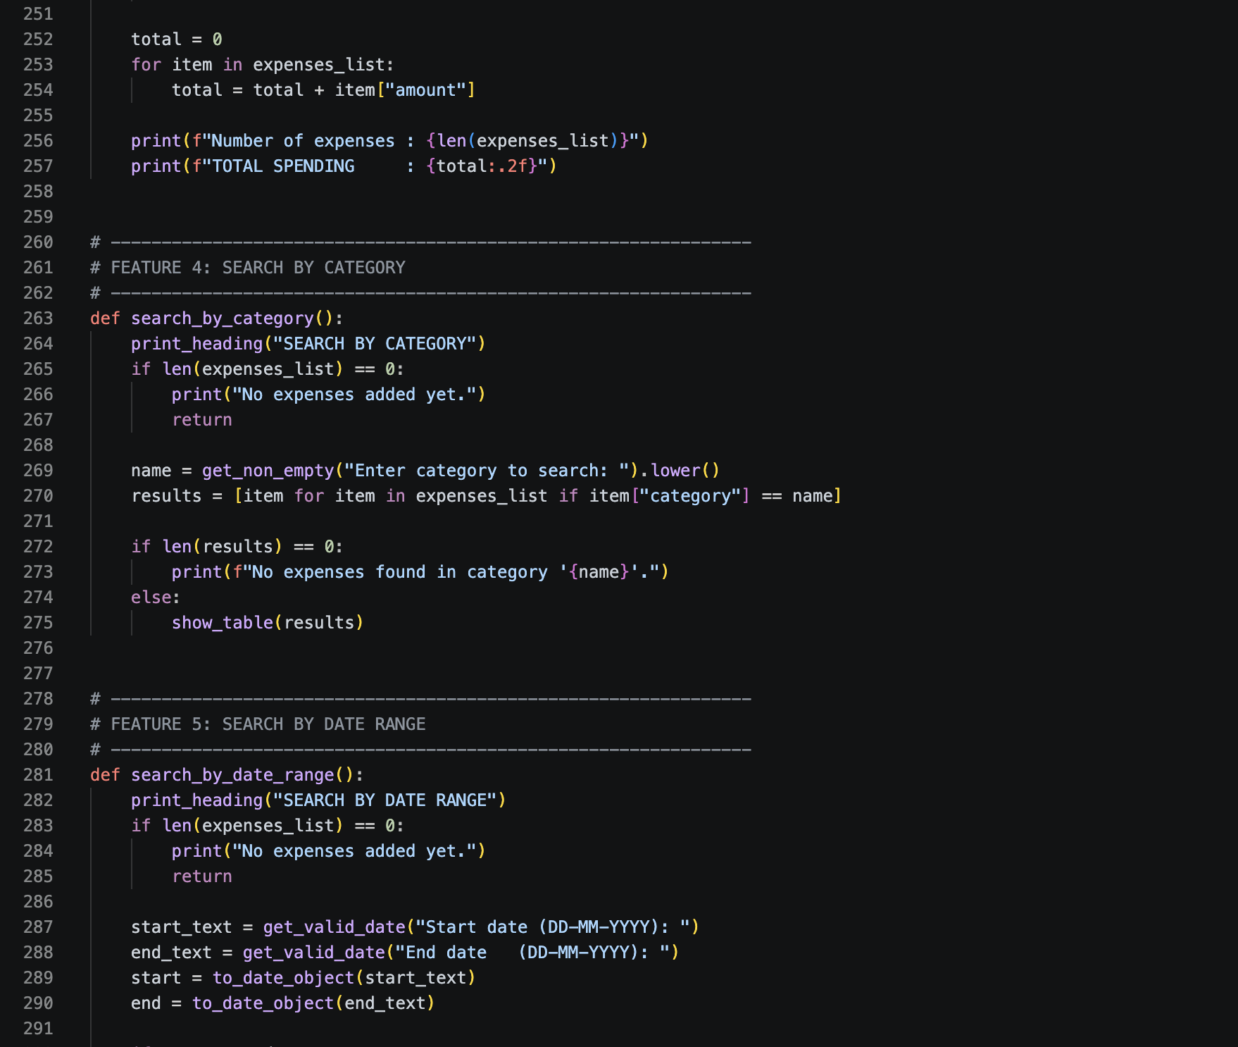
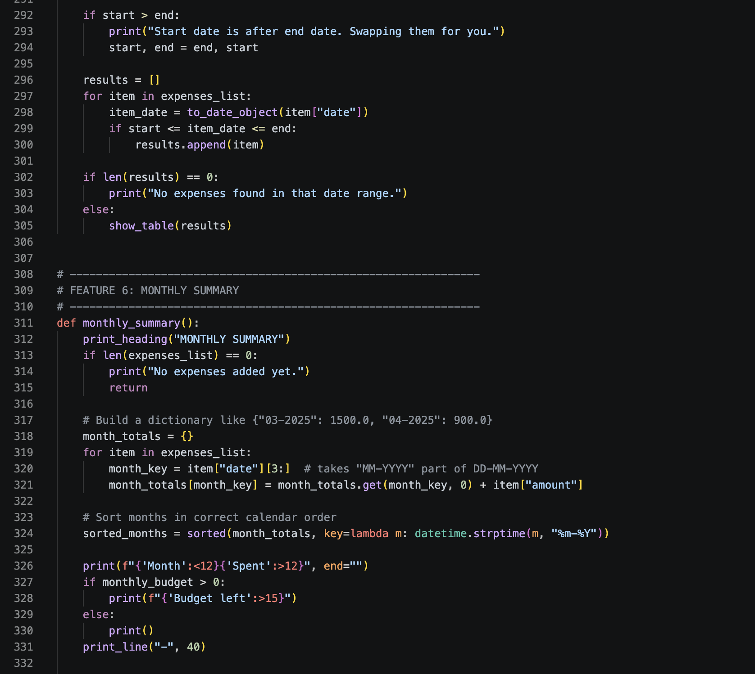
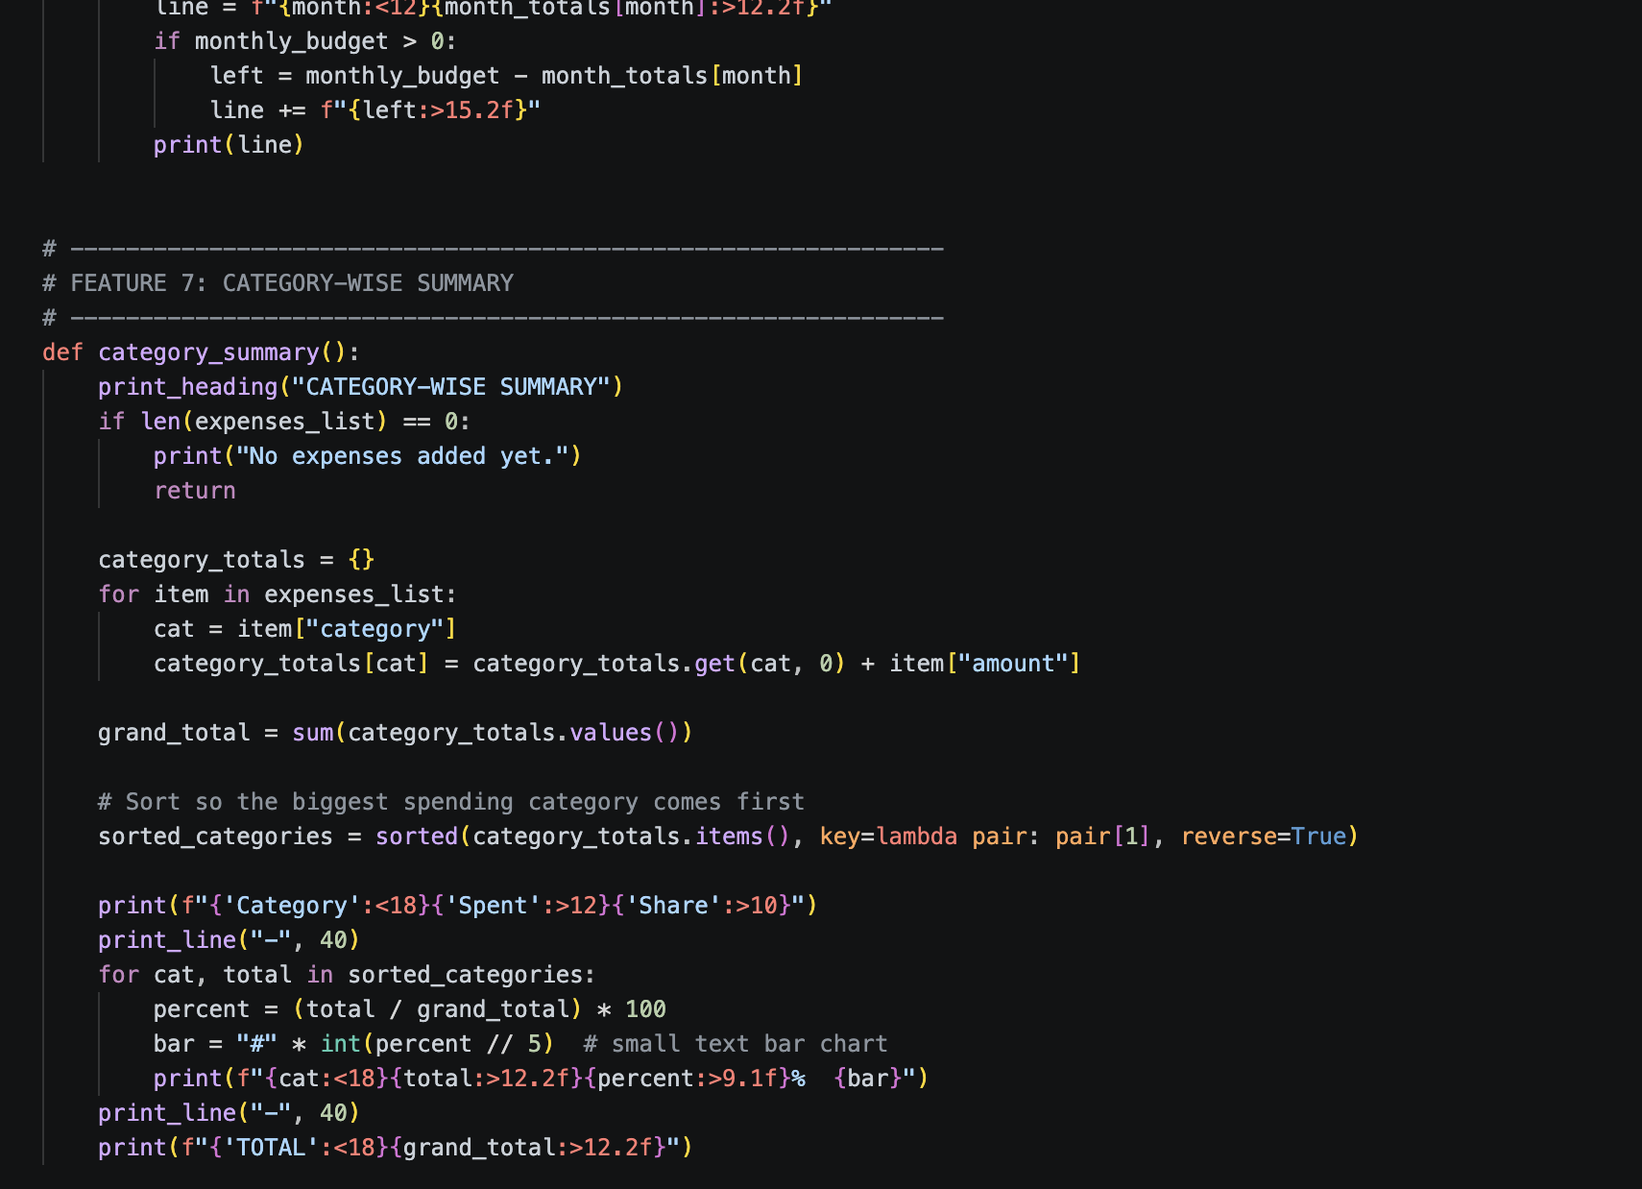
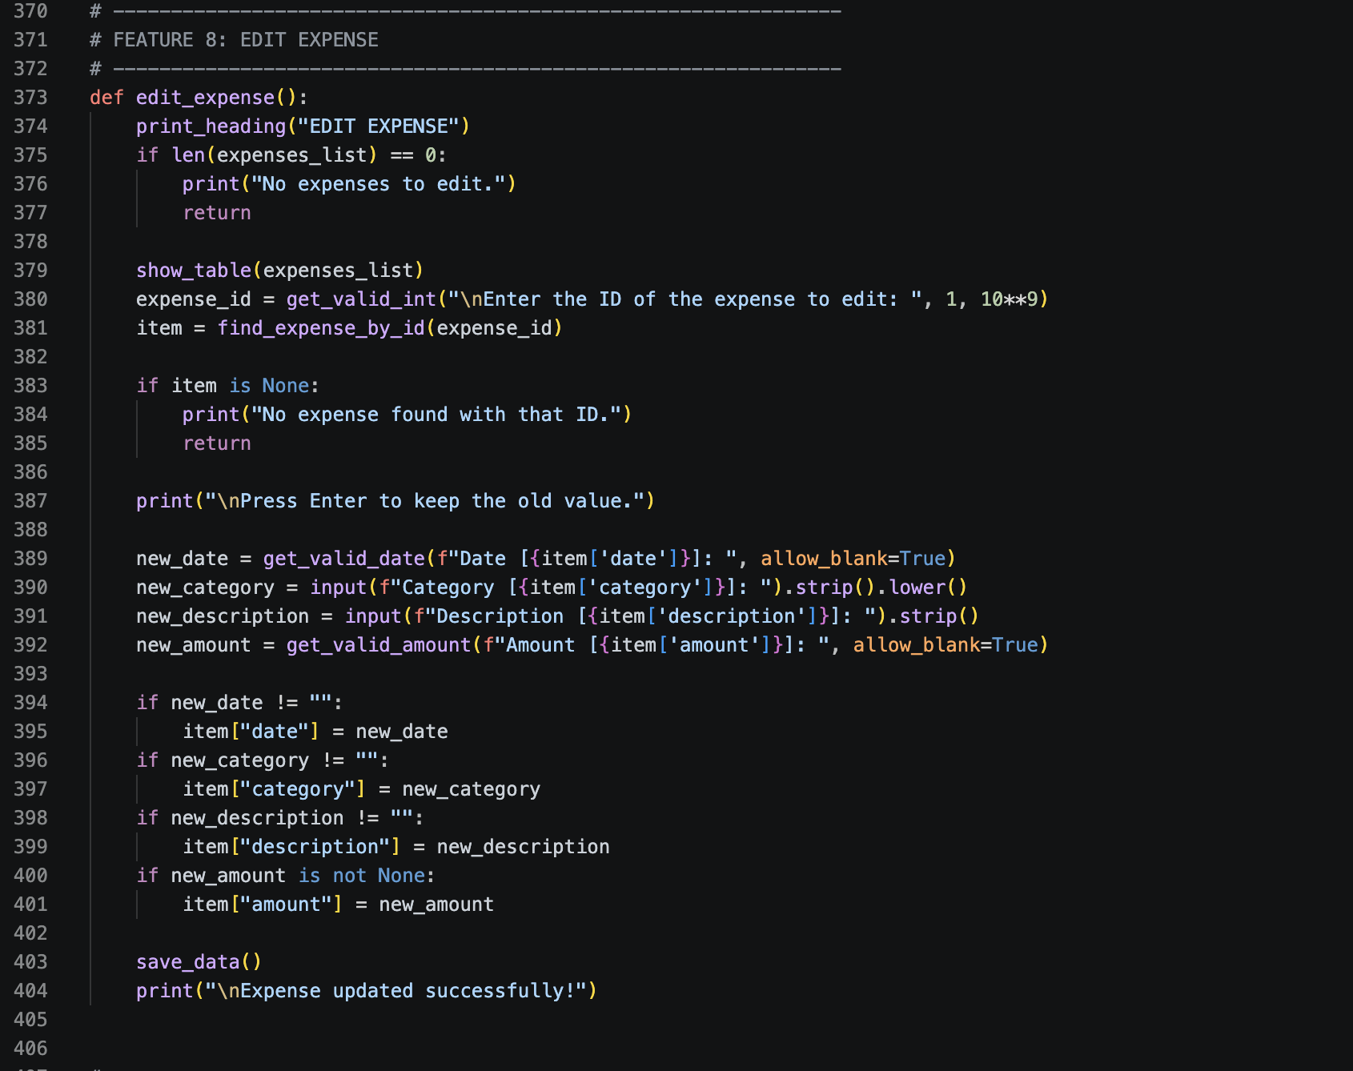
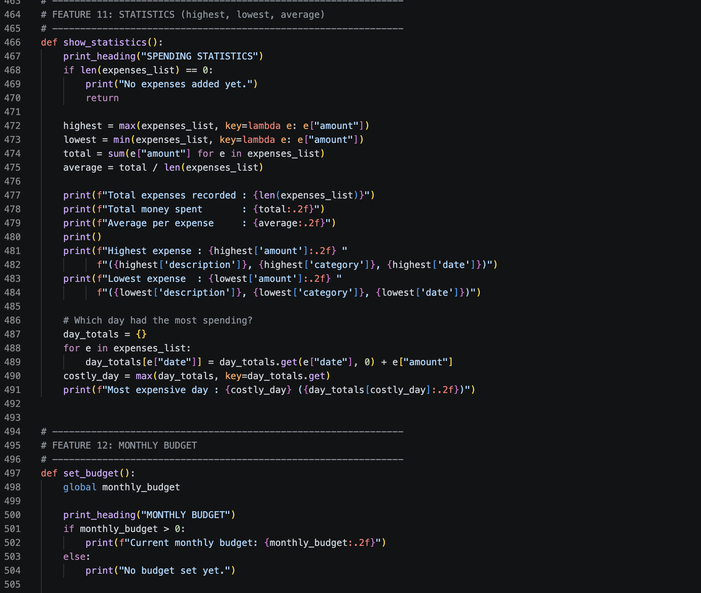
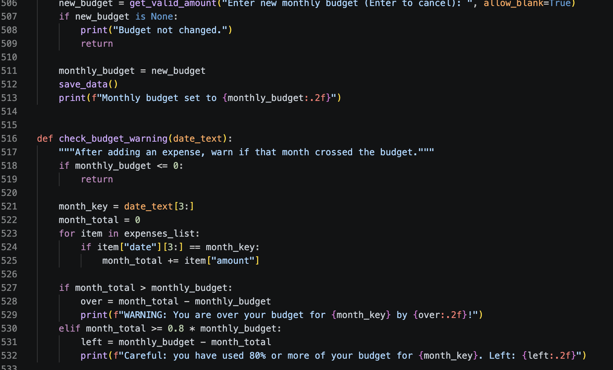
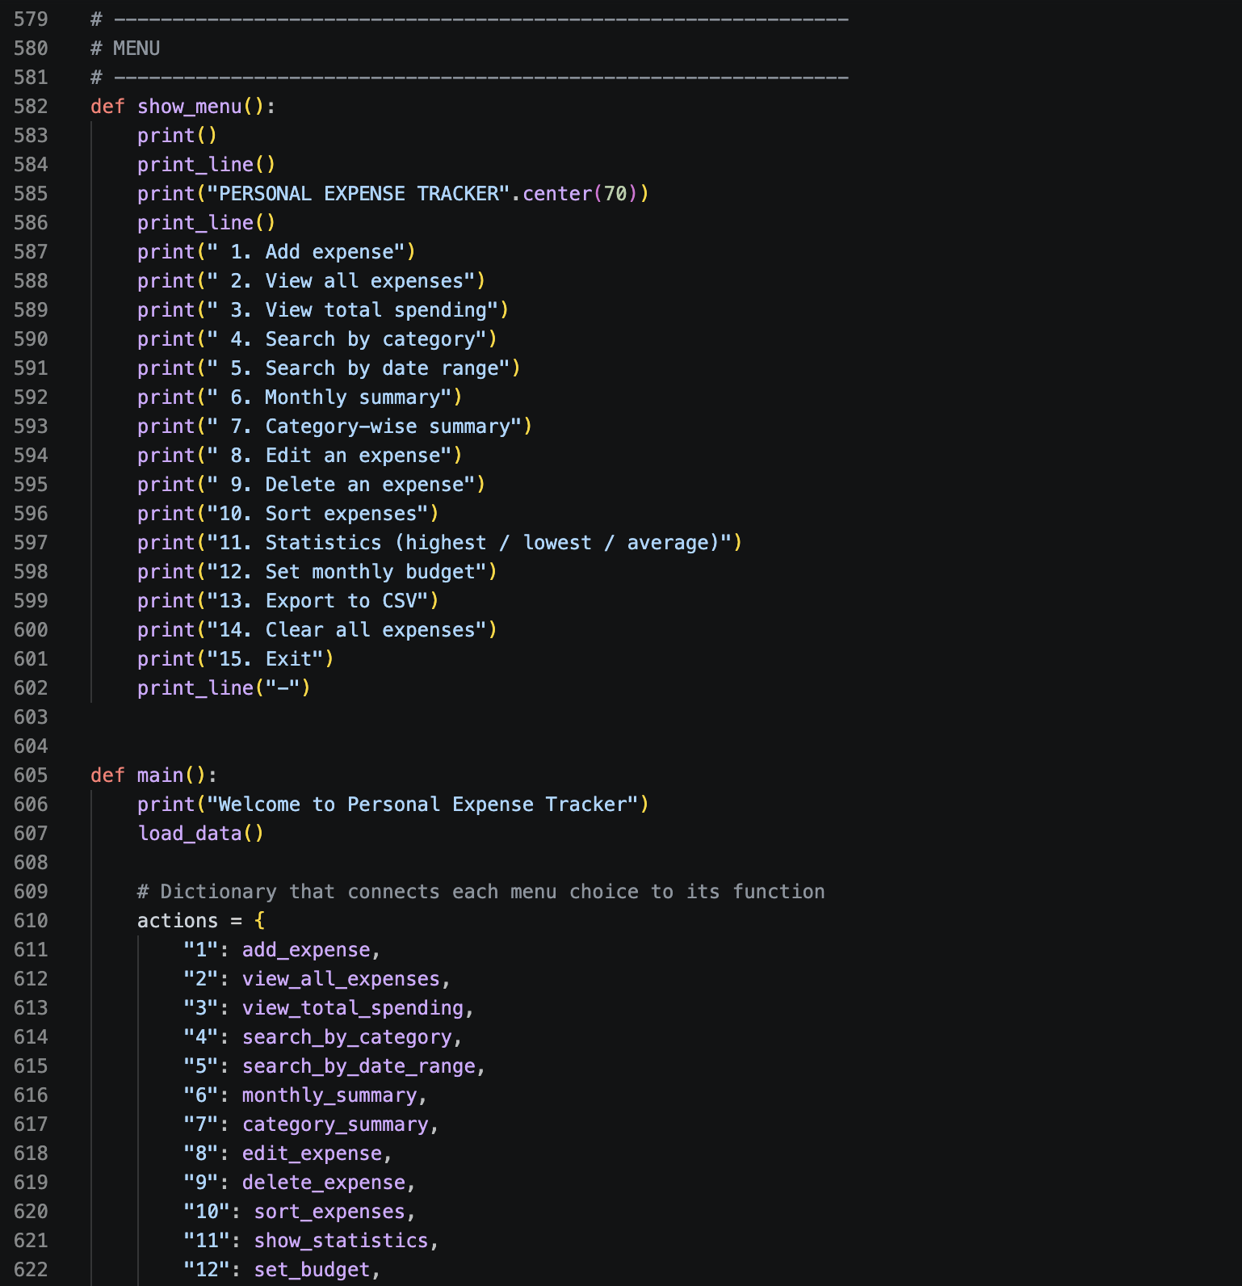
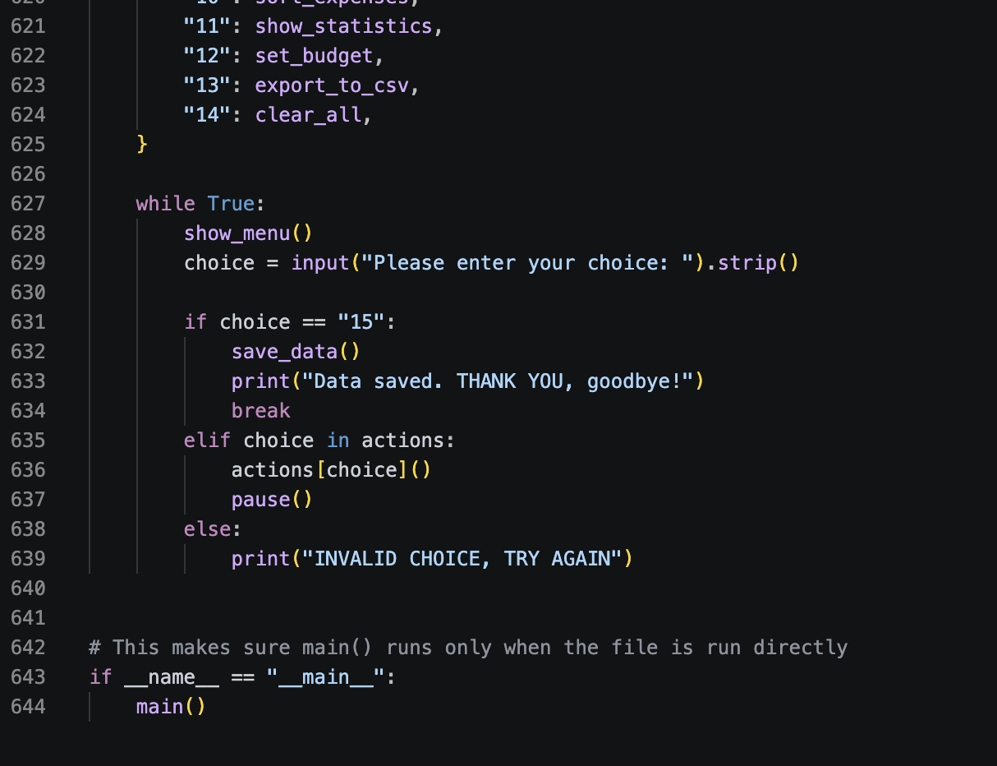
Appendix B: User Manual

A quick, practical guide for anyone who just wants to run this without reading the whole report.

B.1 Running the Program
1 Make sure Python 3 is installed.
2 Save the file as expense_tracker.py (I used VS Code, but any editor works).
3 Open a terminal in that folder - in VS Code you can just use the built-in terminal (Terminal > New Terminal).
4 Run: python expense_tracker.py (or python3 expense_tracker.py on Linux/macOS).
5 The welcome message and menu will show up. Type a number and press Enter.

B.2 Everyday Use
• To log a new expense: option 1, then answer the date/category/description/amount prompts.
• To see everything: option 2 for the full table, or options 4-7 to search or summarise it.
• To fix something: option 8 to edit or option 9 to delete, using the row number from the table.
• To set a spending limit: option 12 - you'll get warned automatically as you get close to it or go over.
- Always exit with option 14 so the program can wrap up cleanly, although honestly your data is already saved after every change anyway.

B.3 Data Files

Two small text files get created in the same folder: expenses.txt (every expense) and budget.txt
(the current budget). You can open either one in a plain text editor to peek at them, but I'd avoid editing them by hand while the program is actually running.
Appendix C: Glossary of Terms

Term | Meaning
Dictionary | A Python data structure that stores values under named keys, e.g. expense["amount"].
List | An ordered collection of items in Python, accessed by position, e.g. expenseslist[0].
Function | A named, reusable block of code that performs one task, defined with def.
Loop | A block of code that repeats, such as a for loop or a while loop.
Validation | Checking that user input is correct and usable before acting on it.
Persistence | Saving data to disk so it isn't lost when the program closes.
Bubble sort | A simple sorting algorithm that repeatedly swaps neighbouring  out-of-order elements.
Menu-driven program | A program controlled through a numbered list of options shown to the  user.
Flat file | A plain text file used to store data, as opposed to a relational database.
Parameter | A named input value that a function accepts, e.g. message in  ask_text(message).
IDE | Integrated Development Environment - an editor like VS Code with  built-in tools for running and debugging code.

