**FasTrak**

**Software Requirements Specification**

*Melinda Kwok, Maize Xylyn Mauricio, and Sitara Meherzad*

**Table of Contents**

**1.Purpose**

1.1 Scope

1.2 Definitions and Acronyms

1.3 References

1.4 Overview

**2. Overall Description**

2.1 Product Perspective

2.2 Product Architecture

2.3 Product Functions

2.4 User Characteristics

2.5 Assumptions and Dependencies

**3. Specific Requirements**

3.1 User Requirements

3.2 System Architecture

3.3 System Requirements

**4. Non-Functional Requirements**

4.1 Security and Privacy Requirements

4.2 Environmental Requirements

4.3 Performance Requirements

# Purpose

**1.1 Scope**

The purpose of this software is to help modernize and expedite travel for the everyday commuter using a new automated toll paying system. Commute is always something people need to consider when planning a trip and part of that commute usually entails waiting in line to pay the toll at a toll booth. By introducing FasTrak, an electronic toll collector (ETC), we can eliminate long wait times and help push commute faster in the right direction. This will not only make commuting faster but also to protect toll workers from possible reckless drivers as well.  This system will work with the use of a FasTrak tag inside of a vehicle and the tag will be scanned at toll gates. We will have a database that stores user information associated with their FasTrak tags and when the tag is scanned it will charge the appropriate account accordingly.  Overall, we hope that the use of FasTrak will make the commuting experience faster and more hands free.

**1.2 Definitions and Acronyms**

FasTrak is an ETC, an electronic toll collector. ETC is a new form of toll collection that is helping expedite backed up commute traffic.

**1.3 References**

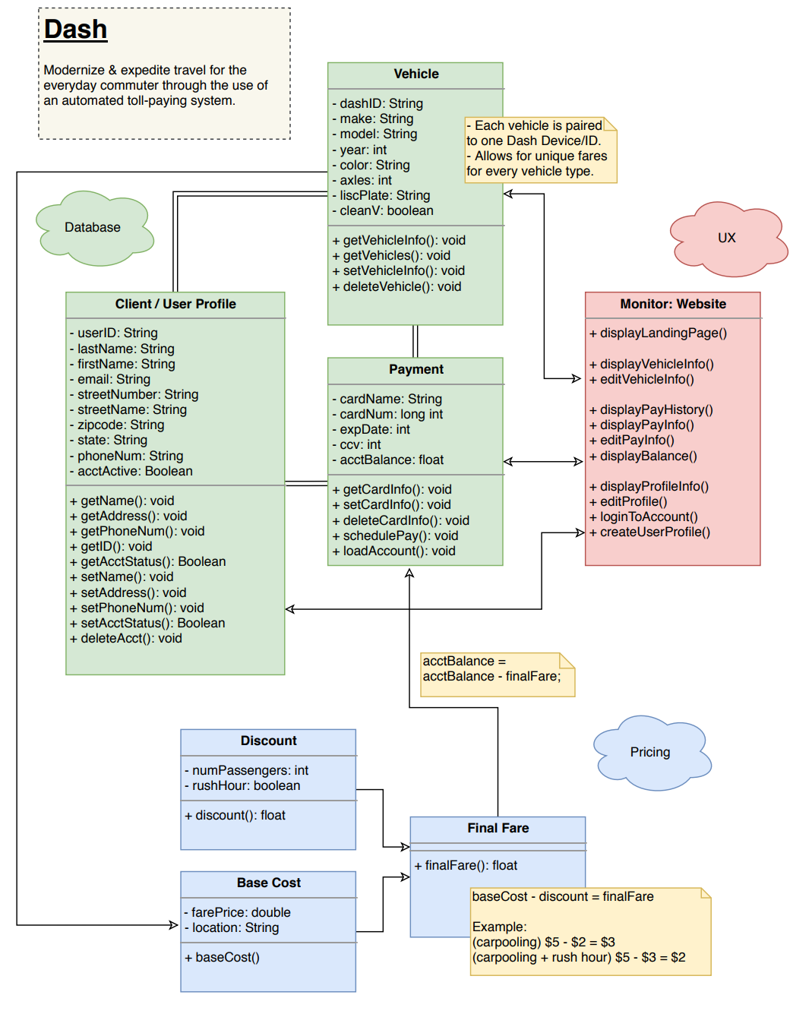

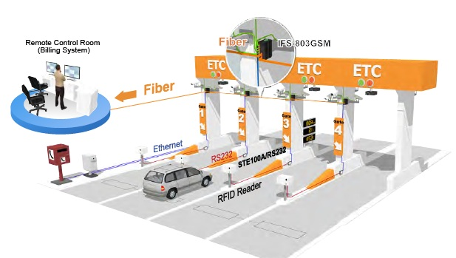

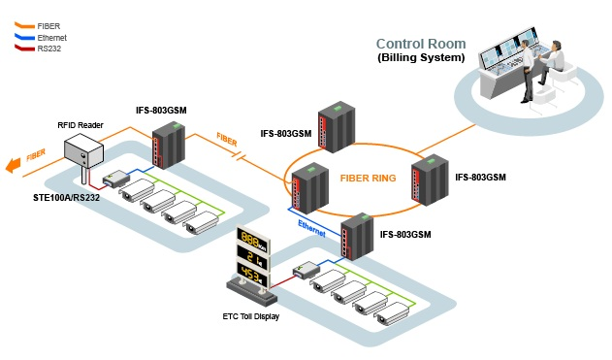

**1.5 Overview**

As they say, “Time is Money”. Waiting in long commutes can be draining especially when you have to be somewhere. The use of an ETC like FasTrak helps to alleviate the stress of traffic and move commuters a little faster as they get where they need to go. Overall, an automated process will make toll collecting much faster and can help prevent possible accidents or robberies at toll booths.

# Overall Description

**2.1 Product Perspective**

This product is available for all to use. The FasTrak tag can be purchase on the FasTrak website at: <https://www.bayareafastrak.org/en/home/index.shtml>. Users can create their accounts and register their vehicles to be tracked with the tags.

**2.2 Product Architecture**

The system will be organized into several classes: the Client class which will connect with a Payment and Vehicle class that will all be stored in a database and accessible via a website portal. We will have a Pricing class that will calculate fares and discounts based off the client’s account and vehicle and connect to the Client class to charge each individual correctly.

**2.3 Product Functionality/Features**

FasTrak is usable on all eight toll bridges in the bay area as well as any express lane open. Users can:

- Add multiple vehicles to their account

- View toll and express lane transactions

- Edit forms of payment

- Earn discounts on tolls using carpool or energy efficient vehicles

**2.4 Constraints**

Users can only access the website with valid credentials saved in the database. This will allow them to modify their own personal information, vehicle information, as well as payment methods. FasTrak itself can only be used properly when FasTrak tag is paired to the appropriate account in order for the database to access client information. Otherwise will result in toll violations.

**2.5 Assumptions and Dependencies**

It is assumed that all users have access to internet or Wi-Fi to access their account information. It is also assumed that users pair their FasTrak tag to their account to be used. The system depends on this for vehicles to be charged appropriately if they are using any FasTrak toll lanes or express lanes.

# Specific Requirements

**3.1 Functional Requirements**

**3.1.1 Common Requirements**

3.1.1.1 Users should be able to log into their accounts with the username and password they created; passwords should be at least 8 characters long in length and use at least one lowercase, one uppercase, and a special character.

3.1.1.2 Users need to either order a FasTrak tag via the website or visit a participating location to purchase one. Without a tag, the vehicle will be penalized with a toll violation.

3.1.1.3 Users must pair their FasTrak tags to their accounts in order for the tags to be functional and scannable. Otherwise will result in toll violations.

**3.1.2 XX Module Requirements:**

**3.2 External Interface Requirements**

3.2.1 When FasTrak tags are scanned, the data must be stored in the system and correctly automatically charge the appropriate accounts. Transactions need to be stored in each client’s account so that it can be viewed either daily, weekly, or monthly with the following fields: transaction id, day of transaction, time of transaction, location of transaction, and amount of the transaction.

**3.3 Internal Interface Requirements**

3.3.1 The system must be able to achieve all transactions for each client profile. The information should be able to be pulled whenever requested and should date back to the creation of their profile.

3.3.2 User profiles should be accessible by any type of device as long as the device is connected to the internet or Wi-Fi. User information can be edited by the user at any time with password authentication and by FasTrak support with the permission of the user.

# 4. Non-Functional Requirements

**4.1 Security and Privacy Requirements**

4.1.1 All transactions done must be encrypted when the data is being transmitted over the Internet to the database.

4.1.2 All client user accounts must be authenticated twice when logging in from a new device.

4.1.3 All client user information can only be edited with password authentication.

4.1.4 All FasTrak tags can only be paired to one account. But multiple tags may be paired to a singular account with the user’s permission.

**4.2 Environmental Requirements**

4.2.1 System cannot require that any software other than a web browser be installed on user computers.

4.2.2 System requires a pdf reader if the client wishes to export transaction data to the user computer.

**4.3 Performance Requirements**

4.3.1 There are no requirements