SmartStock AI
Complete Project Analysis Report
Flask + PostgreSQL + Odoo Inventory Management System
Internship / Academic Documentation • October 2026

1. Project Overview
SmartStock AI is a Flask-based inventory management system connected to an existing Odoo PostgreSQL database. The application manages products, inventory, suppliers, customers, purchases, sales, reviews, reports, audit history, authentication, and user roles.
Technology combination:
• Python and Flask for backend development
• PostgreSQL for data storage
• Odoo database tables for product and stock data
• HTML, CSS, and JavaScript for the user interface
• Bootstrap 5 for responsive styling
• ReportLab for PDF export and openpyxl for Excel export

2. High-Level Architecture
User Browser → HTML/CSS/JS Frontend → Flask Application
→ Authentication / Product / Inventory / Purchase-Sales / Review / Report APIs
→ PostgreSQL (Odoo tables + SmartStock tables)

3. Technology Stack
Layer | Technology | Purpose
Programming language | Python | Backend logic and business rules
Web framework | Flask | Web server, routes, APIs, sessions
Database | PostgreSQL | Data storage
ERP integration | Odoo PostgreSQL tables | Products, variants, stock, prices
Database connector | psycopg2-binary | Python-to-PostgreSQL connection
Frontend | HTML5 + CSS3 + Bootstrap 5 | UI structure and responsive design
Frontend logic | Vanilla JavaScript | API calls and page interaction
Password security | Werkzeug | Password hashing and verification
PDF / Excel / CSV | ReportLab / openpyxl / csv | Report generation and export

4. Main Project Files

Backend
File | Responsibility
app.py | Flask app, routes, pages, schema init, error handling
routes.py | Auth, product, inventory, purchase, sales, reports, admin, review APIs
database.py | PostgreSQL connections and SmartStock table creation
config.py | Environment-based configuration
requirements.txt | Python package list

Frontend Pages
File | Purpose
index.html | Main inventory dashboard
login.html / signup.html | Authentication
product-management.html | Product CRUD, search, pagination
product-details.html / reviews.html | Product details and reviews
categories / suppliers / customers.html | Master data management
stock.html / purchase.html / sales.html | Inventory movements and orders
reports.html / audit.html | Analytics and audit history
admin / profile / settings / forgot-password.html | Admin, profile, settings, reset

5. Available Pages & URLs
Page | URL | Purpose
Dashboard | / | Inventory overview
Login / Signup | /login, /signup | Authentication
Products | /products | Product CRUD
Categories / Suppliers / Customers | /categories, /suppliers, /customers | Master data
Stock In/Out | /stock | Inventory movements
Purchases / Sales | /purchase, /sales | Orders
Reports / Audit / Reviews | /reports, /audit, /reviews | Analytics & history
Admin / Profile / Settings | /admin, /profile, /settings | User & system

6. Dashboard Analysis
Dashboard at / shows navigation, user greeting, Add Product form, cards (Total Products, Total Stock Quantity, Low Stock Items), product tables, and links to all modules.
APIs: GET /api/auth/me, /api/products, /api/dashboard-stats, /api/low-stock; POST/PUT/DELETE /api/products

7. Authentication
Signup: POST /api/auth/signup → validate → hash password → save smartstock_users → session.
Login: POST /api/auth/login → find user → verify hash → session → dashboard.
Logout: POST /api/auth/logout. Passwords hashed with Werkzeug. Reset tokens expire and are single-use.

8. Roles and Authorization
Roles: admin, user (smartstock_roles / smartstock_users). Admin APIs: GET /api/admin/users, PUT /api/admin/users/<id>/role. Page: /admin.

9. Product Management
Page /products: create, view, update, delete, search, pagination. Writes to Odoo product_template, product_product, stock_quant.
APIs: GET/POST /api/products, PUT/DELETE/GET /api/products/<id>

10. Odoo Database Integration
product_template: template, name, list price, type. product_product: variants, standard price. stock_quant: quantity, location.
Flow: product_template → product_product → stock_quant → Flask SQL → JSON → Dashboard. Learning use of direct SQL is fine; production should use Odoo ORM/API.

11. Categories, Suppliers, Customers
Categories (smartstock_categories): GET/POST /api/categories.
Suppliers (smartstock_suppliers): Name, Email, Phone, Address — GET/POST /api/suppliers.
Customers (smartstock_customers): same fields — GET/POST /api/customers.

12. Stock-In and Stock-Out
Page /stock. Types: in / out. Table: smartstock_stock_transactions. Stock-in adds qty; stock-out subtracts (no negative stock). API: POST /api/stock-transactions.

13. Purchase Module
Page /purchase. Flow: select product → qty & price → create PO → increase stock → store record. Table: smartstock_purchase_orders. APIs: POST/GET /api/purchases.

14. Sales Module
Page /sales. Flow: select product → qty & price → check stock → decrease stock → save SO. Table: smartstock_sales_orders. Validates positive qty, non-negative price, sufficient stock.

15. Product Reviews
Pages /reviews, /product-details. 1–5 star rating, comment, user, date, average rating. Table: smartstock_product_reviews. APIs: GET product, GET/POST reviews.

16. Reports and Analytics
Page /reports. Metrics: total products, stock qty, stock value, low-stock count, healthy/low percentages, status bars. API: GET /api/reports (COUNT, SUM, COALESCE, FILTER).

17. Inventory Audit
Page /audit. Actions: created / updated / deleted. Table: smartstock_inventory_history. Export: CSV, Excel, PDF.

18. Export Features
• CSV → GET /api/exports/products.csv
• Excel → GET /api/exports/products.xlsx (openpyxl)
• PDF → GET /api/exports/products.pdf (ReportLab)
All require authentication. Columns: Product ID, name, quantity, unit price.

19. Forgot Password
Page /forgot-password. POST /api/auth/forgot-password → token with expiry; POST /api/auth/reset-password → update hash. Production should email the token.

20. Database Tables

Odoo Tables
Table | Purpose
product_template | Product template data
product_product | Product variant and price data
stock_quant | Current stock quantity

SmartStock Application Tables
Table | Purpose
smartstock_roles / users | Roles and user accounts
smartstock_categories | Product categories
smartstock_suppliers / customers | Supplier and customer master
smartstock_stock_transactions | Stock-in / stock-out records
smartstock_purchase_orders / sales_orders | Purchase and sales orders
smartstock_inventory_history | Product activity history
smartstock_password_reset_tokens | Password reset tokens
smartstock_product_reviews | Ratings and comments

21. Data Flow Diagrams (DFD)
The following diagrams use standard DFD notation: External Entity (green), Process (blue rounded), Data Store (amber with left bar), and labelled Data Flows (arrows).

21.1 Context Level DFD (Level 0)
Shows the entire SmartStock system as one process interacting with the User and PostgreSQL, producing Dashboard / JSON / CSV / Excel / PDF outputs.
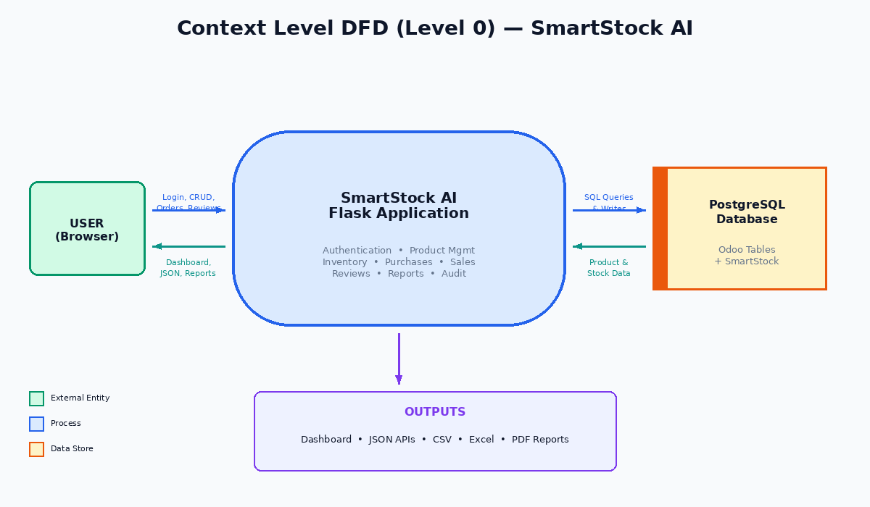
Figure 1: Context Level DFD (Level 0) — SmartStock AI

21.2 Level 1 DFD — Process Decomposition
Decomposes the system into seven processes: Authentication, Product Management, Inventory Transactions, Purchase Management, Sales Management, Review Management, and Reports & Export.
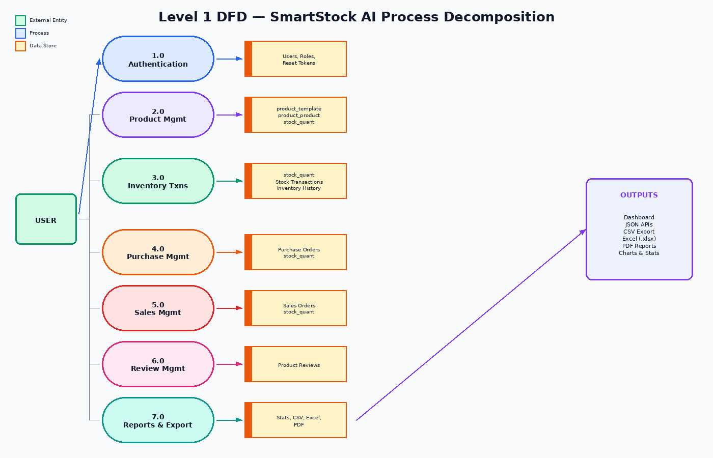
Figure 2: Level 1 DFD — Complete Process Decomposition

21.3 Level 1 Detail — Authentication & Product Management
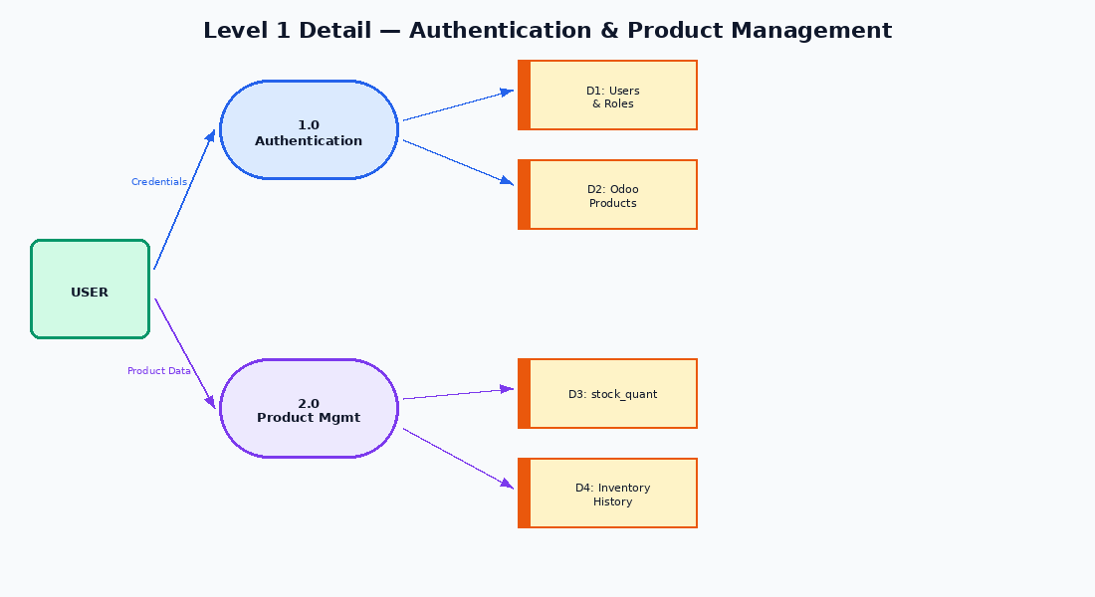
Figure 3: Processes 1.0 Authentication and 2.0 Product Management with data stores

21.4 Level 1 Detail — Inventory, Purchases & Sales
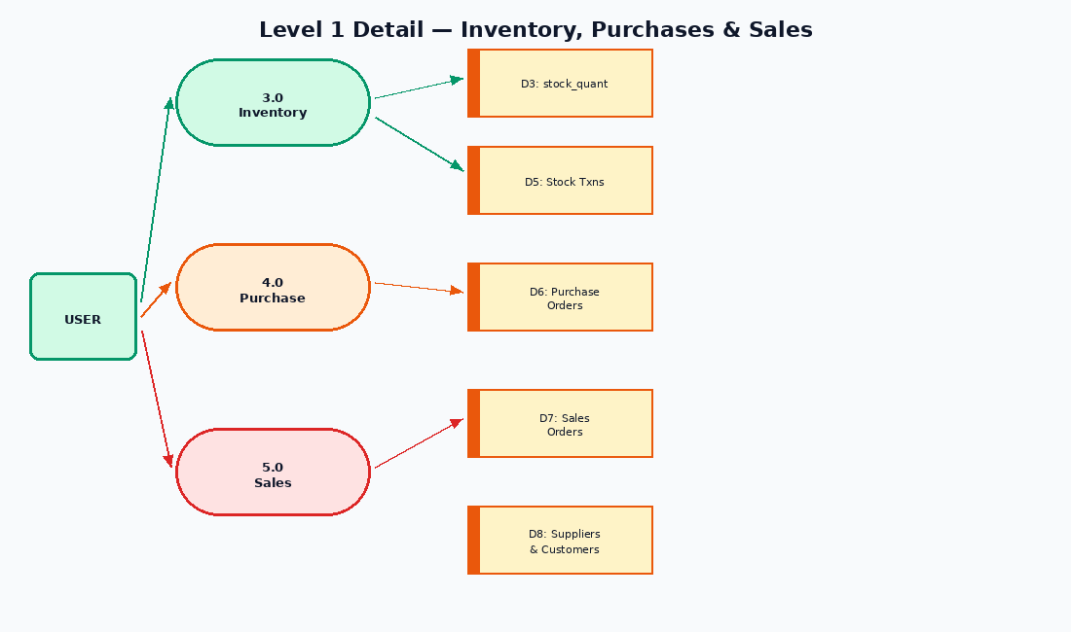
Figure 4: Processes 3.0 Inventory, 4.0 Purchase, 5.0 Sales with data stores

21.5 Level 1 Detail — Reviews & Reports / Exports
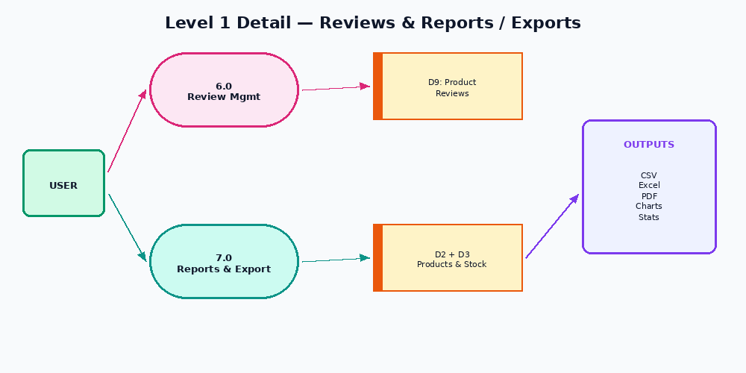
Figure 5: Processes 6.0 Review Management and 7.0 Reports & Export

22. Complete User Flow
Signup → Login → Dashboard
+→ Product Management (Add / Edit / Delete / View reviews)
+→ Categories / Suppliers / Customers
+→ Stock In/Out → Purchases / Sales
+→ Reports / Audit / Reviews → Profile / Settings → Logout

23. Error Handling
Error | HTTP Status
Invalid request data | 400
Unauthorized user | 401
Admin permission missing | 403
Product / user not found | 404
Invalid HTTP method | 405
Database failure | 503
Unexpected server error | 500
JSON format: { "error": "Readable error message" }

24. Validation Rules
• Product name cannot be empty; quantity and unit price cannot be negative
• Stock-out cannot exceed available stock
• Purchase and sales quantity must be positive
• Review rating 1–5; comment cannot be empty
• Password ≥ 8 characters; email required for auth
• Admin role must be admin or user

25. Project Strengths
Strength | Explanation
Complete business flow | Products, inventory, purchases, sales, reviews
Odoo integration | Reads and writes Odoo product and stock tables
Authentication & roles | Login, signup, sessions, hashing, admin/user
Inventory validation | Prevents negative stock; transaction handling
Export & audit | CSV, Excel, PDF + activity history
Modular structure | Backend, database, config, frontend separated
Internship value | Python, Flask, PostgreSQL, SQL, Odoo knowledge

26. Current Limitations

Security
• Strong FLASK_SECRET_KEY, CSRF, rate limiting, email-based reset, HTTPS

Odoo Integration
Direct SQL may bypass Odoo business rules. Prefer custom Odoo module with ORM, XML views, and security rules for production.

Functional
• Update/delete for categories, suppliers, customers
• Customer on sales / supplier on purchases; API pagination; richer charts; tests; migrations

27. Internship Discussion Points

Python
Functions, decorators, context managers, exceptions, transactions, hashing, modular design.

Flask
App factory, blueprints, routes, JSON APIs, sessions, error handlers, auth decorators.

PostgreSQL
Tables, keys, joins, aggregations, transactions, constraints.

Odoo
product_template, product_product, stock_quant, variants, stock, SQL vs ORM.

Frontend
HTML forms, CSS, fetch/JSON, dynamic tables, Bootstrap, validation.

28. Final Conclusion
SmartStock AI is a complete learning-oriented inventory management project (Python + Flask + PostgreSQL + Odoo + HTML/CSS/JS) covering authentication, roles, product CRUD with Odoo tables, stock movements, purchases, sales, reviews, reports, audit, and multi-format export.
It demonstrates strong backend, SQL, REST API, and Odoo database understanding suitable for an Odoo internship. The key production improvement is replacing direct Odoo SQL with a proper custom Odoo module (ORM, views, access rights).
— End of Document —

