Installation & Setup Guide for Video Clip Splitting

Step 1: Create the Main Folder
Create a new folder named 'TABSONS_CLIPS' inside the C drive.
C:\TABSONS_CLIPS

Step 2: Create the Python Script
- Open Notepad on your system.
- Paste the provided Python code into the file.
- Make the required changes in the code according to your setup.

Step 3: Download and Configure FFmpeg
Download FFmpeg from the official website below and extract the downloaded files.
Official Website: https://ffmpeg.org/download.html
- Locate ffmpeg.exe inside the extracted folder.
- Locate ffprobe.exe inside the extracted folder.

Step 4: Update FFmpeg Paths in the Python Script
Copy the full paths of both executable files and update them inside the Python script as shown below:
# ====== FFmpeg Full Paths (IMPORTANT) ======
FFMPEG_PATH = r"C:\ffprobe\ffmpeg-2026-02-18-git-52b676bb29-essentials_build\ffmpeg-2026-02-18-git-52b676bb29-essentials_build\bin\ffmpeg.exe"
FFPROBE_PATH = r"C:\ffprobe\ffmpeg-2026-02-18-git-52b676bb29-essentials_build\ffmpeg-2026-02-18-git-52b676bb29-essentials_build\bin\ffprobe.exe"

Step 5: Save the Python File
Save the Notepad file with the following name:
split_custom.py
Place the saved file inside the following folder:
C:\TABSONS_CLIPS

Step 6: Create the Video Folder
Inside the TABSONS_CLIPS folder, create another folder named 'videos1'.
This folder will store the downloaded 1-hour videos and all generated 10-minute clips.
C:\TABSONS_CLIPS\videos1
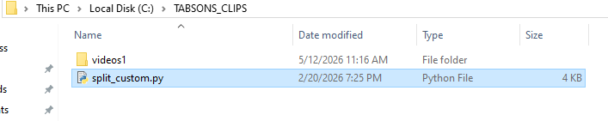

Setup Complete
The installation and configuration process is now complete. The system is ready to split 1-hour videos into multiple 10-minute clips automatically.

How to Run the Code

Step 1: Download the Video
Download the required 1-hour video from CDAPI and paste it inside the videos1 folder.
C:\TABSONS_CLIPS\videos1

Step 2: Open Command Prompt
Open Command Prompt and navigate to the TABSONS_CLIPS folder using the command below:
cd C:\TABSONS_CLIPS

Step 3: Execute the Python Script
Run the following command to start the video splitting process:
python split_custom.py

Output
Once the script starts running, the system will automatically process the 1-hour video and split it into 10-minute clips.
All generated clips will be saved inside the videos1 folder.
Example Command Prompt Output:
