Streaming Platform Catalog Comparison
A Product Analytics Study of Netflix, Hulu, Prime Video & Disney+
Prepared by: Bhumika Jain
Role focus: Product Management / Product Analyst
Tools: MySQL (SQL), Python (data cleaning & visualization)
Dataset: Movies on Streaming Platforms (Kaggle), 9,515 titles

1. Executive Summary
This analysis compares the content catalogs of four major streaming platforms Netflix, Hulu, Prime Video, and Disney+ across 9,515 titles, using SQL-based analysis (MySQL) to answer the kind of strategic questions a streaming product or content team faces: How big is our catalog versus competitors? Are we optimizing for volume or quality? How fresh is our content, and how exclusive is it?

Key finding:
Catalog size and content quality are inversely related in this dataset. Prime Video carries the largest catalog (4,113 titles) but the lowest critic-quality density only 21.4% of its rated titles are "Fresh" on Rotten Tomatoes. Hulu, with the smallest catalog (1,047 titles), has the highest quality density at 52.1%. This is a classic quality-versus-quantity tradeoff with direct implications for content acquisition strategy.
- Catalog Size — Largest catalog: Prime Video (4,113 titles) | Smallest: Disney+ (922 titles)
- Quality Density — Hulu (52.1%) far outpaces Prime Video (21.4%) on share of catalog rated "Fresh"
- Content Age & Audience — Disney+ skews oldest (avg. release year 1997) and most family-friendly; Netflix skews newest (avg. 2014.8) and most mature-rated
- Exclusivity — All platforms exceed 87% single-platform exclusivity, confirming exclusive content is now the norm, not the exception, across the industry

2. Business Context & Objective
Streaming platforms make billions of dollars in content decisions what to license, what to produce, what to renew, what to cancel based on catalog analytics like this. This project simulates the role of a Product/Data Analyst on a streaming platform's content strategy team, tasked with benchmarking the platform's catalog against competitors to inform content acquisition and curation decisions.

Objective
Answer five strategic questions using SQL on a real-world, multi-platform content dataset:
- How does our catalog size compare to competitors?
- Are we competing on volume, quality, or both?
- Is our content library fresh or aging?
- How exclusive is our content versus competitors?
- What does our audience-rating (age) mix say about our positioning?

3. Dataset & Methodology

3.1 Source Data
- Dataset: Movies on Streaming Platforms Kaggle (Ruchi Bhatia)
- Rows: 9,515 unique titles
- Columns: Title, Year, Age rating, Rotten Tomatoes critic score, and binary flags for presence on Netflix, Hulu, Prime Video, and Disney+
- Coverage: 1914–2021

3.2 Known Data Limitations
Before analyzing, I audited the schema and found it leaner than the original project brief assumed — there is no Genre, Director, Cast, Country, or Runtime field, and the only quality signal is Rotten Tomatoes critic score (not IMDb user rating or vote count). Rather than force unreliable analysis onto missing fields, I scoped the project to what the data could honestly support, and documented this tradeoff explicitly — a decision I'd make the same way on a real product team, where flagging data gaps before drawing conclusions matters more than producing a complete-looking report.

3.3 Data Cleaning Steps
- 1. Converted Rotten Tomatoes scores from text format ("98/100") to numeric integers for aggregation
- 2. Added a derived field counting how many platforms carry each title, to identify exclusive vs. shared content
- 3. Verified zero duplicate titles and quantified nulls (7 missing RT scores, 4,177 missing Age ratings) before including fields in analysis

3.4 Tools & Techniques
- SQL: MySQL workbench
- Python: Python (pandas) for initial data audit and schema validation; matplotlib for chart generation

4. Findings

4.1 Catalog Size by Platform
Prime Video has the largest library, more than 4x the size of Disney+, reflecting its breadth-first content strategy versus Disney+'s curated, franchise-focused approach.
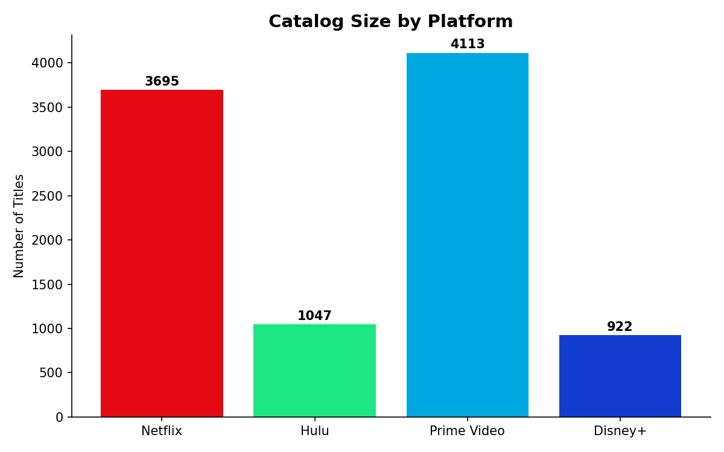
Figure 1: Total title count by platform (n=9,515)
Platform | Title Count | % of Total Catalog
Prime Video | 4,113 | 43.2%
Netflix | 3,695 | 38.8%
Hulu | 1,047 | 11.0%
Disney+ | 922 | 9.7%

4.2 Quality vs. Quantity Positioning
Plotting average critic score against catalog size reveals four distinct competitive postures. Hulu sits in the high-quality, low-volume quadrant; Prime Video sits opposite, in high-volume, lower-quality. This is the single most actionable insight in the dataset for a content strategy team.
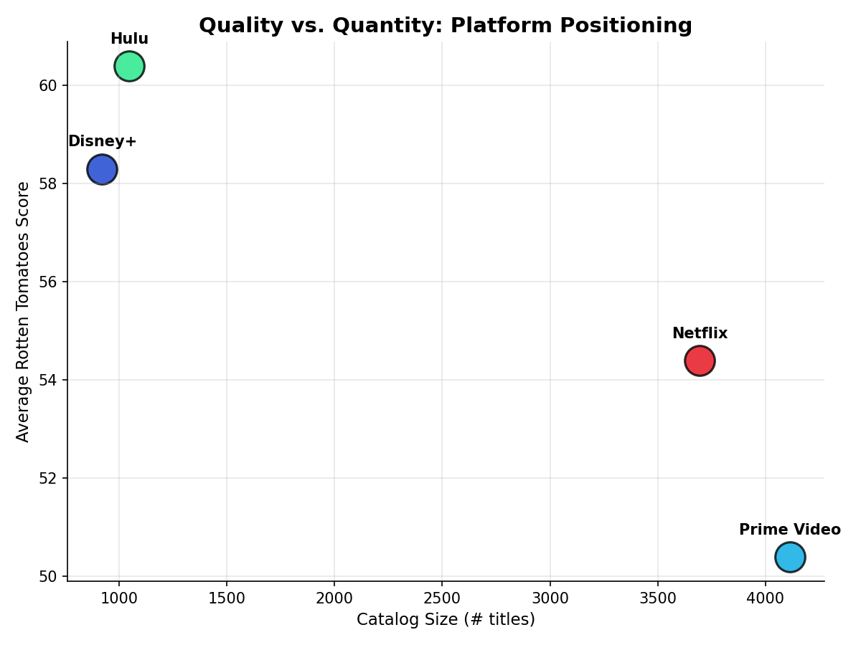
Figure 2: Average Rotten Tomatoes score plotted against catalog size, by platform

4.3 Content Freshness (Quality Density)
Beyond average score, I measured what share of each platform's rated catalog clears the Rotten Tomatoes "Fresh" threshold (≥60). This captures consistency, not just average — a platform could have a high average pulled up by a few outliers while most of its catalog underperforms.
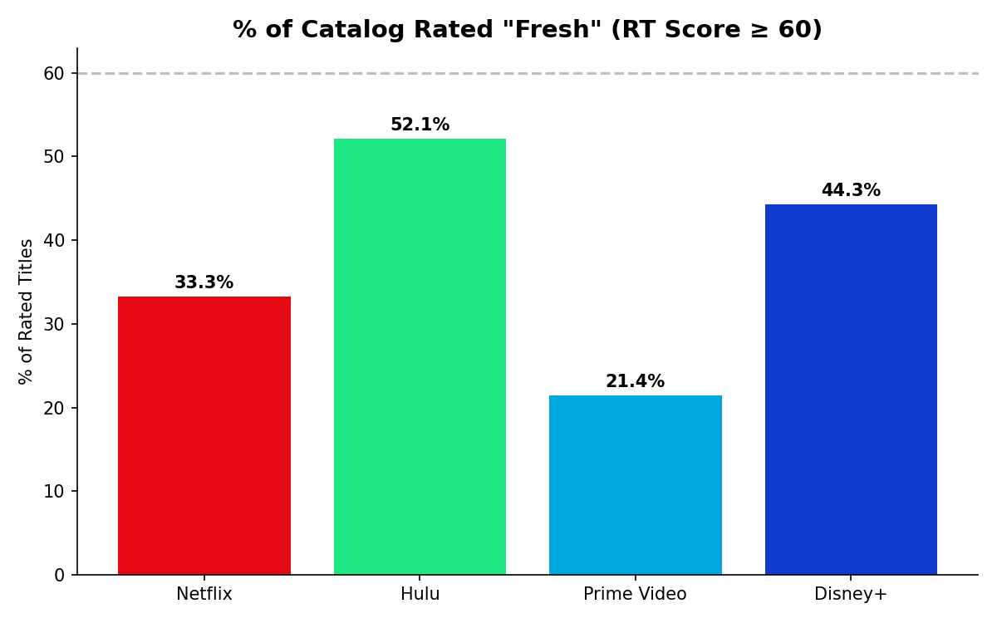
Figure 3: % of each platform's rated catalog scoring "Fresh" (RT ≥ 60)
Hulu's 52.1% Fresh rate — more than double Prime Video's 21.4% — suggests a more selective acquisition strategy relative to its smaller catalog size.

4.4 Content Age Mix by Decade
Breaking each platform's catalog down by release decade shows clearly different content-sourcing strategies: Netflix and Hulu are dominated by 2010s content (modern, originals-heavy), while Prime Video and Disney+ carry significantly more pre-2000 content, consistent with deep back-catalog licensing.
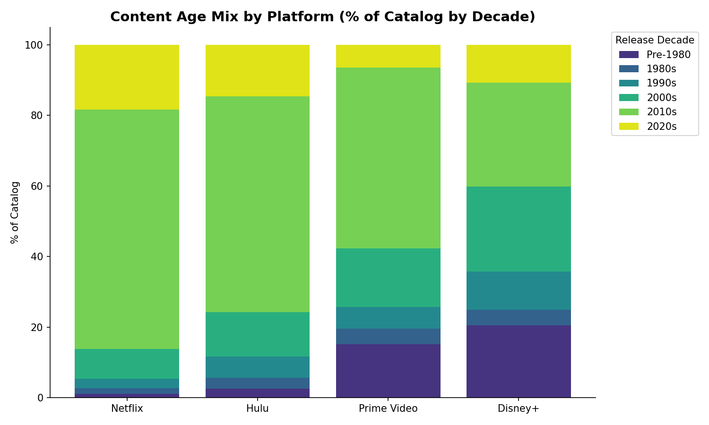
Figure 4: % of each platform's catalog by release decade

4.5 Catalog Exclusivity
Exclusivity is high industry-wide — all four platforms exceed 87% single-platform-only content, confirming that content exclusivity (not just price or UX) is now a primary competitive lever in streaming.
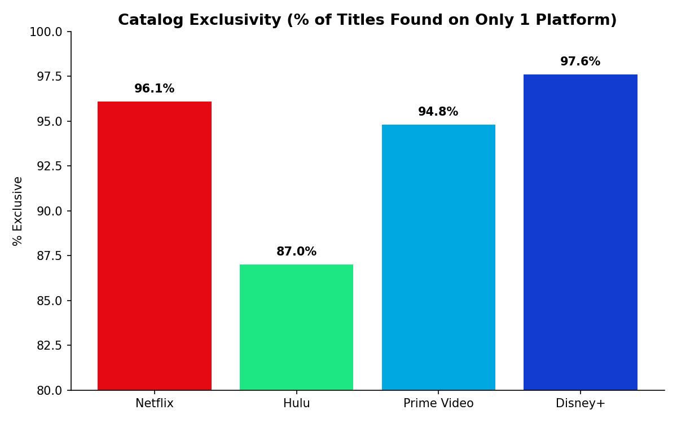
Figure 5: % of each platform's catalog found on no other platform in this dataset
Platform | % Exclusive Content
Disney+ | 97.6%
Netflix | 96.1%
Prime Video | 94.8%
Hulu | 87.0%

4.6 Audience / Age-Rating Positioning
Disney+'s catalog is overwhelmingly skewed toward "all audiences" and "7+" content, consistent with its family-brand positioning. Netflix and Prime Video carry the heaviest share of 18+ mature content, reflecting broader, adult-oriented catalogs.

5. Strategic Recommendations
Framed as a content strategy team would use these findings:
- 1. Audit catalog quality, not just size — Prime Video's low Fresh-rate (21.4%) despite the largest catalog suggests diminishing returns from volume-based acquisition; a curation/quality review of underperforming titles could improve perceived catalog value without growing spend.
- 2. Lean into quality density as differentiation — Hulu's small-but-high-quality catalog is a defensible niche; doubling down on selective, high-RT acquisitions (rather than competing on raw volume against Prime Video) plays to its strength.
- 3. Audience segmentation is already happening — Disney+'s family-content skew and Netflix/Prime's mature skew show genuine audience segmentation already exists across the market useful context for any platform considering expanding into (or defending) a specific audience segment.
- 4. Treat exclusivity as table stakes - High exclusivity (87–97.6%) across all platforms confirms licensing/originals strategy is the primary lever for differentiation any platform entering this space competes on content rights, not catalog breadth alone.

6. Limitations & Next Steps
- Data gaps: No genre, cast,director or runtime data a richer dataset (e.g., merging in IMDb data) would enable genre-level and creator-level analysis.
- Metric limitation: Rotten Tomatoes critic score is a quality proxy, not a popularity or engagement proxy pairing this with viewership/watch-time data (not publicly available) would materially change strategic conclusions.
- Next steps: Merge with a genre-tagged dataset for genre-level competitive analysis; layer in release-year trends to study whether quality-density gaps are widening or narrowing over time.

7. Appendix: SQL Techniques Demonstrated
- CASE WHEN logic — decade bucketing, conditional aggregation for per-platform pivots
- Window functions — DENSE_RANK() for top-N-per-platform ranking
- Conditional aggregation — turning row-level binary flags into a wide, platform-by-platform comparison table
- Derived fields — platform_count and rt_score computed via UPDATE + string parsing (SUBSTRING_INDEX, CAST)
- UNION-based comparison queries — combining per-platform aggregates into single result sets

SCREENSHOTS OF THE QUERIES

QUERY 1: Catalog size
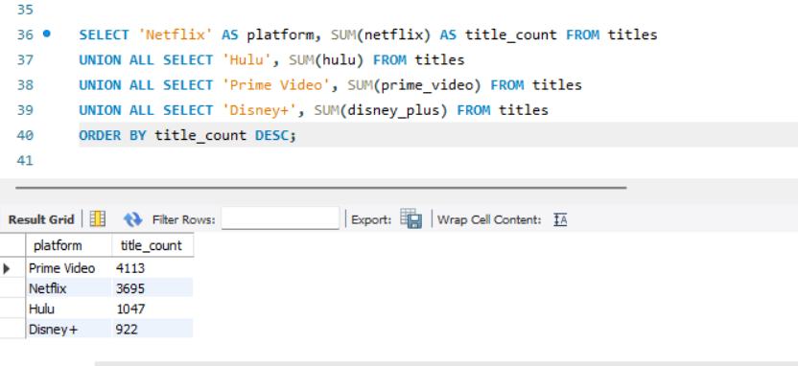

Query 2 — Avg RT score
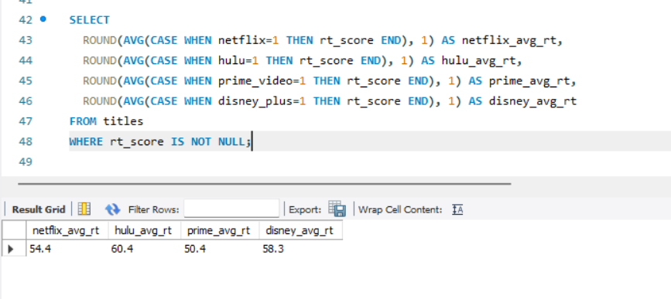

Query 3 — Content freshness (avg release year)
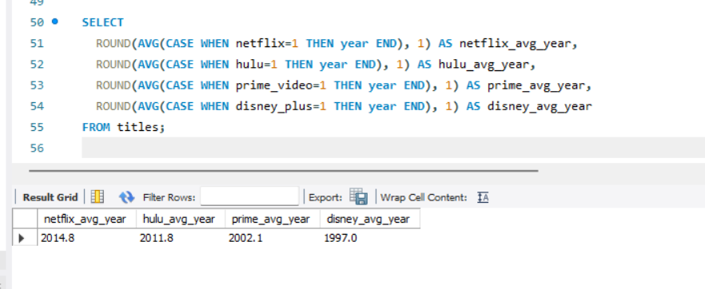

Query 4 — Exclusivity %
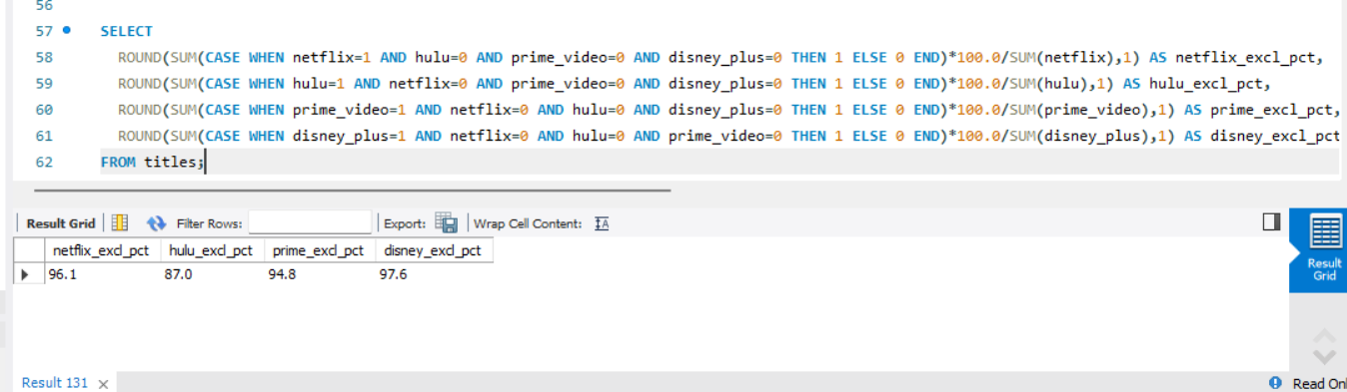

Query 5 — Decade breakdown
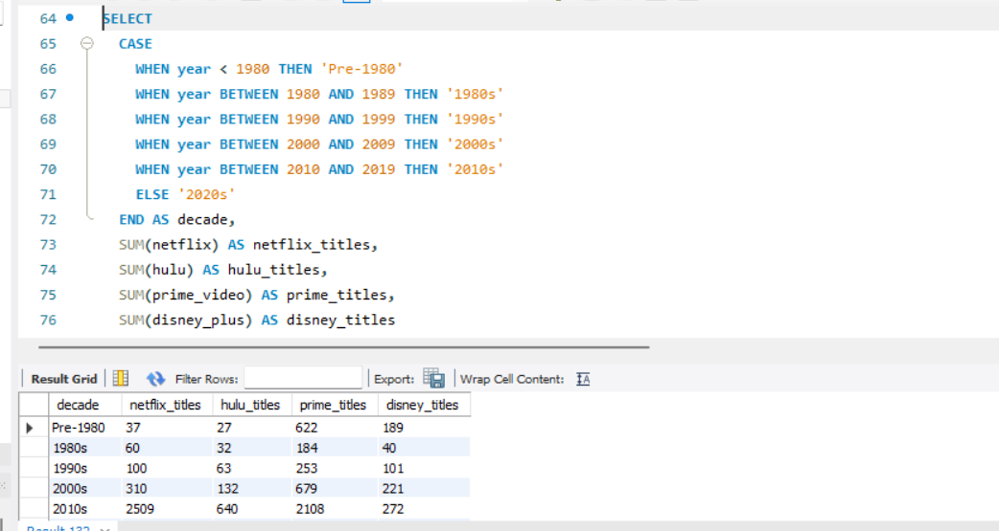

Query 6 — Age rating mix
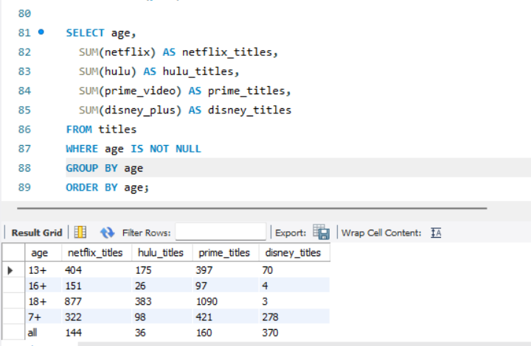

Query 7 — Top 5 titles by RT score, Netflix only
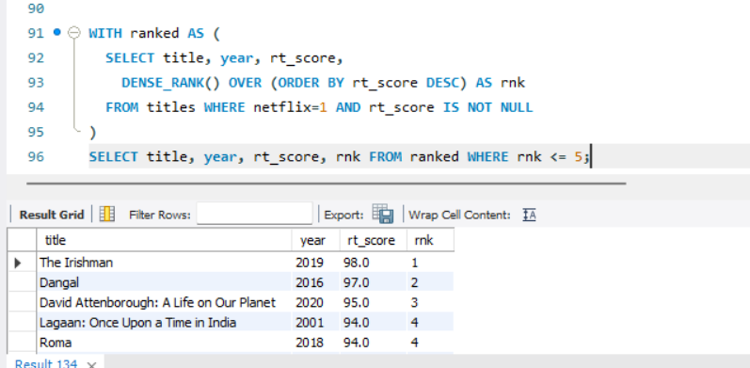

Query 8 — Quality density (Fresh %)
