INTRODUCTION TO DATA-MANAGEMENT
PROJECT REPORT
(August-December 2022)

VIDEO GAME SALES

Submitted by
Bhumika Agrawal
Registration No = 12012822

Programme and Section
BTech CSE KM110
Course Code - INT 217

Under the Guidance of
Tanima Thakur 23532

Discipline of CSE/IT
Lovely School of Computer Science & Engineering
Lovely Professional University, Phagwara


CERTIFICATE

This is to certify that Bhumika Agrawal bearing Registration no. 12012822 has completed INT217 project titled, “Video Game Sales” under my guidance and supervision. To the best of my knowledge, the present work is the result of his/her original development, effort and study.

-----------------
-----------------

Signature and Name of the Supervisor
Designation of the Supervisor

School of Computer Science & Engineering
Lovely Professional University
Phagwara, Punjab.

Date: 09-11-2022

DECLARATION

I, Bhumika Agrawal, student of BTech under CSE/IT Discipline at, Lovely Professional University, Punjab, hereby declare that all the information furnished in this project report is based on my own intensive work and is genuine.

Date: 05-11-2022 Signature

Registration No- 12012822 Bhumika Agrawal

ACKNOWLEDGEMENT

The success and outcome of this project required a lot of guidance and assistance from many people. All that I have done is only due to such supervision and assistance and I would not forget to thank them.

I respect and thank my teachers for providing me with an opportunity to do the Summer Training and giving me all the support and guidance, which made me complete the project duly. I am extremely thankful for providing such a nice support and guidance.

To owe my deep gratitude to my project teacher, who took a keen interest on my project work and guided me all along, till the completion of my project work by providing all the necessary information.

I heartily thank everyone for their guidance and suggestions during this project.

Thank You!

Table of Contents

Serial No. | Title | Page Number
1 | Introduction | Page 6
2 | Scope of the Analysis | Page 7
3 | Source of dataset | Page 8
4 | ETL | Page 9-11
5 | Analysis on Dataset | Page 12-17
6 | Screenshot of Dashboard | Page 18
7 | List of Analysis with results | Page 19-25
8 | Conclusion | Page 26
9 | References | Page 27
10 | Bibliography | Page 28

INTRODUCTION

Video games are popular all over the world. They are enjoyed by all ages. Video game industry is huge and the spending on video games per year is huge too. Sales of different types of games vary widely between countries due to local preferences.
According to the market research firm SuperData, as of May 2015, the global games market was worth USD 74.2 billion. By region, North America accounted for 23.6 billion dollars, Asia for 23.1 billion dollars, Europe for 22.1 billion dollars and South America for 4.5 billion dollars. There are different genres, publisher and platforms for video games.
According to the market research firm Newzoo, the global video game industry drew estimated revenues of over $159 billion in 2020. Mobile games accounted for the bulk of this, with a 48% share of the market, followed by console games at 28% and personal computer games at 23%.^{[1]}
Sales of different types of games vary widely between countries due to local preferences. Japanese consumers tend to purchase much more handheld games than console games and especially PC games, with a strong preference for games catering to local tastes. Another key difference is that, though having declined in the West, arcade games remain an important sector of the Japanese gaming industry. In South Korea, computer games are generally preferred over console games, especially MMORPG games and real-time strategy games. Computer games are also popular in China.
This project relates to the sales of these video games based on different regions and analyzes the sales. Also, I have analyzed which genre, platform or publisher is the most popular and has maximum number of sales.
Motivated by Gregory Smith's web scrape of VGChartz Video Games Sales, this data set simply extends the number of variables with another web scrape from Metacritic.

Scope of the Analysis
Excel dashboards make it easy to perform quick overviews of data reports rather than going through large volumes of data. Overviews help in making quick and urgent decisions since one can skim through a lot of information at once and within a short time.
This dashboard helps in tracking Key Performance Indicators (KPIs) with ease, which can help organizations track the progress on their targets. It provides a high-level summary of key aspects of our data to keep everyone at par with the progress, hence giving the organization a timely indicator for necessary action in real-time.
In this, the main goal was to analyse the sales of video games in the global regions changed during different time. The main idea was to visualize the sales for different genres, publishers and platforms and in which year which publisher games are popular, and which one was grossing at the particular time among which of the consoles and how many publishers are dominating the market with their high sales. This would give the basic idea about the most popular genres, publishers and platforms amongst all in different times. Also analysing the effect of genres on sales in different regions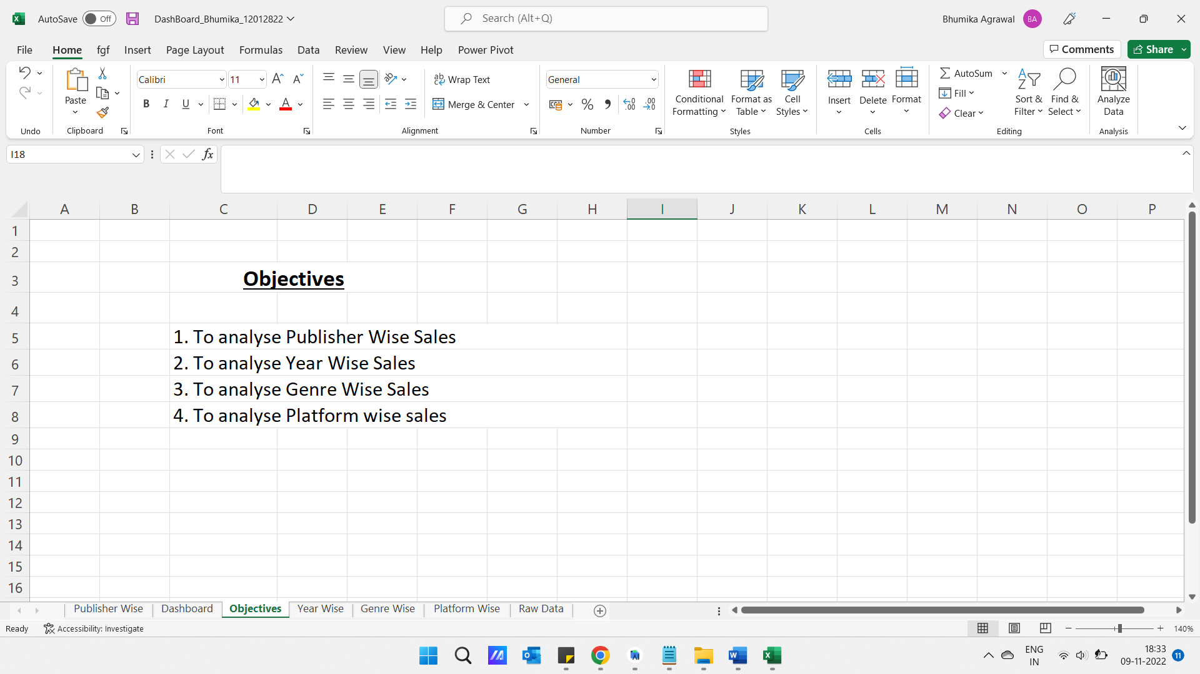

Source Of Dataset
For this project the data was collected from Kaggle (www.kaggle.com). This data gives us the idea about the sales of video games in different regions of the world. The distribution is with respect to genres, publishers and platforms.
Alongside the fields:
Name, Platform, YearofRelease, Genre, Publisher, NASales, EUSales, JPSales, OtherSales, Global_Sales, I have:
- Critic_score - Aggregate score compiled by Metacritic staff
- Criticcount - The number of critics used in coming up with the Criticscore
- User_score - Score by Metacritic's subscribers
- Usercount - Number of users who gave the userscore
- Developer - Party responsible for creating the game
- Rating - The ESRB ratings

ETL

- ETL stands for Extract, Transform and Load.
- An ETL tool extracts the data from different RDBMS source systems, transforms the data like applying calculations, concatenate, etc. and then load the data-to-Data Warehouse system.
- The data is loaded in the DW system in the form of dimension and fact tables.
- ETL combines all the three-database function into one tool to fetch data from one database and place it into another database.
- ETL is used to integrate the data with the help of three steps Extract, Transform, and Load, and it is used to blend the data from multiple sources. It is often used to build a data warehouse.
- In the ETL process, data is extracted from the source system and convert into a format that can be examined and stored into a data warehouse or any other system.

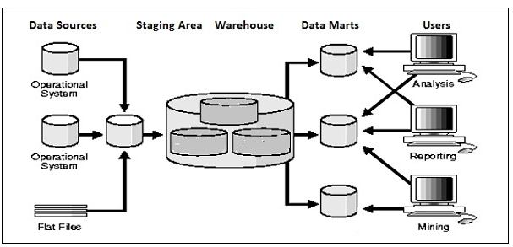

ETL Process

- ETL is a three step process.

1. Extraction

- In this step, data is extracted from the source system to the ETL server or staging area.
- Transformation is done in this area so that the performance of the source system is not degraded.
- If corrupted data is copied directly into the data warehouse from the source system, rollback will be a challenge over there.
- Staging area allows validation of the extracted data before it moves in the data warehouse.
- Validations during the extraction:
- Confirm record with the source data
- The data type should be checked
- It will check whether all the things are in place or not
- We must be sure that no spam/unwanted data is loaded

2. Transformation

- Extracted data from source server is raw and not usable in its original form. Therefore the data should be mapped, cleansed, and transformed.
- Transformation is an important step where the ETL process adds values and change the data.
- In this step, we apply a set of functions on extracted data. Data that does not require any transformation is called direct move or pass-through data.
- Validation during the Transformation:
- Filtering: For loading select only specific columns
- For example, Age cannot be more than two digits
- The required field should not be left blank.

3. Loading

- Loading the data into the data warehouse is the last step of the ETL process.
- The vast volume of data needs to load into the data warehouse for a concise time.
- For increasing the performance, loading should be optimized.
- If the loading fails, the recover mechanism should be there to restart from the point of the failure without data integrity loss.
- Admin of data warehouse needs to monitor, resume, and cancel loads as per server performance.

There are two main types of data loading processes:
- Full Load: This is where all your data is selected, moved in bulk, and then replaced by new data. Although it is not as complex to navigate through, loading time is much slower. With the overwhelming amount of data being moved at once, it is much easier for data to get lost within the big move.

- Incremental Load: This is where you are moving new data in intervals. Due to its intricate nature, delivery time is much faster than its counterpart. However, this speed comes at a cost. Incremental loads are more likely to encounter problems due to the nature of having to manage them as individual batches rather than one big group.

ANALYSIS ON DATASET

Glimpse of my data

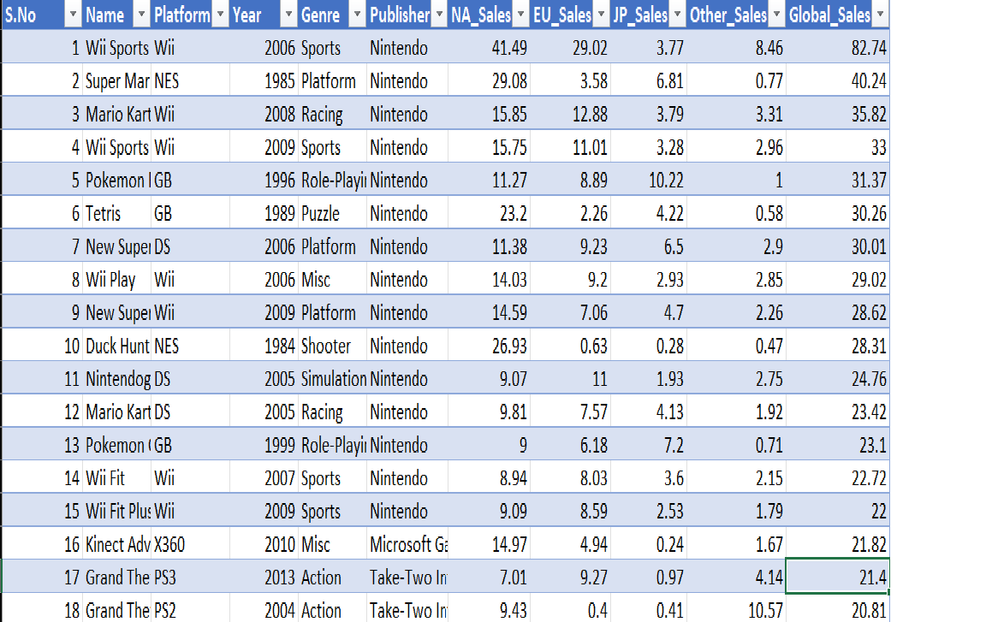

This data gives us the idea about the sales of video games in different regions of the world. The distribution is with respect to genres, publishers and platforms.
Name: Name of the video game
Platform: Platform on which the game was released or is playable
Year: Year in which the game was released
Genre: Genre the game belongs to
Publisher: Name of the publisher who created the game
NA_Sales: Sales in North America
EU_Sales: Sales in Europe
JP_Sales: Sales in Japan
Other_Sales: Sales in other countries
Global_Sales: Global Sales

Introduction:
Data analysis is a process of inspecting, cleansing, transforming, and modeling data with the goal of discovering useful information, informing conclusions, and supporting decision-making. Data analysis has multiple facets and approaches, encompassing diverse techniques under a variety of names, while being used in different technology, science, and social science domains.

Why is Data Analysis Important?
Here is a list of reasons why data analysis is such a crucial part of doing business today.
- Better Customer Targeting:
You don’t want to waste your business’s precious time, resources, and money putting together advertising campaigns targeted at demographic groups that have little to no interest in the goods and services you offer. Data analysis helps you see where you should be focusing your advertising efforts.
- You Will Know Your Target Customers Better:
Data analysis tracks how well your products and campaigns are performing within your target demographic. Through data analysis, your business can get a better idea of your target audience’s spending habits, disposable income, and most likely areas of interest. This data helps businesses set prices, determine the length of ad campaigns, and even help project the quantity of goods needed.

- Reduce Operational Costs:
Data analysis shows you which areas in your business need more resources and money, and which areas are not producing and thus should be scaled back or eliminated outright.
- Better Problem Solving Methods:
Informed decisions are more likely to be successful decisions. Data provides businesses with information. You can see where this progression is leading. Data analysis helps businesses make the right choices and avoid costly pitfalls.
- You Get More Accurate Data:
If you want to make informed decisions, you need data, but there’s more to it. The data in question must be accurate. Data analysis helps businesses acquire relevant, accurate information, suitable for developing future marketing strategies, business plans, and realigning the company’s vision or mission.

What Is the Data Analysis Process?
Answering the question “what is data analysis” is only the first step. Now we will look at how it’s performed. The data analysis process, or alternately, data analysis steps, involves gathering all the information, processing it, exploring the data, and using it to find patterns and other insights. The process consists of:

- Data Requirement Gathering:
Ask yourself why you’re doing this analysis, what type of data analysis you want to use, and what data you are planning on analyzing.
- Data Collection:
Guided by the requirements you’ve identified, it’s time to collect the data from your sources. Sources include case studies, surveys, interviews, questionnaires, direct observation, and focus groups. Make sure to organize the collected data for analysis.
- Data Cleaning:
Not all the data you collect will be useful, so it’s time to clean it up. This process is where you remove white spaces, duplicate records, and basic errors. information is mandatory before sending the information on for analysis.
- Data Analysis:
Here is where you use data analysis software and other tools to help you interpret and understand the data and arrive at conclusions. Data analysis tools include Excel, Python, R, Looker, Rapid Miner, Chartio, Metabase, Redash, and Microsoft Power BI.
- Data Interpretation:
Now that you have your results, you need to interpret them and come up with the best courses of action, based on your findings.
- Data Visualization:
Data visualization is a fancy way of saying, “graphically show your information in a way that people can read and understand it.” You can use charts, graphs, maps, bullet points, or a host of other methods. Visualization helps you derive valuable insights by helping you compare datasets and observe relationships.

What Is the Importance of Data Analysis in Research?
A huge part of a researcher’s job is to sift through data. That is literally the definition of “research.” However, today’s Information Age routinely produces a tidal wave of data, enough to overwhelm even the most dedicated researcher.
Data analysis, therefore, plays a key role in distilling this information into a more accurate and relevant form, making it easier for researchers to do to their job.
Data analysis also provides researchers with a vast selection of different tools, such as descriptive statistics, inferential analysis, and quantitative analysis.
So, to sum it up, data analysis offers researchers better data and better ways to analyse and study said data.

What is Data Analysis: Types of Data Analysis
There are a half-dozen popular types of data analysis available today, commonly employed in the worlds of technology and business. They are:
- Diagnostic Analysis:
Diagnostic analysis answers the question, “Why did this happen?” Using insights gained from statistical analysis (more on that later!), analysts use diagnostic analysis to identify patterns in data. Ideally, the analysts find similar patterns that existed in the past, and consequently, use those solutions to resolve the present challenges hopefully.
- Predictive Analysis:
Predictive analysis answers the question, “What is most likely to happen?” By using patterns found in older data as well as current events, analysts predict future events. While there’s no such thing as 100 percent accurate forecasting, the odds improve if the analysts have plenty of detailed information and the discipline to research it thoroughly.
- Prescriptive Analysis:
Mix all the insights gained from the other data analysis types, and you have prescriptive analysis. Sometimes, an issue can’t be solved solely with one analysis type, and instead requires multiple insights.

- Statistical Analysis:
Statistical analysis answers the question, “What happened?” This analysis covers data collection, analysis, modeling, interpretation, and presentation using dashboards. The statistical analysis breaks down into two sub-categories:

- Descriptive:
Descriptive analysis works with either complete or selections of summarized numerical data. It illustrates means and deviations in continuous data and percentages and frequencies in categorical data.
- Inferential:
Inferential analysis works with samples derived from complete data. An analyst can arrive at different conclusions from the same comprehensive data set just by choosing different samplings.
- Text Analysis:
Also called “data mining,” text analysis uses databases and data mining tools to discover patterns residing in large datasets. It transforms raw data into useful business information. Text analysis is arguably the most straightforward and the most direct method of data analysis.
Specific Requirements, functions and formulas

I used different formulas for data cleaning, data processing and modelling and algorithms.
Main function of excel that I have used are

- Pivot table
- Function analyser (Slicer)
- Different types of graphs
Screenshot of Dashboard

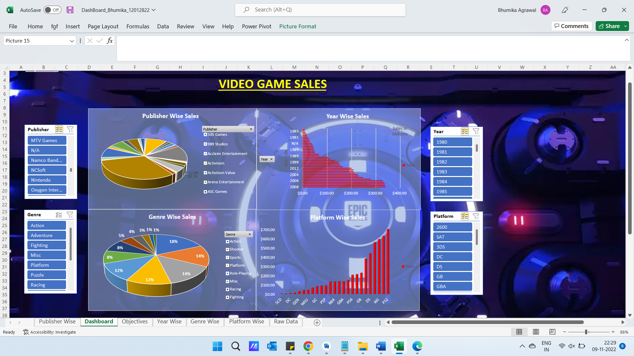

List of Analysis with results

Analysis results are mentioned below:

1. Publisher Wise Sales

Introduction & analysis
In this I filtered how different publishers had their share in the global market.
By this we can also predict that which publisher had more dominance in the market their sales graph looks like this:

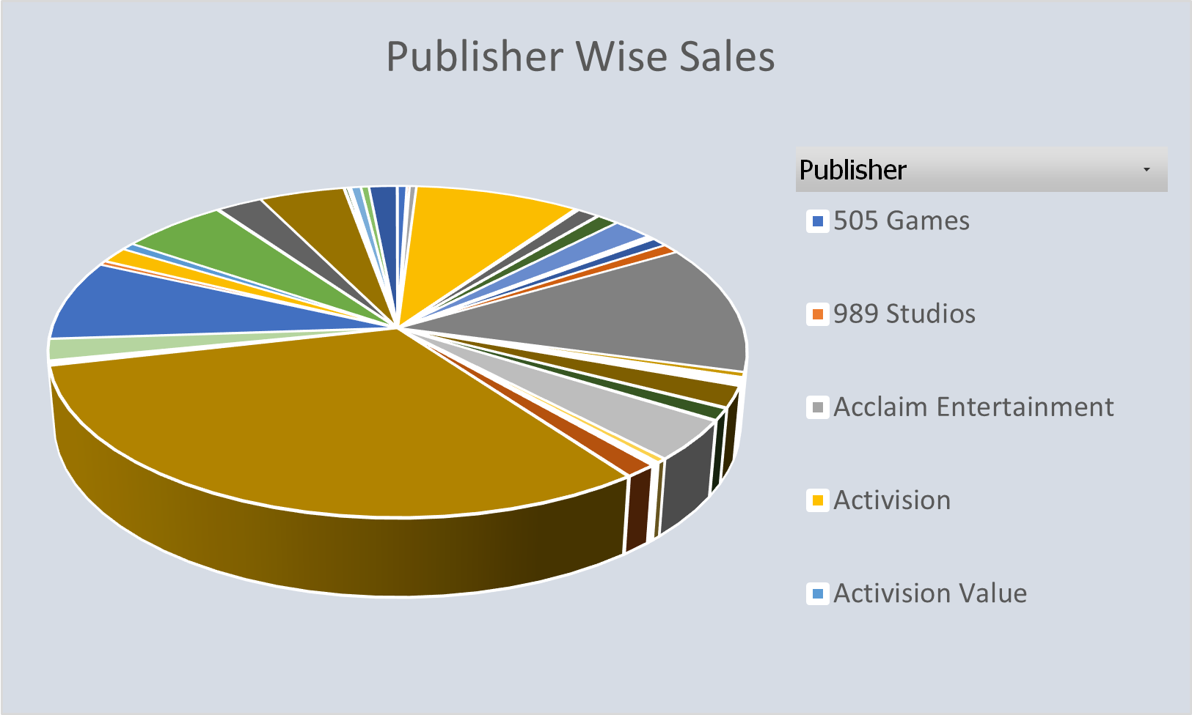

2. Year Wise Sales

Introduction & analysis
In this I filtered how the sales of games are rising by the years as you we can see here in the chart how the market of the game increased drastically in the following years by this, we can also observe that how different games in the different years can drastically increase the market of the games. The graph of the year-wise sales is:

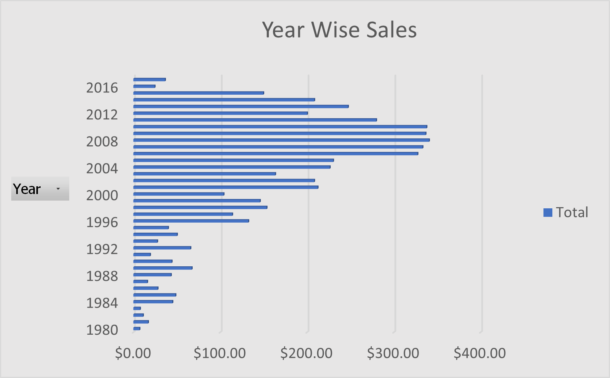

3. Genre Wise Sales

Introduction & analysis
In this I filtered how the sales of games of different genres are rising by which we can also assume and analyze that which types of games are being liked or bought much more by the consumers all around the globe as you we can see here in the chart how the game of different genre are generating revenue compared to other genre of the game this will help us understanding the interest of the people in the particular genre and the game concept. The genre-wise sales graph is:
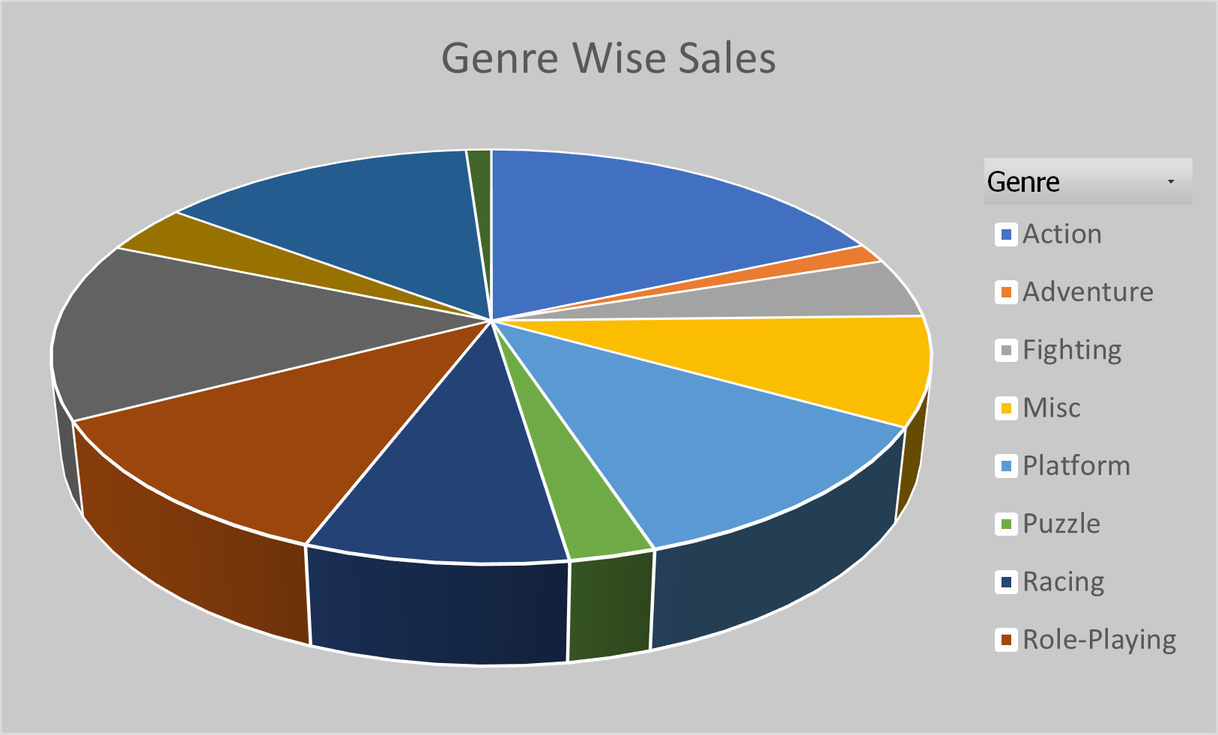

4. Platform wise sales

Introduction & analysis

In this I filtered out how in the recent times different consoles games are being sold in the market which also helps us to find out which console had major percentage in the market and how in recent years different consoles launched and how some consoles got extinct from the market. By this we can also assume that how once a famous console is now vanished completely from the market and how different publishers make their game compatible with majority of consoles so to reach majority of the consumers. The graph for the platform wise sales is

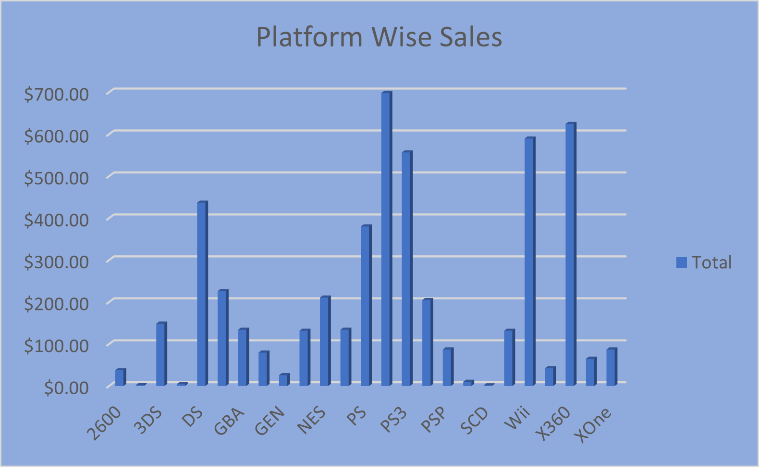

VISUALIZATION

Data visualization is viewed by many disciplines as a modern equivalent of visual communication. It involves the creation and study of the visual representation of data.
To communicate information clearly and efficiently, data visualization uses statistical graphics, plots, information graphics and other tools. Numerical data may be encoded using dots, lines, or bars, to visually communicate a quantitative message. Effective visualization helps users analyze and reason about data and evidence. It makes complex data more accessible, understandable and usable. Users may have analytical tasks, such as making comparisons or understanding causality, and the design principle of the graphic (i.e., showing comparisons or showing causality) follows the task. Tables are generally used where users will look up a specific measurement, while charts of various types are used to show patterns or relationships in the data for one or more variables.

FUTURE SCOPE

Data analytics is a process through which data is cleaned, analyzed and modelled using tools. This data is then used to derive insights. The insights are then used for technology related decision-making purposes. There are many techniques that data analysts use in different fields of work.
In the world of technology, Data analytics is used for making strategies to get the desired technology results. Today, data analytics has become a big career option in India. As a result, big data analytics courses are in huge demand.
Technology have realized the importance of utilizing big data analytics to maximize their profits. They know that it is vital for their growth and for the future health of their technology. Today, major technology decisions are taken by utilizing the insights derived from data related to the organization or industry related data.
As competition increases and customers are flooded with choices, it has become important to move faster in the market and that too with accuracy.

Results
From the above visualizations we can clearly say that PS2 and X360 are the most popular platforms amongst all followed by Wii
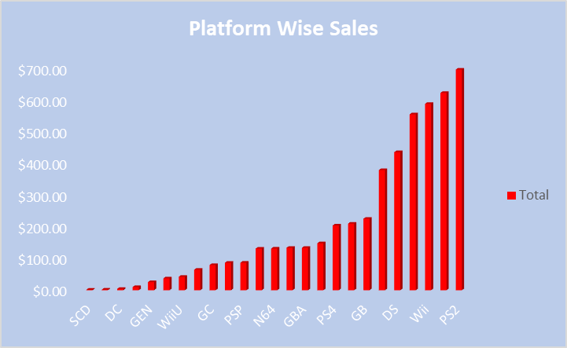
Action genre is the most popular genre of all and is followed by shooting and sports respectively.
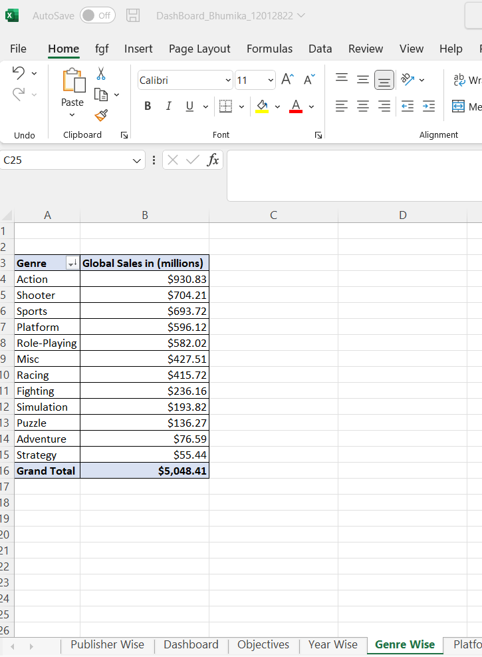
We can also see that Nintendo following with Electronic Arts and Activision had more sales in the market capturing more than 50% of the market.
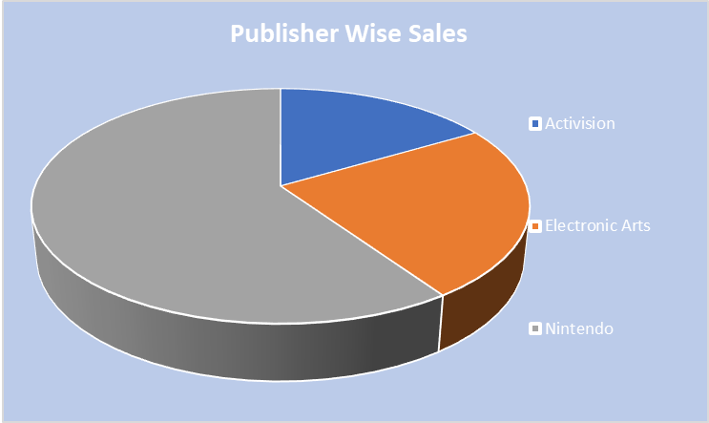
It is obvious from the year wise sales graph that sales kept on increasing with the coming years which signifies that the gaming industry is growing.
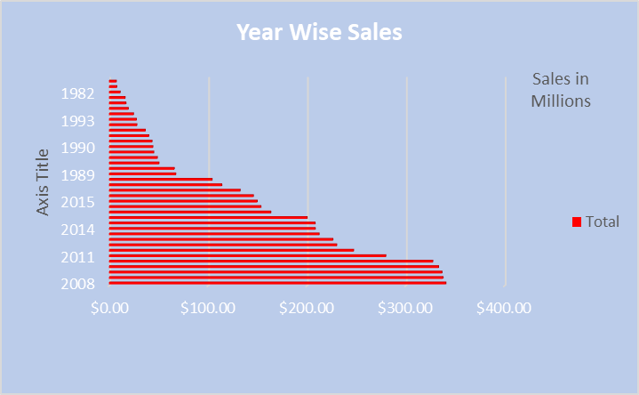

From the above tests we can say that the genres less popular cause significant change in sales in all regions as compared to the ones that are more popular.

Conclusion
By the above data we can say that action games on PC or PlayStation for that matter are the most popular and are the ones responsible for maximum sales all over the globe. Also, as these games are so abundant and popular (ranking wise), variation in the sales of one or two such games would not cause significant change in the overall sales.
After completing this project, I concluded that this project was the good opportunity to implement my information that I have learnt during my lectures. This project is more informative and more helpful for understanding the concept of Dashboard.
This project is only a small and easy one, but it is enough to implement my concept. I can further try much harder to make much more efficient and useful dashboard that can benefit other.

References
- Kaggle (https://www.kaggle.com/datasets/rush4ratio/video-game-sales-with-ratings)
- Wikipedia (https://en.wikipedia.org/wiki/Video_game)
- MS Excel (https://www.microsoft.com/en-ww/microsoft-365/excel)
- Reference Guide (https://www.parse.ly/help/kb/dashboard-reference-guide)

Bibliography

1. FUNDAMENTALS OF BUSINESS ANALYTICS
BY R.N. PRASAD, SEEMA ACHARYA, WILEY

2. EXCEL HACKS,2/ED TIPS & TOOLS FOR STREAMLINING YOUR SPREADSHEETS
BY DAVID, SHROFF/O'REILLY

3. EXCEL 2019 BIBLE BOOK
BY JOHN WALKENBACH, MICHAEL ALEXANDER, AND RICHARD KUSLEIKA

