**HTML**

* HTML → Hypertext Markup Language
* Basic Building block
* Skeleton of the web
* Description of the web
* Not Case-sensitive

**Tags**

* It tells the browser how to render different elements
* Eg: <p>, <h1>, <a>, <img>
* Opening tag – Content – Closing tag
* <h1> Hello World </h1>
* <div> → This is a generic container, which goes hand in hand with CSS

→ Also known as the Division tag, can be used with text, img, link etc

→ Block element

* <span> → Same as div its just that it is an *inline* element
* <pre> tag → represents text as written in the HTML document
* Empty tag/Self closing tag - <br/>, <img/>, <input/>

Typically used to insert/embed something in the document

**Text Elements**

* Two Types → Block elements and Inline Elements
* Block elements
* Takes up the full width
* <p>, <h1> to <h6>, <section>, <article>, <ul>/<ol>
* Inline
* Takes up as much necessary space
* <img>, <a>, <strong>, <em>

**Lists**

* Ordered list → 1, 2, 3 (or) a, b, c <ol>
* Unordered list → Something like dots or arrows (bullet ordering) <ul>
* Description list → Displays elements in definition form like in dictionary <dl>

<ol>

<li></li>

<li></li>

</ol>

**Attributes**

* Provide additional info about element
* Properties of a tag
* Eg: <img> tag has the properties like src, alt, width, height
* href is used with anchor tags for specifying links.
* Download is an attribute of the anchor tag.

**Dissection of the HTML Boilerplate Code**

**<!DOCTYPE html>**

**<html lang="en">**

**<head>**

**<meta charset="UTF-8">**

**<meta name="viewport" content="width=device-width, initial-scale=1.0">**

**<title>Document</title>**

**</head>**

**<body>**

**</body>**

**</html>**

1. <!DOCTYPE html> → Tells your browser that you are using an HTML V5 version
2. <html lang = “en”> → Tells that the content of the webpage is in English
3. <head> → This tag includes metadata, title, styling, viewport, etc
4. <metadata> → Data about the data
5. <meta charset=”UTF-8”> → The character set used in the webpage
6. Meta viewport tag is used to set the width and initial scale of a webpage, allowing it to be optimized for different device sizes.
7. <body> → Actual content resides here + <script> to be inside body below all the content

**Formatting tags**

* Bold, italic, del (strikes off the text), small, mark (highlight the text), sup, sub
* Quotation and Citation tags, blockquote, q, cite, address, abbr, u (underline)
* <blockquote> → Used to enclose a section of text quoted from another source
* <q> → For shorter inline quotes
* <cite> → Used to cite the author of the quote
* <blockquote cite = “www.something.com”></blockquote>

**Tables**

* <table> tag → Consists of <tr> (table row), <td> (table data), <th> (table head)
* Border-collapse: collapse → for getting single line as a border
* <caption> → Name of the table
* To bring the caption name in the bottom add caption-side: bottom; in css
* <thead>, <tbody>, <tfoot> → Used for best practice
* Colspan → To stretch the column to multiple rows
* Rowspan → To stretch the row to multiple col
* Colgroup → If we want to style a specific column
* We will use col - span - style for styling

<colgroup>

<col span="3" style="background-color: green;">

</colgroup>

**Anchor Tag**

* To call → <a href = “tel:+919457852632”>Call me</a>
* To mail → <a href = “mailto:balapriya1801@gmail.com”>Mail</a>
* To link → <a href = “www.hello.com”>Click me</a>
* To download → <a href = “docs.pdf” download>Click here to download</a>
* To bookmark → <a href = “#courses”>Go to courses</a>, where # courses is an id of that particular section
* To make scrolling smooth → inside style tag, html { scroll-behavior : smooth; }

**Semantic Tags**

* Tags which tell something about the content
* Eg: <p>, <article>, <section>, <table>, <form>, <aside>, <nav>, <header>, <figcaption>, <main>
* They are used for better SEO and for better understanding of web-page by other developers

**Forms**

* <form> tag
* <label> → For labeling the form
* <input type = “text” name= “user”> → For textarea
* Radio, checkbox, button, select etc.

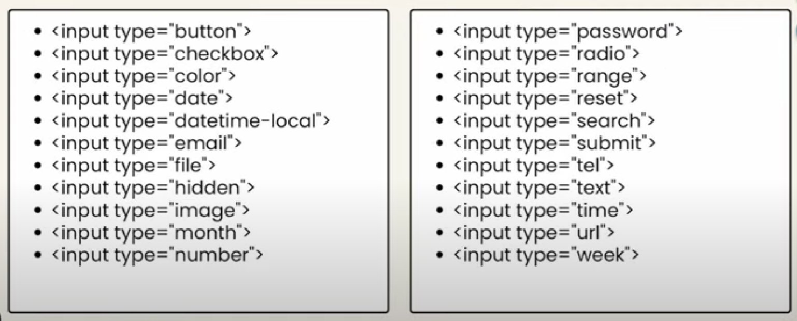

For and id together are used to bind the label and the input.

After binding them, by clicking only the text the input box will be selected.

* Header vs h1 - Header is a container which typically includes site title, logo and sometimes the main navigation menu.
* Multiple header tags can be used in one HTML document. However, header tags cannot be created inside a footer, address, or another header tag.
* Body tag creates the body of the html file, body contains all tags like <h1>-<h6>, <p>, <a>, <ul>, <ol>, etc. and includes the <main> tag. whereas the main tag lies inside the body tag which is used to section the main content of the webpage into a container. The content of the <main> element is unique in all sets of documents.
* Rel - specifies the relationship between the current document and the linked document.
* Iframe tag is used to embed other documents within the current HTML file. It can be used for displaying an advertisement, providing a media player, or displaying another website (to embed a YouTube video or google maps).
* **HTML5 Server-Sent Events (SSEs)** are a new way of pushing data from the server to the client. This technology allows the client to receive updates from the server without the need for the client to make a request. This makes it more efficient than traditional methods such as AJAX requests, as there is no need for the client to continually poll the server for updates. SSEs are also more secure than other methods, as the server only sends data when it is available, rather than allowing the client to make frequent requests. SSEs are also useful for applications such as real-time data streaming, where data needs to be pushed from the server to the client in real time.
* HTML5 has an attribute called “**contenteditable**” which can be set on any element such as DIV, P, UL, etc. This attribute allows the content of the element to be edited directly in the browser, without the need for a form field.