**SE**

**ASSIGNMENT**

**Q1. What is software? What is software engineering?**

**Ans.** The software is a collection of integrated programs.

Software Engineering is an engineering branch related to the evolution of software product using well-defined scientific principles, techniques, and procedures.

**Q2. Explain types of software.**

**Ans.**

* **Application software:** The most common type of software, application software is a computer software package that performs a specific function for a user, or in some cases, for another application. An application can be self-contained, or it can be a group of programs that run the application for the user. Examples of modern applications include office suites, graphics software, databases and database management programs, web browsers, word processors, software development tools, image editors and communication platforms.
* **System software:** These software programs are designed to run a computer's application programs and hardware. System software coordinates the activities and functions of the hardware and software. In addition, it controls the operations of the computer hardware and provides an environment or platform for all the other types of software to work in. The OS is the best example of system software; it manages all the other computer programs. Other examples of system software include the firmware, computer language translators and system utilities.
* **Driver software:** Also known as device drivers, this software is often considered a type of system software. Device drivers control the devices and peripherals connected to a computer, enabling them to perform their specific tasks. Every device that is connected to a computer needs at least one device driver to function. Examples include software that comes with any nonstandard hardware, including special game controllers, as well as the software that enables standard hardware, such as USB storage devices, keyboards, headphones and printers.

**Q3. What is SDLC? Explain each phase of SDLC.**

**Ans.** The software development life cycle is a process that development teams use to create awesome software that's top-notch in terms of quality, cost-effectiveness, and time efficiency. The main goal is to minimize risks long before deciding how to launch your SaaS product and ensure the software meets the customer's expectations during and after production.

**Phases of SDLC :**

1. Planning & Analysis

The first phase of the SDLC is the project planning stage where you are gathering business requirements from your client or stakeholders. This phase is when you evaluate the feasibility of creating the product, revenue potential, the cost of production, the needs of the end-users, etc.

To properly decide what to make, what not to make, and what to make first, you can use a feature prioritization framework that takes into account the value of the software/update, the cost, the time it takes to build, and other factors.

2. Define Requirements

This phase is critical for converting the information gathered during the planning and analysis phase into clear requirements for the development team. This process guides the development of several important documents: a software requirement specification (SRS) or product specification, a Use Case document, and a Requirement Traceability Matrix document.

3. Design

The design phase is where you put pen to paper—so to speak. The original plan and vision are elaborated into a software design document (SDD) that includes the system design, programming language, templates, platform to use, and application security measures. This is also where you can flowchart how the software responds to user actions.

4. Development

The actual development phase is where the development team members divide the project into software modules and turn the software requirement into code that makes the product.

This SDLC phase can take quite a lot of time and specialized development tools. It’s important to have a set timeline and milestones so the software developers understand the expectations and you can keep track of the progress in this stage.

5. Testing

Before getting the software product out the door to the production environment, it’s important to have your quality assurance team perform validation testing to make sure it is functioning properly and does what it’s meant to do. The testing process can also help hash out any major user experience issues and security issues.

In some cases, software testing can be done in a simulated environment. Other simpler tests can also be automated.

6. Deployment

During the deployment phase, your final product is delivered to your intended user. You can automate this process and schedule your deployment depending on the type. For example, if you are only deploying a feature update, you can do so with a small number of users (canary release). If you are creating brand-new software, you can learn more about the different stages of the software release life cycle (SRLC).

7. Maintenance

The maintenance phase is the final stage of the SDLC if you’re following the waterfall structure of the software development process. However, the industry is moving towards a more agile software development approach where maintenance is only a stage for further improvement.

In the maintenance stage, users may find bugs and errors that were missed in the earlier testing phase. These bugs need to be fixed for better user experience and retention. In some cases, these can lead to going back to the first step of the software development life cycle.

**Q4. What is DFD? Create a DFD diagram on Flipkart.**

**Ans.** A Data Flow Diagram (DFD) is a traditional visual representation of the information flows within a system. A neat and clear DFD can depict the right amount of the system requirement graphically. It can be manual, automated, or a combination of both. It shows how data enters and leaves the system, what changes the information, and where data is stored.

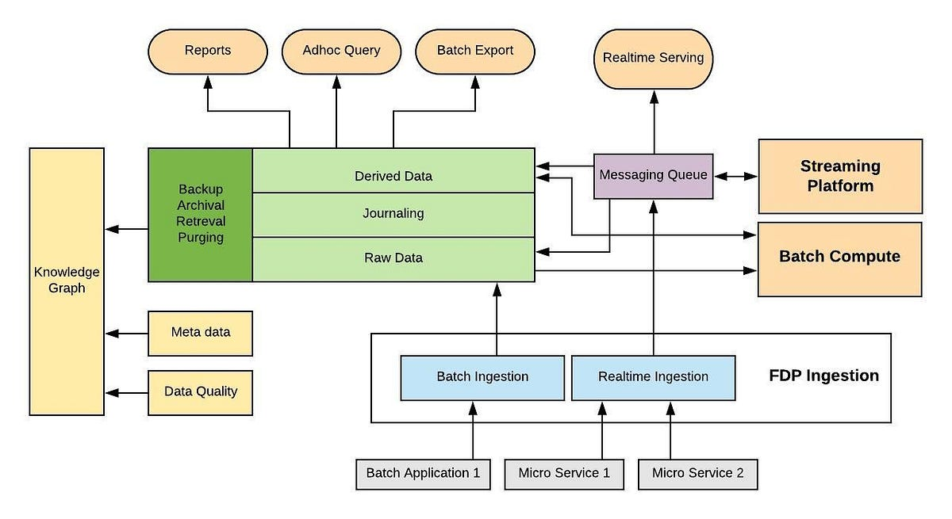

**Q5. What is Flow chart? Create a flowchart to make addition of two**

**Numbers.**

**Ans.** A flowchart is a picture of the separate steps of a process in sequential order. It is a generic tool that can be adapted for a wide variety of purposes, and can be used to describe various processes, such as a manufacturing process, an administrative or service process, or a project plan. It's a common process analysis tool and one of the seven basic quality tools.

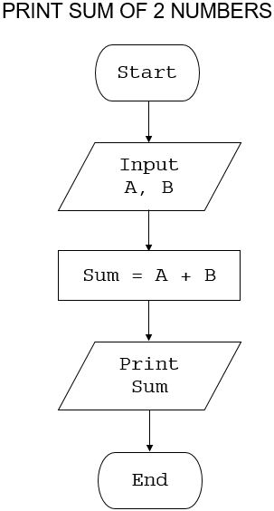

**Q6. What is Use case Diagram? Create a use-case on bill payment on paytm.**

**Ans.** A use case diagram is used to represent the dynamic behavior of a system. It encapsulates the system's functionality by incorporating use cases, actors, and their relationships. It models the tasks, services, and functions required by a system/subsystem of an application. It depicts the high-level functionality of a system and also tells how the user handles a system.

