**Task-1**

**OBJECTIVE**: Create a comprehensive documentation guide for 2 of the following Python visualization libraries: Matplotlib, Seaborn, Plotly, Bokeh, and Pandas. Your guide should focus on the variety of graphs each library can generate and include practical examples with code snippets.

**(A)SEABORN:-**

Seaborn is a library for making statistical graph for visualization. Its is advantage over matplotlib that is in Matplotlib we used to represent only 2D form of data but in Seaborn library we can draw the statistical graph using Python. Its is built on Matplotlib and Pandas.

**TYPES OF CHARTS/GRAPHS/PLOTS OF SEABORN:**

1. Line Plot
2. Count Plot
3. Bar Plot
4. Pair Plot
5. Scatter Plot
6. Histogram

**Importing Seaborn Library:**

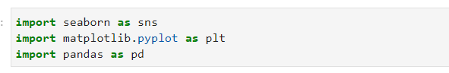

**Creating A DataFrame From List:**

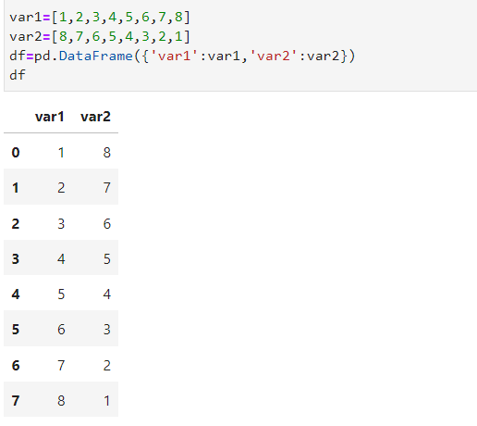

The DataFrame function in Pandas is used to create a 2-D labeled data structure with columns of potentially different types.It can be considered as spreadsheet or SQL table , or a dictionary of Series objects.

**1)Line-Plot Graph :-**

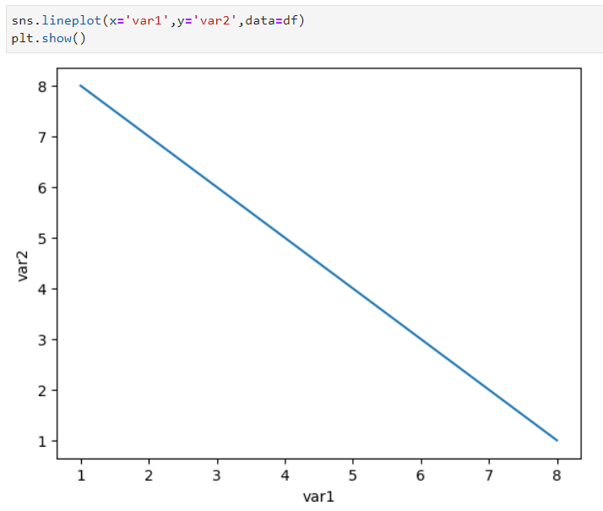

A Line Plot is the simplest plot in all plotting types, as it is the visualization of a single function. This plot helps us to see the relationship between X-Axis, Y-Axis and it also takes some parameters such as hue, size, color, etc.

This is the line-plot graph of the dataframe created above using two lists var1 and var2.

plt.show() function is used to only display the graph.

**2)Count-Plot Graph :-**

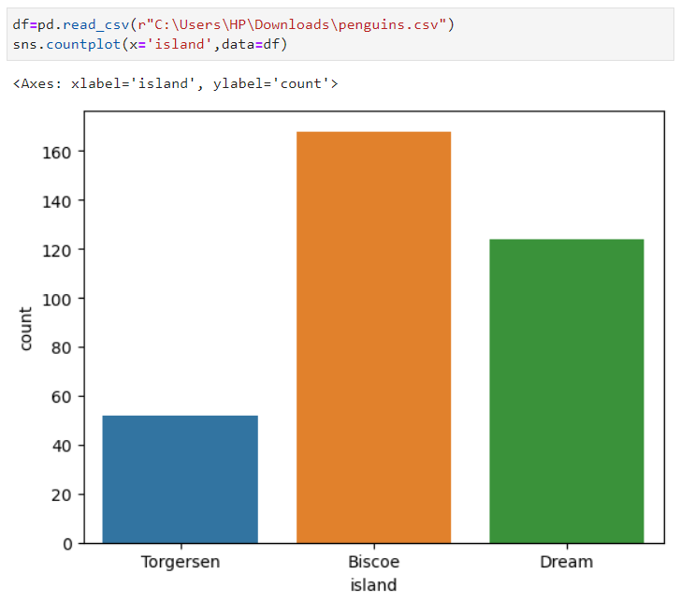

A Count Plot is used to show the counts of observations in each categorical bin using bars.

This method is accepting the parameters X, Y  which take the name of a variable in data, hue it is an Optional Parameter it helps to take column name for Color Encoding. Data is also an optional parameter that takes DataFrame, Array, Or List of Arrays, Dataset for Plotting.

**3)Bar-Plot Graph :-**

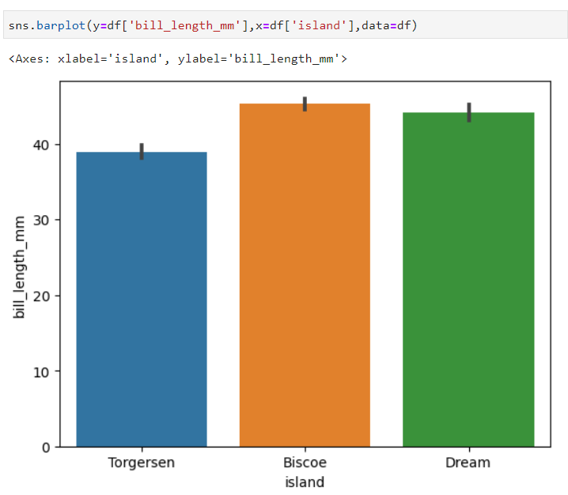

A bar chart is a way of comparing a set of categorical data. It is better to convert continuous data to bins before plotting. The bar chart displays data using several bars, each representing a particular

category. This method is accepting the parameters x, y  which take the name of a variable in data, hue it is an optional parameter it helps to take column name for color encoding.

**4)Pair-Plot Graph :-**

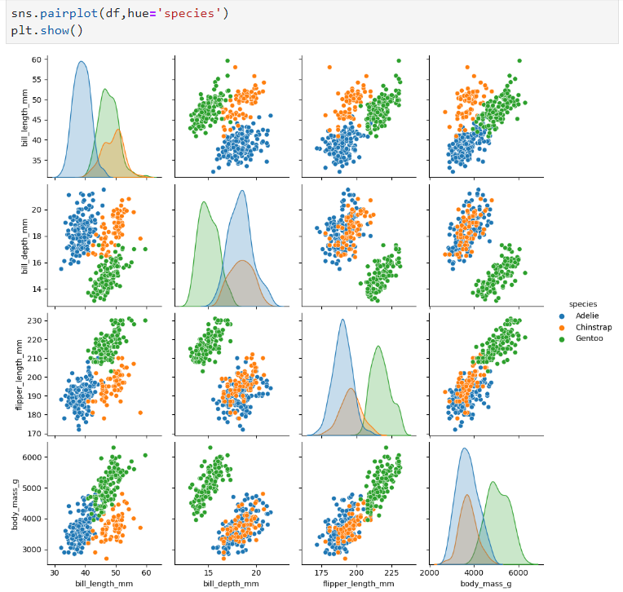

Pair plot creates a grid of axis such that each numeric variable in data will create a plot between each other the y-axis across a single row and the x-axis across a single column. The diagonal plots are a univariate distribution plot that helps to draw the marginal distribution of the data in each column.

A pair plot pairwise relationships with other columns in the data frame and also plot pair plot with itself.

**5)Scatter-Plot Graph :-**

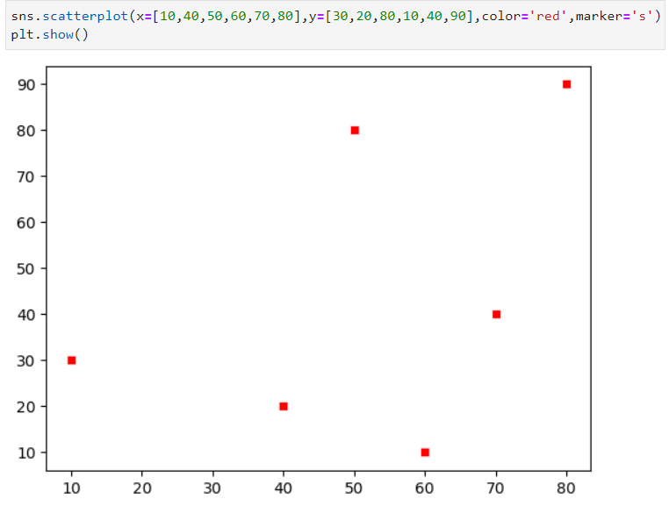

Scatter plot is the same as a line plot, in a line plot instead of points being joined by line segments, the points are shown individually with a dot, circle, or any other shape. The position of each marker on the horizontal and vertical axis indicates values for an individual data point. This plot is used to observe relationships between variables.

This method is accepting the parameters x, y  which take the name of a variable in data, hue it is an optional parameter it helps to take column name for color encoding. Marker is a parameter that is used to change the shape of the point which is shown in the plot.

**(B)MATPLOTLIB:**

Matplotlib is a powerful plotting library in Python used for creating static, animated, and interactive visualizations. Matplotlib’s primary purpose is to provide users with the tools and functionality to represent data graphically, making it easier to analyze and understand.

**TYPES OF CHARTS/GRAPHS/PLOTS OF MATPLOTLIB:**

1. LINE GRAPH
2. STEM PLOT
3. BAR CHART
4. HISTOGRAMS
5. SCATTER PLOT
6. STACK PLOT
7. BOX PLOT
8. PIE CHART
9. ERROR PLOT
10. VIOLIN PLOT
11. 3D PLOTS

**Importing Matplotlib Library :-**

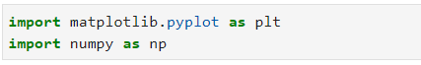

**1)Bar-Plot Graph :-**

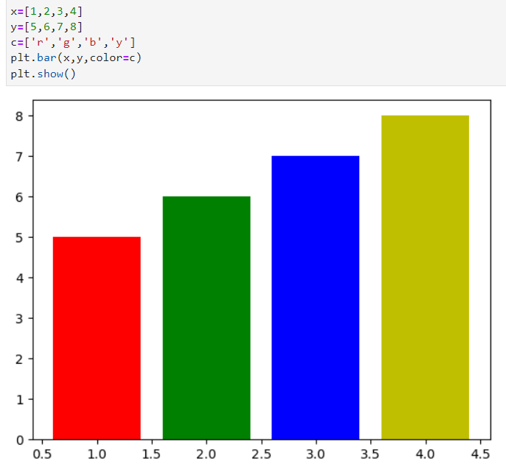

Barplot is used for categorical representation. The values in a bargraph are dependent on each other. It is a graph that represents the category of data with rectangular bars with lengths and heights that is proportional to the values which they represent. The bar plots can be plotted horizontally or vertically. A bar chart describes the comparisons between the discrete categories.

One of the axis of the plot represents the specific categories being compared, while the other axis represents the measured values corresponding to those categories.

**2)Scatter Plot :-**

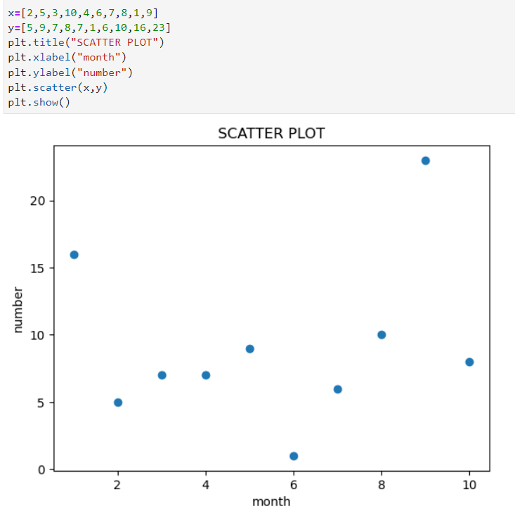

Scatter Chart is used to represent a cluster to see the range of the variables.

They are used to plot data points on horizontal and vertical axis in the attempt to show how much one variable is affected by another.

Each row in the data table is represented by a marker the position depends on its values in the columns set on the X and Y axes.

A third variable can be set to correspond to the color or size of the markers, thus adding yet another dimension to the plot.

**3)Line Chart :-**

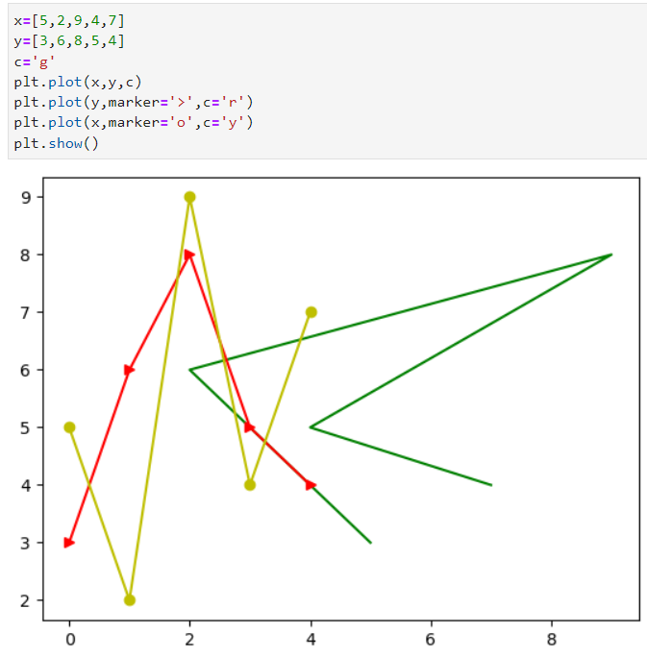

Matplotlib is a data visualization library in Python. The pyplot, a sublibrary of matplotlib, is a collection of functions that helps in creating a variety of charts.

Line chartsare used to represent the relation between two data X and Y on a different axis.

**4)Histogram :-**

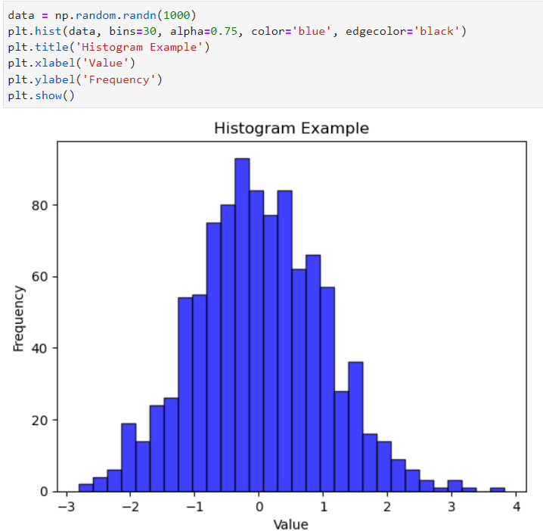

Histogram is used as a count plot. It is used to detect how many values lie in a given range.It is an accurate representation of the distribution of numerical data.

It is an estimate of the probability distribution of a continuous variable. It is a kind of bar graph.

The parameters required to construct a histogram are x, bins, range, density, cimulative, histtype.

**5)Pie-Chart :-**

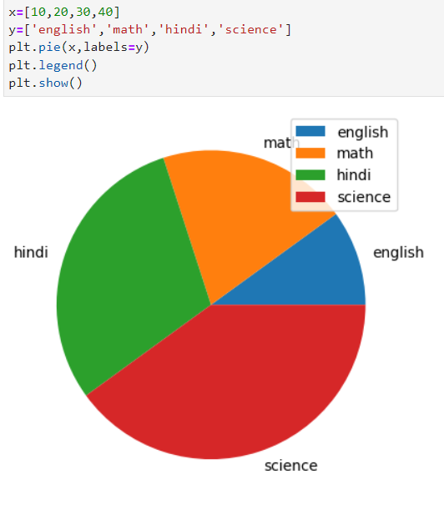

A pie chart is a circular statistical graphic that is divided into slices to illustrate numerical proportions.

Each slice represents a category's contribution to the whole, with the size of each slice being proportional to the quantity it represents.

**(C)DIFFERENCE BETWEEN SEABORN AND MATPLOTLIB :-**

|  |  |  |
| --- | --- | --- |
| ***Aspects*** | ***Seaborn*** | ***Matplotlib*** |
| *Ease of use* | Easier to use for quick and aesthetically pleasing statistical plots | Requires more code but offers greater flexibility. |
| *Customization options* | Limited but simpler customization options | Excels in customization,  allowing detailed control over every aspect. |
| *Interactivity* | Basic interactivity, relies on Matplotlib’s backend | More interactive capabilities, especially with additional libraries. |
| *Performance with Large Datasets* | Handles medium-sized datasets effectively. | Generally performs better with large datasets due to lower-level control. |