**Diwali Sales Analysis**

**Problem Statement:**

1. Which buyer is more buy the Product on the basis of Gender?
2. What is the count of age group on the basis of Gender and calculate the buyer for most age-group?
3. From which state maximum amount of sales has been done and maximum order has been place?
4. Who is the most buyer on the basis of marital status and gender ?
5. From which sector maximum amount of sales has been done?
6. Which product has been sold maximum from which Product Category?
7. Find Top 10 Most sold Products.

**Visulization Report :**

1)From Below graph shows most of the buyers are females.

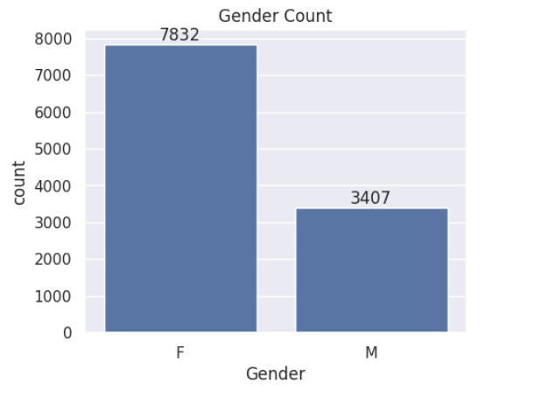

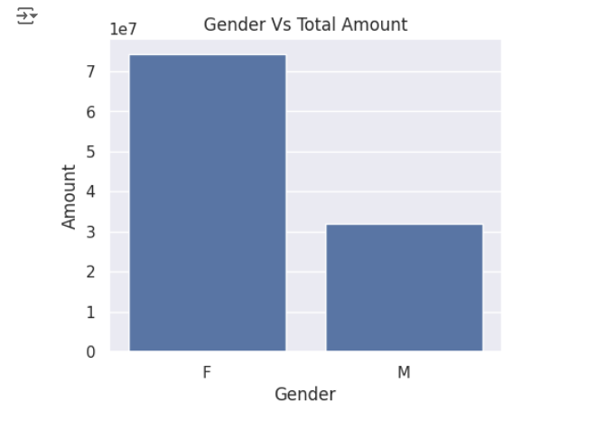

2)From Below graph shows the count of age group on the basis of Gender.

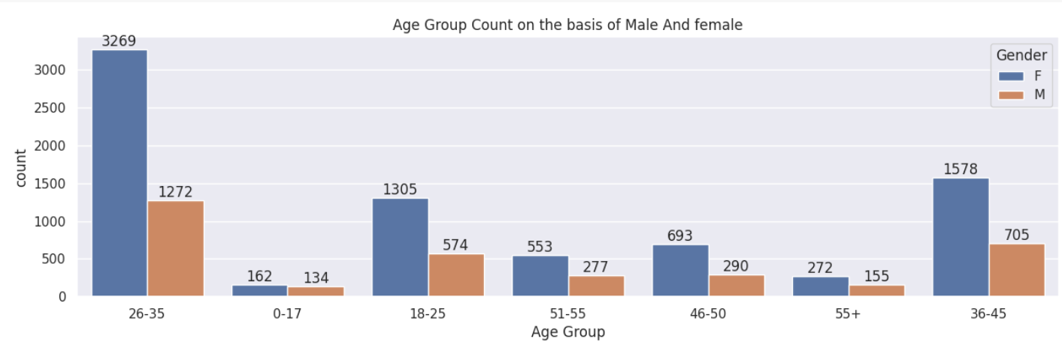

From Below graphs shows most of the buyers are female in the age group 26-35.

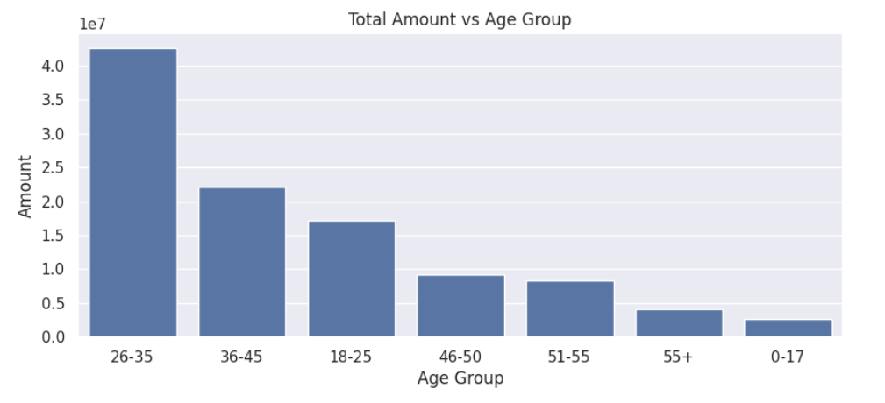

3) From below graph shows most of the orders has been placed & total sales has been done from Uttar Pradesh, Maharashtra and Karnataka.

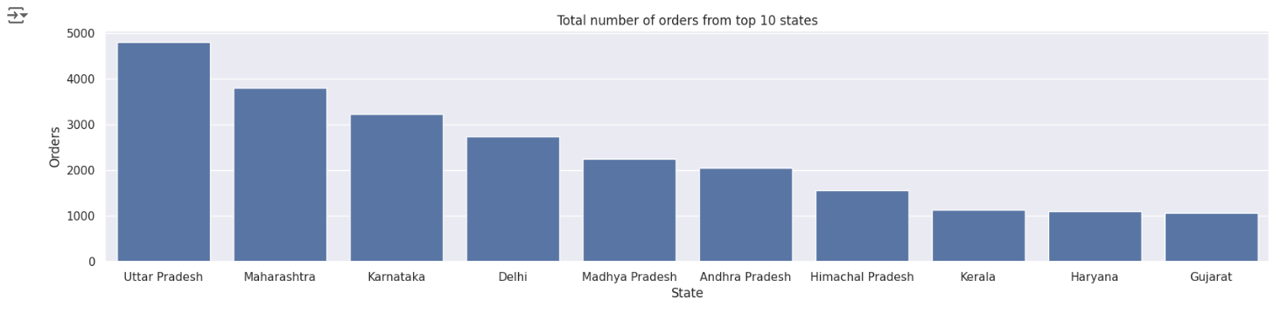

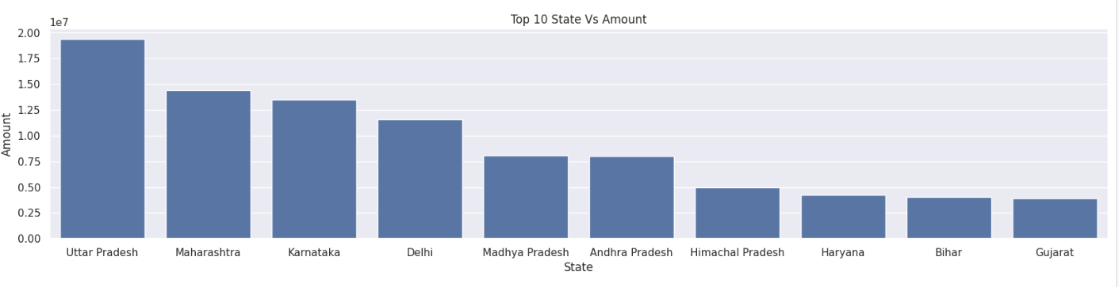

4)From below graph shows most of the buyers are married (women).

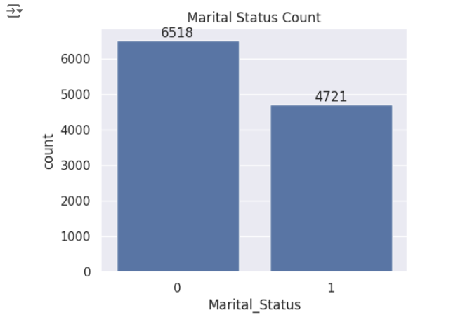

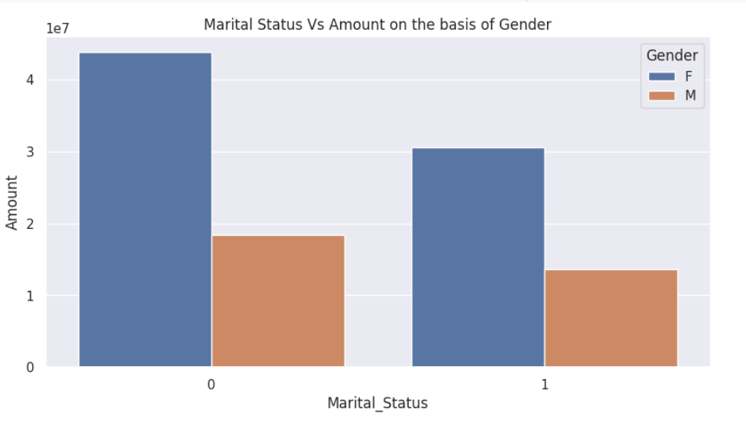

5)From below graph shows most of the buyers are working in IT, Healthcare and Aviation sector

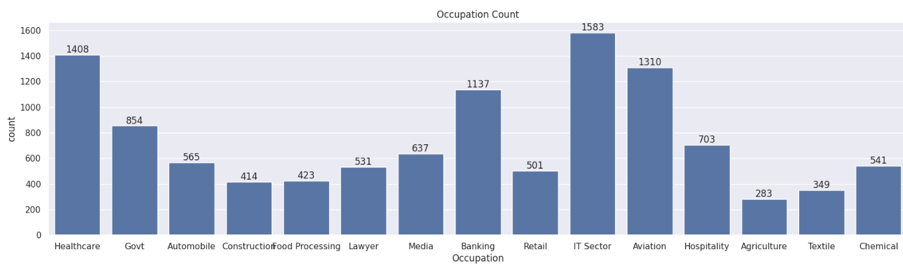

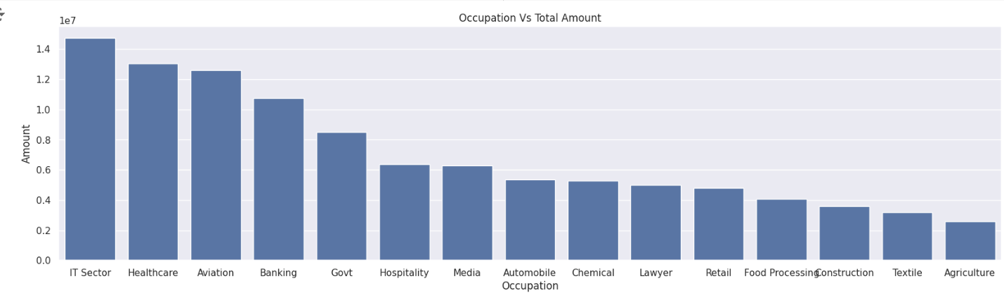

6)From below graph shows most of the sold products are from Food, Clothing and Electronics category.

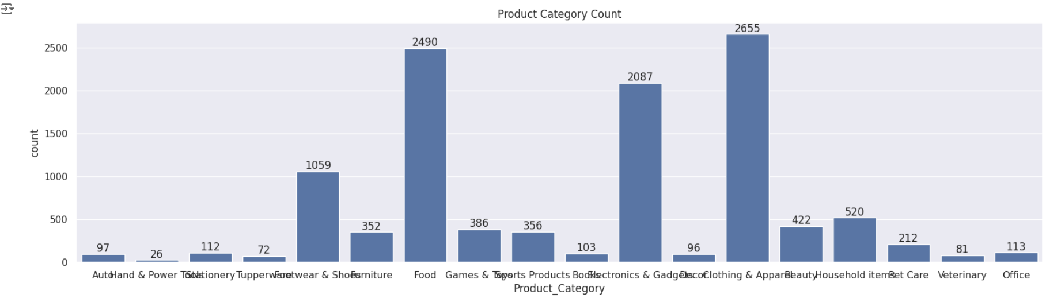

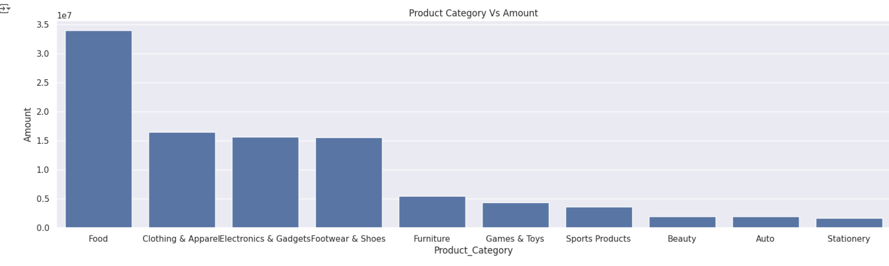

7)From below graph shows Top 10 most of the sold products.

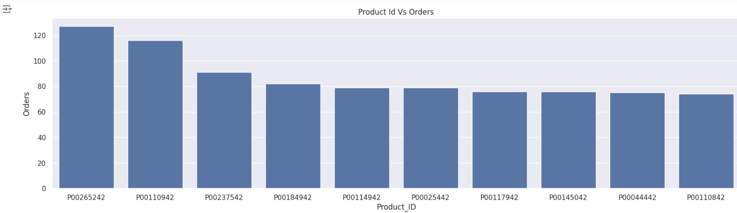

**Conclusion**

From above analysis Married women having age group 26-35 yrs from UP, Maharastra and Karnataka working in IT, Healthcare and Aviation are more likely to buy products from Food, Clothing and Electronics category.