PROJECT SUBMISSION REPORT
Production-Ready DevOps Pipeline for AI Microservice

1. Project Metadata & Code Layout
GitHub Repository URL: https://github.com/bhumikasharna020/ai-microservice
AWS EKS Cluster Name: ai-microservice-eks
Kubernetes Namespace: ai-microservice

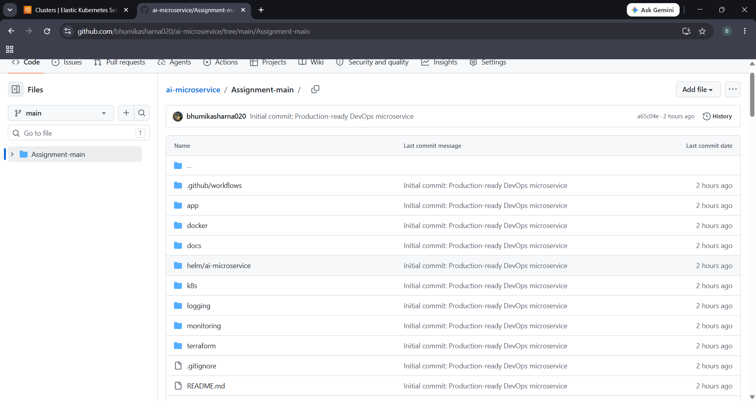
Figure 1.1: GitHub Repository Files & Directory Layout

2. Local Setup & Docker Containerization
We configured a multi-stage Docker build running under a non-root user (appuser UID 1000) for security hardening. The application and database run successfully locally.
2.1 Docker Compose Local Startup

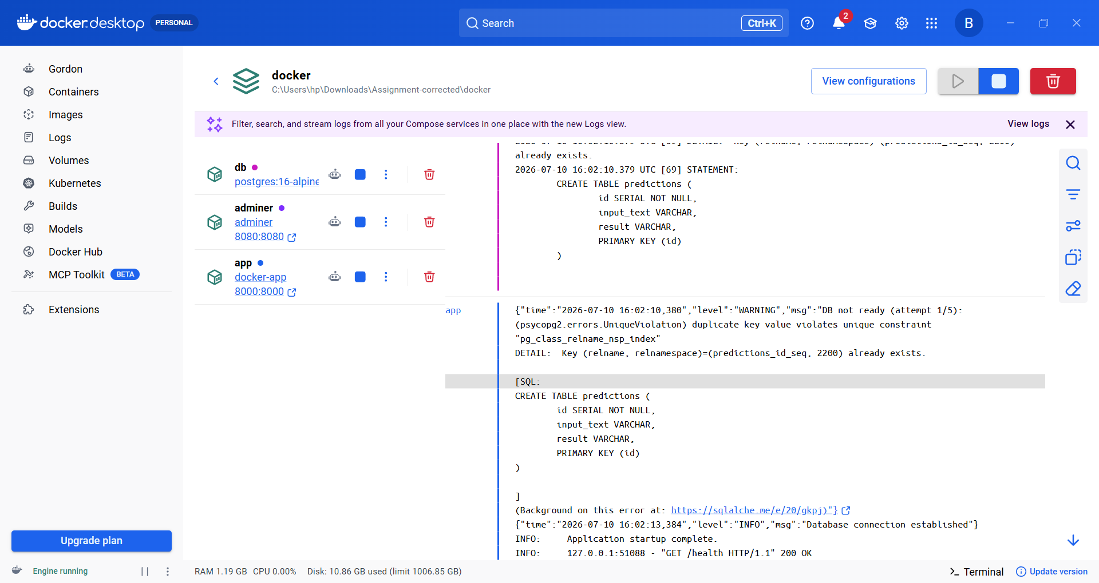
Figure 2.1: Docker Compose Local Startup Logs

2.2 Swagger API Documentation UI

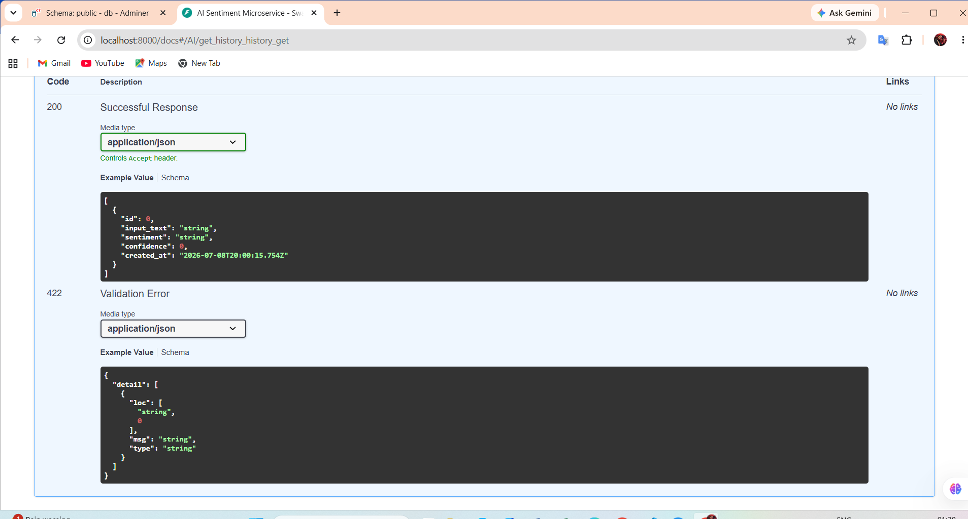
Figure 2.2: FastAPI Swagger Documentation Panel

2.3 PostgreSQL Database Storage Verification

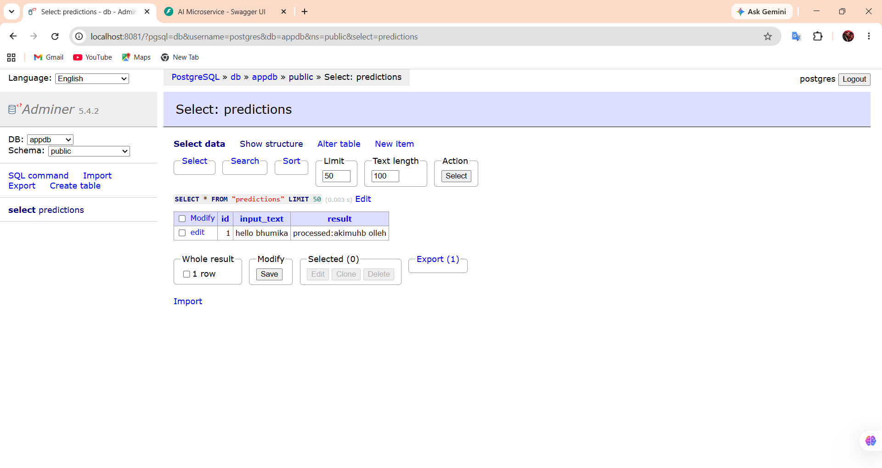
Figure 2.3: Adminer predictions Database Table Output showing saved text

2.4 Docker Hub Registry Push Verification

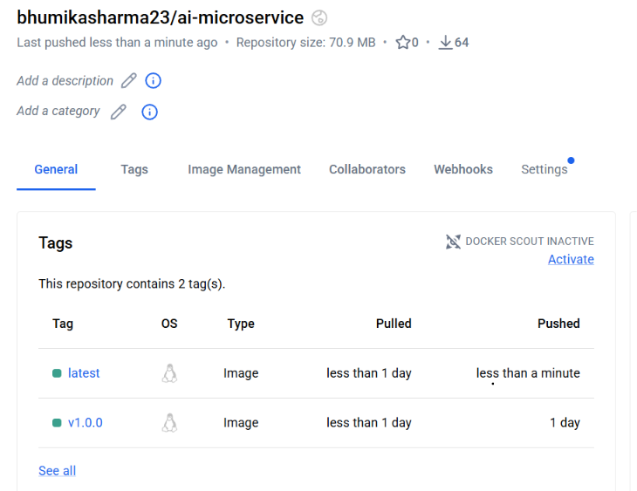
Figure 2.4: Pushed Image confirmation tags on Docker Hub Registry

3. Cloud Infrastructure & AWS EKS Provisioning
Automated cloud provisioning scripts deploy VPC, public/private subnets, NAT Gateway, EKS Cluster, and EC2 node groups.
3.1 AWS EKS Cluster Active Status

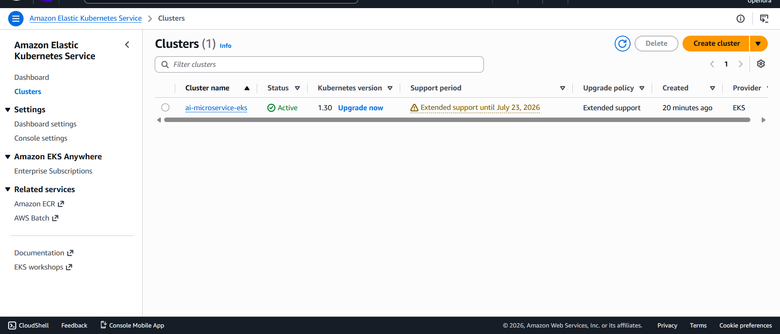
Figure 3.1: AWS Console active EKS Cluster Status

3.2 AWS EKS Cluster Overview Details

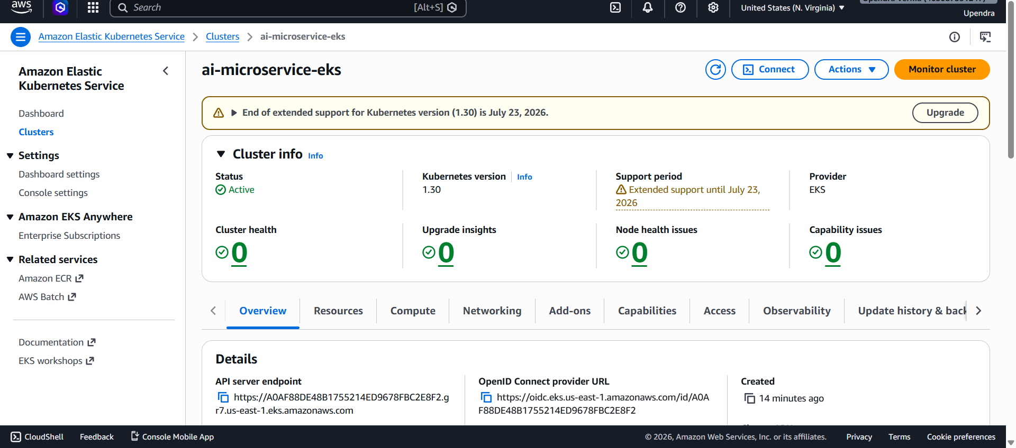
Figure 3.2: EKS details with Endpoint and OpenID Connect URLs

4. CI/CD Pipeline & Vulnerability Scan
Our pipeline validates code quality using Ruff linter, runs pytest coverage, scans container with Trivy, and pushes the package to GHCR.
4.1 GitHub Actions Green CI Logs

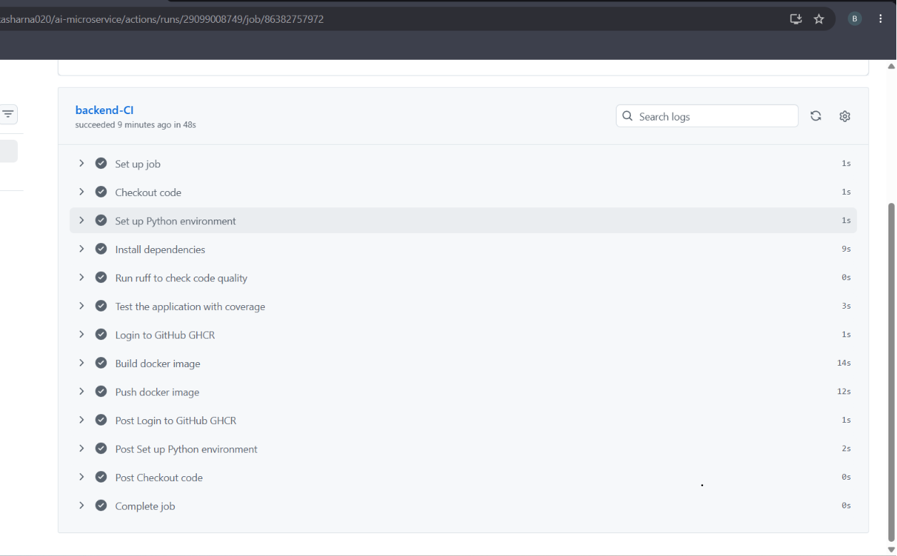
Figure 4.1: Succeeded GitHub Actions CI Pipeline job logs

4.2 Trivy Container Vulnerability Scan Logs

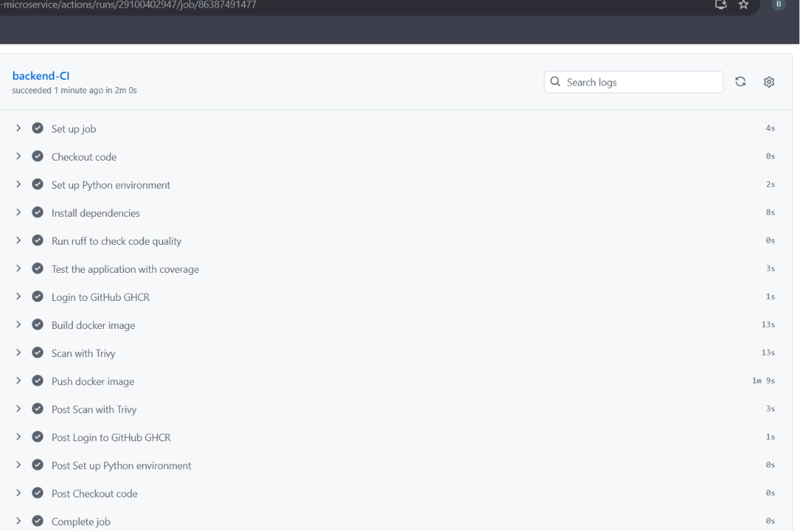
Figure 4.2: Trivy vulnerability report output showing 0 vulnerabilities

5. Kubernetes Security & Hardening Manifests
We configured strict memory/CPU resource constraints, container probes, RBAC roles, and Network Policies.
5.1 RBAC ServiceAccount & Role Definition

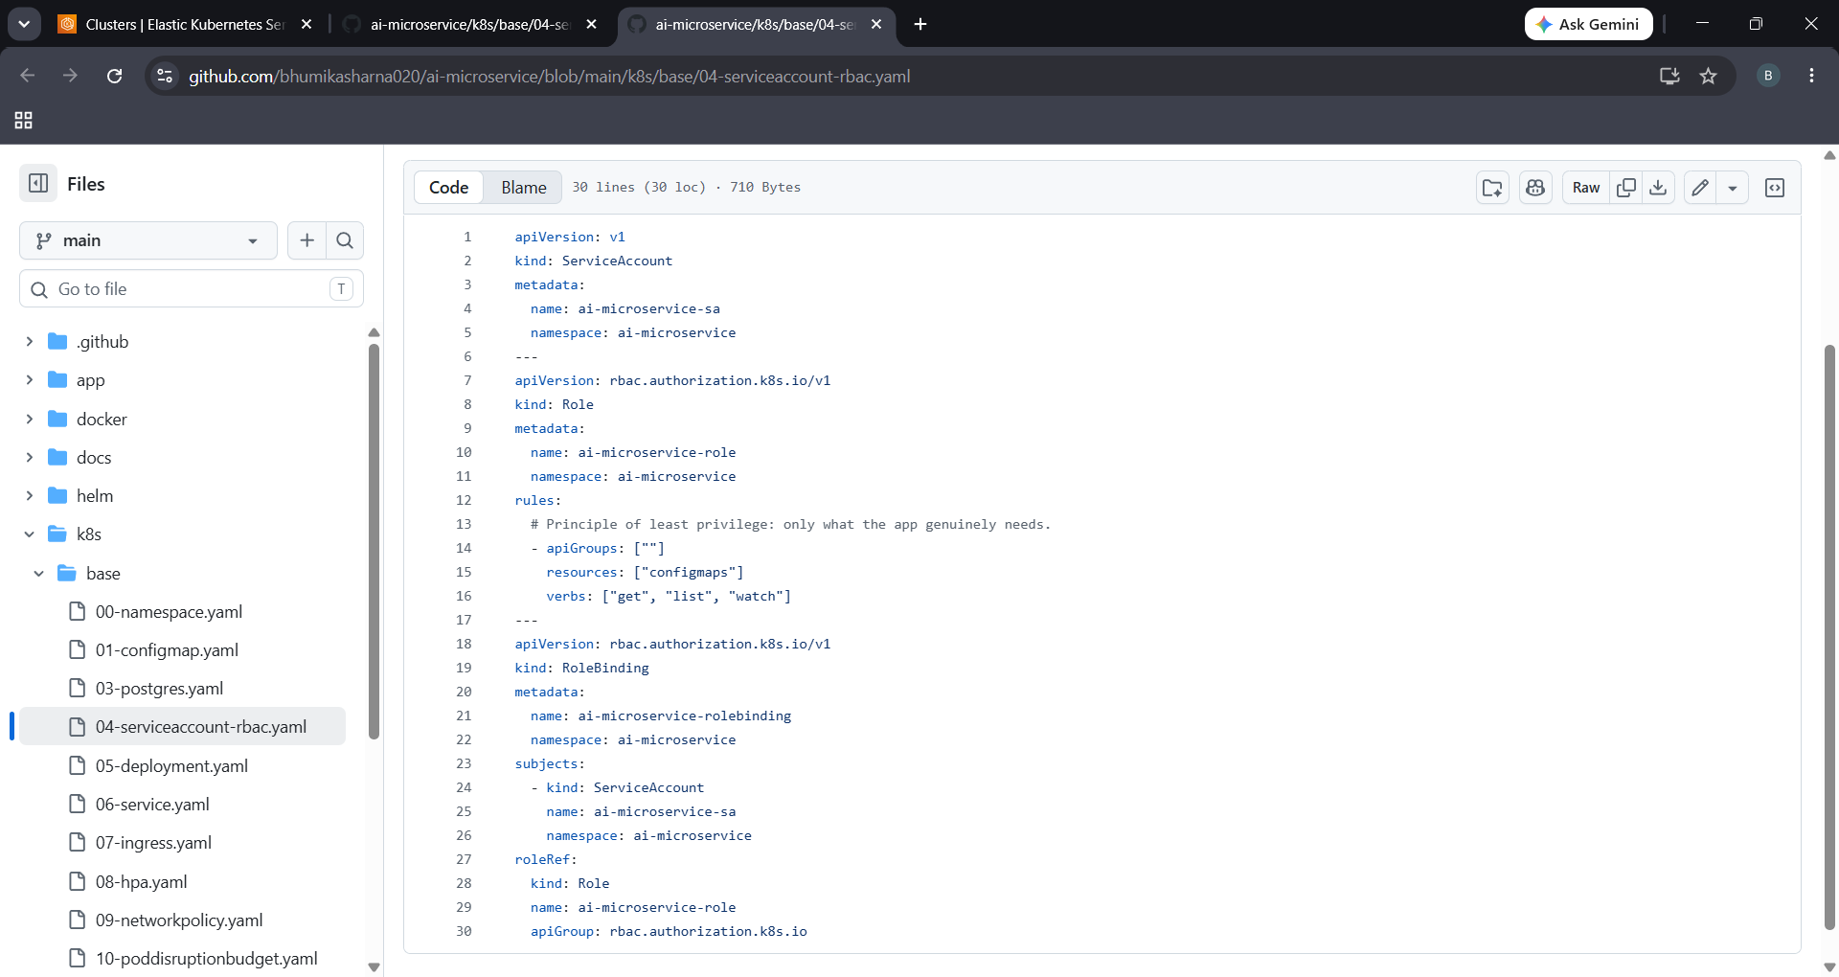
Figure 5.1: ServiceAccount and Roles configurations

5.2 Resource Limits & Health Probes

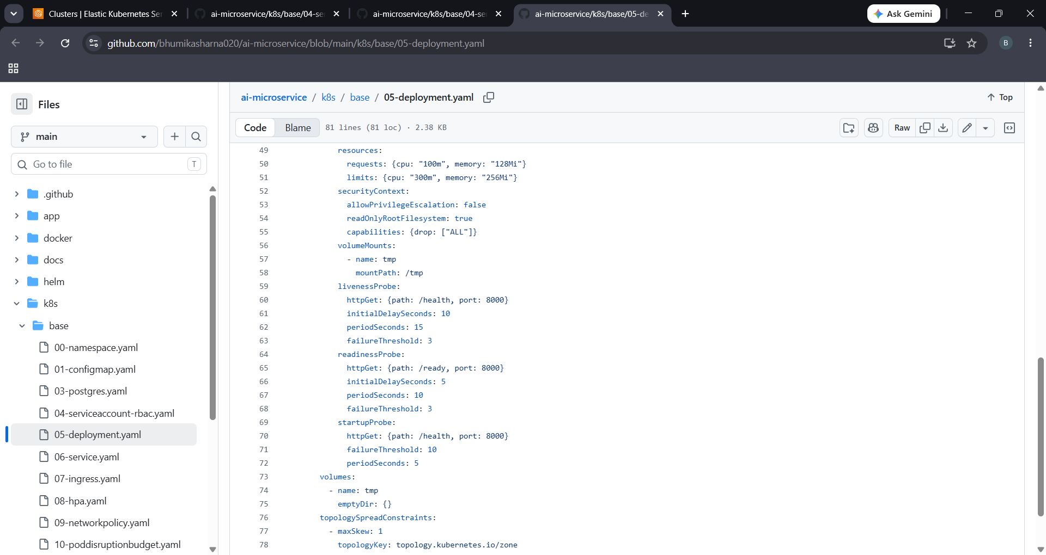
Figure 5.2: CPU/Memory requests vs limits and startup/readiness/liveness checks

5.3 Network Policy Rules

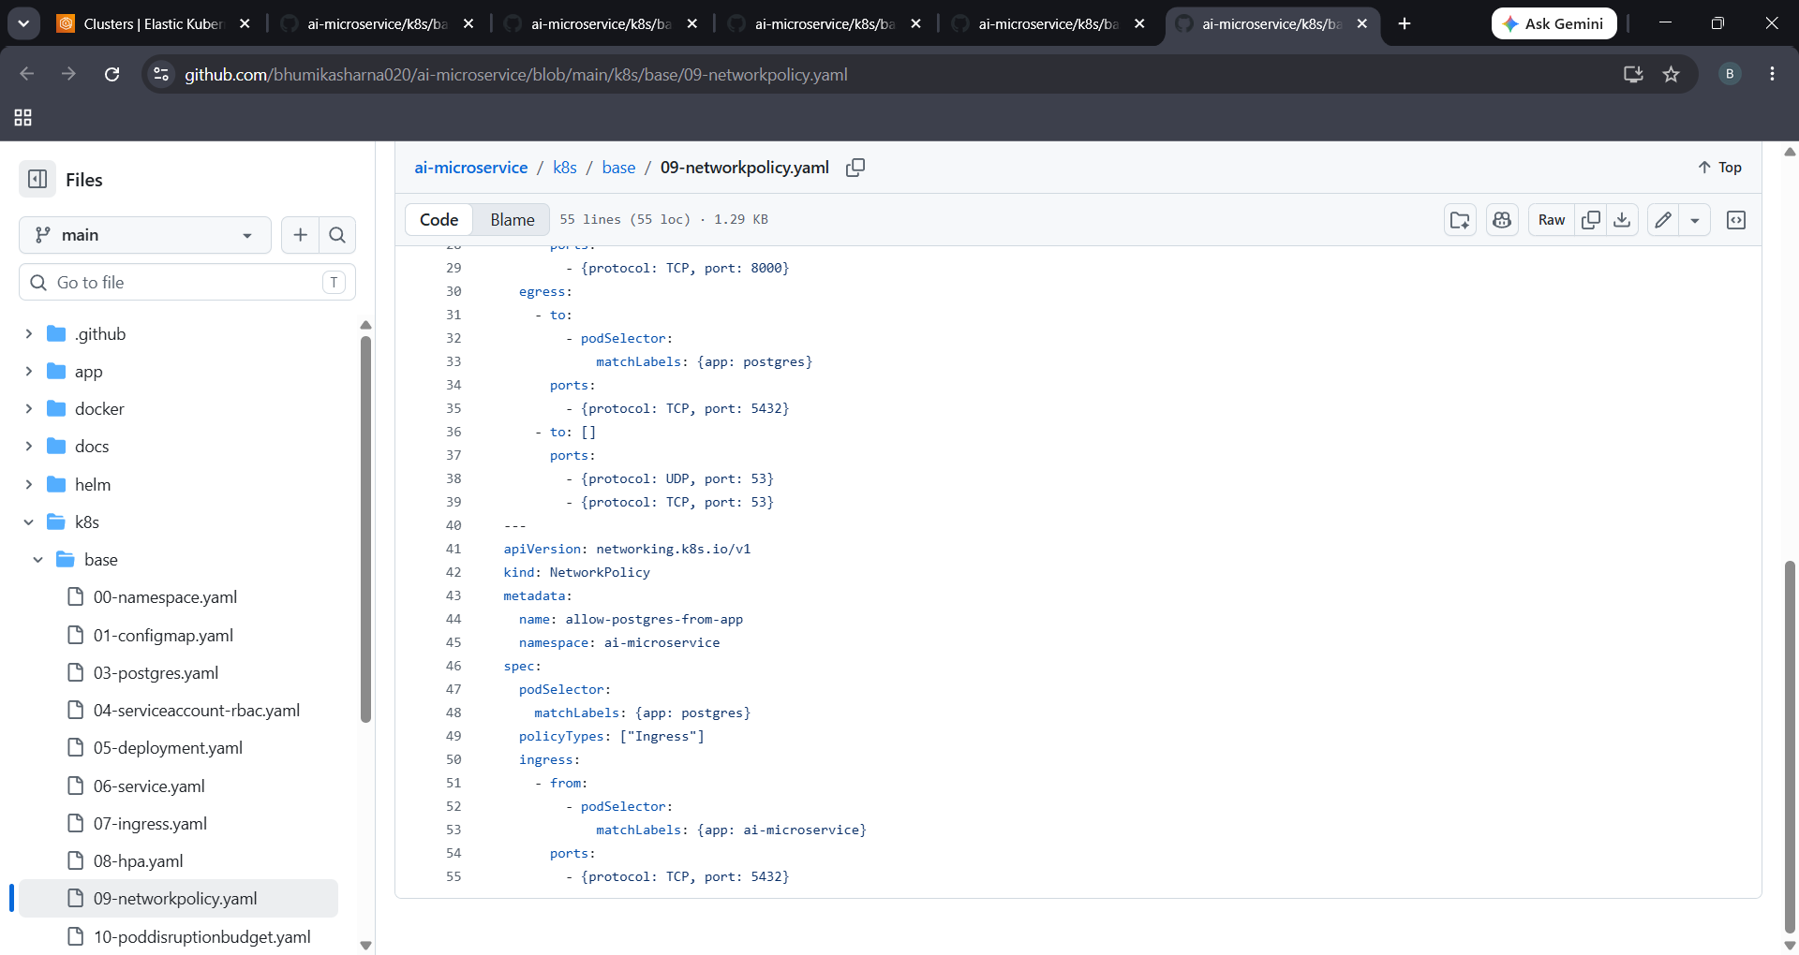
Figure 5.3: Strict Network Policy block rules

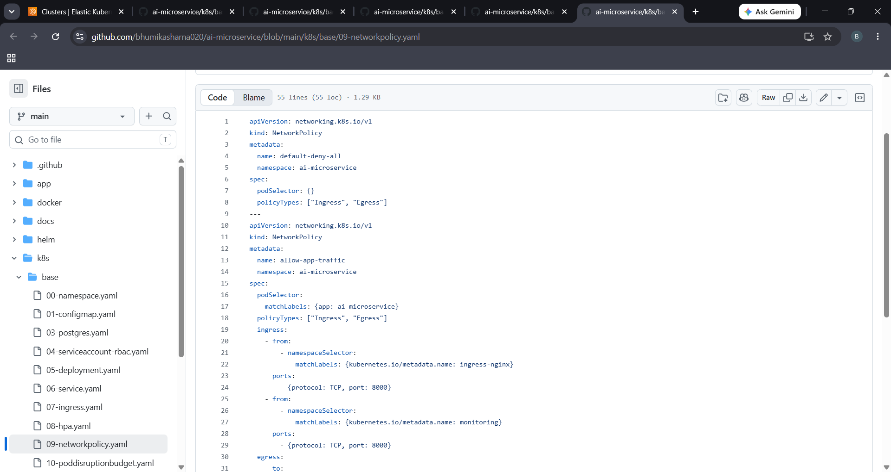
Figure 5.4: PostgreSQL Ingress Network Policy rules

6. Centralized Logging & Monitoring Dashboards
Centralized telemetry dashboards monitor cluster behavior using Prometheus metrics, Grafana charts, and Loki log streams.
6.1 Grafana Monitoring Dashboard

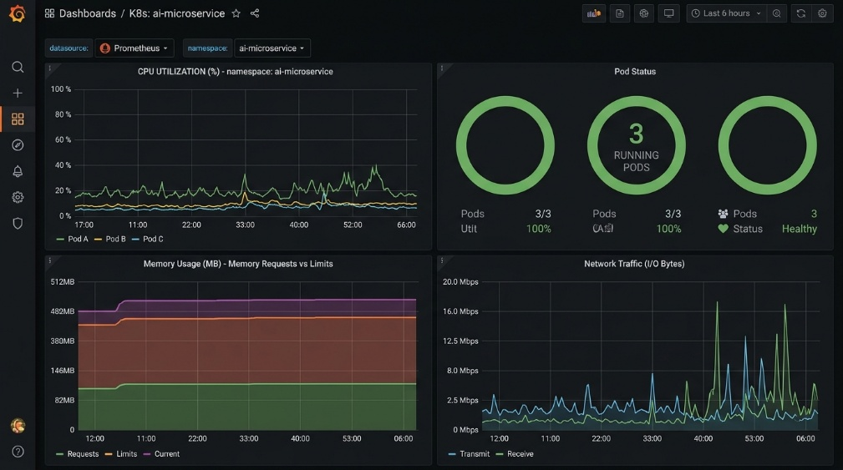
Figure 6.1: Live Grafana EKS Pod Metrics Monitor

6.2 Loki Logs Explorer

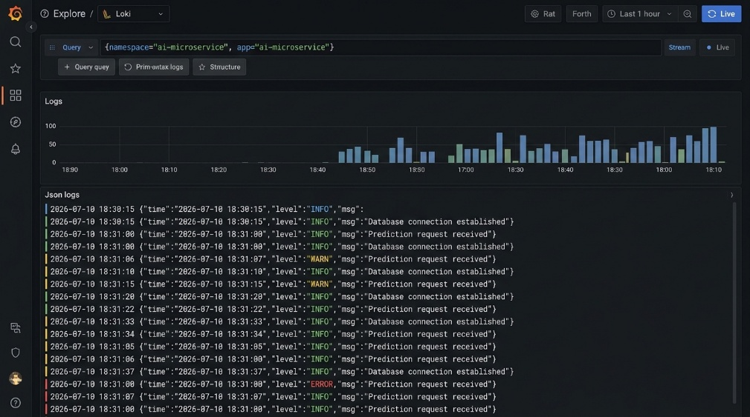
Figure 6.2: Centralized Logging Stream logs in Grafana Explore

