Student Performance Tracker - User Guide
1. Introduction
Student Performance Tracker is a web-based application developed using Python Flask that helps manage student information, store subject marks, and analyze academic performance.
The application allows users to add student details, assign grades, search student records, find subject toppers, and generate performance reports. It provides an easy and efficient way to track student performance.
2. Application Access
The application can be accessed through a web browser using the deployed application link:
Deployed Application Link:
https://student-performance-tracker-mklk.onrender.com/
Steps to open the application:
- Open any web browser such as Google Chrome or Microsoft Edge.
- Enter the deployed application link.
- The Student Performance Tracker home page will be displayed.
- Select the required option from the available features.

3. Home Page Overview
The home page provides different options to manage and analyze student performance.
The available features are:
- Add Student
- Add Grade
- Search Student
- Subject Topper
- Average Report
- View Students
Each option performs a specific task related to student performance management.
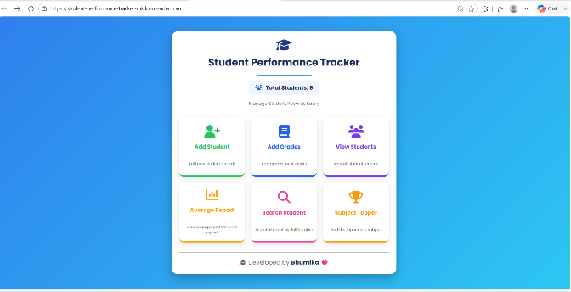

4. Adding Student Details
The Add Student feature is used to store new student information in the system.
Steps:
- Click on the Add Student option from the home page.
- Enter the required student details.
- Click the submit button to save the information.
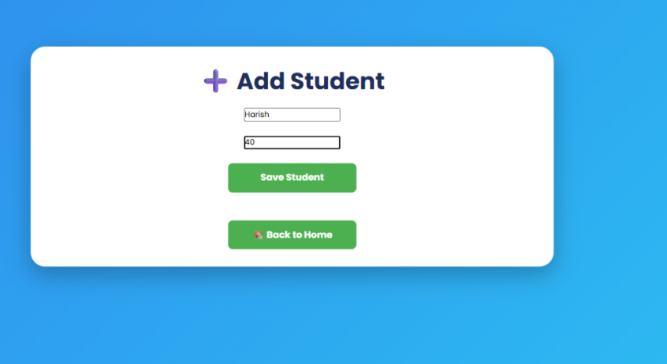
Example:
Roll Number: 40
Student Name:Harish
After submitting, the student details will be stored successfully in the database.

5. Assigning Grades
The Add Grade feature is used to assign subject marks to students.
Steps:
- Click on the Add Grade option.
- Enter the student's roll number.
- Enter the subject name.
- Enter the marks obtained.
- Click the submit button.
Example:
Roll Number: 40
Subject: Python
Marks: 90
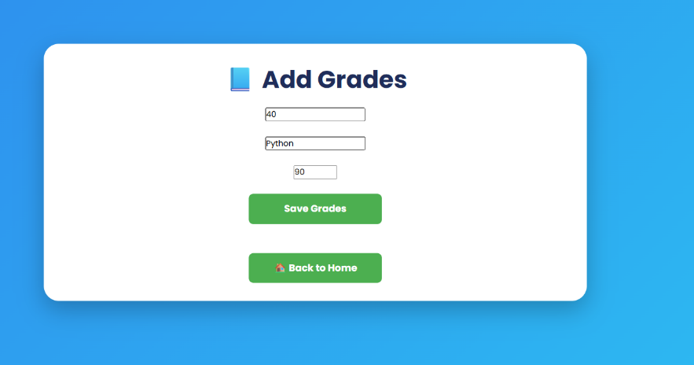
The marks will be added to the student's record.

6. Searching Student Details
The Search Student feature helps users find student information using the roll number.
Steps:
- Click on the Search Student option.
- Enter the student's roll number.
- Click the search button.
Example:
Roll Number: 40
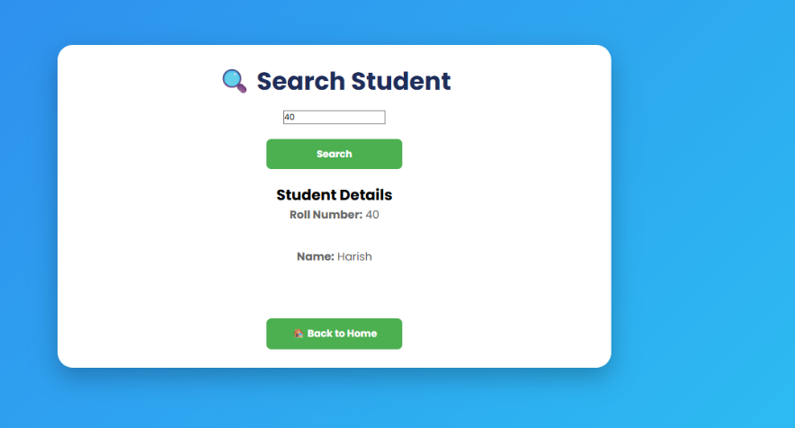
Output:
Roll Number: 40
Name: Harish
If the entered roll number is not available, the system displays an appropriate message.

7. Finding Subject Topper
The Subject Topper feature identifies the student who scored the highest marks in a particular subject.
Steps:
- Click on the Subject Topper option.
- Enter the subject name.
- Click the Find Topper button.
Example:
Subject: Python
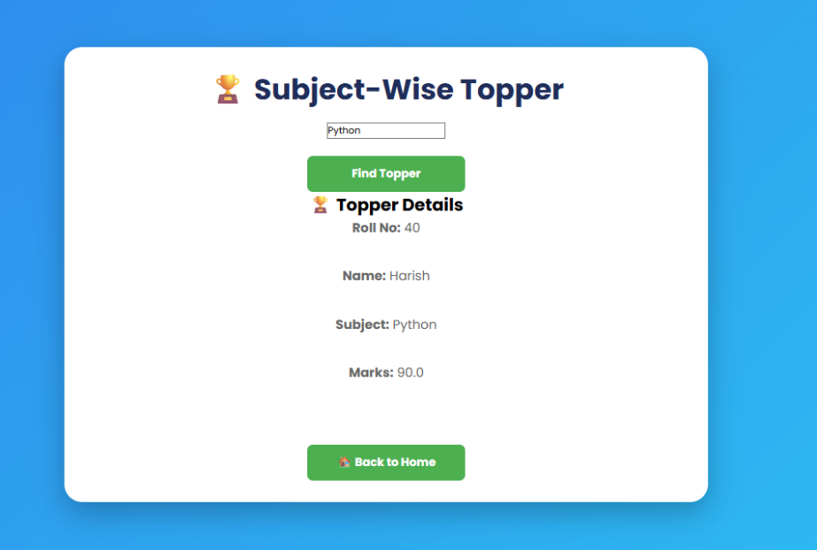
Output:
Topper Name: Harish
Subject: Python
Marks: 90
If the subject is not available in the database, the application displays:
❌ Subject not found

8. Viewing Average Report
The Average Report feature calculates the average marks obtained by students for a particular subject.
Steps:
- Click on the Average Report option.
- Enter the subject name.
- Click the calculate button.
Example:
Subject: Python
Output:
Subject: Python
Average Marks: 85
If the entered subject does not exist, the system displays:
❌ Subject not found

9. Viewing Reports
The Reports section provides an overview of student performance.
Users can view stored student details and academic performance information through generated reports.
Reports help in understanding student progress and performance analysis.

10. Error Handling
The application provides messages when incorrect or unavailable information is entered.
Examples:
Invalid Subject:
❌ Subject not found
Invalid Student Details:
Student record not found
These messages help users understand and correct their input.

11. Technologies Used
The Student Performance Tracker application is developed using the following technologies:
- Python - Programming language used for backend development
- Flask - Web framework used to create the application
- SQLite - Database used for storing student and grade information
- HTML - Used for creating web pages
- CSS - Used for styling the application interface
- Render - Used for deploying the Flask web application

12. Conclusion
The Student Performance Tracker provides a simple and effective solution for managing student records and analyzing academic performance.
The application reduces manual work by storing student details digitally and providing quick access to performance reports, subject toppers, and average marks.
This system helps users efficiently monitor and manage student academic progress.

