CLOUD ENGINEERING INTERNSHIP
WEEK 2 PROJECT REPORT
Cloud Automation and Infrastructure as Code Implementation
Multi-Tier Application Deployment using Terraform on AWS

Internship Task | Week 2 – Cloud Automation & Infrastructure as Code
Technology | Terraform + Amazon Web Services
Application | Nginx Web Tier + Python Application Tier + PostgreSQL RDS
Submission | Technical project, source code, testing evidence and report

1. Abstract
This project demonstrates the use of Infrastructure as Code (IaC) to automate the deployment of a multi-tier cloud application on AWS. Terraform is used to define networking, security, load balancing, compute, auto scaling, IAM, and database resources in declarative configuration. The design separates the web, application, and database responsibilities across different network tiers. The web tier is exposed through a public Application Load Balancer, while the application and database tiers remain private. The solution is designed to be repeatable, version-controllable, and easier to validate than manual cloud provisioning.

2. Objective
The objective is to automate the creation, modification, and management of cloud resources using Infrastructure as Code. The project also demonstrates networking, security groups, load balancing, Auto Scaling, monitoring-related configuration, and deployment validation for a multi-tier application.

3. Requirements Addressed
- Select an Infrastructure as Code tool: Terraform.
- Define cloud components and dependencies in code.
- Create a multi-tier cloud environment.
- Configure networking and security groups.
- Deploy web, application, and database components.
- Configure Auto Scaling and health checks.
- Provide validation and testing steps.
- Document deployment, results, challenges, and recommendations.

4. Architecture
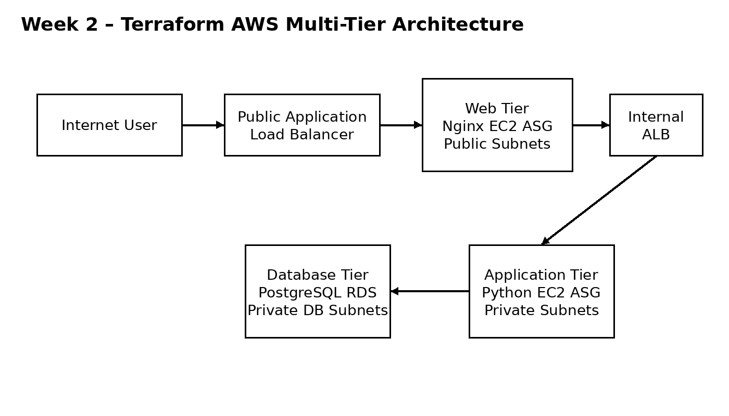
Figure 1. Proposed AWS multi-tier architecture implemented by Terraform.
Traffic enters through a public Application Load Balancer and is distributed to Nginx web servers. The web servers forward requests to an internal Application Load Balancer, which distributes requests to Python application servers in private subnets. The application tier has network permission to reach the PostgreSQL RDS instance on port 5432. The database is placed in private database subnets and is not publicly accessible.

5. Infrastructure Components
Component | Purpose
VPC | 10.20.0.0/16 network containing public, application and database subnets.
Public Subnets | Two subnets across two Availability Zones for the public ALB and web tier.
Application Subnets | Two private subnets across two Availability Zones for the application tier.
Database Subnets | Two private subnets used by the RDS subnet group.
Public ALB | Receives HTTP traffic from the Internet and forwards it to the web tier.
Internal ALB | Routes private traffic from Nginx to application servers.
Web ASG | Nginx EC2 instances with configurable minimum, desired and maximum capacity.
App ASG | Python application EC2 instances in private subnets with Auto Scaling.
RDS | Private PostgreSQL database instance.
IAM/SSM | EC2 role enabling Systems Manager access without requiring SSH keys.

6. Terraform Project Structure
week2_cloud_automation/
├── README.md
├── .gitignore
├── terraform/
│ ├── versions.tf
│ ├── variables.tf
│ ├── network.tf
│ ├── security.tf
│ ├── iam.tf
│ ├── compute.tf
│ ├── load_balancing.tf
│ ├── database.tf
│ ├── outputs.tf
│ └── terraform.tfvars.example
├── scripts/
│ ├── web_userdata.sh
│ └── app_userdata.sh
└── docs/
├── DEPLOYMENT.md
├── TESTING.md
├── REPORT_CONTENT.md
├── YUVA_SUBMISSION_DESCRIPTION.txt
└── architecture.png

7. Deployment Procedure
1. Install Terraform and AWS CLI.
2. Configure an AWS identity with the permissions required to create the project resources.
3. Copy terraform/terraform.tfvars.example to terraform/terraform.tfvars and set a strong database password.
4. Run terraform init to initialize the AWS provider.
5. Run terraform fmt -recursive and terraform validate.
6. Run terraform plan and inspect the proposed resources.
7. Run terraform apply and approve the deployment.
8. Use terraform output -raw application_url to obtain the public application endpoint.
9. Verify load-balancer health, application response, Auto Scaling state and RDS availability.
10. After completing the demonstration, run terraform destroy to avoid unnecessary AWS charges.

8. Security Implementation
- The RDS instance is configured as publicly inaccessible.
- Database port 5432 is permitted only from the application security group.
- Application port 5000 is permitted only from the internal ALB security group.
- Web port 80 is permitted only from the public ALB security group.
- EC2 metadata is configured to require IMDSv2.
- AWS Systems Manager access is provided through an IAM role rather than embedding SSH credentials in the project.
- The repository excludes .tfvars and Terraform state files to reduce the risk of committing secrets.

9. Auto Scaling and Monitoring Approach
Both the web and application tiers use EC2 Auto Scaling Groups. The default configuration keeps two instances in each tier, permits scaling up to four instances, and uses target tracking based on average CPU utilization of approximately 60 percent. Load-balancer health checks determine whether targets are healthy. EC2 detailed monitoring is enabled in the launch templates. During the actual deployment, CloudWatch/EC2 metrics should be captured as evidence and used to discuss resource behavior.

10. Testing and Validation
- Terraform formatting completes without errors.
- terraform validate reports a valid configuration.
- terraform plan completes and shows the expected resource changes.
- terraform apply creates the infrastructure successfully.
- Public ALB reports healthy web targets.
- Internal ALB reports healthy application targets.
- The public application URL returns JSON from the application tier.
- RDS is available and has no public network exposure.
- Security groups enforce the intended tier-to-tier communication.
- Auto Scaling Groups maintain their configured desired capacity.
- terraform destroy removes the stack after the demonstration.

11. Expected Output
When the deployment is healthy, opening the public ALB URL should return a JSON response containing a message, the hostname of the application instance, and the application service name. Because the application tier is load balanced, different requests may be served by different application instances when more than one instance is active.

12. Challenges and Resolutions
Challenge | Resolution
Network separation | Resolved by using dedicated public, application and database subnets with route tables.
Tier-to-tier access | Resolved using security-group references instead of broad inbound CIDR rules.
Repeatable provisioning | Resolved by defining resources declaratively in Terraform.
Application installation | Resolved with EC2 user-data scripts so instances self-configure at launch.
Secret handling | Resolved by keeping the real tfvars file out of Git and documenting secure credential handling.

13. Limitations and Production Improvements
This internship demonstration intentionally keeps the architecture manageable and cost-conscious. For a production environment, the design should add HTTPS/TLS certificates, AWS WAF, centralized logging, Secrets Manager, encrypted and remotely locked Terraform state, stronger IAM least-privilege policies, Multi-AZ RDS configuration, deletion protection, final snapshots, private package access or NAT where required, and a more complete application that reads and writes database records.

14. Conclusion
The project demonstrates how Terraform can automate a structured AWS environment instead of requiring manual creation of each cloud resource. The resulting architecture separates application responsibilities, restricts network access between tiers, supports horizontal scaling, and provides a repeatable deployment workflow. The source code is organized for GitHub and includes deployment and testing documentation. Actual AWS screenshots and measured results should be added after the student performs the deployment.

15. Evidence to Attach
- Screenshot of terraform validate success.
- Screenshot of terraform plan.
- Screenshot of successful terraform apply.
- AWS VPC and subnet view.
- Public ALB target health.
- Internal ALB target health.
- Web and application Auto Scaling Groups.
- RDS status showing private configuration.
- Browser output of the application URL.
- CloudWatch/EC2 CPU or monitoring evidence.

Implementation & Evidence Note
This submission contains the complete Terraform Infrastructure as Code implementation, supporting server bootstrap scripts, architecture documentation, and GitHub-ready project structure. No AWS account was used for this submission, so it does not claim a live AWS deployment. Actual AWS screenshots or live resource IDs should only be added if the infrastructure is later deployed.

