Logical regression:

Accuracy is 0.91

import pandas as pd

import matplotlib.pyplot as plt

import seaborn as sns

from sklearn.model_selection import train_test_split

from sklearn.linear_model import LogisticRegression

from sklearn.metrics import accuracy_score, confusion_matrix

# Load your existing dataset

existing_data = pd.read_excel(r"C:\Users\Hi\OneDrive\Desktop\rnsit\8th sem\final year project\dry eyes dataset\augmented_dataset1222.xlsx")

# Prepare features (X) and target variable (y)

X = existing_data[[ 'age', 'q1', 'q2', 'q3', 'q4', 'q5', 'q6', 'q7', 'q8', 'q9', 'q10', 'q11', 'q12','Score','Score_code']]

y = existing_data['Score_code']

# Split the data into training and testing sets

X_train, X_test, y_train, y_test = train_test_split(X, y, test_size=0.2, random_state=42)

# Train Logistic Regression model

log_reg_model = LogisticRegression()

log_reg_model.fit(X_train, y_train)

# Predict on the testing set

y_pred = log_reg_model.predict(X_test)

# Calculate accuracy

accuracy = accuracy_score(y_test, y_pred)

print("Accuracy:", accuracy)

# Plot a line graph for accuracy

plt.plot([0, 1], [accuracy, accuracy], linestyle='--', marker='o')

plt.title('Accuracy of Logistic Regression Model')

plt.xlabel('Iterations')

plt.ylabel('Accuracy')

plt.xticks([0, 1], ['Iteration 1', 'Iteration 2'])

plt.ylim(0, 1) # Set y-axis limits

plt.grid(True)

plt.savefig('accuracy_line_graph_lr.png') # Save the line graph as an image

plt.show()

# Calculate confusion matrix

conf_matrix = confusion_matrix(y_test, y_pred)

# Plot confusion matrix

plt.figure(figsize=(8, 6))

sns.heatmap(conf_matrix, annot=True, cmap='Blues', fmt='g')

plt.xlabel('Predicted Label')

plt.ylabel('True Label')

plt.title('Confusion Matrix for Logistic Regression Model')

plt.savefig('confusion_matrix_lr.png') # Save the confusion matrix as an image

plt.show()

line graph and confusion matrix:

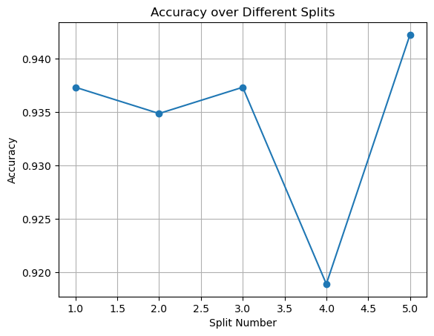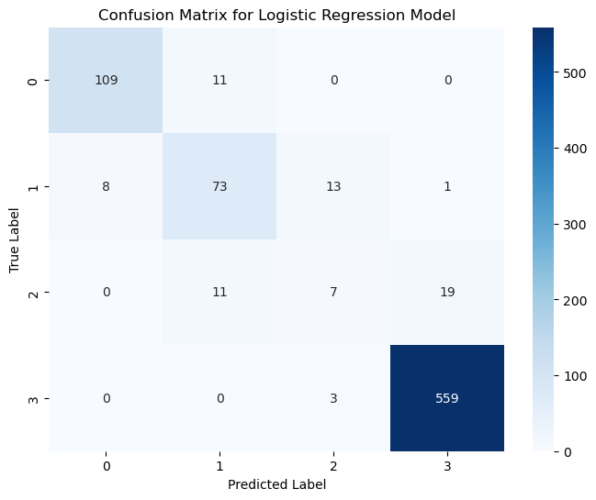

KNN algorithm:

Accuracy is 0.95

import pandas as pd

import matplotlib.pyplot as plt

import seaborn as sns

from sklearn.model_selection import train_test_split

from sklearn.neighbors import KNeighborsClassifier

from sklearn.metrics import accuracy_score, confusion_matrix

# Load your existing dataset

existing_data = pd.read_excel(r"C:\Users\Hi\OneDrive\Desktop\rnsit\8th sem\final year project\dry eyes dataset\augmented_dataset1222.xlsx")

# Take a smaller sample of the data

sample_size = 100 # You can adjust this as needed

existing_data_sample = existing_data.sample(n=sample_size, random_state=42)

# Prepare features (X) and target variable (y)

X = existing_data_sample[['age', 'q1', 'q2', 'q3', 'q4', 'q5', 'q6', 'q7', 'q8', 'q9', 'q10', 'q11', 'q12', 'Score']]

y = existing_data_sample['Score_code']

# Split the data into training and testing sets

X_train, X_test, y_train, y_test = train_test_split(X, y, test_size=0.2, random_state=42)

# Initialize KNN classifier with k=3 (you can adjust k as needed)

knn = KNeighborsClassifier(n_neighbors=3)

# Train the KNN classifier

knn.fit(X_train, y_train)

# Predict on the testing set

y_pred = knn.predict(X_test)

# Calculate accuracy

accuracy = accuracy_score(y_test, y_pred)

print("KNN Accuracy:", accuracy)

# Plot line graph

plt.figure(figsize=(10, 6))

plt.plot(y_test.values, label='Actual')

plt.plot(y_pred, label='Predicted')

plt.title('Actual vs Predicted Scores')

plt.xlabel('Index')

plt.ylabel('Score')

plt.legend()

plt.show()

# Plot confusion matrix

conf_matrix = confusion_matrix(y_test, y_pred)

plt.figure(figsize=(8, 6))

sns.heatmap(conf_matrix, annot=True, fmt='d', cmap='Blues', cbar=False)

plt.title('Confusion Matrix')

plt.xlabel('Predicted Labels')

plt.ylabel('Actual Labels')

plt.show()

Line graph and confusion matrix:

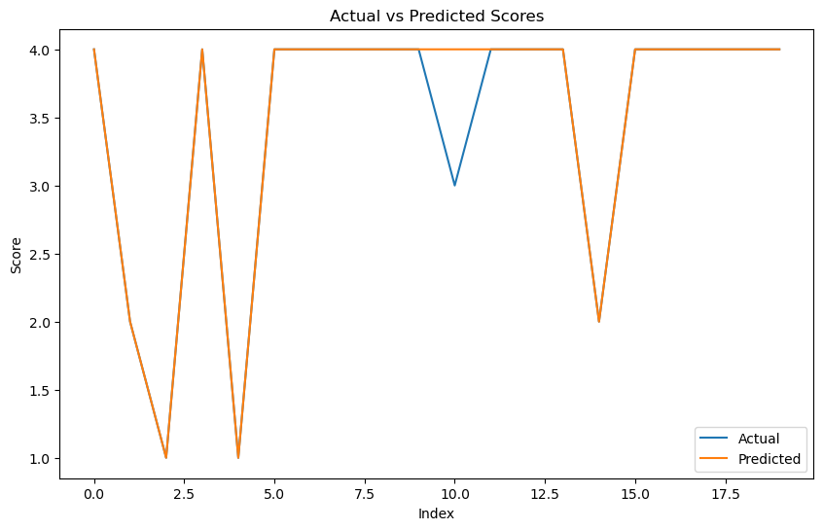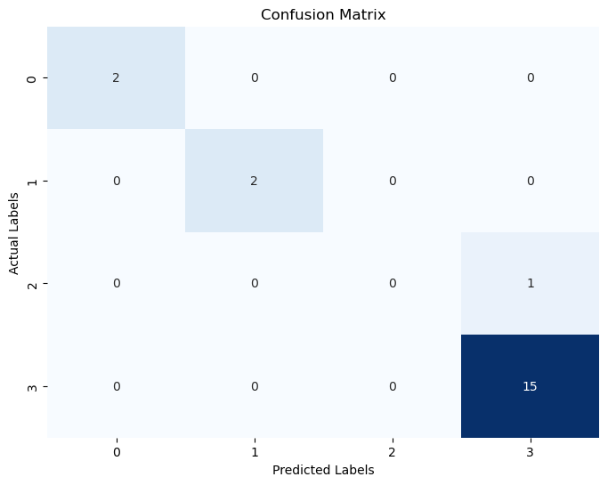

Random forest:

Accuracy is 0.95.

import pandas as pd

import matplotlib.pyplot as plt

import seaborn as sns

from sklearn.model_selection import train_test_split

from sklearn.ensemble import RandomForestClassifier

from sklearn.metrics import accuracy_score, confusion_matrix

# Load your existing dataset

existing_data = pd.read_excel(r"C:\Users\Hi\OneDrive\Desktop\rnsit\8th sem\final year project\dry eyes dataset\augmented_dataset1222.xlsx")

# Take a smaller sample of the data

sample_size = 100 # You can adjust this as needed

existing_data_sample = existing_data.sample(n=sample_size, random_state=42)

# Prepare features (X) and target variable (y)

X = existing_data_sample[['age', 'q1', 'q2', 'q3', 'q4', 'q5', 'q6', 'q7', 'q8', 'q9', 'q10', 'q11', 'q12', 'Score']]

y = existing_data_sample['Score_code']

# Split the data into training and testing sets

X_train, X_test, y_train, y_test = train_test_split(X, y, test_size=0.2, random_state=42)

# Initialize Random Forest classifier

rf_classifier = RandomForestClassifier(n_estimators=100, random_state=42)

# Train the Random Forest classifier

rf_classifier.fit(X_train, y_train)

# Predict on the testing set

y_pred = rf_classifier.predict(X_test)

# Calculate accuracy

accuracy = accuracy_score(y_test, y_pred)

print("Random Forest Accuracy:", accuracy)

# Plot line graph

plt.figure(figsize=(10, 6))

plt.plot(y_test.values, label='Actual')

plt.plot(y_pred, label='Predicted')

plt.title('Actual vs Predicted Scores')

plt.xlabel('Index')

plt.ylabel('Score')

plt.legend()

plt.show()

# Plot confusion matrix

conf_matrix = confusion_matrix(y_test, y_pred)

plt.figure(figsize=(8, 6))

sns.heatmap(conf_matrix, annot=True, fmt='d', cmap='Blues', cbar=False)

plt.title('Confusion Matrix')

plt.xlabel('Predicted Labels')

plt.ylabel('Actual Labels')

plt.show()

line graph and confusion matrix:

svm:

accuracy is 0.95.

import pandas as pd

import matplotlib.pyplot as plt

import seaborn as sns

from sklearn.model_selection import train_test_split

from sklearn.svm import SVC

from sklearn.metrics import accuracy_score, confusion_matrix

# Load your existing dataset

existing_data = pd.read_excel(r"C:\Users\Hi\OneDrive\Desktop\rnsit\8th sem\final year project\dry eyes dataset\augmented_dataset1222.xlsx")

# Take a smaller sample of the data

sample_size = 100 # You can adjust this as needed

existing_data_sample = existing_data.sample(n=sample_size, random_state=42)

# Prepare features (X) and target variable (y)

X = existing_data_sample[['age', 'q1', 'q2', 'q3', 'q4', 'q5', 'q6', 'q7', 'q8', 'q9', 'q10', 'q11', 'q12', 'Score']]

y = existing_data_sample['Score_code']

# Split the data into training and testing sets

X_train, X_test, y_train, y_test = train_test_split(X, y, test_size=0.2, random_state=42)

# Initialize SVM classifier

svm_classifier = SVC(kernel='linear', random_state=42)

# Train the SVM classifier

svm_classifier.fit(X_train, y_train)

# Predict on the testing set

y_pred = svm_classifier.predict(X_test)

# Calculate accuracy

accuracy = accuracy_score(y_test, y_pred)

print("SVM Accuracy:", accuracy)

# Plot line graph

plt.figure(figsize=(10, 6))

plt.plot(y_test.values, label='Actual')

plt.plot(y_pred, label='Predicted')

plt.title('Actual vs Predicted Scores')

plt.xlabel('Index')

plt.ylabel('Score')

plt.legend()

plt.show()

# Plot confusion matrix

conf_matrix = confusion_matrix(y_test, y_pred)

plt.figure(figsize=(8, 6))

sns.heatmap(conf_matrix, annot=True, fmt='d', cmap='Blues', cbar=False)

plt.title('Confusion Matrix')

plt.xlabel('Predicted Labels')

plt.ylabel('Actual Labels')

plt.show()

line graph and confusion matrix:

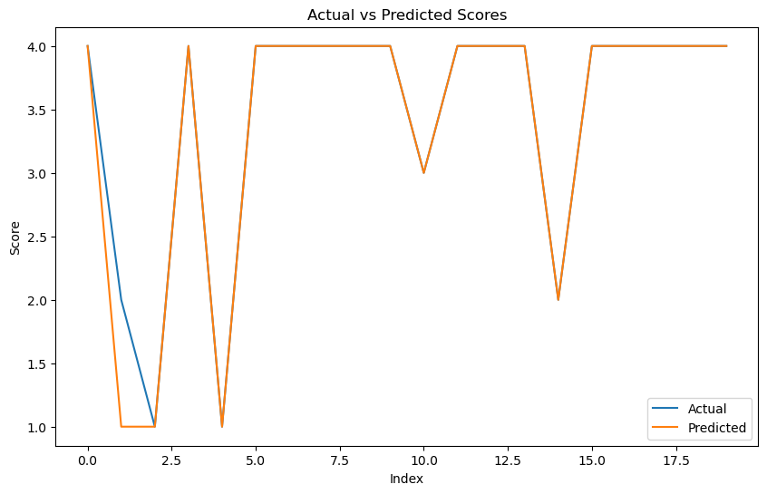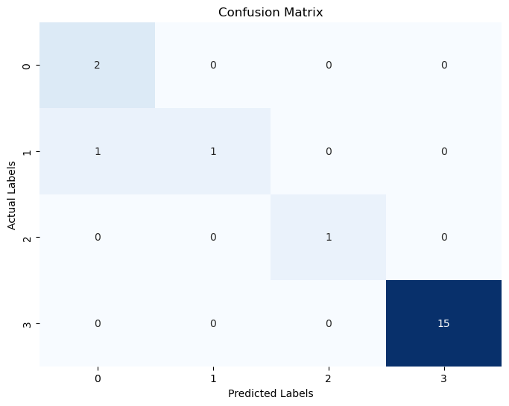

Ensemble model:

Accuracy is 0.95.

import pandas as pd

import matplotlib.pyplot as plt

import seaborn as sns

from sklearn.model_selection import train_test_split

from sklearn.ensemble import VotingClassifier

from sklearn.linear_model import LogisticRegression

from sklearn.neighbors import KNeighborsClassifier

from sklearn.ensemble import RandomForestClassifier

from sklearn.svm import SVC

from sklearn.metrics import accuracy_score, confusion_matrix

# Load your existing dataset

existing_data = pd.read_excel(r"C:\Users\Hi\OneDrive\Desktop\rnsit\8th sem\final year project\dry eyes\dry eyes dataset\augmented_dataset1222.xlsx")

# Take a smaller sample of the data

sample_size = 1000 # You can adjust this as needed

existing_data_sample = existing_data.sample(n=sample_size, random_state=42)

# Prepare features (X) and target variable (y)

X = existing_data_sample[['age', 'q1', 'q2', 'q3', 'q4', 'q5', 'q6', 'q7', 'q8', 'q9', 'q10', 'q11', 'q12', 'Score']]

y = existing_data_sample['Score_code']

# Split the data into training and testing sets

X_train, X_test, y_train, y_test = train_test_split(X, y, test_size=0.2, random_state=42)

# Initialize individual classifiers

log_reg_model = LogisticRegression()

knn_classifier = KNeighborsClassifier()

rf_classifier = RandomForestClassifier()

svm_classifier = SVC(kernel='linear')

# Create an ensemble model using VotingClassifier

ensemble_model = VotingClassifier(estimators=[

('logistic', log_reg_model),

('knn', knn_classifier),

('random_forest', rf_classifier),

('svm', svm_classifier)

], voting='hard')

# Train the ensemble model

ensemble_model.fit(X_train, y_train)

# Predict on the testing set

y_pred = ensemble_model.predict(X_test)

# Calculate accuracy

accuracy = accuracy_score(y_test, y_pred)

print("Ensemble Model Accuracy:", accuracy)

# Plot confusion matrix

conf_matrix = confusion_matrix(y_test, y_pred)

plt.figure(figsize=(8, 6))

sns.heatmap(conf_matrix, annot=True, fmt='d', cmap='Blues', cbar=False)

plt.title('Confusion Matrix')

plt.xlabel('Predicted Labels')

plt.ylabel('Actual Labels')

plt.show()

line graph and confusion matrix

