Final Project  
Name - Bhumika Punjabi, NUID- 001061256

# Serverless Architecture:

## Data Ingestion>Model Building>Inference >Deploy:

### Deployed HTTP API: Using AWS API Gateway to Lambda

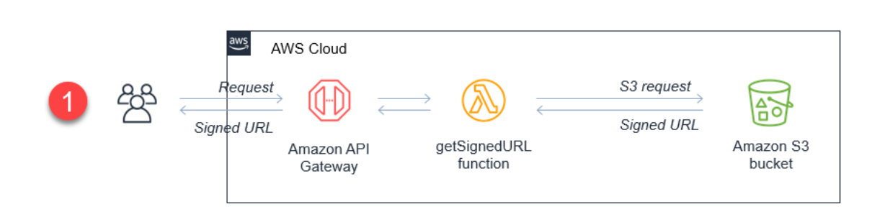

API Gateway which is an AWS service that allows to build HTTP API: Created a HTTP endpoint, followed by a Lambda function. And connected the Lambda function to the API Gateway endpoint!

## 

## **Data Pipeline key Steps-**

AS OF TIME-->HITS API-->Get data as of date--> Generate o/p VIL images--> Upload it to S3 bucket

* Created Pycharm project with a virtual environment
* Install the required libraries
* Packaged the code & prepared the deployment pipeline.
* Created Lambda function
* Created the REST API in API Gateway
* Configured the Lambda function as a proxy to forward requests (to fetch and to create) from API Gateway to Amazon Lambda.
* Deployed the API to dev stage.
* Tested the endpoint.
* Did the Inference of the Data using Streamlit application, and deployed the same.

# Detail Flow of the pipeline-

API Gateway to Lambda

**Lambda Function:**

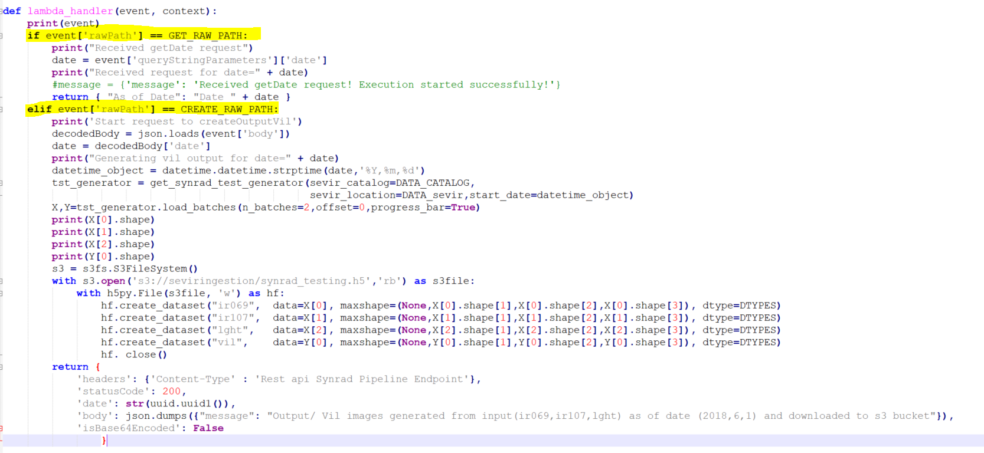

**HTTP API:**

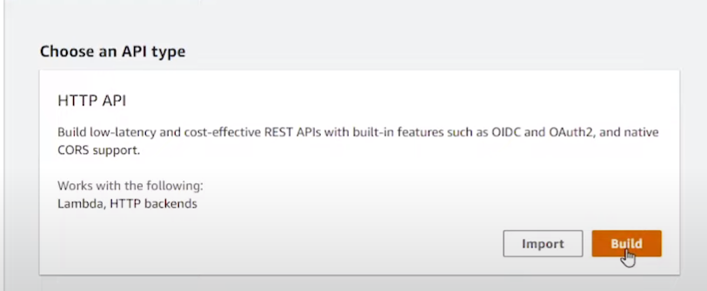

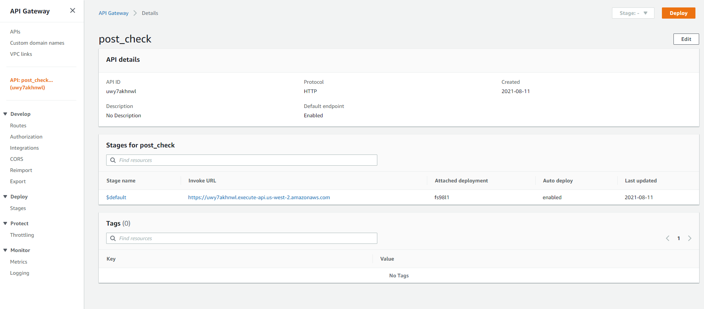

Lambda function **Overview-**

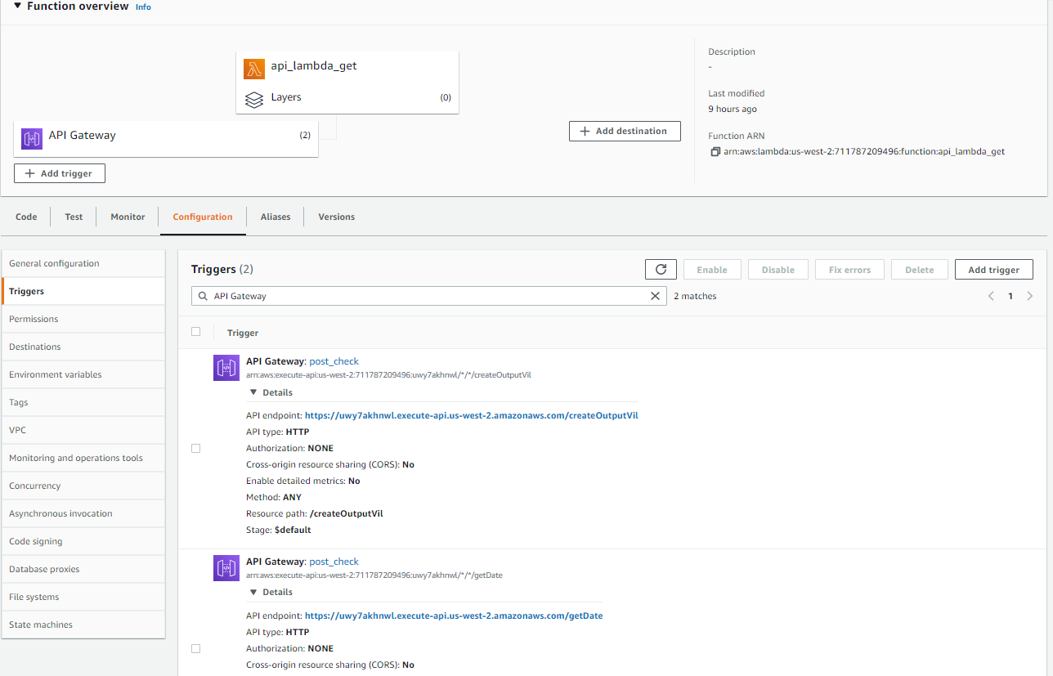

**Postman** app: Message generated by **Invoking GET** date URL

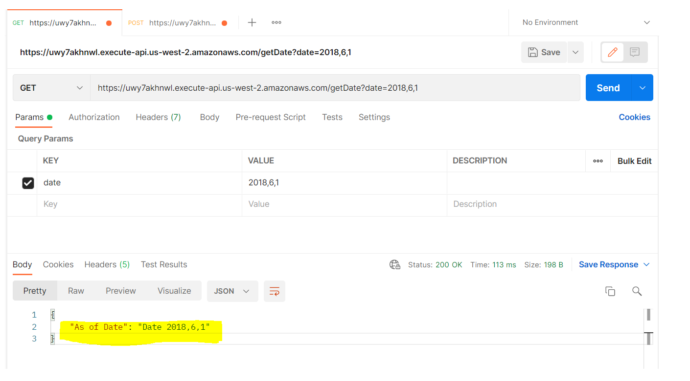

**JSON Data**

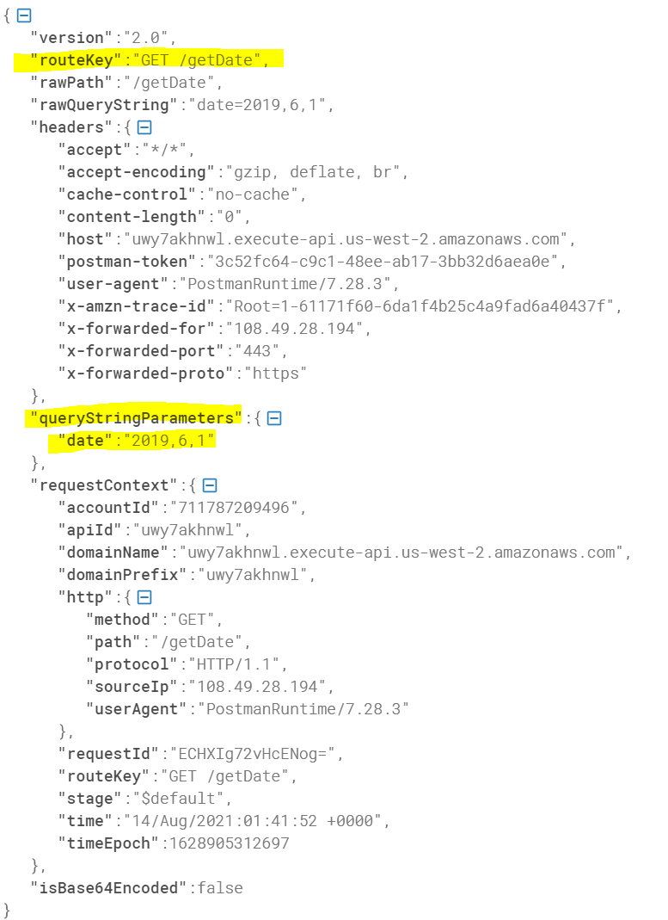

**Postman** app: Message generated by **Invoking POST** / CREATE URL

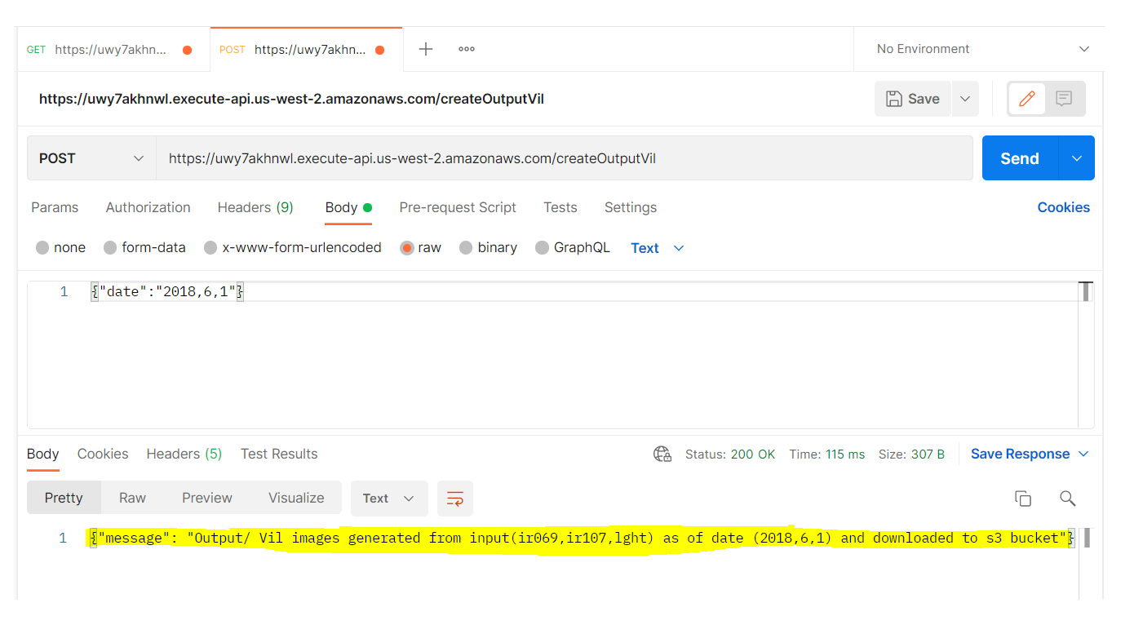

**JSON data**

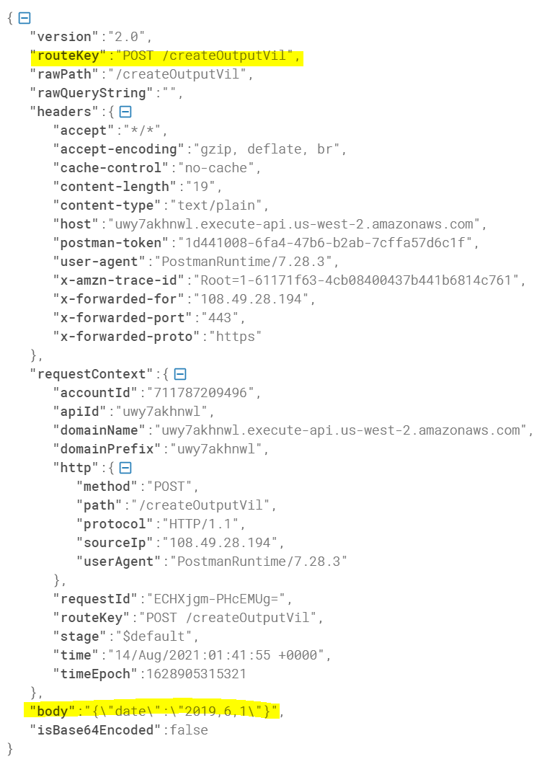

**Logs** from **CloudWatch**:

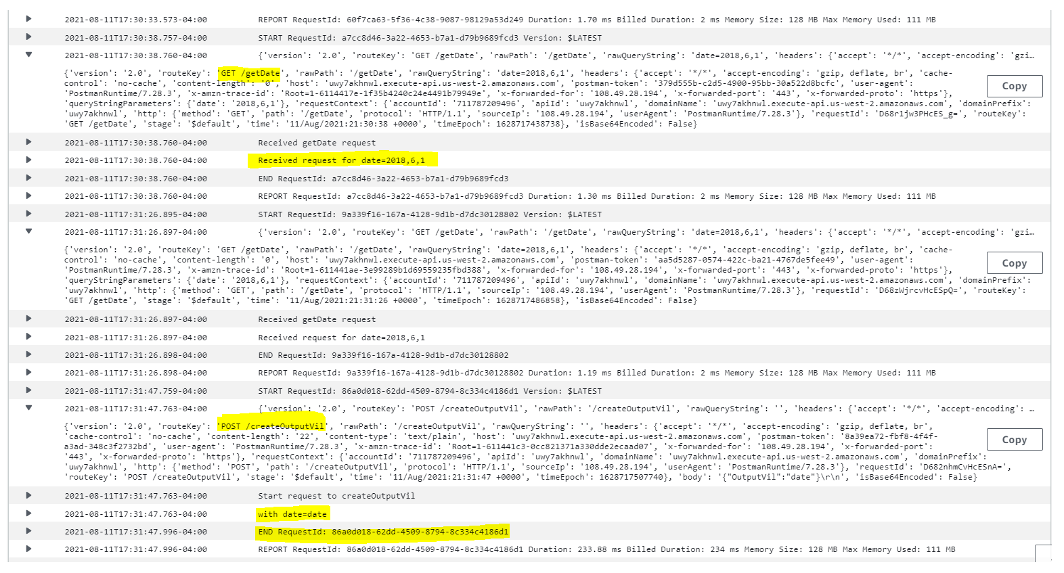

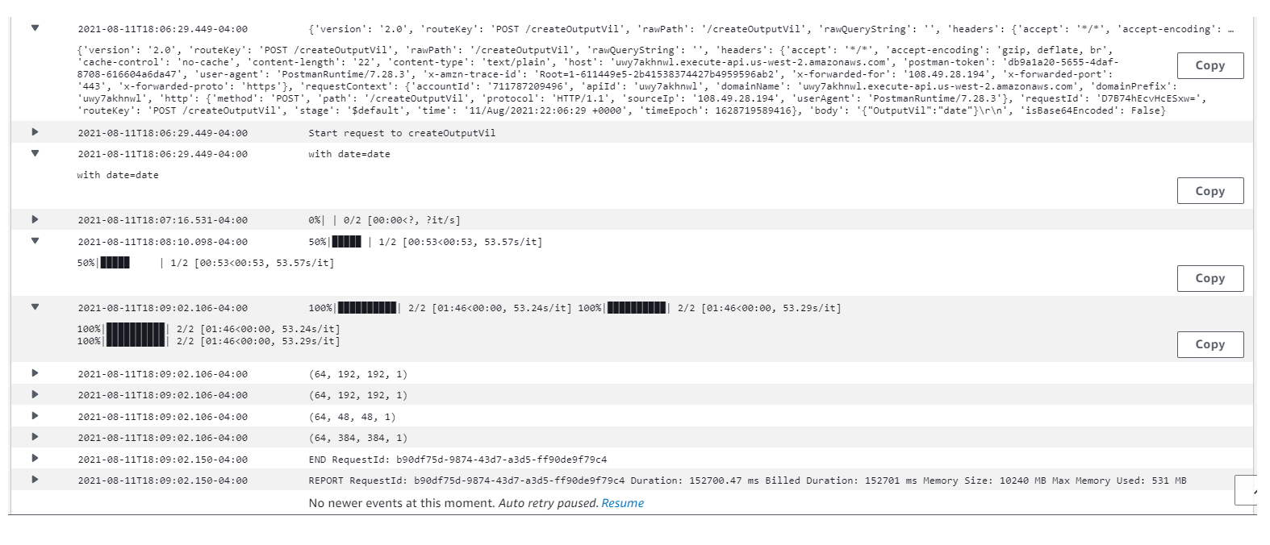

**CloudWatch Metrics:**

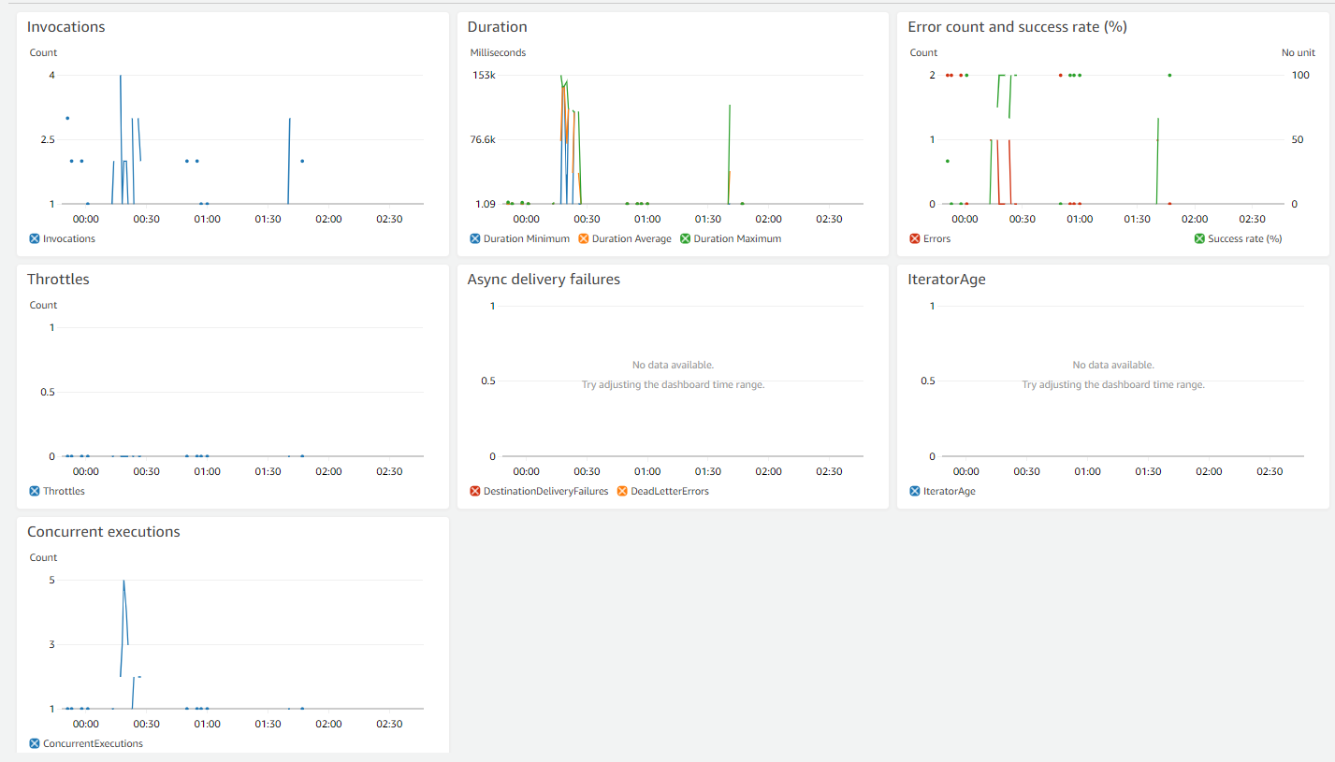

# **Streamlit** app: **Inference** of Data generated

