*Are the statements below the text TRUE, FALSE or NOT GIVEN? The answers are given at the bottom of this post*

[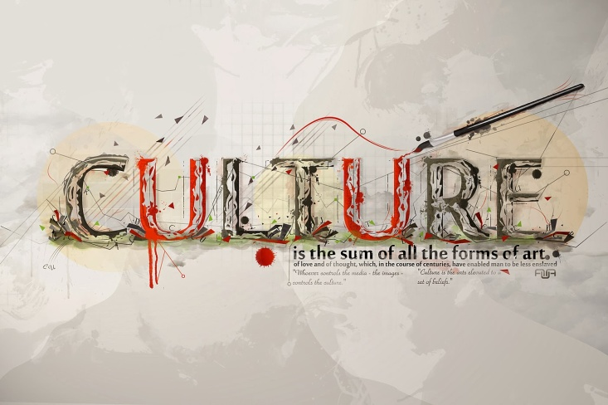](http://2.bp.blogspot.com/-HaSKJHkTOaA/UuHj4Kw4qTI/AAAAAAAAABA/EQbOalXd77g/s1600/culture.jpg)

Culture is defined as the ‘socially transmitted behaviour patterns, arts, beliefs, and institutions that are the expression of a particular class, community or period’ ([www.dictionary.com](http://www.facebook.com/l.php?u=http%3A%2F%2Fwww.dictionary.com%2F&h=4AQHkHCR6&s=1)). To most people, this is seen in terms of books, paintings, rituals and ceremonies, but recently there has been a new entrant in the field of what is considered to be ‘culture’ – the Internet.   
  
On the Internet, science and art, media and mind combine to create a modern culture which is far more widespread than any of its predecessors. Not referring to the casual user who has no particular interest in the Internet, active supporters of the Internet as a culture have given themselves nomenclature to reflect their cultural aspirations – they are the new cyberpoets. A cyberpoet can be defined as ‘one who makes frequent trips to the edge of technology, society and traditional culture and strives to be artful in their use of virtual space’.   
  
Supporter or opponent of this new culture, there is little doubt that the Internet offers a lot to our traditional view of culture. In just a few minutes in front of a keyboard, we can read almost anything that has ever been written, yet no paper had to be made, no library had to stay open and thus the cost remains minimal. All of this encourages even the casual surfer to explore further than he or she otherwise would have. The same effect can be observed with works of art. Previously available to be viewed only in museums if they were not in the hands of private collectors, all but a few famous works are now replicated on the Internet.   
  
Yet the Internet is not merely a mirror of traditional culture – it is also a new culture in its own right. The medium of the Net allows for wider distribution and new platforms for most forms of art. ‘Kinetic art’ and other such computerised art forms occur with increasing regularity, both motivated by and generating an upsurge in popular and computer-mediated art.   
  
In addition, if culture is said to be ‘socially transmitted’, then the Internet is remarkable in its ability to share, on an almost global scale, all the factors that constitute culture. We have only to hear the influence of jargon as we visit dub-dub-dub dot sites and surf the web to see how international the Internet has become to the majority.   
  
Very few people would disagree that the cyberpoets are increasingly asserting themselves into popular culture. What is not so certain is how far this will go, as the Internet continues to assimilate more and more forms of culture, reaching global audiences. It is not inconceivable that our entire perception of culture will soon become cyber-focused.   
  
  
a The majority of people consider ‘culture’ to be represented by books, paintings, rituals and ceremonies.  
b Our understanding of what constitutes culture is unaffected by the Internet.  
c Through the Internet, every written word can be accessed.  
d The Internet provides a stage for all forms of art.  
e An insignificant number remain unaffected by the international nature of the Internet.  
f Only a few people believe that ‘cyberpoets’ are becoming part of our popular culture.  
  
Scroll down to check your answers!  
  
  
  
  
  
  
  
  
  
  
  
  
  
  
  
  
  
Here are the answers. We have interactive lessons, videos and exercises, as well as full IELTS practice tests, on our complete IELTS preparation site - [click here to find out more about our FREE course!](http://www.ieltsforfree.com/)

1. The majority of people consider ‘culture’ to be represented by books, paintings, rituals and ceremonies.  
   **This is TRUE** ('to most people, this is seen in terms of books, paintings, rituals and ceremonies')
2. Our understanding of what constitutes culture is unaffected by the Internet.  
   **This is FALSE** ('there is little doubt that the internet offers a lot to our traditional veiw of culture')
3. Through the Internet, every written word can be accessed.  
   **This is FALSE** ('we can read *almost* anything')
4. The Internet provides a stage for all forms of art.  
   **This is FALSE**(' the net allows for wider distribution and new platforms for *most* forms of art')
5. An insignificant number remain unaffected by the international nature of the Internet.  
   **This is NOT GIVEN**
6. Only a few people believe that ‘cyberpoets’ are becoming part of our popular culture.  
   **This is FALSE** ('very few would disagree')

So much of the literature of the western world, including a large part of its greatest literature, was either written for actual speaking or in a mode of speech, that we are likely to deform it if we apply our comparatively recent norm of writing for silent reading. It is only that so much of this work is drama or oratory (the latter including the modern forms of sermons, lectures and addresses which as late as the nineteenth century play a most important part). It is also thought that through classical and mediaeval times, and in many cases beyond these, most reading was either aloud or silently articulated as if speaking: a habit we now recognise mainly in the slow. Most classical histories were indeed quite close to oratory and public speech, rather than silent reading of an artefact, was the central condition of linguistic composition.

1. Until the twentieth century, most people could only read with difficulty. **NG**

2. In ancient times, literature was intended to be read aloud. **True**

3. Classical histories were passed on orally and never written down. **False**

4. Only people with literacy problems now read aloud. **True**

The Suzuki method is a method of teaching music conceived and executed by Japanese violinist Shin'ichi Suzuki (born 1898, died 1998), dating from the mid-20th century. The central belief of Suzuki is that all people are capable of learning from their environment. The essential components of his method spring from the desire to create the "right environment" for learning music. He also believed that this positive environment would also help to foster character in students.

As a skilled violinist but a beginner at the German language who struggled to learn it, Suzuki noticed that children pick up their native language quickly, and even dialects adults consider "difficult" to learn are spoken with ease by 5-year-olds. He reasoned that if children have the skill to acquire their mother tongue, then they have the necessary ability to become proficient on a musical instrument. He pioneered the idea that pre-school age children could learn to play the violin if learning steps were small enough and if the instrument was scaled down to fit their body.

***Decide whether the following statements are true, false or not given.***

1. Suzuki believed that environment is crucial for anyone learning a musical instrument.
2. His method helped him to learn German.
3. Suzuki compared language learning with learning to play an instrument.
4. He introduced new ideas about teaching music to infants.

Posted by [Simon](http://profile.typepad.com/6p0120a5bb05d8970c) in [IELTS Reading](http://ielts-simon.com/ielts-help-and-english-pr/ielts-reading/) | [Permalink](http://ielts-simon.com/ielts-help-and-english-pr/2013/02/ielts-reading-true-false-not-given.html)

**Comments**

[Feed](http://ielts-simon.com/ielts-help-and-english-pr/2013/02/ielts-reading-true-false-not-given/comments/atom.xml)You can follow this conversation by subscribing to the [comment feed](http://ielts-simon.com/ielts-help-and-english-pr/2013/02/ielts-reading-true-false-not-given/comments/atom.xml) for this post.

1. Suzuki believed that environment is crucial for anyone learning a musical instrument. True  
2. His method helped him to learn German. Not given  
3. Suzuki compared language learning with learning to play an instrument. false  
4. He introduced new ideas about teaching music to infants. False(I considered infants’ age 6-8)