Portfolio Project Showcase
This document accompanies the screenshots in my portfolio repository and explains the purpose and key features of each page.

Home / Landing Page
The landing page introduces me as a Computer Science student and provides quick access to all sections of the portfolio.
- Key Features:
- Hero section
- Resume download
- Smooth navigation
- Responsive design
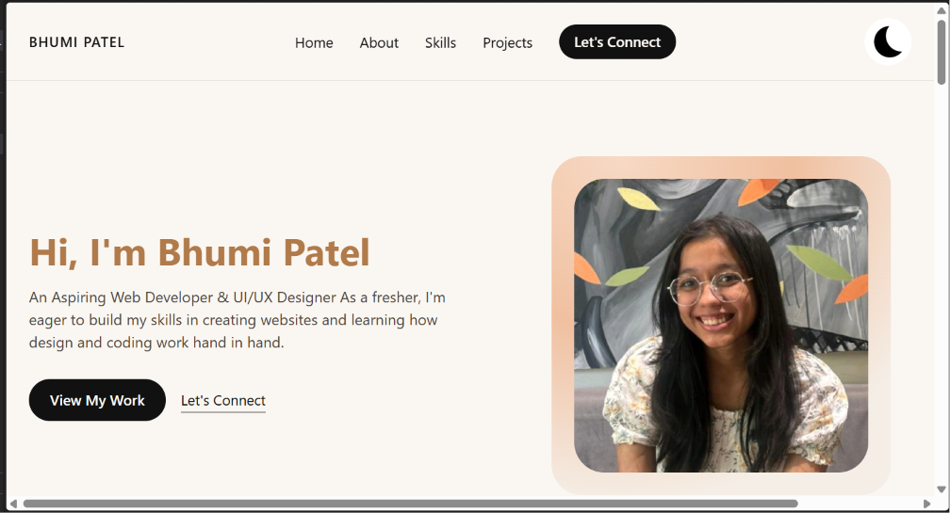

About Me
Summarizes my background, interests, education and career goals.
- Key Features:
- Education
- Career objective
- Personal introduction

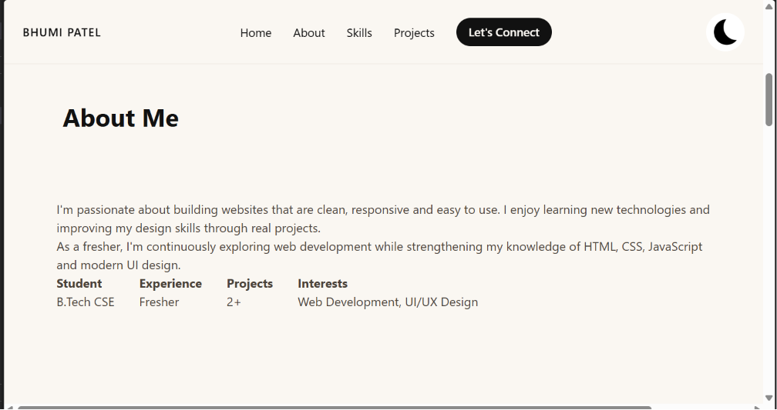Skills
Displays my technical skills in an organized manner.
- Key Features:
- Programming Languages
- Web Development
- Databases
- Tools
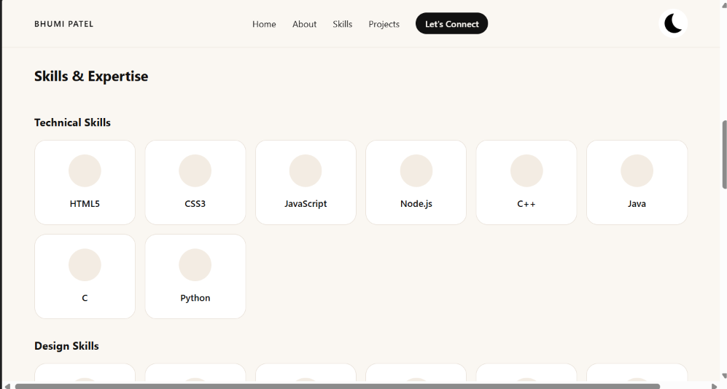
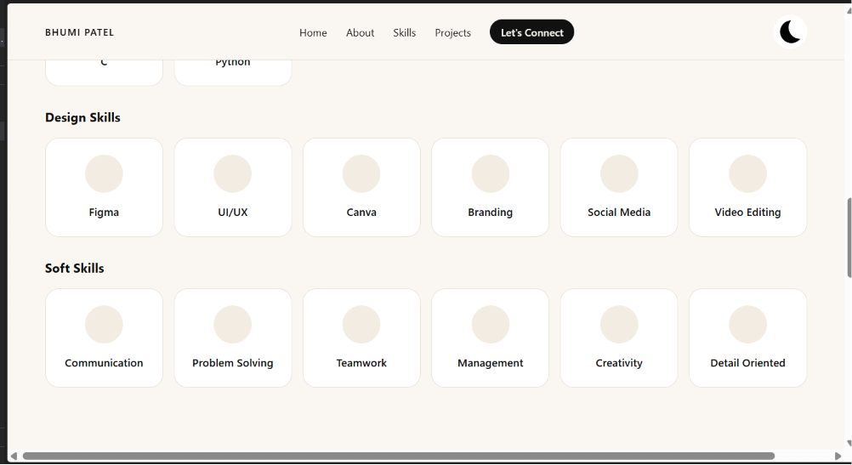

Projects ( In progress)
Highlights academic and personal projects with descriptions and GitHub links.
- Key Features:
- Technologies used
- Key features
- Repository links

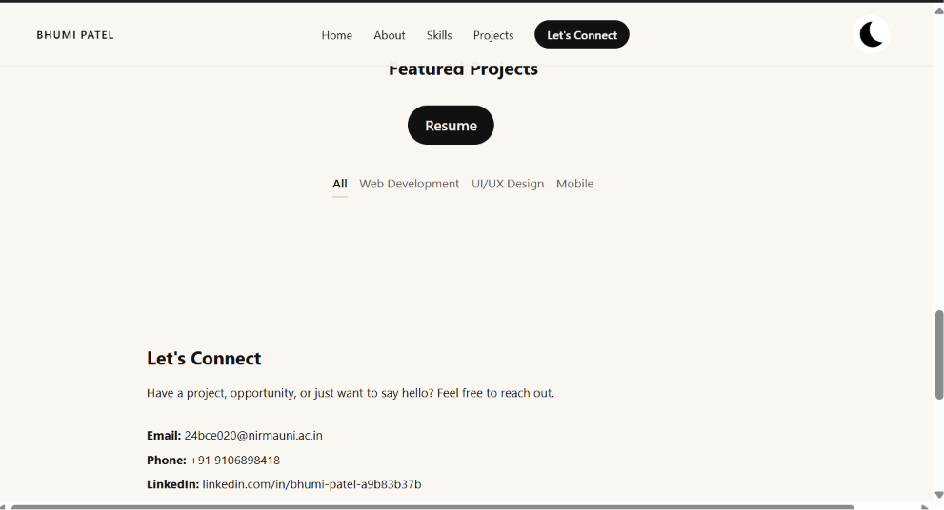Certificates ( pending )
Shows certifications and achievements.
- Key Features:
- Course certificates
- Technical accomplishments

Contact
Allows visitors to connect with me.
- Key Features:
- Contact form
- Email
- LinkedIn
- GitHub

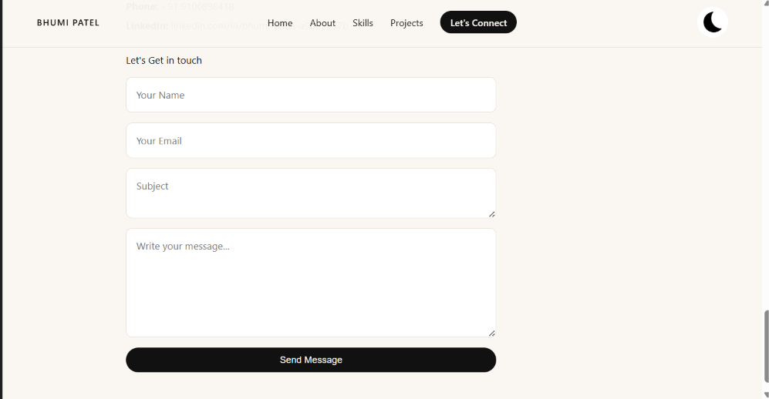Dark Mode
A toggle switches between light and dark themes for improved user experience.
- Key Features:
- Theme persistence
- Smooth transitions

Responsive Design ( In progress )
The portfolio adapts to desktop, tablet and mobile screens.
- Key Features:
- Flexible layouts
- Mobile friendly
( yet to be fully deployed

