Assignment question

1.Check Status of your order

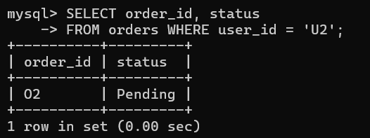

2.Find total amount of your orders.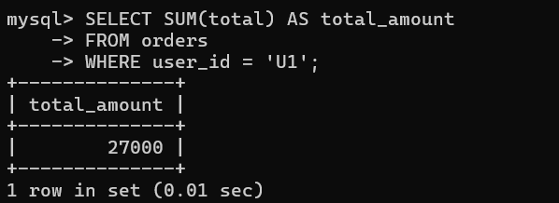

3.update your city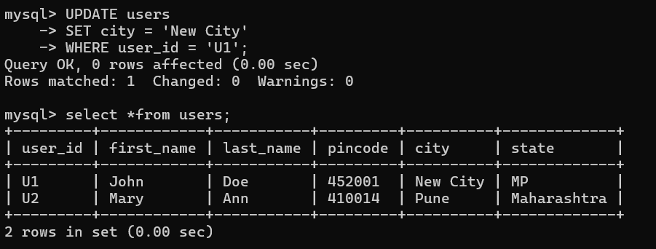

4.Change product description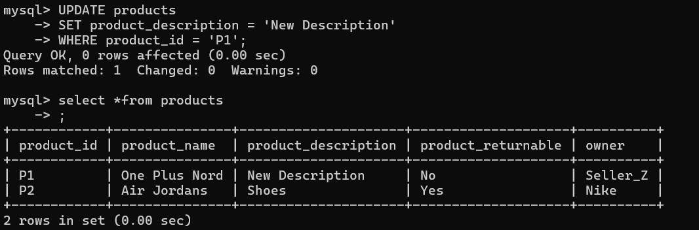

5.Display Returnable product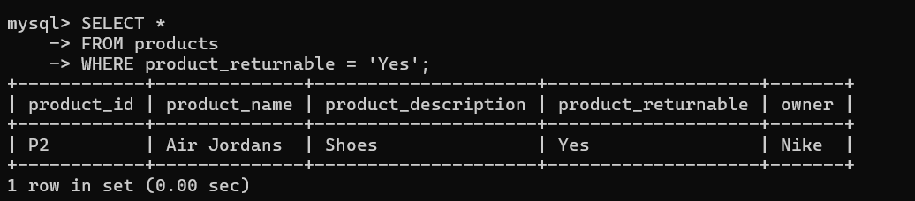

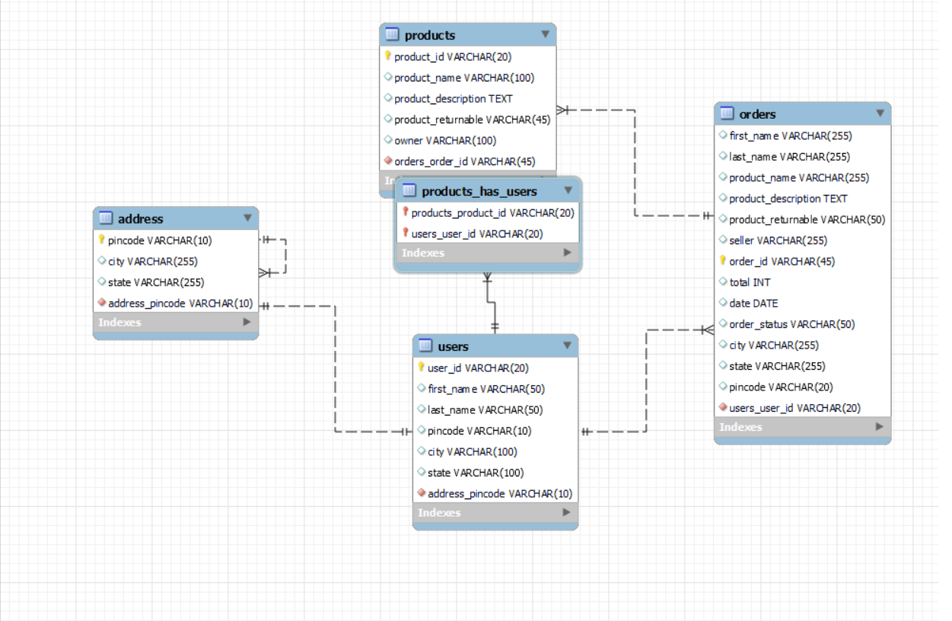

-- create database bhumi;

-- use bhumi;

CREATE TABLE orders (

order_id VARCHAR(45) PRIMARY KEY,

product_id VARCHAR(45),

user_id VARCHAR(45),

total DOUBLE,

date DATE,

status VARCHAR(50),

FOREIGN KEY (product_id) REFERENCES products(product_id),

FOREIGN KEY (user_id) REFERENCES users(user_id)

);

CREATE TABLE products (

product_id VARCHAR(20) PRIMARY KEY,

product_name VARCHAR(100),

product_description TEXT,

product_returnable VARCHAR(45),

owner VARCHAR(100)

);

INSERT INTO products (product_id, product_name, product_description, product_returnable, owner)

VALUES

('P1', 'One Plus Nord', 'Red Mobile Phone', 'No', 'Seller_Z'),

('P2', 'Air Jordans', 'Shoes', 'Yes', 'Nike');

CREATE TABLE address (

pincode VARCHAR(10) PRIMARY KEY,

city VARCHAR(255),

state VARCHAR(255)

);

INSERT INTO address (pincode, city, state)

VALUES

('452001', 'Indore', 'MP'),

('410014', 'Pune', 'Maharashtra');

CREATE TABLE users (

user_id VARCHAR(20) PRIMARY KEY,

first_name VARCHAR(50),

last_name VARCHAR(50),

pincode VARCHAR(10),

city VARCHAR(100),

state VARCHAR(100)

);

INSERT INTO users (user_id, first_name, last_name, pincode, city, state)

VALUES

('U1', 'John', 'Doe', '452001', 'Indore', 'MP'),

('U2', 'Mary', 'Ann', '410014', 'Pune', 'Maharashtra');

INSERT INTO orders (order_id, product_id, user_id, total, date, status)

VALUES

('O1', 'P1', 'U1', 2000, '2024-03-04', 'Approved'),

('O2', 'P2', 'U2', 7000, '2024-03-04', 'Pending'),

('O3', 'P1', 'U1', 25000, '2024-03-04', 'Shipped');

-- check status of your order

SELECT order_id, status

FROM orders WHERE user_id = 'U2';

-- find total amount of your order

SELECT SUM(total) AS total_amount

FROM orders

WHERE user_id = 'U1';

-- update your city

UPDATE users

SET city = 'New City'

WHERE user_id = 'U1';

-- change product description

UPDATE products

SET product_description = 'New Description'

WHERE product_id = 'P1';

-- Display returnable products

SELECT *

FROM products

WHERE product_returnable = 'Yes';