 



SMART MUSHROOM FARMING

**GROUP-13**

**A BHUMIKA RAO | SANJANA NETAM** | **SHIVA CHUNBUK 211020401 | 211020444 | 211020447**

**ABSTRACT:**

 IoT system implementation in agricultural field is used widely for efficient farming solutions. Hereby, we are making a smart mushroom farming system which helps in providing hassle -free and time efficient environment to the farmer for mushroom Cultivation. The major problem faced in the mushroom cultivation process is related to the irrigation, environmental parameter monitoring and reducing human intervention.IoT can help to improve agricultural and farming industries by reducing labor cost through automation and increase the yield by providing optimum conditions for growth.The aim of this report is to deliver a development of an IoT-based Smart mushroom farming consisting of a temperature& humidity sensor and Ldr sensor, an IoT platform called ESP8266. The system will provide a real-time data of the temperature, humidity and light intensity. Equipped with an Android application, the data from the sensors will be transferred into the cloud server and subsequently transferred into the app for display and to enable remote monitoring.



**Keywords: Mushroom, IoT (Internet of Things), Temperature humidity sensor, LDR sensor, Nodemcu.**

**INTRODUCTION**

Mushroom are fungus also known as fungi. Mushroom cultivation requires closed space to be done. Mushroom Farming is a great concern in today’s time. We have used the handling method for mushroom farming in this project. The plastic bags that are used in mushroom framing cannot be kept on the ground. Handling method is used to keep them. The temperature, humidity, light intensity is some of the important parameters need to manage in a mushroom farm and these data are collected through wireless sensors. The implementation of this smart mushroom system has optimized the usage of resources such as water and fertilizer and will also maximized the quality and productivity of the mushroom. Manpower is needed to ensure environment conditions of mushroom cultivation and there are many factors to successfully develop mushroom cultivation appropriate. Environmental conditions must be maintained to enable profitable growth and business.

The key contributions of this project are:

* Real-time monitoring of temperature and humidity, light intensity.
* Continuous pushing of data on the cloud with a very little time gap.
* Android application that is very easy to use.
* Accurate positioning of sensors.



**OBJECTIVE**

The proposed design aims to implement a smart mushroom farming system, which is easy to use and economical for the user. ● The primary objective of this project is to measure the infiltration rate of the soil. ● To make model at low cost that which help to people to purchase easily. ● Help farmers during cultivation of crops.

**Components used and steps involved in designing of the system**

1.NodeMcu

2.DHT22

3.Jumper wires

4. Relay module

5. LDR Sensor

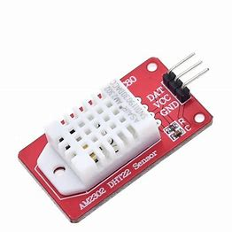

Fig 1: DHT22

The DHT-11 sensor, which combines a temperature and humidity sensor, typically outputs either digital or analog data. It contains information about the temperature around the plant if it needs extra sunshine and the degree of humidity in the surrounding environment. Water vapor is detected by measuring the electrical resistance between the two electrodes. The humidity sensing component consists of the electrode and the substrate, which is

responsible for retaining moisture while in contact with the surface. Ions are released by the substrate. The conductivity between the electrodes rises as soon as water vapor is absorbed by it.



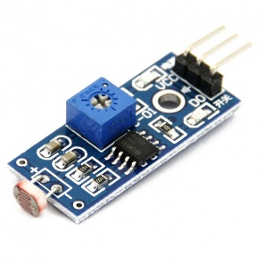

Fig 2: LDR Sensor

The most common light sensor type that’s used in a light sensor circuit are photoresistors, also known as a light-dependent resistor (LDR). Photoresistors are used to simply detect whether a light is on or off and compare relative light levels throughout a day.

Fig 3: nodemcu

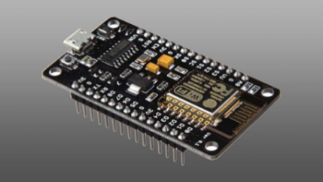 NodeMCU is an Internet of Things (IoT)-focused open-source Lua-based firmware and development board. It includes software for Expressive Systems’ ESP8266 Wi-Fi SoC as well as hardware for the ESP12 Module. The major argument for choosing this is that it is cheap and includes a built-in Wi-Fi Module because it is similar to Arduino, it can be programmed using the Arduino IDE software. It has ten General Purpose Input/Output pins for connecting to external devices. A standard NodeMCU, complete with pin numbers.

**Fig 4: Relay module**

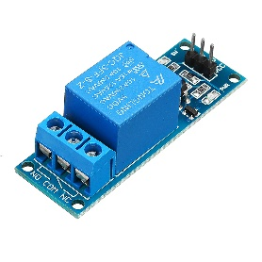

**Proposed Methodology**

1. The temperature & humidity sensor (DHT11) sends the temperature & humidity value to our controller.
2. There is also a light sensor which monitors the light intensity and sends status value to the controller.
3. We are using ESP-8266 as main controller this is where all input parameters are received and processed for automation.
4. ESP-8266 monitors the environment with its sensors and if needed it can control the environment temperature & humidity.
5. Breadboard and jumper wires for connection of the hardware parts





**CONCLUSION**

**FUTURE WORK**

**REFERENCES**