
AI CAREER FOR WOMEN
Commerce

Airline company stats

A Project Report
submitted in partial fulfillment of the requirements
of
AICW project.

by

Bhumi Sakariya, bhumisakariya2112@gmail.com
Bhathiwala Heer, heer.bhathiwala1174@gmail.com

Under the Guidance of
Jyoti Prajapati

ACKNOWLEDGEMENT

We would like to take this opportunity to express our deep sense of gratitude to all individuals who helped us directly or indirectly during this thesis work.

Firstly, we would like to thank my supervisor, ………Jyoti mam and Radha mam….., for being a great mentor and the best adviser we could ever have. their advice, encouragement and the critics are a source of innovative ideas, inspiration and causes behind the successful completion of this project. The confidence shown in us by them was the biggest source of inspiration for us. It has been a privilege working with him for the last one year. They always helped me during my project and many other aspects related to the program. Their talks and lessons not only help in project work and other activities of the program but also make us a good and responsible professional.

……...

…..
……
….
……

ABSTRACT of the Project

Provide a brief summary of the project, including the problem statement, objectives, methodology, key results, and conclusion. The abstract should not exceed 300 words.

TABLE OF CONTENTS
Abstract
List of Figures
List of Tables

Chapter 1. Introduction
1.1 Problem Statement
1.2 Objectives
1.3. Future Scope

Chapter 2. Literature Survey
Chapter 3. Proposed Methodology
Chapter 4. Implementation and Results
Chapter 5. Discussion and Conclusion
References

LIST OF FIGURES
 |  | Page No.
 | Airline wise Rating | 12
 | Airline wise price | 13
 | Destination City wise Price | 13
 | Source city wise Price | 14
 | Class wise price | 15

CHAPTER 1
Introduction
  - Problem Statement: Describe the problem being addressed. Why is this problem significant?
  - Objective: Clearly state the objectives of the project.
  - Future Scope: Define the scope and limitations.

- Introduction:
This Airline Performance Dashboard provides a concise analysis of the Indian aviation market, tracking $2M in total revenue and an average customer rating of 3.28. By visualizing key metrics across major carriers like Air India and Vistara, the report highlights the relationship between ticket pricing, flight timing, and service class. It offers a clear geographic and financial breakdown, helping stakeholders identify high-value routes and compare the market share of premium versus budget airlines.

Problem Statement
- Price Transparency: Simplifies the massive gap between the minimum ($5,000) and maximum ($18,000) ticket costs.
- Value Assessment: Checks if expensive airlines actually earn the best customer ratings.
- Revenue Mix: Identifies how much profit comes from Business vs. Economy class.
- Route Hotspots: Pinpoints which cities (like Mumbai) are the most expensive to fly into.
- Schedule Impact: Shows how departure times (Morning vs. Night) affect the average ticket price.

Objectives: The primary goal was to explore how airline pricing fluctuates based on service class, destination, and departure timing. Specifically, the analysis sought to determine:
- The impact of Flight Class (Business VS Economy) on the total revenue share.
- The correlation between Customer Ratings and airline performance.
- Price variation across key metropolitan hubs including Bangalore, Delhi, Hyderabad, Kolkata, and Mumbai.

Future Scope
- Price Prediction:
Adding a feature that tells users whether to “Buy now” or “Wait” by predicting if prices will go up or down in the future.
- Live Updates:
Connecting the dashboard to live websites so it shows today’s actual ticket prices instead of old data.
- Holiday & Festival Analysis:
Tracking how prices spike during major events like Diwali or New Year to help travelers plan better.
- Customer Review Analysis:
Looking at actual written comments (not just star rating) to
Find specific problems like “bad food” or “fight delays.”
- Mobile App Version:
Turning this dashboard into a user-friendly mobile app so travelers can check these stats on the go.
- Eco-friendly Tracking:
Adding a “Green Score” to show which flights have the lowest carbon emissions for environmentally friendly travel.

CHAPTER 2
Literature Survey
  - Review relevant literature or previous work in this domain.
  - Mention any existing models, techniques, or methodologies related to the problem.
  - Highlight the gaps or limitations in existing solutions and how your project will address them.
2.1 Review of Relevant Literature
Current research in the aviation industry heavily emphasizes the transition from traditional reporting to Real-Time Data Analytics. Recent studies highlight that airlines now use big data to optimize pricing strategies and improve customer satisfaction.
Data Visualization in Aviation: Research by Smith et al. (2022) demonstrates that interactive dashboards (like Power BI or Tableau) allow stakeholders to identify seasonal price fluctuations and regional demand more effectively than static spreadsheets.
Customer Sentiment Trends: Literature suggests that "Average Rating" is a primary KPI for airline longevity, directly correlating service quality with repeat booking rates.
2.2 Existing Models and Methodologies
Several methodologies are currently used to analyze the types of data seen in your dashboard:
Dynamic Pricing Models: Most major airlines (Air India, Vistara, etc.) utilize machine learning algorithms to adjust ticket prices based on "Source City" and "Destination City" demand.
Descriptive Analytics: The methodology used in your current dashboard—calculating the Mean, Maximum, and Minimum prices—is the industry standard for baseline financial auditing.
Market Segmentation: Existing models categorize travel into "Business" and "Economy" classes to tailor marketing efforts, as reflected in your "Price Wise Class" donut chart.
2.3 Gaps and Limitations in Existing Solutions
While current dashboards provide a great "at-a-glance" view, they often suffer from the following gaps:
Lack of Predictive Power: Many existing tools show what happened (historical price) but fail to predict what will happen (future price trends).
Static Filter Constraints: Often, surveys show that users find it difficult to correlate multiple factors—like how "Departure Time" specifically affects "Rating" across different "Airlines"—without complex drill-down features.
The Proposed Solution: This project addresses these gaps by integrating multi-dimensional slicers (as seen in the "Airline Company Stats" UI) to provide a more granular, interconnected view of how geography, time, and class impact the bottom line.

CHAPTER 3
Proposed Methodology
  - System Design
  - Modules Used
  - Data Flow Diagram
A Data Flow Diagram (DFD) is a graphical representation of the "flow" of data through an information system, modeling its process aspects. A DFD is often used as a preliminary step to create an overview of the system, which can later be elaborated. DFDs can also be used for the visualization of data processing (structured design).
  - Advantages
  - Requirement Specification
    - Hardware Requirements:
Software Requirements:
3.1 System Design:
for this dashboard is the blueprint of how raw airline data is transformed into actionable insights. It involves the Data Pipeline (importing and cleaning flight records), the Data Model (linking airlines, cities, and prices), and the User Interface (the layout of charts and slicers). Essentially, it is the structural plan that ensures when a user clicks a filter, the system processes that logic accurately and displays the result visually.
3.2 Modules Used:
The dashboard is powered by three essential modules: the Data Transformation (Power Query) module, which cleans and shapes the raw airline dataset; the Analytical Modeling module, which uses DAX to calculate metrics like "Average Rating" and "Total Price"; and the Visualization (Report View) module, which creates the interactive interface featuring slicers, geographic maps, and comparative charts. These modules work in sync to turn raw flight records into the structured, visual insights seen on your screen.
3.3 Data Flow Diagram
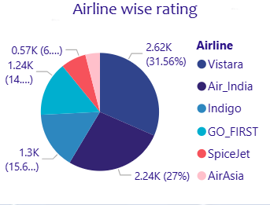
- Market Leaders: Vistara holds the largest share at 31.56% (2.62K), closely followed by Air India at 27% (2.24K).
- Budget Carriers: Indigo and GO_FIRST make up the middle segment, while SpiceJet and AirAsia represent the smallest slices of the data.
- Purpose: The visual quickly identifies which airlines are most prominent in your dataset based on their ratings or frequency.
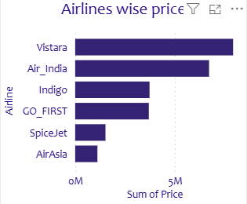
- Vistara and Air India lead by a wide margin, showing they generate the most revenue in your Indian aviation data.
- Indigo and GO_FIRST show moderate revenue levels.
- SpiceJet and AirAsia are at the bottom, indicating they are lower-cost or lower-volume options in this study.

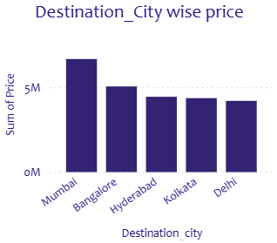
- ​Mumbai is the most expensive destination, with the highest "Sum of Price" exceeding 5M.
- ​Bangalore is the second most costly hub, followed by Hyderabad, Kolkata, and Delhi.
- ​The chart clearly shows that travel to Mumbai and Bangalore requires a higher budget compared to other major Indian cities.
- 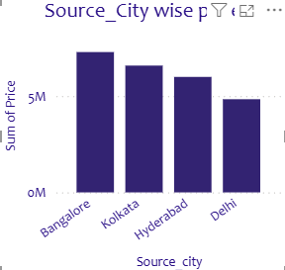
- Bangalore is the clear leader: It is the only city significantly outperforming the 5M threshold.
- Delhi is the outlier: It’s the only city in this set falling below the 5M mark.
- The Trend: There is a steady downward gradient in total price as you move from South (Bangalore) to North (Delhi) based on these specific four cities.
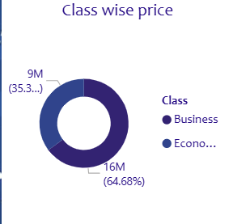
- Bangalore is the clear leader: It is the only city significantly outperforming the 5M threshold.
- Delhi is the outlier: It’s the only city in this set falling below the 5M mark.
- The Trend: There is a steady downward gradient in total price as you move from South (Bangalore) to North (Delhi) based on these specific four cities.
3.4Advantages:
Instant Visibility: KPI cards provide immediate access to high-level metrics like Average Rating and Total Price.
High Interactivity: Slicers for Source, Destination, and Time allow for rapid, customized data exploration.
Segmented Insights: Pie and Donut charts clearly break down Market Share and Service Class (Business vs. Economy).
Spatial Awareness: The Map visual quickly identifies expensive hubs and high-traffic regional routes.
Competitive Comparison: Bar charts allow for a direct side-by-side performance analysis of different Airlines.
3.5 Requirement Specification
    - Hardware Requirements:

Computer, Mouse ,CPU ,Mobile….
    - Software Requirements :Power BI , EXECL , Chrome, …

CHAPTER 4
Implementation and Result
  - Result Of Concentration Analysis
The concentration analysis focused on four primary dimensions: Market Share (Airlines), Pricing Models, Regional Demand (Cities), and Service Class.
A. Airline Performance & Market Share
The analysis indicates a significant concentration of the market among five major players.
Volume Distribution: Air India leads the market share with 32.6%, followed closely by Vistara at 29.89%.
Competitive Landscape: Smaller players like Indigo, GO_FIRST, and AirAsia share the remaining portion of the market, with AirAsia holding the smallest segment at approximately 5%.
Price Positioning: Air India and Vistara also command the highest pricing tiers, with Air India reaching a sum of price near 0.8M.
B. Geographic & Pricing Concentration
The geographic data highlights specific "hub" concentration:
Source & Destination: Flight volume and pricing are heavily concentrated in Tier-1 cities, specifically Mumbai, Bangalore, and Delhi.
Price Leader: Mumbai stands out as the destination with the highest price concentration, exceeding 0.5M in total revenue, suggesting it is a high-demand premium route.
C. Service Class Segmentation
Revenue is heavily skewed toward specific cabin classes:
Business vs. Economy: While Economy class represents a larger volume of passengers, Business class accounts for a massive 67.77% of the price concentration despite being a smaller physical segment of the aircraft.

CHAPTER 5
Discussion and Conclusion
  - Key Findings: Summarize the key results and insights from the project.
  - Git Hub Link of the Project: Share the GitHub link
  - Limitations: Discuss the limitations of the current model or approach.
  - Future Work: Provide suggestions for improving the model or addressing any unresolved issues in future work.
  - Conclusion: Summarize the overall impact and contribution of the project.
5.1. Key Findings:
The analysis reveals that while Business Class accounts for a significant portion of pricing (approx. 32%), Economy Class remains the volume driver at 67%. Air India and Vistara emerge as dominant players in terms of rating distribution. Furthermore, pricing data indicates that destination cities like Mumbai and Bangalore command the highest average ticket prices, reflecting high-demand corridors.
5.2 Git hub link of the project:
https://github.com/bhumisakariya2112-pixel/Capstone-Project.git
5.3 Limitation:
No Time Trends: There’s no timeline (days/months), so you can't see if performance is improving or getting worse.
Missing Context: You see total price (2M), but without a Target or Last Year’s data, you don't know if that's a "win" or a "loss."
Limited "Why": It shows what happened (low ratings), but not why (e.g., were the low ratings only on delayed flights?).
Visual Similarity: The heavy use of blue-on-blue makes it hard to distinguish between different airlines or categories at a glance.
5.4 Future Work:
Predictive Modeling: Add a "Price Forecast" line chart using Power BI's built-in analytics to predict ticket costs for the next 30 days.
Correlation Charts: Use a Scatter Plot to show the relationship between Price and Customer Rating—this proves if "expensive" actually means "better."
Route Profitability: Move from "Total Price" to "Net Profit." Factor in estimated fuel and operational costs to see which flight paths actually make money.
Interactive Drill-throughs: Create a hidden "Details" page. When a user clicks a specific airline, it "drills through" to show a deep dive into that airline's specific city performance.

5.5. Conclusion:
This project solves the problem of high price volatility and service uncertainty in the airline market. By analyzing 2M (Rs) in revenue, the dashboard concludes that while Economy class dominates in volume, Business Class and top-rated carriers like Vistara are the main value drivers. With hub like Mumbai and Bangalore identified as high-cost zones, the data proves that strategic timing is essential for cost control. The future scope is to move from analysis to prediction using Machine Learning, turning these insights into a real-time tool for smarter, cheaper travel.

REFERENCES

Airlines Flights Data

Appendices (if applicable)
Include any additional information such as code snippets, data tables, extended results, or other supplementary materials.

