

CHAROTAR UNIVERSITY OF SCIENCE AND TECHNOLOGY

FACULTY OF TECHNOLOGY AND ENGINEERING

B. TECH (IT/CE/CSE/AIML)

Subject: Advanced Web Development Frameworks (ITUE301) | Semester: 5th

Practical Statement:
• Create a React application using Vite for a student portfolio page.
• The application must include at least 4 reusable components:
Header, About, Skills, and Footer.
• Each component must be independently structured and composed
into a single-page layout.
• No logic or JSX should be duplicated across components.
• Props must be used to pass at least one piece of data into a
minimum of 2 components.

Screenshots (It should include the date and time from the bottom right corner):
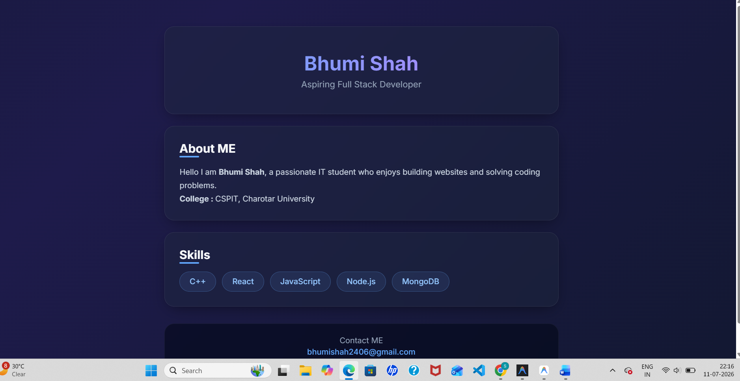
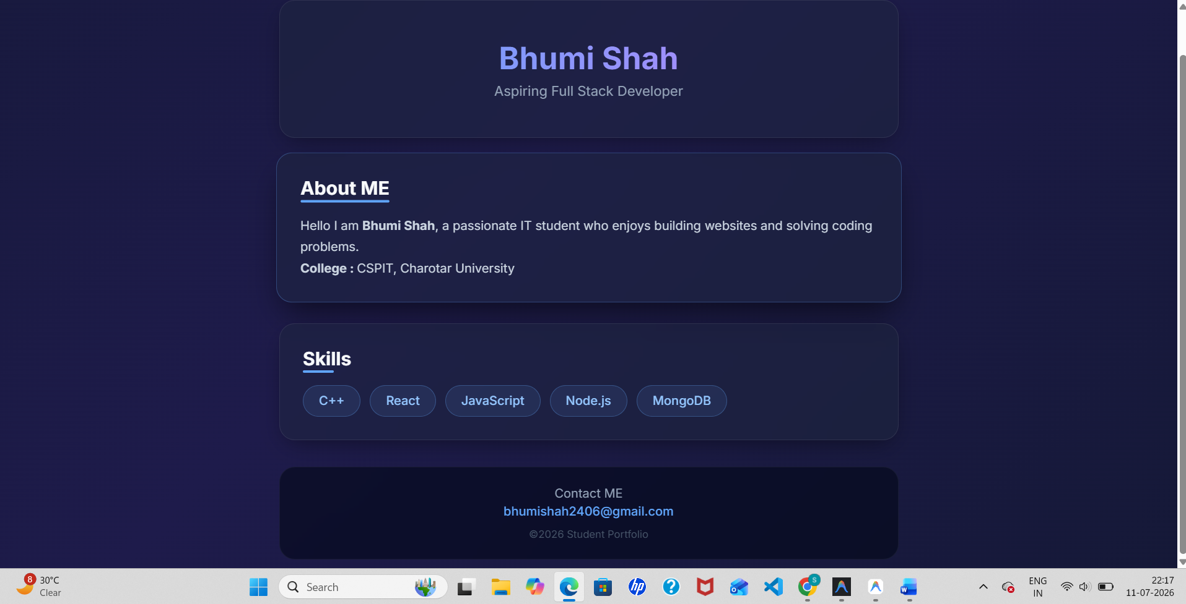
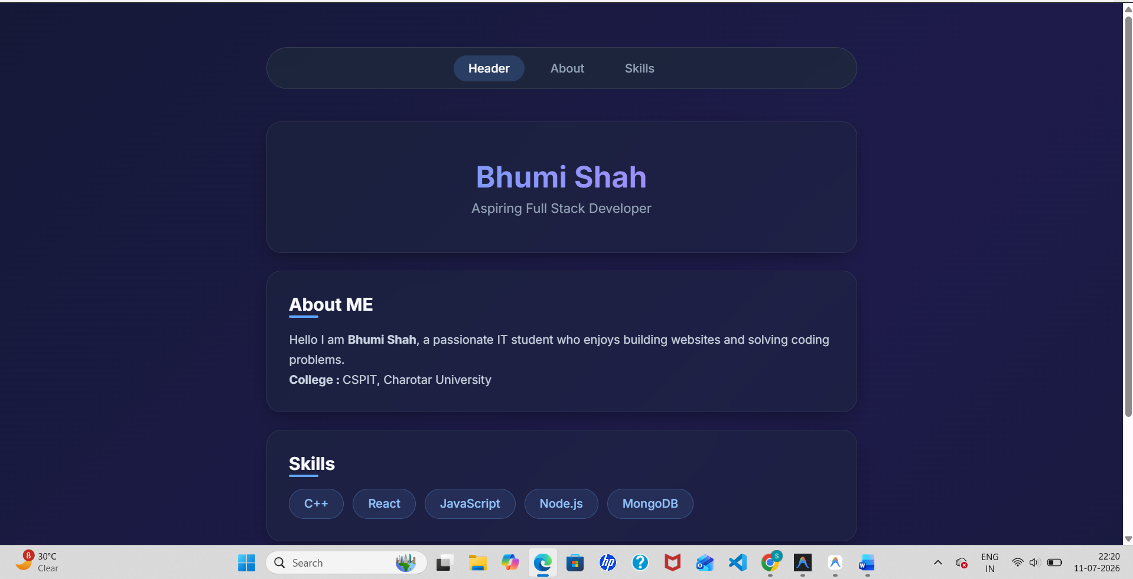
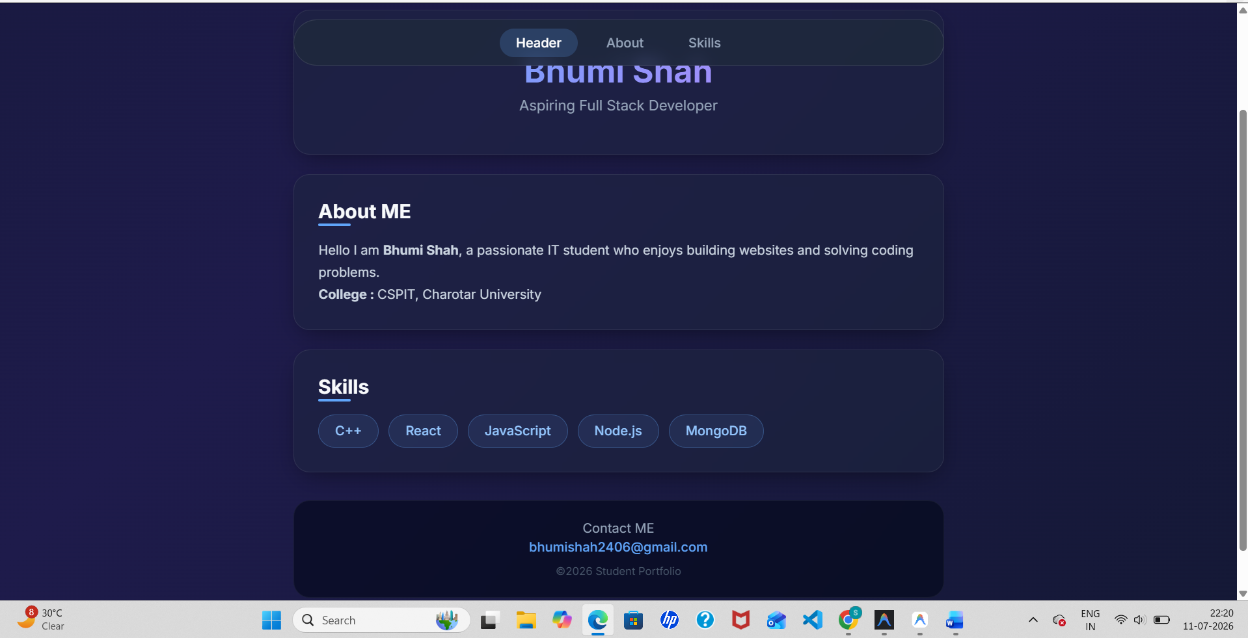

Github Repo Link:
https://github.com/bhumishah2411/AWDF/tree/main/Pr1

