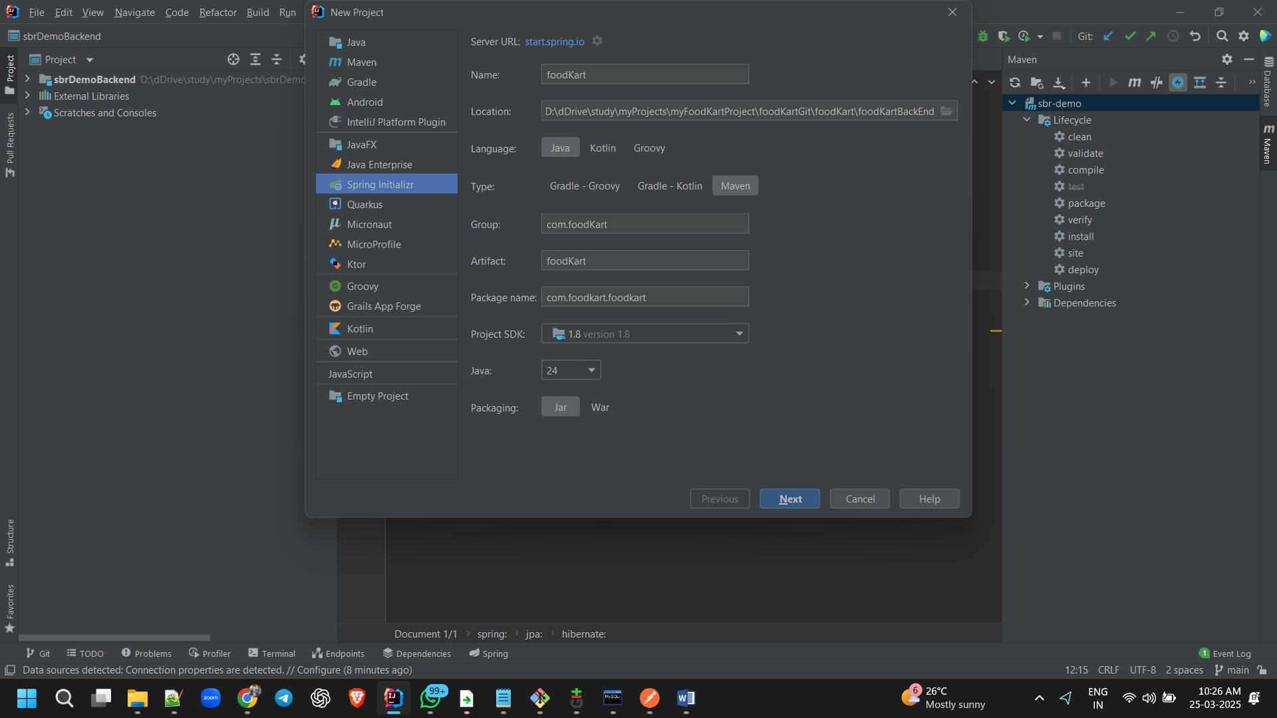

Next 🡪

Select Lombok

And select jpa  
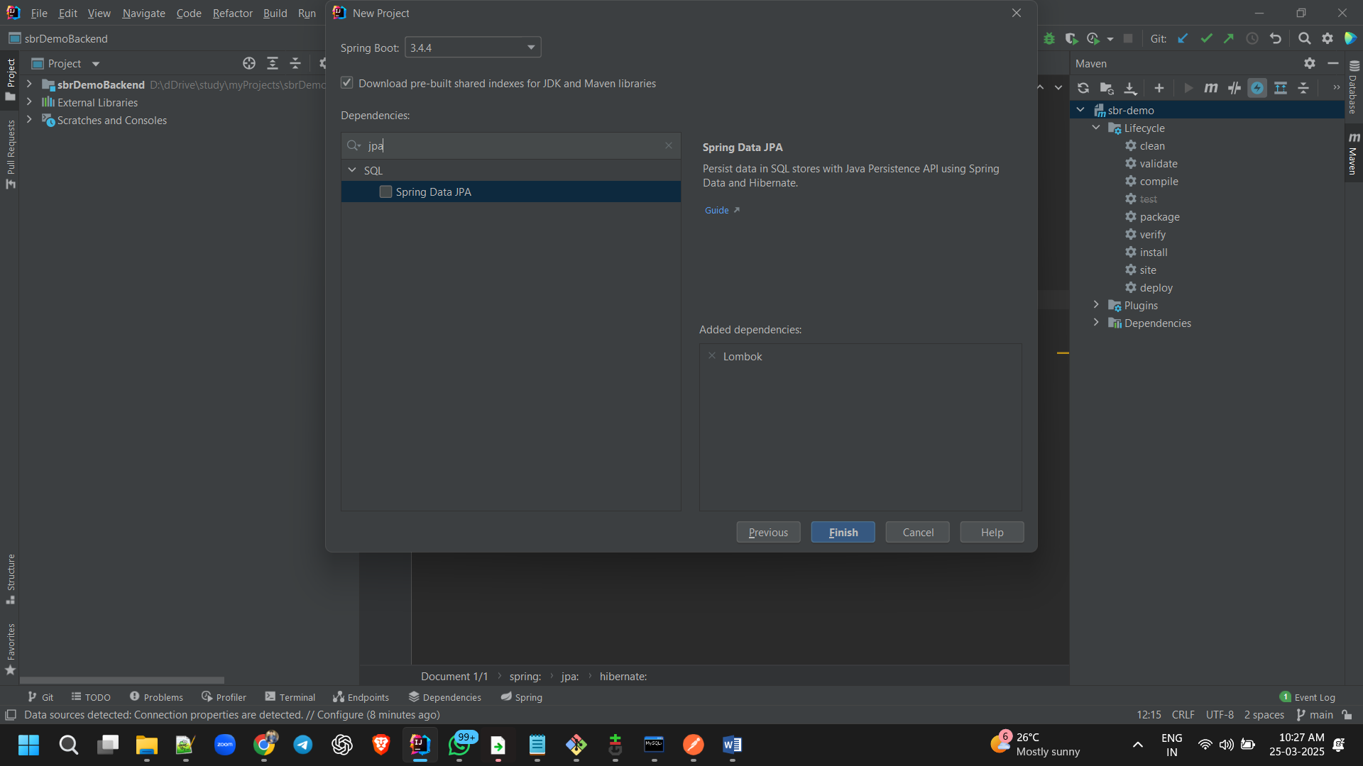

Select spring web

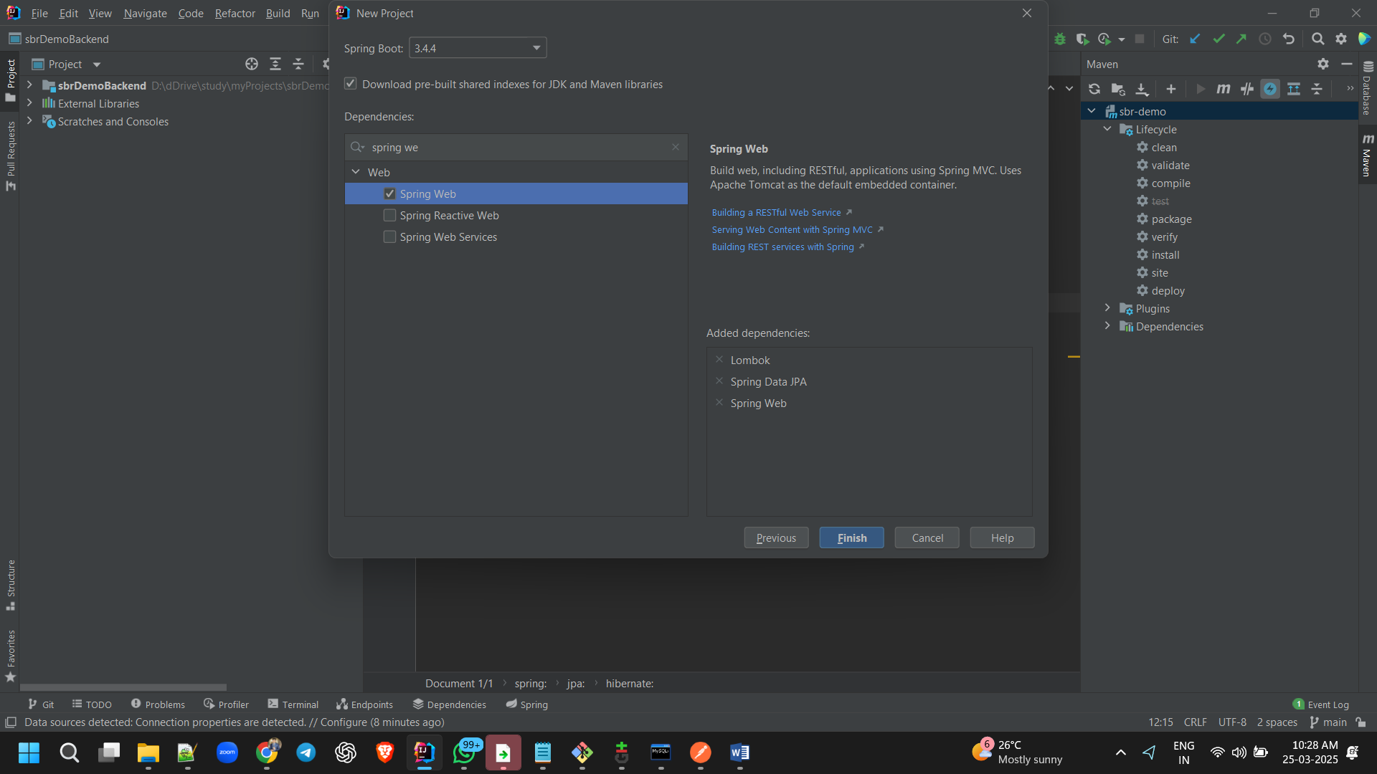

My sql driver

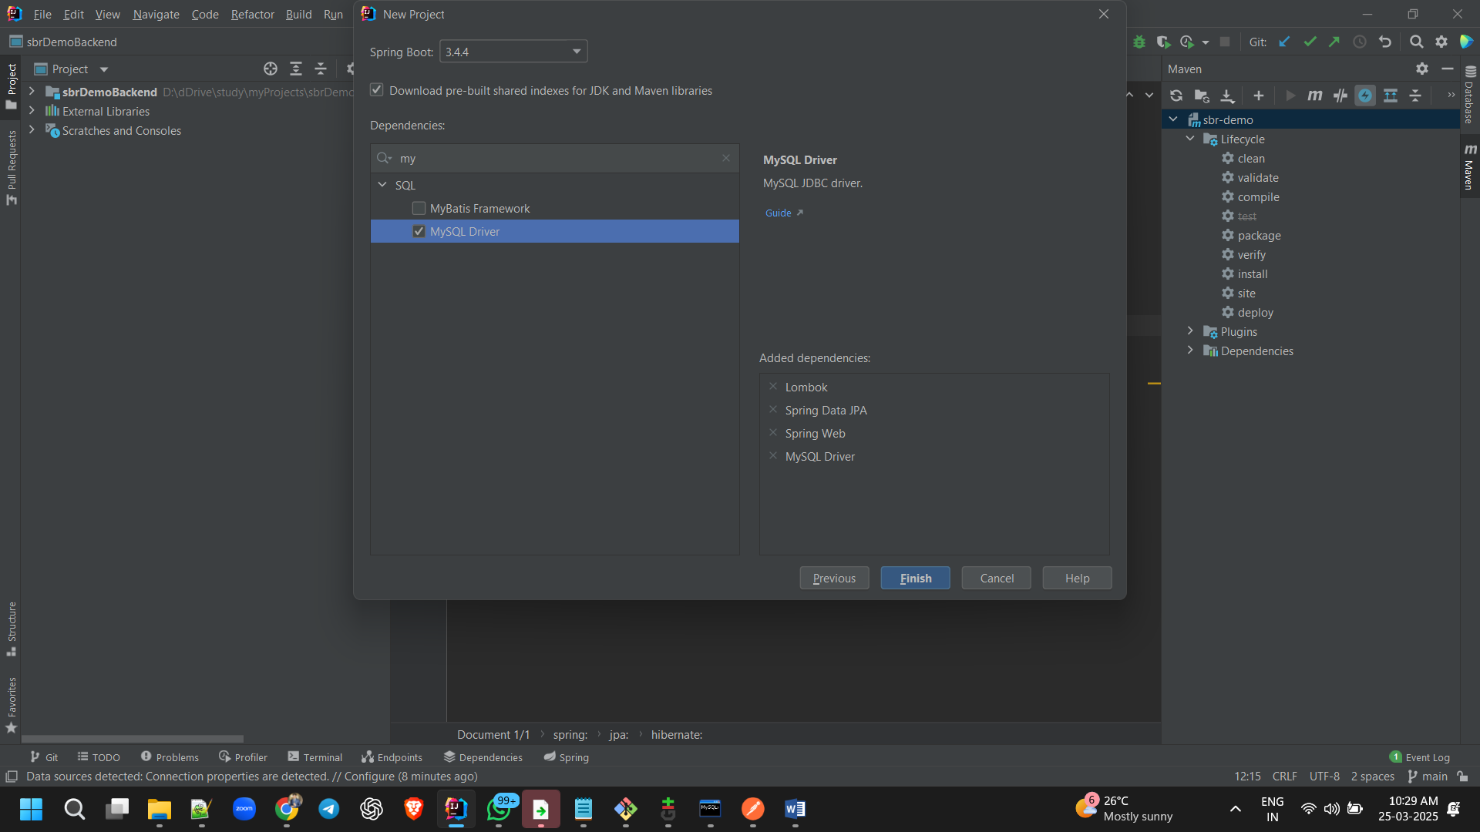

Finish

New window

rightClick pom.xml 🡪 maven 🡪 generate source and upload folders 🡪

create packages:

com.foodkart.foodkart.model

com.foodkart.foodkart.service

com.foodkart.foodkart.repository

com.foodkart.foodkart.controller

clean install

[ERROR] /D:/dDrive/study/myProjects/myFoodKartProject/foodKartGit/foodKart/foodKartBackEnd/src/main/java/com/foodkart/foodkart/FoodKartApplication.java:[3,32] cannot access org.springframework.boot.SpringApplication

bad class file: D:\dDrive\study\myProjects\myFoodKartProject\foodKartGit\foodKart\dependency\org\springframework\boot\spring-boot\3.4.4\spring-boot-3.4.4.jar(org/springframework/boot/SpringApplication.class)

class file has wrong version 61.0, should be 52.0

Please remove or make sure it appears in the correct subdirectory of the classpath.

[INFO] 1 error

cannot access org.springframework.boot.SpringApplication

download java 21

