TDF-Vashi Landing Page

* Menu
* DESIGN Reference:- <https://anamika-theme.myshopify.com/>
* CONTENT As per TDF-vashi-landing-page.
* Banner Img :-



SECTION – 1

* Product Feature
* Slider Reference link :- <https://www.tanishq.co.in/home>
* 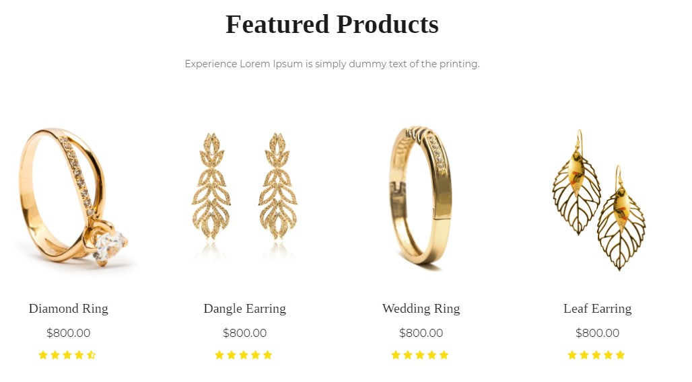 DESIGN Reference:-

SECTION – 2

* Exclusively for you
* 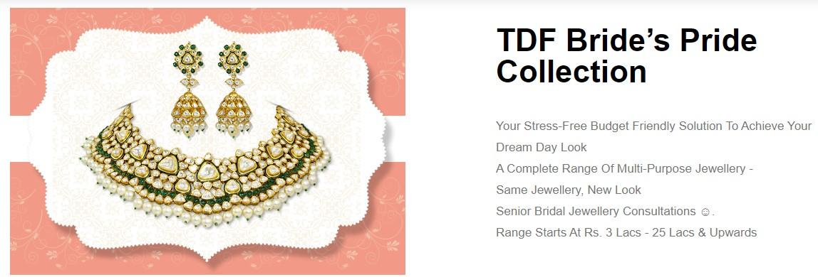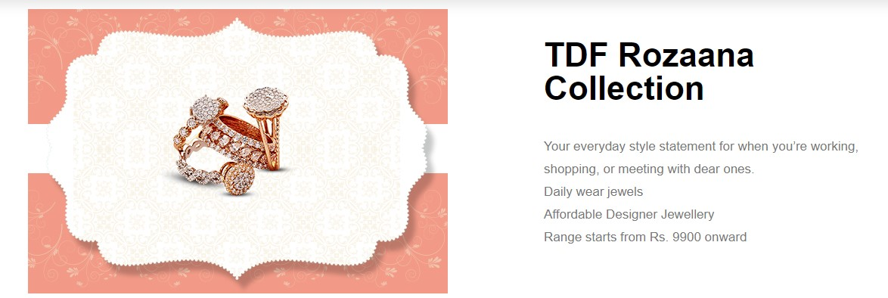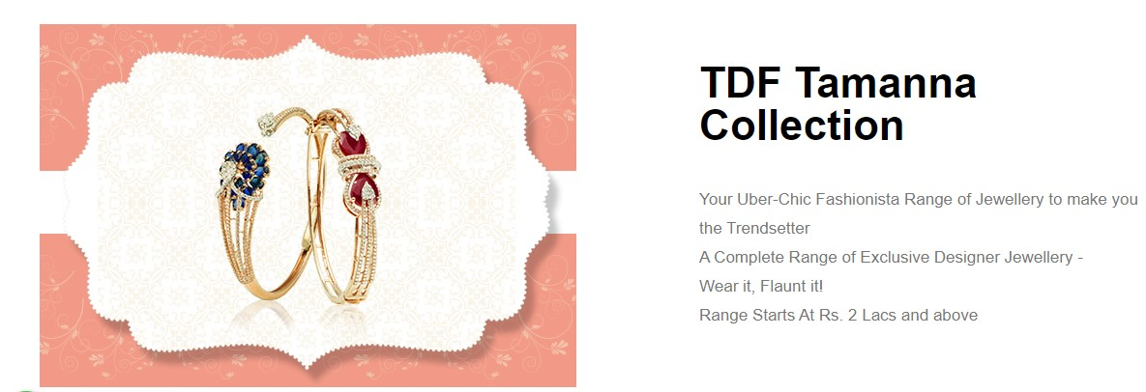Reference link :- <https://tdfjewellery.com/tdf-vashi/>
* Design Same As Per Image.

SECTION – 3

* Trending products

1. Reference Link :- :- <http://preview.themeforest.net/item/jewelry-responsive-shopify-theme/full_screen_preview/12066973?_ga=2.124187465.273058934.1616648448-495503666.1616569602shopify-theme/full_screen_preview/12066973?_ga=2.124187465.273058934.1616648448-495503666.1616569602>
2. 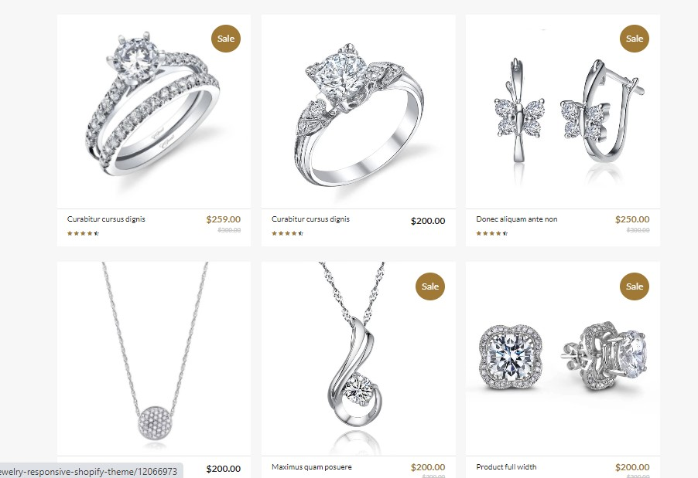Design reference :-

SECTION – 4

* Advertising :
* Only Image :-
* Top Seller
* Reference Link Slider check top seller section :- <https://www.tanishq.co.in/home>
* 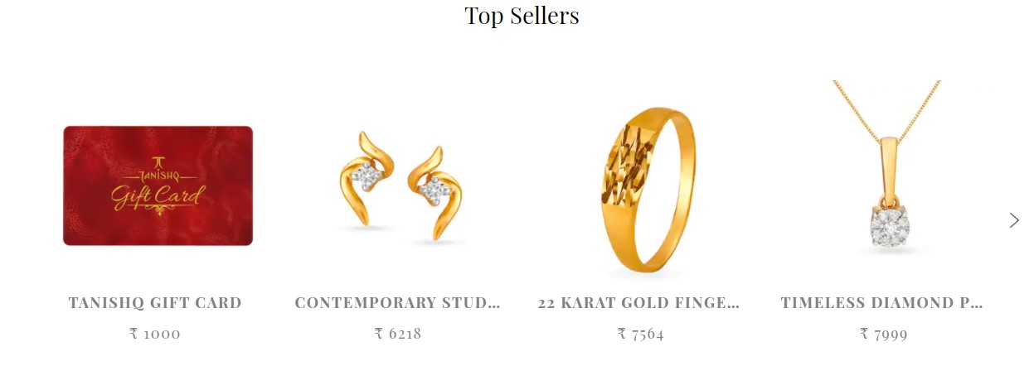Design reference :-

SECTION – 5

* New Product
* Reference link for slider check out for (New for you) :- <https://www.tanishq.co.in/home>
* 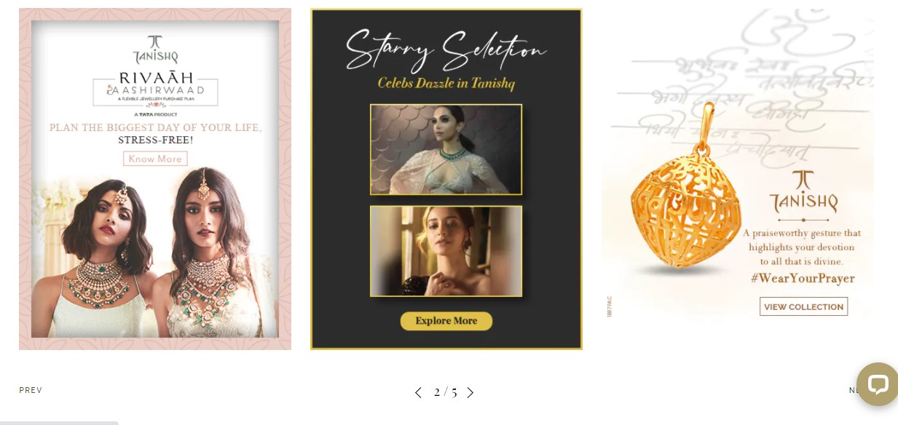Design reference :-

SECTION -6

* Promise
* Reference link for slider check out for (PROMISE) :- <https://www.tanishq.co.in/home>
* 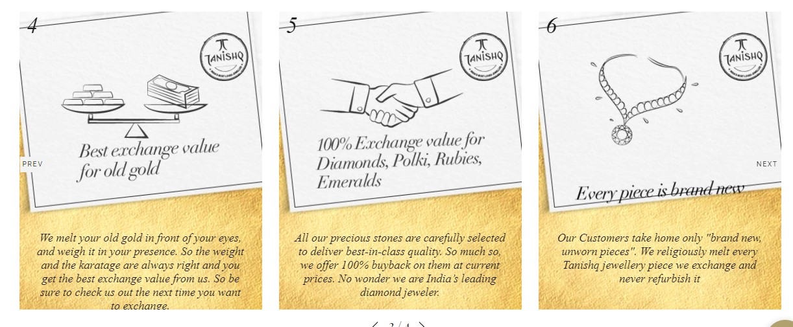Reference Design :-

SECTION -6

* Contact us
* Reference Link :- [http://colibri-template.webflow.io/#Features](http://colibri-template.webflow.io/%23Features)
* 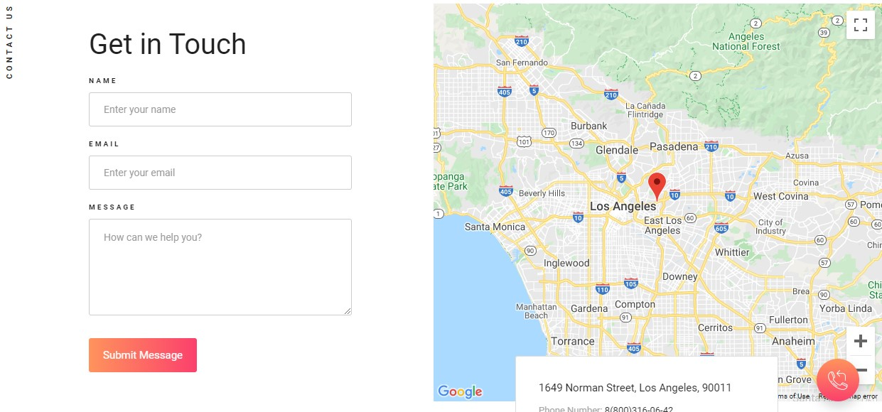Design :-

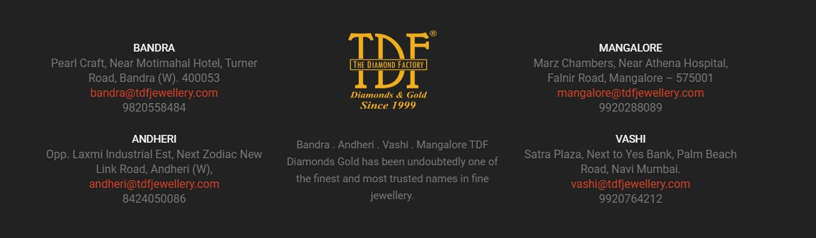

Section 7

* Footer

Reference link look footer:- <https://www.motocms.com/website-templates/demo/65023.html>

* 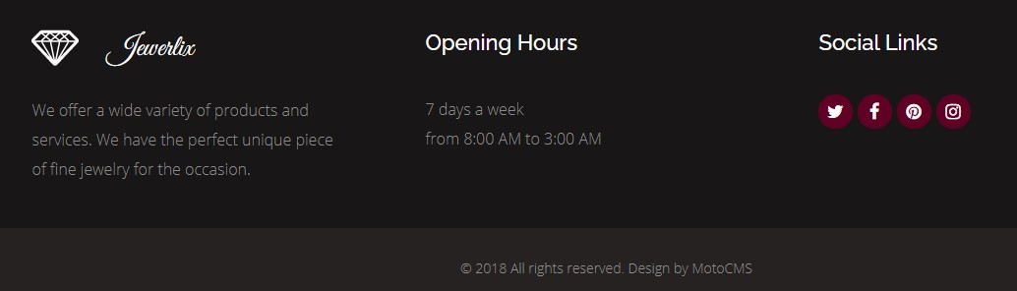Design :-