Using UI-Path Cloud

(3 step workflow)

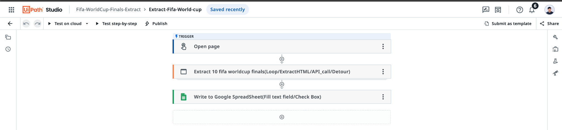

Stages in the workflow:

1. Manual Trigger
2. Extract 10 fifa worldcup finals.
3. Write the table into google spreadsheet

Execution Process:

1. During development: select test on cloud option

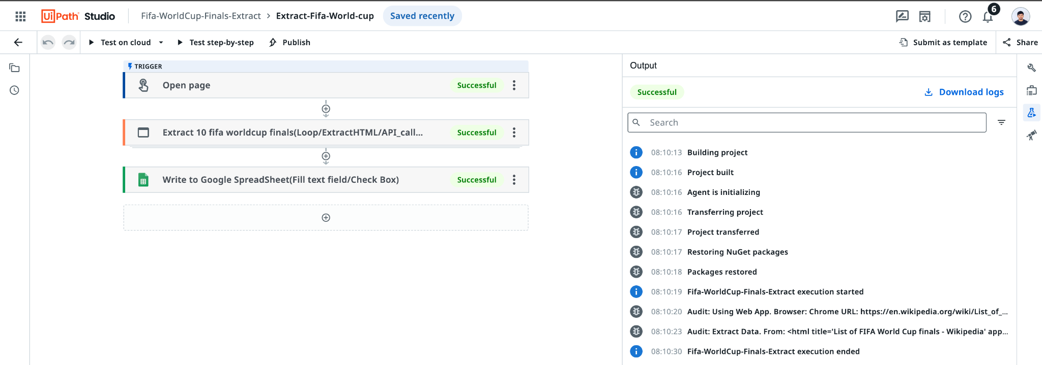

1. After publishing the automation: (click on start a job)

Go to Menu >> Orchestrator >> select “automations” tab

>> click on start a job / play symbol

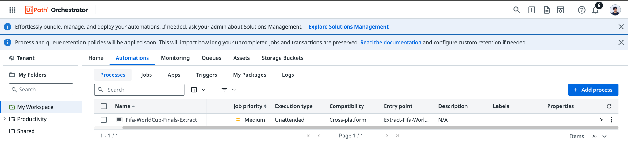

Steps innvvolved in development:

1. Login into <https://cloud.uipath.com/robotcecjzku/portal_/home>
2. Go to studio from the menu.

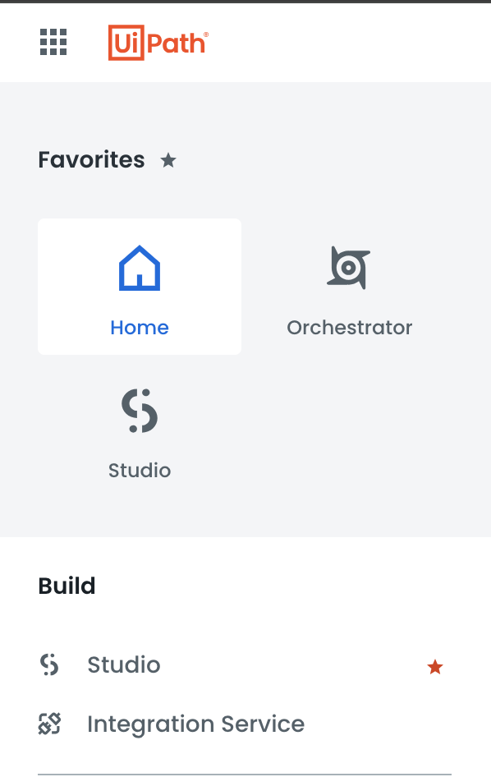

3. Create new project (in my case select the existing project)

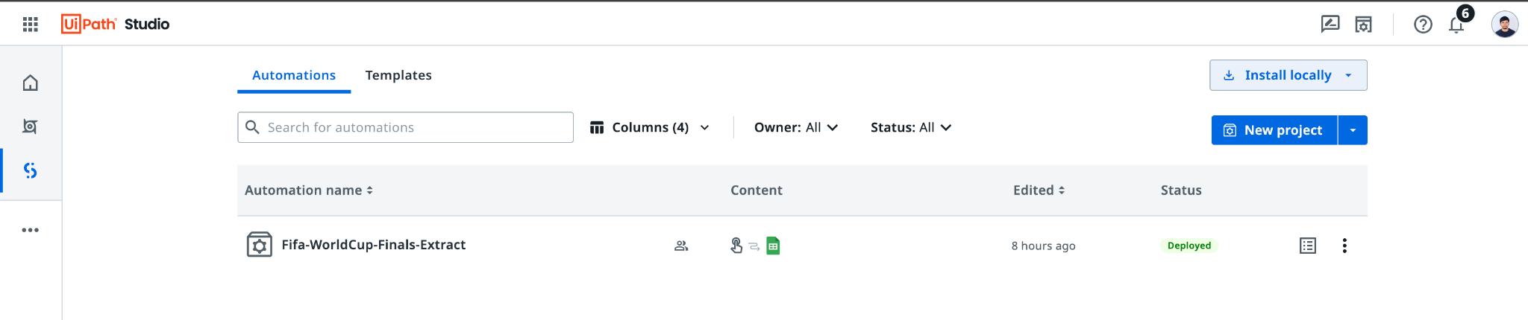

4. Do the configuratio as per requirement, test it & deploy.

Configurations:

1. Trigger:

Input: click on start a job in the automation sections

Ouput: Trigger to Open web page

>> Add activity & select manual automation

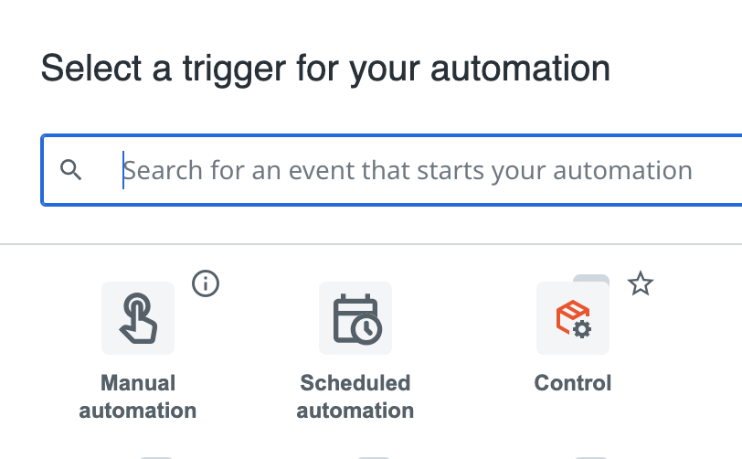

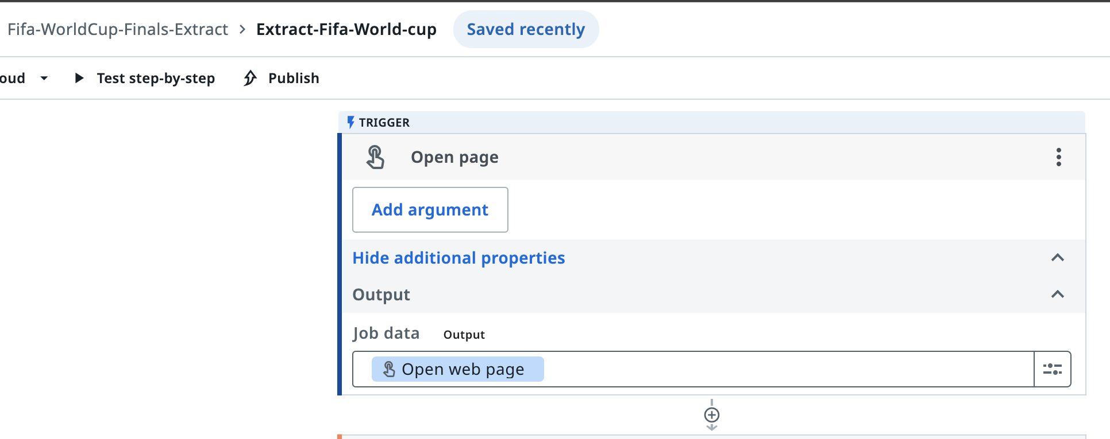

1. Extract 10 fifa worldcup finals:

Input: Trigger from previous step

Output: Simulated Webpage

>> Add activity & select “extract table data”

(Extracts tabular data from specified web page or application)

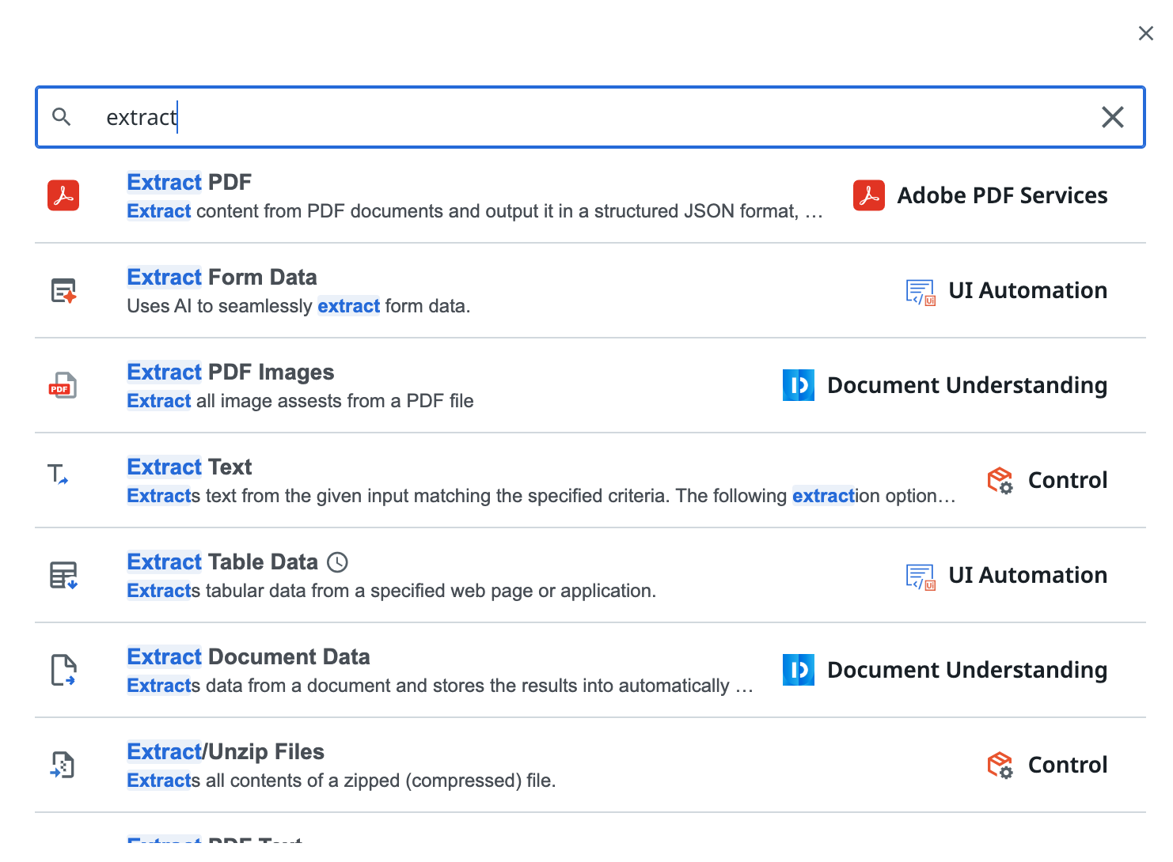

>> Add navigation URL && simulate the selection of html elements in the web page

>> validate the selected records, remove any unnecessary columns

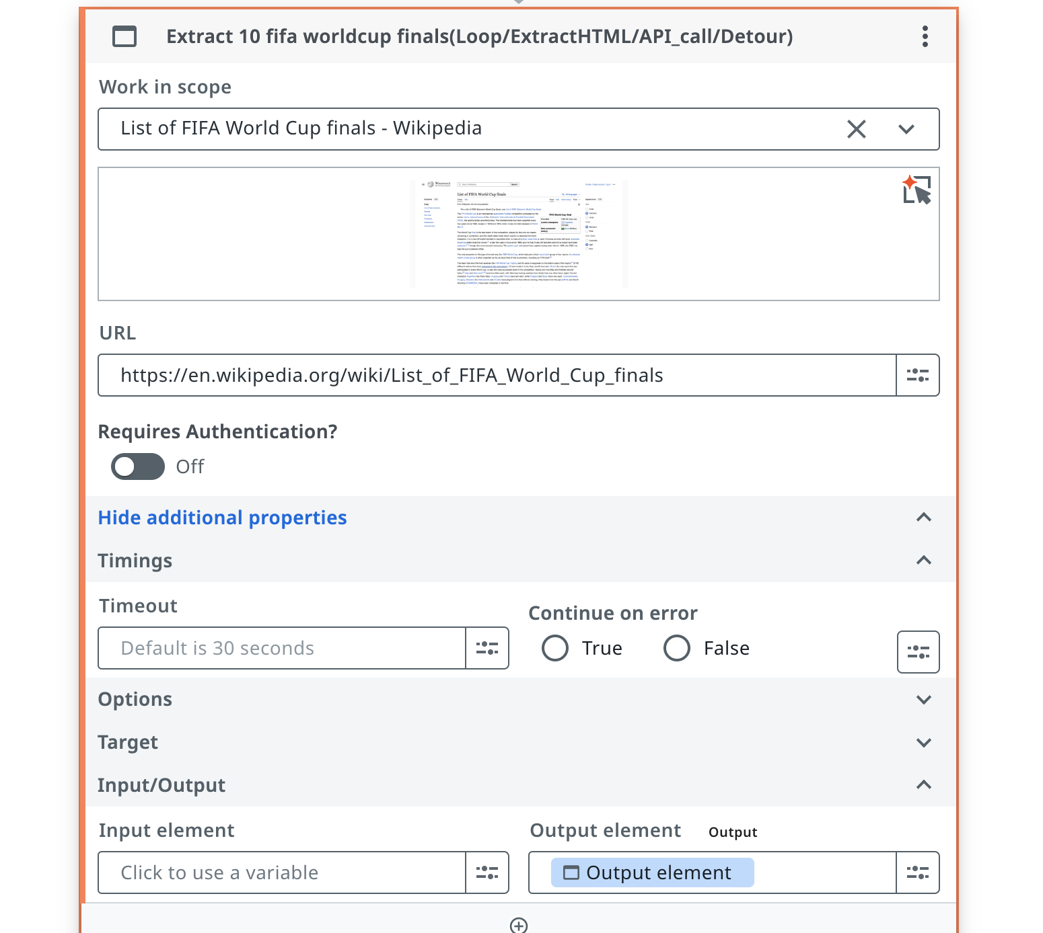

Second, extract 10 fifa worldcup finals:

Input: Simulated Webpage

Output: Data table with limit on max rows 10

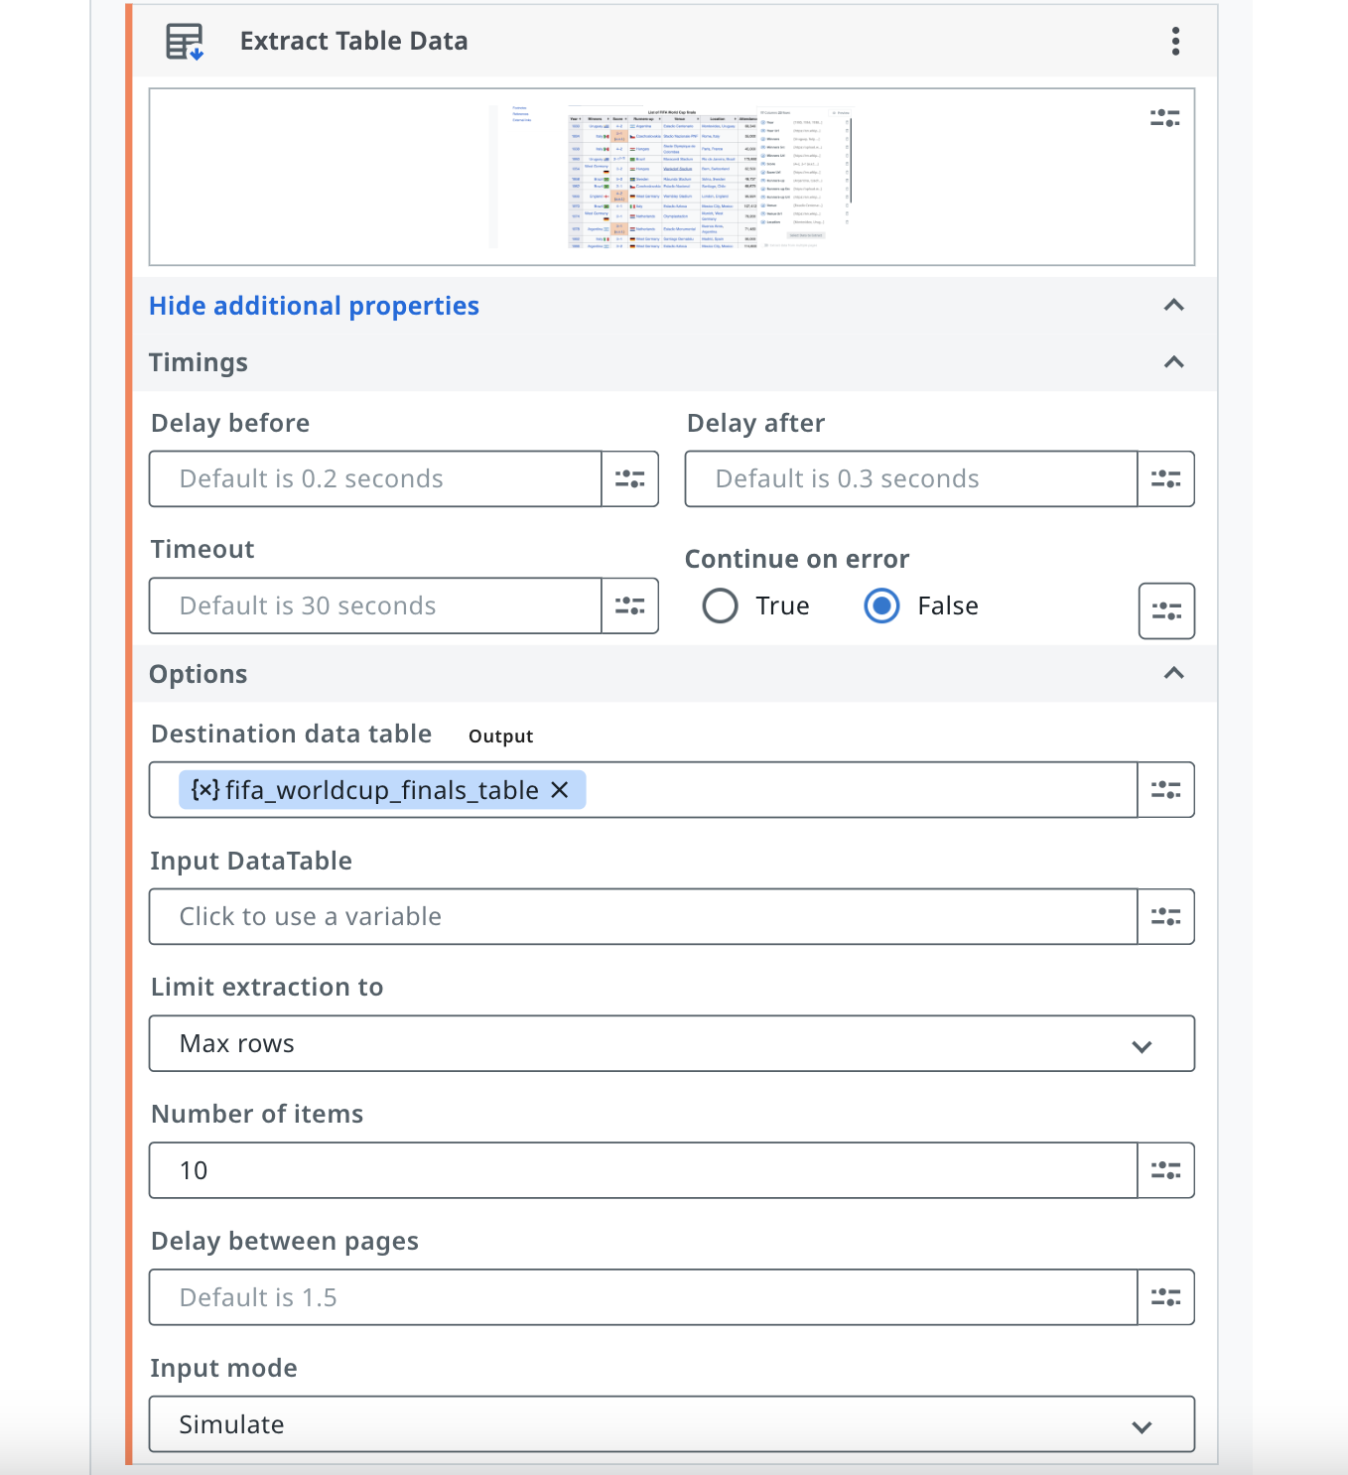

1. Write into google spreadsheet:  
     
   Input: Data table having extracted table from web

Output: Writing into Google spreadsheet

>> add activity & select “write row”.

>> Authorize Uipath to your google account &

Provide client id & client secret for your spreadsheet

