UNDER THE GUIDANCE OF

**MRS. SARITA KUMARI**

BACHELOR OF COMPUTER SCIENCE

2017-18



**Certificate**

This is to certify that the experimental work entered in this journal as per the syllabus in **B.Sc. (Computer Science) TY Semester-VI** prescribed by University of Mumbai for the project of **College Management System** was successfully done by **Mr. Bhupend Pradeep Patil** (2025157) in the computer laboratory of Yashwantrao Chavan College of Arts Commerce and Science, Koparkhairane Navi Mumbai-400709 for the Academic Year 2017-2018.

Place: Seat Number: **2025157**

Date:

Project Guide External Examiner

(Internal)

Coordinator Principal

**ACKNOWLEDGEMENT**

A project is always a result of the amalgamation of various ideas and support from countless people. We would like to acknowledge the contribution made by them.

I express my sincere thanks to the principal **Dr. Ganesh Pawar.** Also express my thanks to CO-ORDINATOR and staff of the C.S. Section. I would like to thanks my guide **Mrs. Sarita Kumari** for her encouragement and guidance, which helped me in completing the project.

We are immensely grateful to all those involved in this project because without their inspiration, constant prompting and useful suggestions, it wouldn’t have been possible to bring out this project in an allotted time.

We sincerely appreciate the help provided by those in the careful preparation of the project.

|  |  |  |
| --- | --- | --- |
| **INDEX** | | |
| **SR. NO** | **PARTICULARS** | **PAGE NO.** |
|  | **PRELIMINARY INVESTIGATION** |  |
| 1 | Organization Overview | 6 |
| 2 | Description Of Current System | 10 |
| 3 | Limitations Of Current System | 11 |
| 4 | Proposed System And Its Advantages | 12 |
| 5 | Feasibility Study | 13 |
| 6 | Stakeholders | 19 |
| 7 | Gantt Chart | 20 |
|  | **SYSTEM ANALYSIS** |  |
| 8 | Fact Finding Techniques | 22 |
| 9 | Event Table | 23 |
| 10 | E-R Diagram | 26 |
| 11 | Class Diagram | 27 |
| 12 | Use Case Diagram | 28 |
| 13 | Activity Diagram | 29 |
| 14 | Sequence Diagram | 30 |
|  | **SYSTEM DESIGN** |  |
| 15 | Converting Class Diagram to Tables | 32 |
| 16 | Component Diagram | 33 |
| 17 | Package Diagram | 34 |
| 18 | 0-level DFD | 35 |
| 19 | 1-level DFD | 36 |
|  | **SYSTEM CODING** |  |
| 20 | Sitemap | 40 |
| 21 | List Of Table With Attributes And Constraints | 41 |
| 22 | Screen Layouts | 43 |
| 23 | Future Enhancements | 64 |
| 24 | References and Bibliography | 65 |

**PRELIMINARY INVESTIGATION**



1. **ORGANIZATIONAL OVERVIEW**

**INTRODUCTION**

The **“Recognition of need”** that is very first step in developing the software. Recognition can be defined in short as identification, detection, acknowledgement, acceptance, awareness, perception. The need of **Preliminary Survey** as a formal examination to determine whether alternatives can solve the problem it entails looking into the duplication of efforts bottlenecks.

If the problem is serious enough management main want to have an analyst look at it. Such as Assignment implies a commitment specially the analyst is hired from outside wherever the final procedures are normal the analyst task is to prepare a statement specifying the scope and objective of a problem. She/he then reviews it with the user for accuracy at this stage only a rough “ball park” estimate of the development cost of the project may be reached, however and accurate cost of next phase feasibility study can be produced.

For the preliminary survey the system analyzed develop rough estimate and collect samples of documents, the system analyst may take interview of only a few people and use approximation.

In short recognition of need is nothing but:

* To find out what are the limitations in current system.
* What are the drawbacks of current existing system?
* Determining the user request to change, improve or enhance an existing system.
* Make a list of objectives for new system.
* Problem definition for “Existing System” report form

**PRELIMINARY SURVEY**

Preliminary Survey is the Formal Investigation to determine the project.

**Why Survey is needed?**

* Consider in a comprehensive way
* Look over carefully or inspect
* Surveillance
* Review
* A detailed critical inspection
* Make a survey of (for statistical purposes)
* Sketches (for short descriptive summary)
* Plot a map of
* View (the act of looking or seeing or observing)

**PROBLEM DEFINITION**

* What is about the system that is not satisfactory?
* Has the input Changed inform lost or availability?
* What is the objective of system analysis?

Understand the system and define it because the system is hierarchical and are interrelated with their environment in can be very Difficulties to define exactly what construction the system under steady this activity can be further subdivided:

* What alternative exist to it achieve our objective with respect to modify the system?
* What choices are there to improve their system what is their cost and their cost and can be implemented?

In current date, there are number of the organizations which are carrying into existence just with aim of earning money.

This profit is earned by the use of the internet.

Though they are accessible by many users at a time, they cannot exist on a machine for longer line without internet.

**2. DESCRIPTION OF CURRENT SYSTEM**

* “College Management System” is a System which acts as a management portal for the faculty and administrators of different Language.
* This system is very easy to understand and user friendly.
* Teachers, students, librarian are connected with each other on one system.
* This system is saving the time for student and teachers too.
* In this system user can connect any time whenever he/she wants.

**3. LIMITATIONS OF CURRENT SYSTEM**

* With these system we can translate the one word meaning in to another language.
* These system helps to people who from different language.
* This system can be easily installed on any system by executing the setup file along with its supportive files provided.

**4. PROPOSED SYSTEM AND ITS ADVANTAGES**

* Quality time Reduction.
* Feasible and Reliable in usage.
* Cuts down the cost as compared to variable Dictionaries.
* User friendly.
* Less space on hard-disk drive and no extra hardware required.

**5. Feasibility Study**

**Feasibility** defines the possibility and affordability of a system that can be acquired by a customer in an effective manner without any misconceptions about the system that is being sold to the customer.

The objective of a feasibility study is to find out if an information system project can be done, and if so, how.

**Things to be studied during the feasibility study phase:**

1. The present organizational system, including users, Policies, functions, objectives.
2. Problems with the present system (inconsistencies, Inadequacies in functionality, performance.
3. Objectives and other requirements for the new system (What needs to change?)
4. Constraints, including nonfunctional requirements on the System (preliminary pass)
5. Possible alternatives (the current system is always one of Those)
6. Advantages and disadvantages of the alternatives.

**Things to conclude**:

Feasibility of the project and the preferred alternative.

The feasibility of a project can be ascertained in terms of technical factors, economic factors, or both.  A feasibility study is documented with a report showing all the ramifications of the project.  In project finance, the pre-financing work (sometimes referred to as due diligence) is to make sure there is no "dry rot" in the project and to identify project risks ensuring they can be mitigated and managed in addition to ascertaining "debt service" capability.

Feasibility can be classified into the following three forms:

1. **Technical Feasibility**
2. **Operational Feasibility**
3. **Economical Feasibility**
   1. **TECHNICAL FEASIBILITY**

**Technical Feasibility** refers to the ability of the process to take advantage of current state of the technology in pursuing further improvement.

It includes mainly the following terms:

* Is the proposed technology or solution practical?
* Do we currently possess the necessary technology?
* Do we possess the necessary technical expertise, and is the schedule reasonable?
* The technology for any defined solution is usually available; however, the question is whether that technology is mature enough to be easily applied to our problem.
* Some firms like to use state-of-the-art technology, but most firms prefer to use mature and proven technology.
* A mature technology has a larger customer base for obtaining advice concerning problems and improvements.
* Assuming that required technology is practical, is it available in the information systems shop? If the technology is available, does it have the capacity to handle the solution?

**5.2 OPERATIONAL FEASIBILITY**

**(“PIECES” FRAMEWORK)**

The PIECES framework can help in identifying problems to be solved, and their urgency:

* **P**erformance --- Does current mode of operation provide adequate throughput and response time?
* **I**nformation --- Does current mode provide end users and managers with timely, pertinent, accurate and usefully formatted information?
* **E**conomy --- Does current mode of operation provide cost-effective information services to the business? Could there be a reduction in costs and/or an increase in benefits?
* **C**ontrol --- Does current mode of operation offer effective controls to protect against fraud and to guarantee accuracy and security of data and information?
* **E**fficiency --- Does current mode of operation make maximum use of available resources, including people, time, flow of forms,...?
* **S**ervices --- Does current mode of operation provide reliable service? Is it flexible and expandable?

This will enable user to use the **Multilingual Dictionary** anywhere and at anytime, thus working our System Operational Feasibility.

**5.3 ECONOMICIAL FEASIBILTY**

The Bottom line in many projects is **Economical Feasibility**. During the early phases of the project, economic feasibility analysis amounts to little more than judging whether the possible benefits of solving the problem are worthwhile. As soon as specific requirements and solutions have been identified, the analyst can weigh the costs and benefits of each alternative.

**Economical Feasibility** involves the capability of the project to raise the appropriate funds needed to implement the proposed project.  Project financing can be a major obstacle in large Multi-party projects because of the level of capital required.  Loan Availability, Credit Worthiness, Equity, and Loan Schedule are important aspects of Financial Feasibility Analysis.

Being an independent system, **Multilingual Dictionary** does not need any other external Hardware or Software requirements. This makes our System cost efficient and thus Financial Feasibility too.

**5.4 COST /BENEFIT ANALYSIS**

The purpose of a **Cost/Benefit Analysis** is to answer questions such as:

* Is the project justified (because benefits outweigh costs)?
* Can the project be done, within given cost constraints?
* What is the minimal cost to attain a certain system?
* What is the preferred alternative, among candidate solutions?

Examples of things to consider:

* Hardware/Software selection
* How to convince management to develop the new system?
* Selection among alternative financing arrangements(rent/lease/purchase)

**Difficulties** -- discovering and assessing benefits and costs; they can both be intangible, hidden and/or hard to estimate, it's also hard to rank multi-criteria alternatives

**6. STAKEHOLDERS**

* **Admin:** Admin will control management of entire system.
* **Others:** Others will browse through website and work accordingly.

**HARDWARE SPECIFICATION:**

Minimum requirements for this website are listed below:

* Processor : Intel Core 2 Duo and onwards
* RAM : 1 GB min
* Hard Disk : 20GB
* Input Device : Keyboard, Mouse, Touchpad
* Output Device : Monitor

**SOFTWARE SPECIFICATION:**

* Front End : Microsoft Visual Studio 2017
* Back End : Microsoft SQL Server
* Operating Systems : Windows 10
* For Documentation : Microsoft Office 2007

**7. Gantt Chart**

Base Line



Phase Complete



Phase Complete

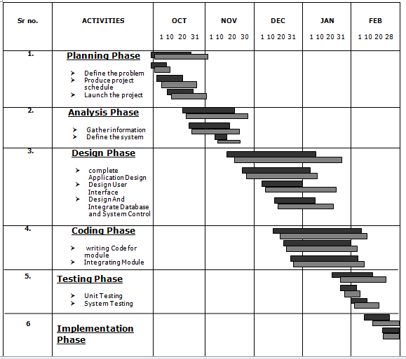

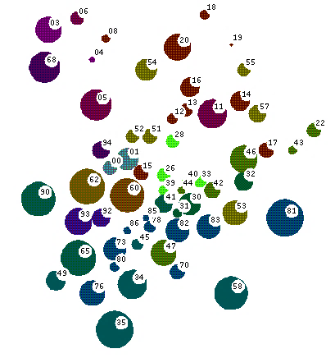**SYSTEM ANALYSIS**

**8. Fact Finding Techniques**

**Onsite Observation**

Observations were done during the first interview with the director. It was very useful in which it helps us to understand how many employee work and interact with the current system.

**Review the existing documents**

Various types of document were collected. These documents include forms, timetables, results, attendance, records, application and brochures.

**Interview**

We mainly interviewed the executive director and staff

The information provided by both interviewees was very important because it help us in the analysis of current system and constructs of the data flow diagrams. In the interview some objectives are considered such as:

1. Determining the areas to be discovered.
2. Lists the facts you want to gather.

**9. Event Table**

|  |  |  |  |  |  |
| --- | --- | --- | --- | --- | --- |
| **Event** | **Trigger** | **Source** | **Activity** | **Response** | **Destination** |
| Student calls for Profile | Get information about profile | Student | Check details | Shows profile | Student |
| Student calls for Time Table | Get information about Time Table | Student | Check details | Shows time table | Student |
| Student calls for Assignments | Get information about Assignment | Assignment | Check assignment | Shows assignment/s | Student |
| Student calls for Result | Get information about Result | Result | Check Result | Shows result | Student |
| Student calls for Events | Get information about Events | Events | Filters Events | Shows event | Student |
| Faculty calls for Profile | Get information about profile | Faculty | Filters details | Shows details | Faculty |
| Faculty wants to Add Assignment | Add details | Faculty | Checks values | Adds Assignment | Assignment |
| Faculty wants to View Assignment | Get information about Assignment | Assignment | Check assignment | Shows assignment/s | Faculty |
| Faculty wants to Delete Assignment | Add details | Faculty | Checks values | Delete Assignment | Assignment |
| Faculty wants to Add Result | Add details | Result | Checks values | Result Assignment | Result |
| Faculty wants to View Results | Get information about Results | Result | Check Result | Shows Result/s | Faculty |
| Faculty wants to Delete Result | Add details | Faculty | Checks values | Delete Result | Faculty |
| Faculty wants to view Events | Get information about Events | Events | Filters Events | Shows event | Faculty |
| Admin calls for Profile | Get information about profile | Admin | Check details | Shows profile | Admin |
| Admin wants to Add Admin | Add details | Admin | Checks values | Adds Admin | Admin |
| Admin wants to View Admin | Get information about Admin | Admin | Check Admin | Shows Admin/s | Faculty |
| Admin wants to Delete Admin | Add details | Admin | Checks values | Delete Admin | Admin |
| Admin wants to Add Student | Add details | Admin | Checks values | Adds Student | Student |
| Admin wants to View Student | Get information about Student | Student | Check Student | Shows Admin/s | Admin |
| Admin wants to Delete Student | Add details | Student | Checks values | Delete Admin | Admin |
| Admin wants to Add Faculty | Add details | Admin | Checks values | Adds Faculty | Faculty |
| Admin wants to View Faculty | Get information about Faculty | Faculty | Check Faculty | Shows Faculty/s | Admin |
| Admin wants to Delete Faculty | Add details | Faculty | Checks values | Delete Faculty | Admin |
| Admin wants to Add Event | Add details | Admin | Checks values | Adds Event | Assignment |
| Admin wants to View Event | Get information about Assignment | Assignment | Check Event | Shows Event/s | Admin |
| Faculty wants to Delete Event | Add details | Admin | Checks values | Delete Event | Assignment |

**10. ER DIAGRAM**

Admin

Faculty

Student

Manage

Teaches

1

M

M

1

**11. CLASS DIAGRAM**

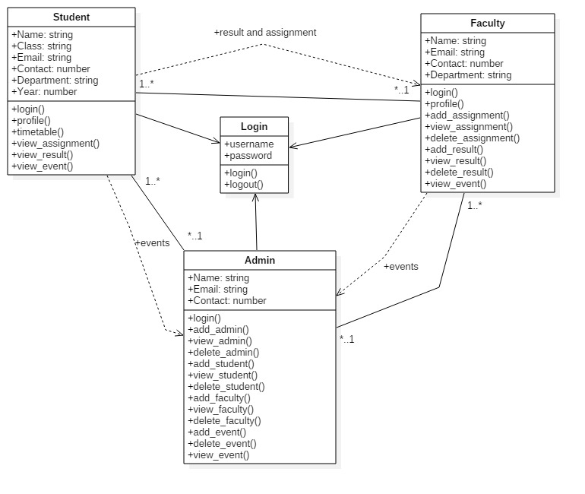

**12. USECASE DIAGRAM**

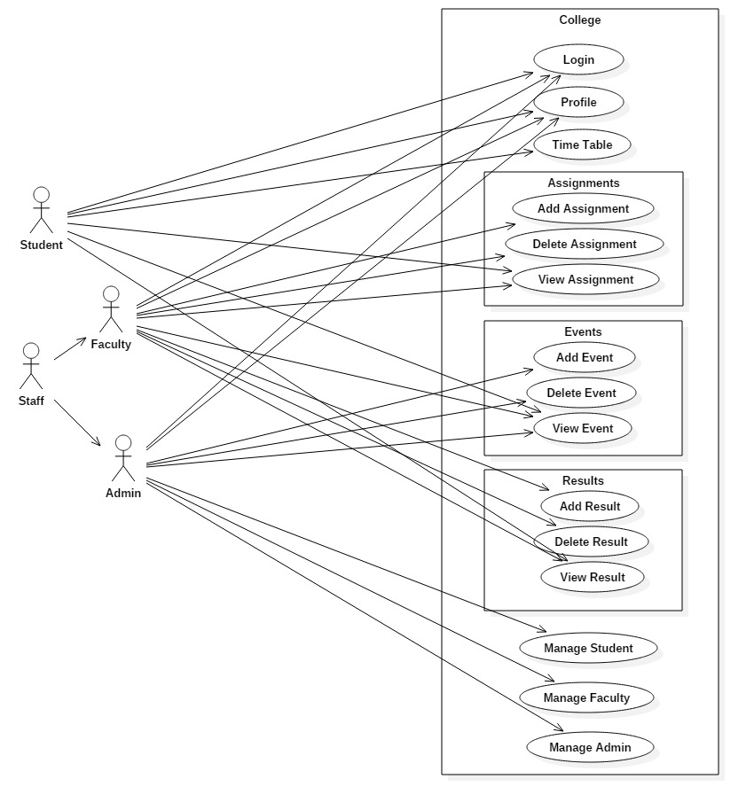

**13. ACTIVITY DIAGRAM**

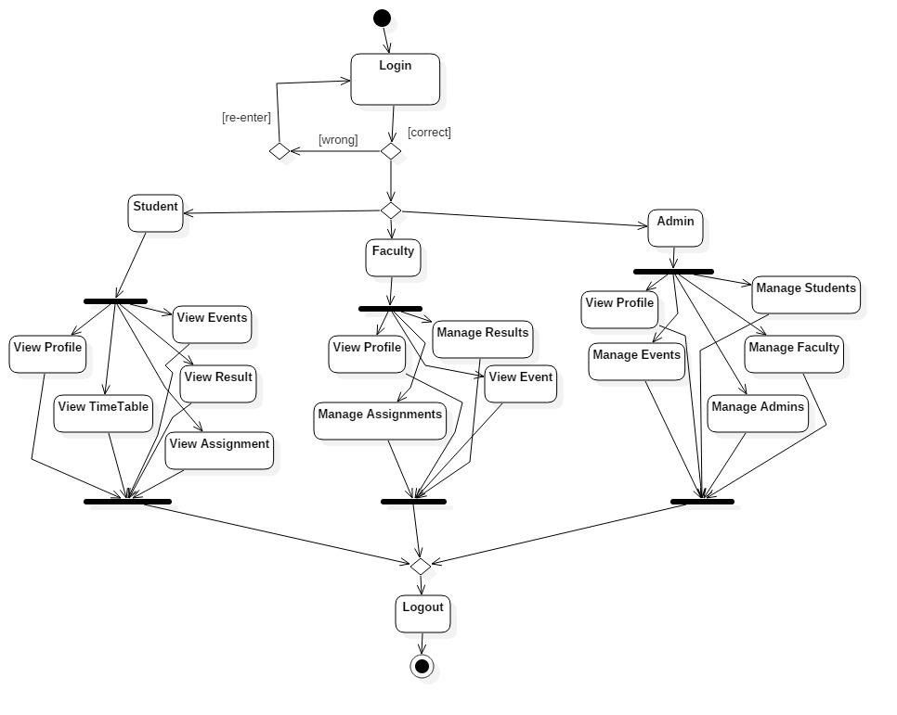

**14. SEQUENCE DIAGRAM**

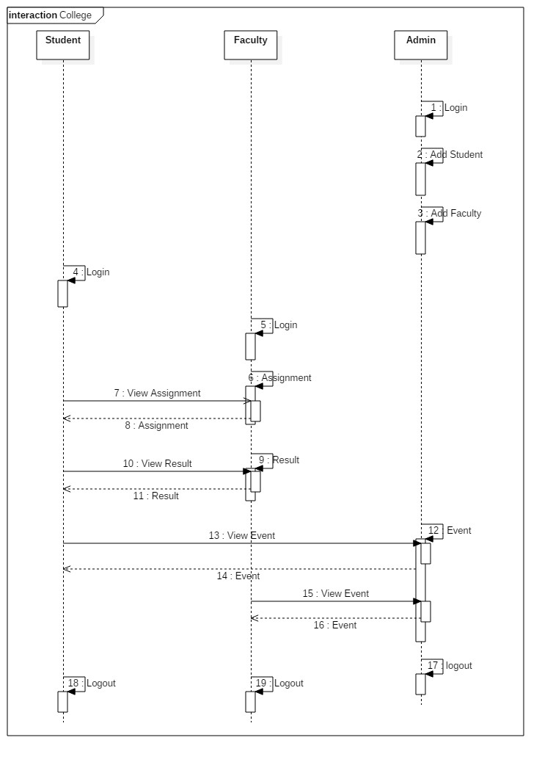

**SYSTEM DESIGN**



**15. CONVERTING CLASS DIAGRAM TO TABLES**

|  |  |  |
| --- | --- | --- |
| **Sr. No** | **Table Name** | **Description** |
| 1 | tblStudent | It stores data of Student. |
| 2 | tblFaculty | It stores data of Faculty. |
| 3 | tblAdmin | It stores data of Admin |
| 4 | tblAssignment | It stores data of Students Assignment |
| 5 | tblResult | It stores data of all Results |
| 6 | tblEvent | It stores data of Events to be occurred and past events too |

**16. COMPONENT DIAGRAM**

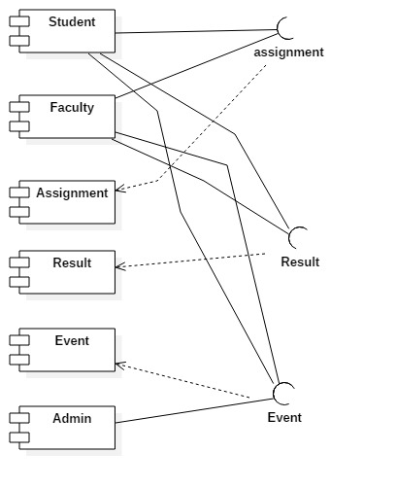

**17. PACKAGE DIAGRAM**

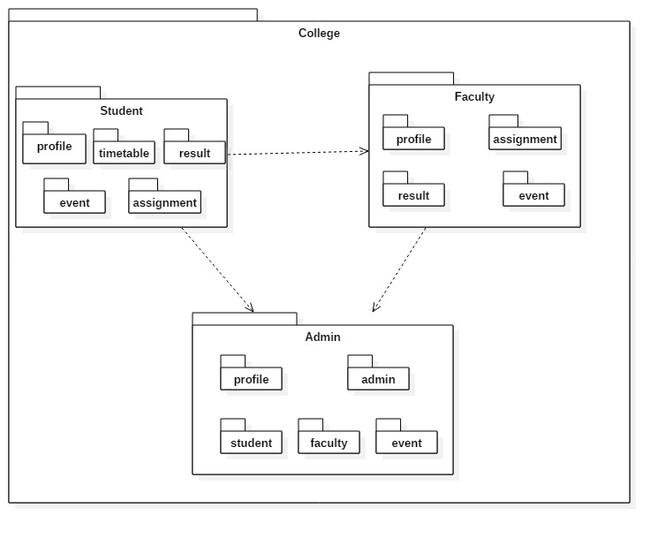

**18. 0-LEVEL DFD**

Delete Result

Delete Assignment

Add Assignment

Sign in

Add Result

View Events

View Result

View Assignment

Profile

Time-Table

Profile

Sign in

Result

Assignments

Events

Delete Faculty

View Faculty

Add Faculty

Delete Event Event

View Event

Add Event

Delete Student

View Student

Add Student

Delete Admin

View Admin

Add Admin

Profile

Sign in

Admin

0

Faculty

Student

**19. 1-LEVEL DFD**

Fill Sign in details

dbo.Student

Assignment

Result

Profile

Time Table

dbo.Event

dbo.Result

dbo.Assignment

Event

Student

Event

Event

Assignment

Time Table

Result

Profile

View Assignment

Delete Assignment

Add Assignment

View Result

Delete Result

Add Result

Assignment

dbo.Faculty

Profile

Result

Profile

dbo.Event

dbo.Result

dbo.Assignment

Event

Fill Sign in details

Faculty

Event

Event

dbo.Admin

Student

Faculty

Profile

Admin

dbo.Event

dbo.Faculty

dbo.Student

Event

Fill Sign in details

Admin

Add Event

Delete Event

View Event

View Student

Delete Student

Add Student

Add Admin

Delete Admin

View Admin

Delete Faculty

View Faculty

Add Faculty

Profile

Event

**SYSTEM CODING**

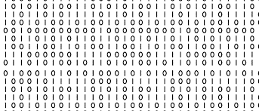

**20. Sitemap**

Delete Faculty

View Faculty

Add Faculty

Delete Event

View Event

Delete Student

View Student

Add Student

Delete Admin

View Admin

Add Admin

Add Event

Profile

View Event

Delete Result

View Result

Add Result

Delete Assignment

View Assignment

Add Assignment

Profile

Profile

Time Table

Assignment

Result

Event

Faculty

Student

Admin

Login

**21. LIST OF TABLE WITH ATTRIBUTES AND CONSTRAINTS**

1. dbo.Admin

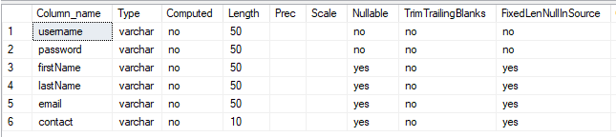

1. dbo.Student

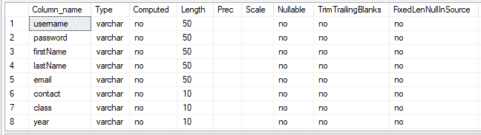

1. dbo.Faculty

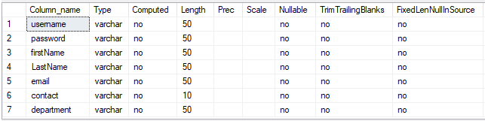

1. dbo.Assignment

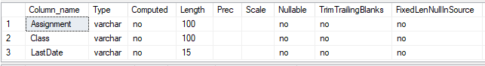

1. dbo.Event

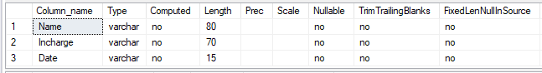

1. dbo.Result

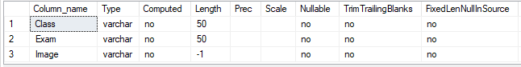

**22. SCREEN LAYOUT**

Student/Profile.aspx

<%@ Page Title="" Language="C#" MasterPageFile="~/Student/Student.master" AutoEventWireup="true" CodeFile="Profile.aspx.cs" Inherits="Student_Profile" %>

<asp:Content ID="Content1" ContentPlaceHolderID="head" Runat="Server">

</asp:Content>

<asp:Content ID="Content2" ContentPlaceHolderID="ContentPlaceHolder1" Runat="Server">

<div class="container text-center" style="padding-top: 1%">

<h1>Profile</h1>

<br />

<form>

<div class="form-group row d-flex justify-content-center">

<asp:label runat="server" text="Name" cssclass="col-sm-2 col-form-label" font-bold="True"></asp:label>

<div class="col-sm-3">

<asp:label id="SName" runat="server" text="Name" cssclass="form-control"></asp:label>

</div>

</div>

<div class="form-group row d-flex justify-content-center">

<asp:label runat="server" text="Email" cssclass="col-sm-2 col-form-label" font-bold="True"></asp:label>

<div class="col-sm-3">

<asp:label id="SEmail" runat="server" text="EmailID" cssclass="form-control"></asp:label>

</div>

</div>

<div class="form-group row d-flex justify-content-center">

<asp:label runat="server" text="Contact" cssclass="col-sm-2 col-form-label" font-bold="True"></asp:label>

<div class="col-sm-3">

<asp:label id="SContact" runat="server" text="Contact number" cssclass="form-control"></asp:label>

</div>

</div>

<div class="form-group row d-flex justify-content-center">

<asp:label runat="server" text="Department" cssclass="col-sm-2 col-form-label" font-bold="True"></asp:label>

<div class="col-sm-3">

<asp:label id="SDepartment" runat="server" text="Department" cssclass="form-control"></asp:label>

</div>

</div>

<div class="form-group row d-flex justify-content-center">

<asp:label runat="server" text="Class" cssclass="col-sm-2 col-form-label" font-bold="True"></asp:label>

<div class="col-sm-3">

<asp:label id="SClass" runat="server" text="Year" cssclass="form-control"></asp:label>

</div>

</div>

<div class="form-group row d-flex justify-content-center">

<asp:label runat="server" text="Year" cssclass="col-sm-2 col-form-label" font-bold="True"></asp:label>

<div class="col-sm-3">

<asp:label id="SYear" runat="server" text="Year" cssclass="form-control"></asp:label>

</div>

</div>

</form>

</div>

</asp:Content>

Student/Profile.aspx.cs

using System;

using System.Collections.Generic;

using System.Linq;

using System.Web;

using System.Web.UI;

using System.Web.UI.WebControls;

public partial class Student_Profile : System.Web.UI.Page

{

protected void Page_Load(object sender, EventArgs e)

{

SName.Text = Session["SName"].ToString();

SEmail.Text = Session["SEmail"].ToString();

SContact.Text = Session["SContact"].ToString();

SDepartment.Text = Session["SDepartment"].ToString();

SClass.Text = Session["SClass"].ToString();

SYear.Text = Session["SYear"].ToString();

}

}

Screenshot

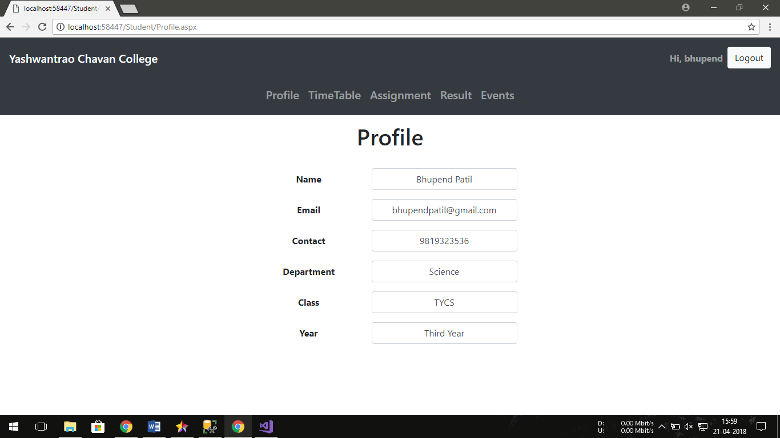

Faculty/AddAssignment.aspx

<%@ Page Title="" Language="C#" MasterPageFile="~/Faculty/Faculty.master" AutoEventWireup="true" CodeFile="AddAssignment.aspx.cs" Inherits="Faculty_AddAssignment" %>

<asp:Content ID="Content1" ContentPlaceHolderID="head" Runat="Server">

</asp:Content>

<asp:Content ID="Content2" ContentPlaceHolderID="ContentPlaceHolder1" Runat="Server">

<div class="container text-center" style="padding-top: 1%">

<h1>Add Assignment</h1>

<br />

<div class="form-group row d-flex justify-content-center">

<asp:label runat="server" text="Assignment" cssclass="col-sm-2 col-form-label" font-bold="True"></asp:label>

<asp:requiredfieldvalidator runat="server" errormessage="*" Display="Dynamic" controltovalidate="AAssignment" forecolor="Red"></asp:requiredfieldvalidator>

<div class="col-sm-5">

<asp:textbox runat="server" ID="AAssignment" cssclass="form-control" ></asp:textbox>

</div>

</div>

<div class="form-group row d-flex justify-content-center">

<asp:label runat="server" text="Class" cssclass="col-sm-2 col-form-label" font-bold="True"></asp:label>

<asp:requiredfieldvalidator runat="server" errormessage="*" Display="Dynamic" controltovalidate="AClassName" forecolor="Red"></asp:requiredfieldvalidator>

<div class="col-sm-5">

<asp:textbox runat="server" id="AClassName" cssclass="form-control" ></asp:textbox>

</div>

</div>

<div class="form-group row d-flex justify-content-center">

<asp:label runat="server" text="Last Date" cssclass="col-sm-2 col-form-label" font-bold="True"></asp:label>

<asp:requiredfieldvalidator runat="server" errormessage="*" Display="Dynamic" controltovalidate="ADate" forecolor="Red"></asp:requiredfieldvalidator>

<div class="col-sm-5 input-group date form_date" data-date="" data-date-format="dd/mm/yyyy" data-link-field="dtp_input2" data-link-format="yyyy-mm-dd">

<asp:textbox runat="server" ID="ADate" cssclass="form-control" ></asp:textbox>

<span class="input-group-addon"><span class="glyphicon glyphicon-remove fas fa-redo"></span></span>

<span class="input-group-addon"><span class="glyphicon glyphicon-calendar far fa-calendar-alt"></span></span>

<asp:RegularExpressionValidator ID="RegularExpressionValidator1" runat="server" ValidationExpression="^(?:(?:31(\/|-|\.)(?:0?[13578]|1[02]))\1|(?:(?:29|30)(\/|-|\.)(?:0?[1,3-9]|1[0-2])\2))(?:(?:1[6-9]|[2-9]\d)?\d{2})$|^(?:29(\/|-|\.)0?2\3(?:(?:(?:1[6-9]|[2-9]\d)?(?:0[48]|[2468][048]|[13579][26])|(?:(?:16|[2468][048]|[3579][26])00))))$|^(?:0?[1-9]|1\d|2[0-8])(\/|-|\.)(?:(?:0?[1-9])|(?:1[0-2]))\4(?:(?:1[6-9]|[2-9]\d)?\d{2})$" ControlToValidate="ADate" Display="Dynamic" ErrorMessage="dd/mm/yyyy format" ForeColor="Red"></asp:RegularExpressionValidator>

</div>

</div>

<br />

<div class="form-group row d-flex justify-content-center">

<asp:Button ID="AssignmentAdd" runat="server" Text="Add" CssClass="btn btn-dark" OnClick="AssignmentAdd_Click" />

&nbsp;

<asp:Button ID="AssignmentClear" runat="server" CausesValidation="False" Text="Clear" CssClass="btn btn-outline-dark" OnClick="AssignmentClear_Click"/>

</div>

</div>

</asp:Content>

Faculty/AddAssignment.aspx.cs

using System;

using System.Collections.Generic;

using System.Linq;

using System.Web;

using System.Web.UI;

using System.Web.UI.WebControls;

using System.Data;

using System.Data.SqlClient;

public partial class Faculty_AddAssignment : System.Web.UI.Page

{

SqlConnection conn = new SqlConnection("Data Source=BHUPENDS-PC;Initial Catalog=CollegeERP;Integrated Security=True");

SqlCommand query;

ConnectionState state = new ConnectionState();

protected void Page_Load(object sender, EventArgs e)

{

}

protected void AssignmentAdd_Click(object sender, EventArgs e)

{

String Assignment = AAssignment.Text.Trim();

String className = AClassName.Text.Trim();

String date = ADate.Text.Trim();

if (state == ConnectionState.Open)

{

conn.Close();

}

else

{

conn.Open();

query = new SqlCommand("insert into Assignment (Assignment, Class, LastDate) values ('" + Assignment + "','" + className + "','" + date + "')", conn);

query.ExecuteNonQuery();

conn.Close();

AAssignment.Text = "";

AClassName.Text = "";

ADate.Text = "";

ScriptManager.RegisterClientScriptBlock(this, this.GetType(), "alertMessage", "alert('Deleted Assignment')", true);

}

}

protected void AssignmentClear_Click(object sender, EventArgs e)

{

AAssignment.Text = "";

AClassName.Text = "";

ADate.Text = "";

}

}

Screenshot

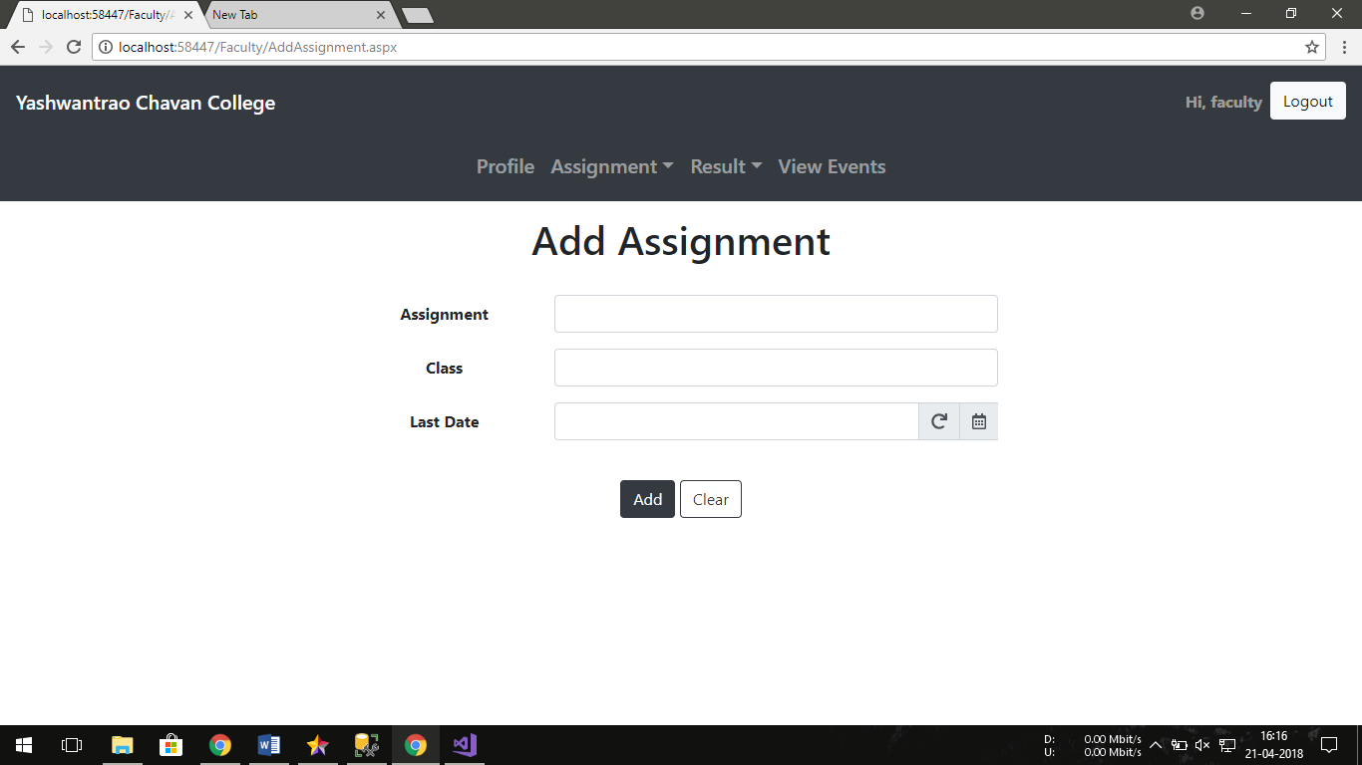

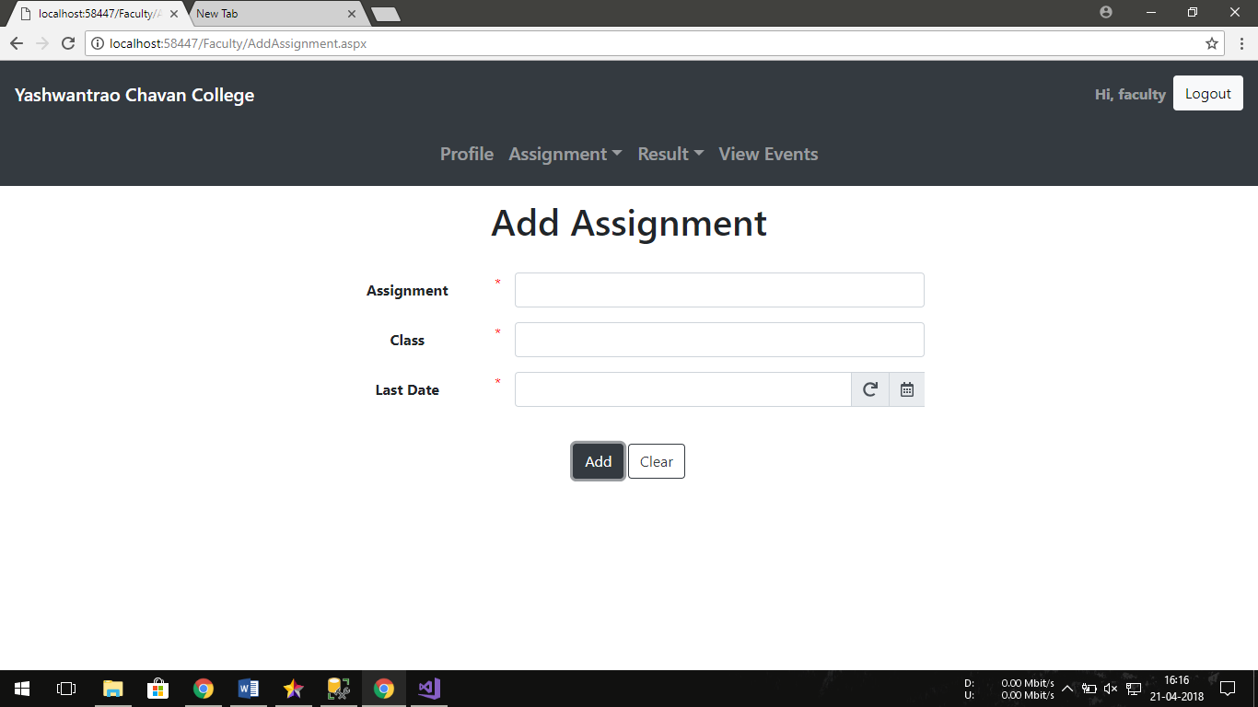

Admin/AddStudent.aspx

<%@ Page Title="" Language="C#" MasterPageFile="~/Admin/Admin.master" AutoEventWireup="true" CodeFile="AddStudent.aspx.cs" Inherits="Admin_AddStudent" %>

<asp:Content ID="Content1" ContentPlaceHolderID="head" Runat="Server">

</asp:Content>

<asp:Content ID="Content2" ContentPlaceHolderID="ContentPlaceHolder1" Runat="Server">

<div class="container text-center" style="padding-top: 1%">

<h1>Add Student</h1>

<br />

<div class="form-group row d-flex justify-content-center">

<asp:label runat="server" text="Username" cssclass="col-sm-2 col-form-label" font-bold="True"></asp:label>

<asp:requiredfieldvalidator runat="server" errormessage="*" Display="Dynamic" controltovalidate="SUser" forecolor="Red"></asp:requiredfieldvalidator>

<div class="col-sm-3">

<asp:textbox runat="server" id="SUser" cssclass="form-control" ></asp:textbox>

</div>

</div>

<div class="form-group row d-flex justify-content-center">

<asp:label runat="server" text="First Name" cssclass="col-sm-2 col-form-label" font-bold="True"></asp:label>

<asp:requiredfieldvalidator runat="server" errormessage="*" Display="Dynamic" controltovalidate="SFName" forecolor="Red"></asp:requiredfieldvalidator>

<div class="col-sm-3">

<asp:textbox runat="server" ID="SFName" cssclass="form-control" ></asp:textbox>

</div>

</div>

<div class="form-group row d-flex justify-content-center">

<asp:label runat="server" text="LastName" cssclass="col-sm-2 col-form-label" font-bold="True"></asp:label>

<asp:requiredfieldvalidator runat="server" errormessage="*" Display="Dynamic" controltovalidate="SLName" forecolor="Red"></asp:requiredfieldvalidator>

<div class="col-sm-3">

<asp:textbox runat="server" ID="SLName" cssclass="form-control" ></asp:textbox>

</div>

</div>

<div class="form-group row d-flex justify-content-center">

<asp:label runat="server" text="Email" cssclass="col-sm-2 col-form-label" font-bold="True"></asp:label>

<asp:requiredfieldvalidator runat="server" errormessage="*" Display="Dynamic" controltovalidate="SEmail" forecolor="Red"></asp:requiredfieldvalidator>

<div class="col-sm-3">

<asp:textbox runat="server" ID="SEmail" cssclass="form-control" ></asp:textbox>

<asp:RegularExpressionValidator ID="RegularExpressionValidator2" runat="server" ValidationExpression="\w+([-+.]\w+)*@\w+([-.]\w+)*\.\w+([-.]\w+)*" ControlToValidate="SEmail" Display="Dynamic" ErrorMessage="Check Email ID" ForeColor="Red"></asp:RegularExpressionValidator>

</div>

</div>

<div class="form-group row d-flex justify-content-center">

<asp:label runat="server" text="Contact" cssclass="col-sm-2 col-form-label" font-bold="True"></asp:label>

<asp:requiredfieldvalidator runat="server" errormessage="*" Display="Dynamic" controltovalidate="SContact" forecolor="Red"></asp:requiredfieldvalidator>

<div class="col-sm-3">

<asp:textbox runat="server" id="SContact" cssclass="form-control" ></asp:textbox>

<asp:RegularExpressionValidator ID="RegularExpressionValidator1" runat="server" ValidationExpression="[0-9]{10}" ControlToValidate="SContact" Display="Dynamic" ErrorMessage="10 digit number" ForeColor="Red"></asp:RegularExpressionValidator>

</div>

</div>

<div class="form-group row d-flex justify-content-center">

<asp:label runat="server" text="Department" cssclass="col-sm-2 col-form-label" font-bold="True"></asp:label>

<asp:requiredfieldvalidator runat="server" errormessage="*" Display="Dynamic" controltovalidate="SDepartment" forecolor="Red"></asp:requiredfieldvalidator>

<div class="col-sm-3">

<asp:textbox runat="server" ID="SDepartment" cssclass="form-control" ></asp:textbox>

</div>

</div>

<div class="form-group row d-flex justify-content-center">

<asp:label runat="server" text="Class" cssclass="col-sm-2 col-form-label" font-bold="True"></asp:label>

<asp:requiredfieldvalidator runat="server" errormessage="*" Display="Dynamic" controltovalidate="SClass" forecolor="Red"></asp:requiredfieldvalidator>

<div class="col-sm-3">

<asp:textbox runat="server" ID="SClass" cssclass="form-control" ></asp:textbox>

</div>

</div>

<div class="form-group row d-flex justify-content-center">

<asp:label runat="server" text="Year" cssclass="col-sm-2 col-form-label" font-bold="True"></asp:label>

<asp:requiredfieldvalidator runat="server" errormessage="*" Display="Dynamic" controltovalidate="SYear" forecolor="Red"></asp:requiredfieldvalidator>

<div class="col-sm-3">

<asp:textbox runat="server" ID="SYear" cssclass="form-control" ></asp:textbox>

</div>

</div>

<div class="form-group row d-flex justify-content-center">

<asp:label runat="server" text="Password" cssclass="col-sm-2 col-form-label" font-bold="True"></asp:label>

<asp:requiredfieldvalidator runat="server" errormessage="*" Display="Dynamic" controltovalidate="Spass" forecolor="Red"></asp:requiredfieldvalidator>

<div class="col-sm-3">

<asp:textbox runat="server" ID="Spass" TextMode="Password" cssclass="form-control" ></asp:textbox>

</div>

</div>

<div class="form-group row d-flex justify-content-center">

<asp:label runat="server" text="Confirm Password" cssclass="col-sm-2 col-form-label" font-bold="True"></asp:label>

<asp:requiredfieldvalidator runat="server" errormessage="*" Display="Dynamic" controltovalidate="SCPass" forecolor="Red"></asp:requiredfieldvalidator>

<div class="col-sm-3">

<asp:textbox runat="server" ID="SCPass" TextMode="Password" cssclass="form-control" ></asp:textbox>

<asp:CompareValidator ID="CompareValidator1" runat="server" ErrorMessage="Check Password -_-" ControlToCompare="Spass" ControlToValidate="Scpass" ForeColor="Red"></asp:CompareValidator>

</div>

</div>

<div class="form-group row d-flex justify-content-center">

<asp:Button ID="AddStudent" runat="server" Text="Add" CssClass="btn btn-dark" OnClick="AddStudent_Click"/>

&nbsp;

<asp:Button ID="ClearStudent" runat="server" Text="Clear" CauseValidation="False" CssClass="btn btn-outline-dark" OnClick="ClearStudent_Click"/>

</div>

</div>

</asp:Content>

Admin/AddStudent.aspx.cs

using System;

using System.Collections.Generic;

using System.Linq;

using System.Web;

using System.Web.UI;

using System.Web.UI.WebControls;

using System.Data;

using System.Data.SqlClient;

public partial class Admin_AddStudent : System.Web.UI.Page

{

SqlConnection conn = new SqlConnection("Data Source=BHUPENDS-PC;Initial Catalog=CollegeERP;Integrated Security=True");

SqlCommand query;

ConnectionState state = new ConnectionState();

protected void Page_Load(object sender, EventArgs e)

{

}

protected void ClearStudent_Click(object sender, EventArgs e)

{

SUser.Text = "";

SFName.Text = "";

SLName.Text = "";

SEmail.Text = "";

SContact.Text = "";

SDepartment.Text = "";

SClass.Text = "";

SYear.Text = "";

Spass.Text = "";

SCPass.Text = "";

}

protected void AddStudent_Click(object sender, EventArgs e)

{

String username = SUser.Text.Trim();

String Pass = Spass.Text.Trim();

String firstName = SFName.Text.Trim();

String lastName = SLName.Text.Trim();

String email = SEmail.Text.Trim();

String contact = SContact.Text.Trim();

String department = SDepartment.Text.Trim();

String classs = SClass.Text.Trim();

String year = SYear.Text.Trim();

if (state == ConnectionState.Open)

{

conn.Close();

}

else

{

conn.Open();

query = new SqlCommand("insert into Student (username, password, firstName, lastName, email, contact, class, year, department) values ('" + username + "','" + Pass + "','" + firstName + "','" + lastName + "','" + email + "','" + contact + "','" + classs + "','" + year + "','" + department + "')", conn);

query.ExecuteNonQuery();

conn.Close();

SUser.Text = "";

SFName.Text = "";

SLName.Text = "";

SEmail.Text = "";

SContact.Text = "";

SDepartment.Text = "";

SClass.Text = "";

SYear.Text = "";

Spass.Text = "";

SCPass.Text = "";

ScriptManager.RegisterClientScriptBlock(this, this.GetType(), "alertMessage", "alert('Added Student')", true);

}

}

}

Screenshot

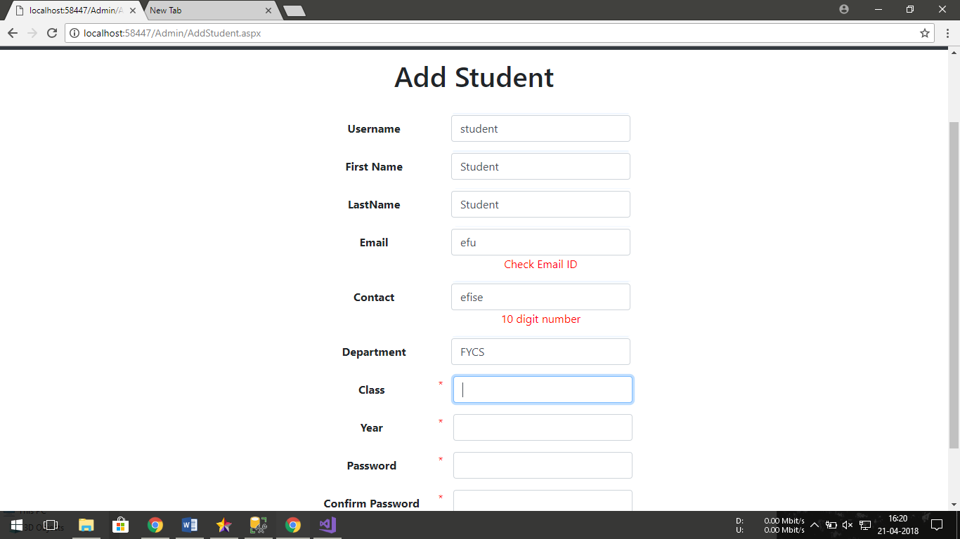

Admin/DeleteAdmin.aspx

<%@ Page Title="" Language="C#" MasterPageFile="~/Admin/Admin.master" AutoEventWireup="true" CodeFile="DeleteAdmin.aspx.cs" Inherits="Admin_DeleteAdmin" %>

<asp:Content ID="Content1" ContentPlaceHolderID="head" Runat="Server">

</asp:Content>

<asp:Content ID="Content2" ContentPlaceHolderID="ContentPlaceHolder1" Runat="Server">

<div class="container text-center" style="padding-top: 1%">

<h1>Delete Admin</h1>

<br />

<div class="form-group row d-flex justify-content-center">

<asp:Label runat="server" Text="Enter Username of admin to delete" CssClass="col-form-label" Font-Bold="True"></asp:Label>

<asp:RequiredFieldValidator runat="server" ErrorMessage="*" Display="Dynamic" ControlToValidate="AUsername" ForeColor="Red"></asp:RequiredFieldValidator>

</div>

<div class="form-group row d-flex justify-content-center">

<asp:TextBox ID="AUsername" runat="server" CssClass="col-sm-3 form-control"></asp:TextBox>

</div>

<div class="form-group row d-flex justify-content-center">

<h6>

<asp:HyperLink Target="_blank" href="/Admin/ViewAdmin.aspx" runat="server" ForeColor="Black">check here for correct username</asp:HyperLink></h6>

</div>

<div class="form-group row d-flex justify-content-center">

<h6>You cannot delete logged in admin.</h6>

</div>

<br />

<div class="form-group row d-flex justify-content-center">

<asp:Button ID="AdminDelete" runat="server" Text="Delete" CssClass="btn btn-danger" OnClick="AdminDelete_Click" />

&nbsp;

<asp:Button ID="AdminClear" runat="server" Text="Clear" CausesValidation="False" CssClass="btn btn-outline-dark" OnClick="AdminClear_Click" />

</div>

</div>

</asp:Content>

Admin/DeleteAdmin.aspx.cs

using System;

using System.Collections.Generic;

using System.Linq;

using System.Web;

using System.Web.UI;

using System.Web.UI.WebControls;

using System.Data;

using System.Data.SqlClient;

public partial class Admin_DeleteAdmin : System.Web.UI.Page

{

SqlConnection conn = new SqlConnection("Data Source=BHUPENDS-PC;Initial Catalog=CollegeERP;Integrated Security=True");

SqlCommand query;

ConnectionState state = new ConnectionState();

protected void Page_Load(object sender, EventArgs e)

{

}

protected void AdminDelete_Click(object sender, EventArgs e)

{

String username = AUsername.Text.Trim();

if (username.Equals(Session["AUser"].ToString()))

{

Response.Redirect("/Admin/Profile.aspx");

}

else

{

if (state == ConnectionState.Open)

{

conn.Close();

}

else

{

conn.Open();

query = new SqlCommand("Delete from Admin where username='" + username + "'", conn);

query.ExecuteNonQuery();

conn.Close();

AUsername.Text = "";

ScriptManager.RegisterClientScriptBlock(this, this.GetType(), "alertMessage", "alert('Deleted " + username +"')", true);

}

}

}

protected void AdminClear_Click(object sender, EventArgs e)

{

AUsername.Text = "";

}

}

Screenshot

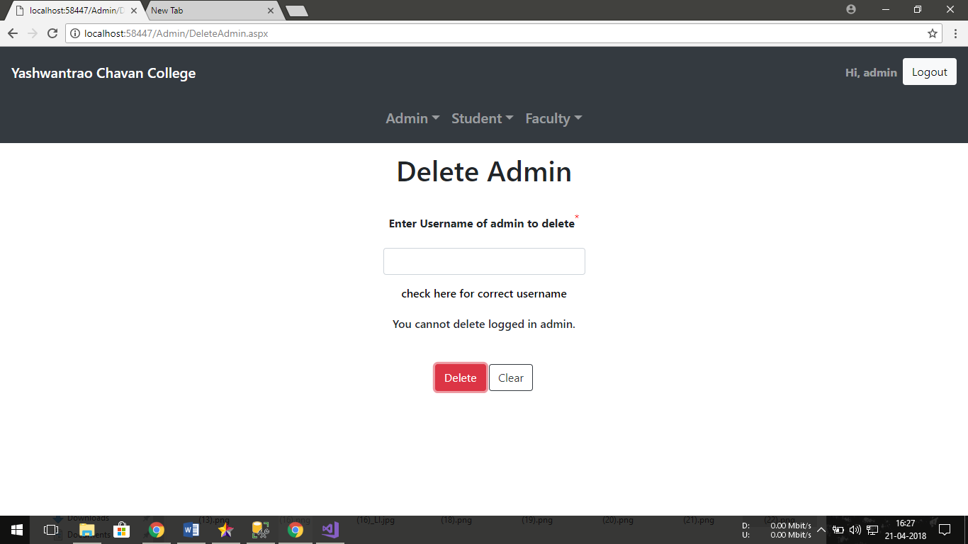

Admin/ViewStudent.aspx

<%@ Page Title="" Language="C#" MasterPageFile="~/Admin/Admin.master" AutoEventWireup="true" CodeFile="ViewStudent.aspx.cs" Inherits="Admin_ViewStudent" %>

<asp:Content ID="Content1" ContentPlaceHolderID="head" Runat="Server">

</asp:Content>

<asp:Content ID="Content2" ContentPlaceHolderID="ContentPlaceHolder1" Runat="Server">

<div class="container text-center" style="padding-top: 1%">

<h1>View Student</h1>

<br />

<div class="form-group row d-flex justify-content-center" style="height: 328px">

<asp:GridView ID="GridView1" runat="server" AutoGenerateColumns="False" BackColor="White" BorderColor="#CCCCCC" BorderStyle="None" BorderWidth="1px" CellPadding="4" DataSourceID="StudentData" ForeColor="Black" GridLines="Horizontal">

<Columns>

<asp:BoundField DataField="username" HeaderText="Username" SortExpression="username" />

<asp:BoundField DataField="firstName" HeaderText="First Name" SortExpression="firstName" />

<asp:BoundField DataField="lastName" HeaderText="Last Name" SortExpression="lastName" />

<asp:BoundField DataField="email" HeaderText="Email" SortExpression="email" />

<asp:BoundField DataField="contact" HeaderText="Contact" SortExpression="contact" />

<asp:BoundField DataField="class" HeaderText="Class" SortExpression="class" />

<asp:BoundField DataField="year" HeaderText="Year" SortExpression="year" />

<asp:BoundField DataField="department" HeaderText="Department" SortExpression="department" />

</Columns>

<FooterStyle BackColor="#CCCC99" ForeColor="Black" />

<HeaderStyle BackColor="#333333" Font-Bold="True" ForeColor="White" />

<PagerStyle BackColor="White" ForeColor="Black" HorizontalAlign="Right" />

<SelectedRowStyle BackColor="#CC3333" Font-Bold="True" ForeColor="White" />

<SortedAscendingCellStyle BackColor="#F7F7F7" />

<SortedAscendingHeaderStyle BackColor="#4B4B4B" />

<SortedDescendingCellStyle BackColor="#E5E5E5" />

<SortedDescendingHeaderStyle BackColor="#242121" />

</asp:GridView>

<asp:SqlDataSource ID="StudentData" runat="server" ConnectionString="<%$ ConnectionStrings:CollegeERPConnectionString %>" SelectCommand="SELECT [username], [firstName], [lastName], [email], [contact], [class], [year], [department] FROM [Student]"></asp:SqlDataSource>

</div>

</div>

</asp:Content>

Screenshot

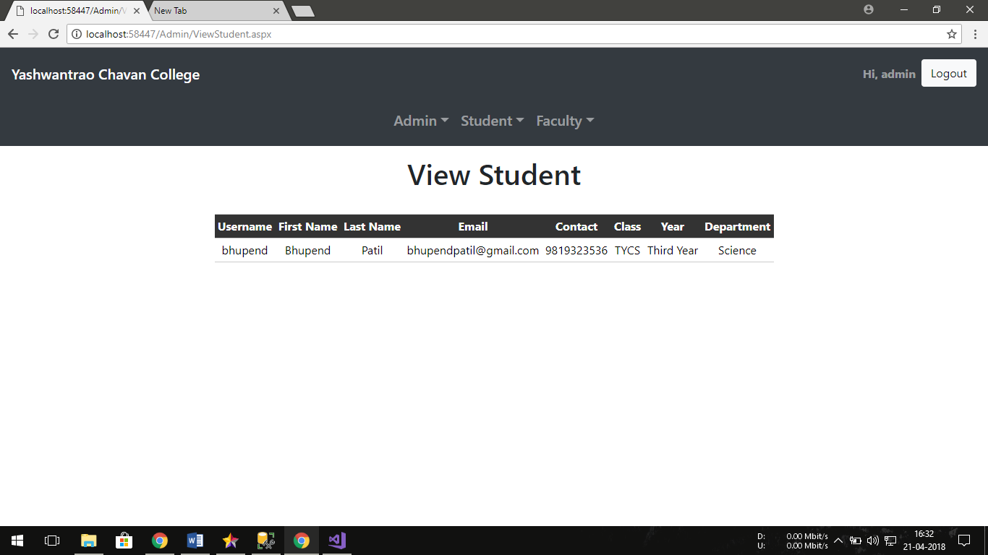

Admin/AddAdmin.aspx

<%@ Page Title="" Language="C#" MasterPageFile="~/Admin/Admin.master" AutoEventWireup="true" CodeFile="AddAdmin.aspx.cs" Inherits="Admin_AddAdmin" %>

<asp:Content ID="Content1" ContentPlaceHolderID="head" Runat="Server">

</asp:Content>

<asp:Content ID="Content2" ContentPlaceHolderID="ContentPlaceHolder1" Runat="Server">

<div class="container text-center" style="padding-top: 1%">

<h1>Add Admin</h1>

<br />

<div class="form-group row d-flex justify-content-center">

<asp:label runat="server" text="Username" cssclass="col-sm-2 col-form-label" font-bold="True"></asp:label>

<asp:requiredfieldvalidator runat="server" errormessage="*" Display="Dynamic" controltovalidate="AUser" forecolor="Red"></asp:requiredfieldvalidator>

<div class="col-sm-3">

<asp:textbox id="AUser" runat="server" cssclass="form-control" ></asp:textbox>

</div>

</div>

<div class="form-group row d-flex justify-content-center">

<asp:label runat="server" text="First Name" cssclass="col-sm-2 col-form-label" font-bold="True"></asp:label>

<asp:requiredfieldvalidator runat="server" errormessage="*" Display="Dynamic" controltovalidate="FName" forecolor="Red"></asp:requiredfieldvalidator>

<div class="col-sm-3">

<asp:textbox id="FName" runat="server" cssclass="form-control" ></asp:textbox>

</div>

</div>

<div class="form-group row d-flex justify-content-center">

<asp:label runat="server" text="LastName" cssclass="col-sm-2 col-form-label" font-bold="True"></asp:label>

<asp:requiredfieldvalidator runat="server" errormessage="*" controltovalidate="LName" forecolor="Red"></asp:requiredfieldvalidator>

<div class="col-sm-3">

<asp:textbox id="LName" runat="server" cssclass="form-control" ></asp:textbox>

</div>

</div>

<div class="form-group row d-flex justify-content-center">

<asp:label runat="server" text="Email" cssclass="col-sm-2 col-form-label" font-bold="True"></asp:label>

<asp:requiredfieldvalidator runat="server" errormessage="*" Display="Dynamic" controltovalidate="Email" forecolor="Red"></asp:requiredfieldvalidator>

<div class="col-sm-3">

<asp:textbox id="Email" runat="server" cssclass="form-control" ></asp:textbox>

<asp:RegularExpressionValidator ID="RegularExpressionValidator2" runat="server" ValidationExpression="\w+([-+.]\w+)*@\w+([-.]\w+)*\.\w+([-.]\w+)*" ControlToValidate="Email" Display="Dynamic" ErrorMessage="Check Email ID" ForeColor="Red"></asp:RegularExpressionValidator>

</div>

</div>

<div class="form-group row d-flex justify-content-center">

<asp:label runat="server" text="Contact" cssclass="col-sm-2 col-form-label" font-bold="True"></asp:label>

<asp:requiredfieldvalidator runat="server" errormessage="*" Display="Dynamic" controltovalidate="Contact" forecolor="Red"></asp:requiredfieldvalidator>

<div class="col-sm-3">

<asp:textbox id="Contact" runat="server" cssclass="form-control" ></asp:textbox>

<asp:RegularExpressionValidator ID="RegularExpressionValidator1" runat="server" ValidationExpression="[0-9]{10}" ControlToValidate="Contact" Display="Dynamic" ErrorMessage="10 digit number" ForeColor="Red"></asp:RegularExpressionValidator>

</div>

</div>

<div class="form-group row d-flex justify-content-center">

<asp:label runat="server" text="Password" cssclass="col-sm-2 col-form-label" font-bold="True"></asp:label>

<asp:requiredfieldvalidator runat="server" errormessage="*" Display="Dynamic" controltovalidate="pass" forecolor="Red"></asp:requiredfieldvalidator>

<div class="col-sm-3">

<asp:textbox id="pass" runat="server" TextMode="Password" cssclass="form-control" ></asp:textbox>

</div>

</div>

<div class="form-group row d-flex justify-content-center">

<asp:label runat="server" text="Confirm Password" cssclass="col-sm-2 col-form-label" font-bold="True"></asp:label>

<asp:requiredfieldvalidator runat="server" errormessage="*" Display="Dynamic" controltovalidate="cpass" forecolor="Red"></asp:requiredfieldvalidator>

<div class="col-sm-3">

<asp:textbox ID="cpass" runat="server" TextMode="Password" cssclass="form-control" ></asp:textbox>

<asp:CompareValidator ID="CompareValidator1" runat="server" ErrorMessage="Check Password -_-" ControlToCompare="pass" ControlToValidate="cpass" ForeColor="Red"></asp:CompareValidator>

</div>

</div>

<div class="form-group row d-flex justify-content-center">

<asp:Button ID="AddAdmin" runat="server" Text="Add" CssClass="btn btn-dark" OnClick="AddAdmin_Click"/>

&nbsp;

<asp:Button ID="ClearAdmin" runat="server" Text="Clear" CausesValidation="False" CssClass="btn btn-outline-dark" OnClick="ClearAdmin_Click"/>

</div>

</div>

</asp:Content>

Admin/AddAdmin.aspx.cs

using System;

using System.Collections.Generic;

using System.Linq;

using System.Web;

using System.Web.UI;

using System.Web.UI.WebControls;

using System.Data;

using System.Data.SqlClient;

public partial class Admin_AddAdmin : System.Web.UI.Page

{

SqlConnection conn = new SqlConnection("Data Source=BHUPENDS-PC;Initial Catalog=CollegeERP;Integrated Security=True");

SqlCommand query;

ConnectionState state = new ConnectionState();

protected void Page_Load(object sender, EventArgs e)

{

}

protected void AddAdmin_Click(object sender, EventArgs e)

{

String username = AUser.Text.Trim();

String Pass = pass.Text.Trim();

String firstName = FName.Text.Trim();

String lastName = LName.Text.Trim();

String email = Email.Text.Trim();

String contact = Contact.Text.Trim();

if (state == ConnectionState.Open)

{

conn.Close();

}

else {

conn.Open();

query = new SqlCommand("insert into Admin (username, password, firstName, lastName, email, contact) values ('" + username + "','" + Pass + "','" + firstName + "','" + lastName + "','" + email + "','" + contact + "')", conn);

query.ExecuteNonQuery();

conn.Close();

AUser.Text = "";

FName.Text = "";

LName.Text = "";

Email.Text = "";

Contact.Text = "";

pass.Text = "";

cpass.Text = "";

ScriptManager.RegisterClientScriptBlock(this, this.GetType(), "alertMessage", "alert('Added Admin')", true);

}

}

protected void ClearAdmin_Click(object sender, EventArgs e)

{

AUser.Text = "";

FName.Text = "";

LName.Text = "";

Email.Text = "";

Contact.Text = "";

pass.Text = "";

cpass.Text = "";

}

}

Screenshot

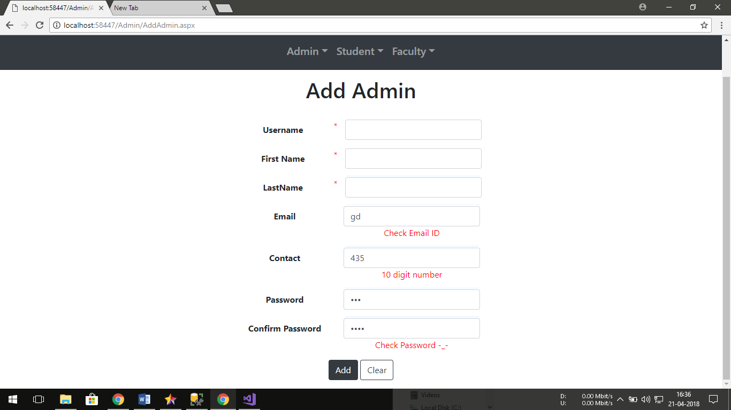

**23. FUTURE ENHANCEMENTS**

The system is designed keeping in mind the current requirements of the organization. However, need do not arise all at once. They surface as per course of time. Some aspect was not considered and some new can added in the system to cater charging user requirement.

* The system is being flexible so that new module can be added at any given time.
* The system’s Front End should be changed into ASP.NET so that it can perform web based transactions and so that it can put up less load on CPU and can be optimized for a better performance.
* Also based on the above transformation one machine would be kept as database so that the data can be accessed be any device through the browser.
* Also, to add certain more type of reports.
* Through future need can be predicted, they will be added and improved over the course of time.

**24. REFERENCES AND BIBLIOGRAPHY**

**References**

Jeoff Richters - Windows Programming

Professional Visual Studio 2017 by Bruce Johnson

Pro C# 7: With .NET and .NET Core by Andrew Troelsen

Reporting with Visual Studio and Crystal Reports by Mahmoud Elkoush

**Bibliography**

<https://www.w3schools.com/>

<https://www.tutorialspoint.com>

<https://docs.microsoft.com/en-in/>

<https://www.youtube.com/>

<https://www.google.com>

<https://mva.microsoft.com/>

<https://www.edx.org/>