Bug Report – Buggy To-Do Web App
Project Name: Buggy To-Do Web App Manual Testing
Application URL: https://bug-test-swart.vercel.app/
Prepared By: Bhupendra Sen
Date: November 15 ,2025
BUG-01
Field | Description
Bug ID | BUG-01
Title | System allows adding tasks with past due dates
Section | Add Task
Environment | 1.Browser: Chrome 139.0  2.network:Wifi  3.OS:windows 11  4.URL: https://bug-test-swart.vercel.app/
Preconditions | User i has navigated to the to- do web app and fill the add task form is accessible
Steps to Reproduce | 1. Navigate to to-do web app  2. Open Add Task form  3. Enter valid task name  4. Select any past date (e.g., yesterday)  5. Click on add task
Expected Result | System should block past dates and show validation error:  Due date cannot be in the past.
Actual Result | Task gets added successfully without validation error
Severity | Medium
Priority | High
Attachments | Screenshot  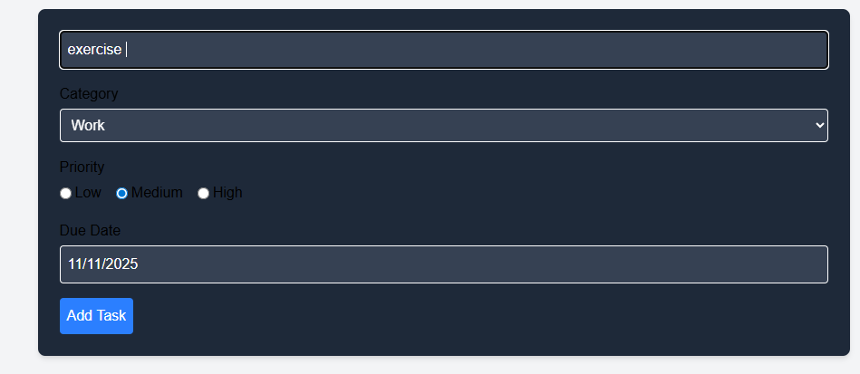  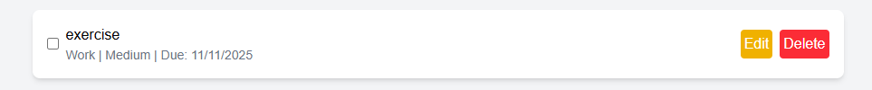
Status | Open

BUG-02
Field | Description
Bug ID | BUG-02
Title | Long task description overflows task container and UI overlapp
Section | Add Task
Environment | 1.Browser: Chrome 139.0  2.network:Wifi  3.OS:windows 11  4.URL: https://bug-test-swart.vercel.app/
Preconditions | User i has navigated to the to- do web app and fill the add task form is accessible
Steps to Reproduce | 1. Navigate to to-do web app  2. Open Add Task form  3. Enter long task description name  4. Select any deu date  5. Click on add task
Expected Result | Task should be display on the task list box and no UI break
Actual Result | Task is display on task list but task name goes out of the task container
Severity | Major
Priority | Medium
Attachments | Screenshot  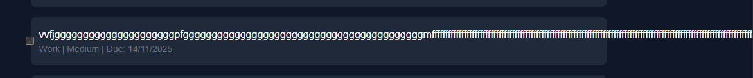
Status | Open

BUG-03
Field | Description
Bug ID | BUG-03
Title | System allows adding a task with spaces-only in task description
Section | Add Task
Environment | 1.Browser: Chrome 139.0  2.network:Wifi  3.OS:windows 11  4.URL: https://bug-test-swart.vercel.app/
Preconditions | User i has navigated to the to- do web app and fill the add task form is accessible
Steps to Reproduce | 1. Navigate to to-do web app  2. Open Add Task form  3. Enter space only on description  4. Select any past date (e.g., yesterday)  5. Click on add task
Expected Result | Task should not be added and shown validation error
Actual Result | Task is added with no validation errror
Severity | Medium
Priority | High
Attachments | Screenshot  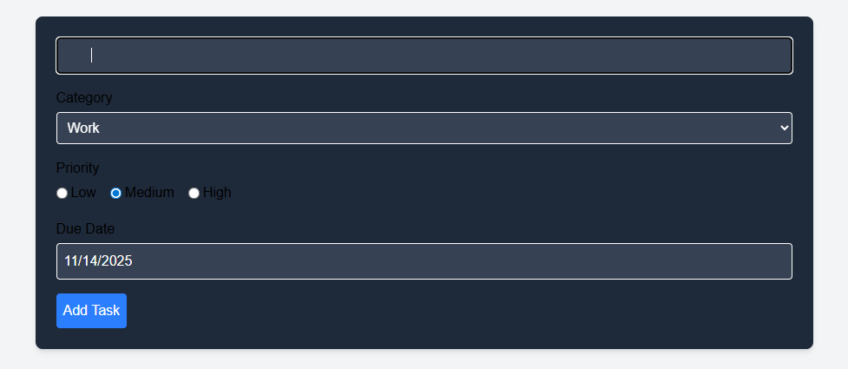
Status | Open

BUG-04
Field | Description
Bug ID | BUG-04
Title | When I try to see only work task only by apply filter on category but Category filter shows tasks from other categories
Section | Filters
Environment | 1.Browser: Chrome 139.0  2.network:Wifi  3.OS:windows 11  4.URL: https://bug-test-swart.vercel.app/
Preconditions | User i has navigated to the to- do web app and apply filters
Steps to Reproduce | 1. Navigate to to-do web app  2. Ensure tasks exist in multiple categories (Work, Personal, Other)  3. Select Work in Category filter dropdown  4. Apply filter / wait for filter to apply  5. Observe the result
Expected Result | Only work tasks should be display
Actual Result | work task is display but with other task also
Severity | High
Priority | High
Attachments | Screenshot  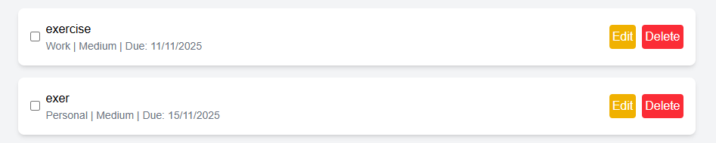
Status | Open

BUG-05
Field | Description
Bug ID | BUG-05
Title | Status filter and priority sort combination shows incorrect tasks
Section | Filters
Environment | 1.Browser: Chrome 139.0  2.network:Wifi  3.OS:windows 11  4.URL: https://bug-test-swart.vercel.app/
Preconditions | User i has navigated to the to- do web app and apply filters
Steps to Reproduce | 1. Navigate to to-do web app  2. Ensure tasks exist in multiple categories (Work, Personal, Other)  3. Create tasks with incomplete Status and sort by Priority  4. Observe the task list
Expected Result | Both should apply correctly by showing incomple task with high priority
Actual Result | complete task with low priority is shown
Severity | High
Priority | High
Attachments | Screenshot  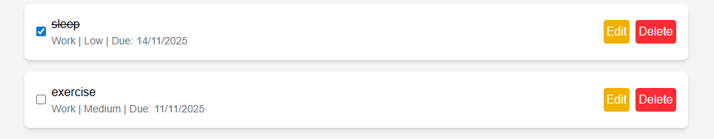
Status | Open

BUG-06
Field | Description
Bug ID | BUG-06
Title | Task list checkbox misaligned in Dark Mode
Section | Toggle dark mode
Environment | 1.Browser: Chrome 139.0  2.network:Wifi  3.OS:windows 11  4.URL: https://bug-test-swart.vercel.app/
Preconditions | - User i has navigated to the to- do web app  - Task list has at least one task.  - Dark Mode toggle is visible and functional.
Steps to Reproduce | 1. Navigate to to-do web app  2.Click on the Dark Mode toggle to enable Dark Mode.  3. Observe the task list and checkboxes next to each task.
Expected Result | Task list should aligh properly and checkbox should inside the container
Actual Result | task list is shown but checkbox move slightly out of the containter which is UI issuues
Severity | Medium
Priority | Medium
Attachments | Screenshot  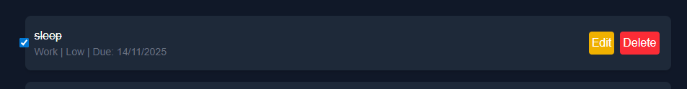
Status | Open
BUG-07
Field | Description
Bug ID | BUG-07
Title | Text are not visible when editing task in Dark Mode
Section | Toggle dark mode
Environment | 1.Browser: Chrome 139.0  2.network:Wifi  3.OS:windows 11  4.URL: https://bug-test-swart.vercel.app/
Preconditions | - User i has navigated to the to- do web app  - Dark Mode toggle is visible and functional.
Steps to Reproduce | - Navigate to to-do web app  - Enable Dark Mode by toggling the switch.  - Open an existing task for editing.  - Observe the text visible or not.
Expected Result | text should me remain readable and visible
Actual Result | Text is not visible
Severity | Medium
Priority | Medium
Attachments | Screenshot  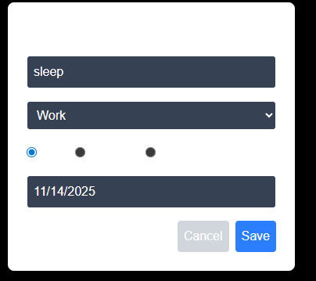
Status | Open

