**Name: - Isha Raut**

**TE Comps 03 BATCH: -B**

**Roll NO: - 18**

**Experiment No 2**

**Aim:** Use basic networking commands in Linux (ping, tracert, nslookup, netstat, ARP, RARP, ip, ifconfig, dig, route)

**Theory and Output:**

**Ipconfig for windows And ifconfig for linux:**

Displays all current TCP/IP network configuration values and refreshes Dynamic Host Configuration Protocol (DHCP) and Domain Name System (DNS) settings. Used without parameters, ipconfig displays Internet Protocol version 4 (IPv4) and IPv6 addresses, subnet mask, and default gateway for all adapters.

**Output:**

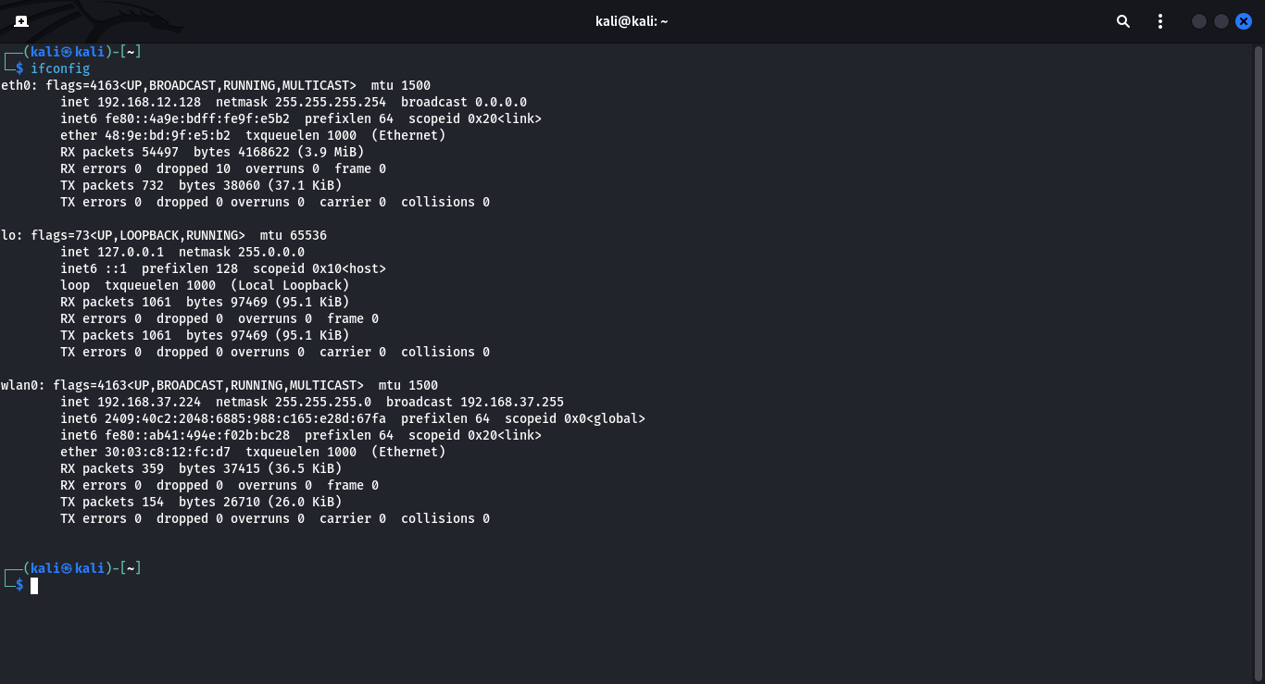

**Ipconfig /all for windows & ip r for linux:**

Displays all configuration information for each adapter bound to TCP/IP.

**Output:**

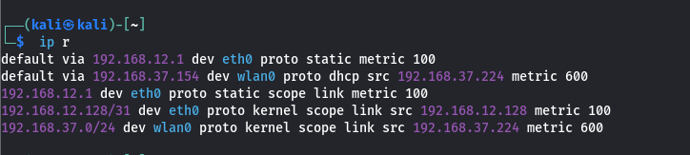

**Ping:**

The ping command is a command-prompt command, used to test the ability of the source computer to reach a specified destination computer.It’s usually used as a simple way to verify that a computer can communicate over the network with another computer or network device.

**Output:**

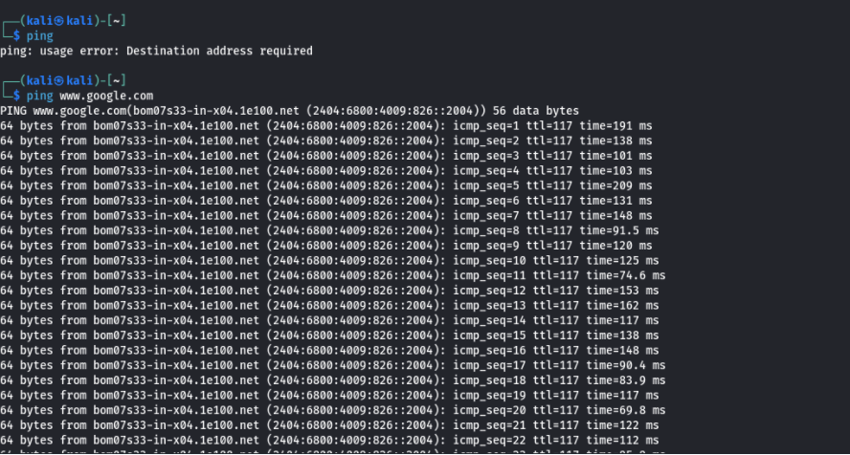

**Tracert for windows & traceroute for linux:**

The tracert command (spelled traceroute in Unix/linux implementations) is one of the key diagnostic tools for TCP/IP. It displays a list of all routers that a packet must go through to get from the computer where tracert is run to any other computer on the internet.

**Output:**

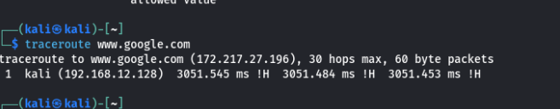

**Nslookup:**

Nslookup(from name server lookup) is a network administration command line tool for querying the domain name system (DNS) to obtain the mapping between domain name and IP address ,or other DNS records.

**Output:**

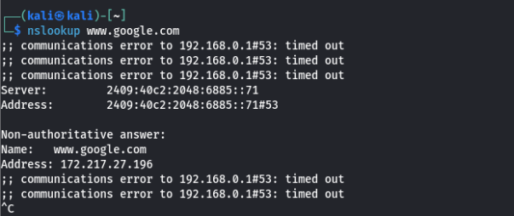

**Hostname:**

A hostname is a label that is assigned to a device connected to a computer network and that is used to identify the device in various forms of electronic communication ,such as the World Wide Web .Hostnames may be simple names consisting of a single word or phrase ,or they may be structured .Each hostname usually has at least one numeric network address associated with it for routing packets for performance and other reasons.

**Output:**



**Arp:**

Arp command manipulates the System’s ARP cache . It allows a complete dump of the ARP cache .ARP stands for Address Resolution Protocol.The primary function of this protocol is to resolve the IP address of a system to its mac address, and hence it works between level 2(Data link layer ) and level 3 ( Network layer).

**Output:**

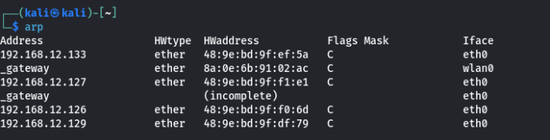

**CONCLUSION:**

We have understood and implemented the functions of all the basic networking commands.