**Experiment No 3**

**Aim: Build a simple network topology and configure it for static routing protocol using packet tracer. Setup a network and configure IP addressing, subnetting, masking**

**Theory:**

**Static routing** is a form of routing that occurs when a router uses a manually-configured routing entry, rather than information from a dynamic routing protocol to forward traffic. In many cases, static routes are usually manually configured by a network administrator by adding in entries into a routing table, though this may not always be the case. Unlike dynamic routing, static routes are fixed and do not change if the network is changed or reconfigured. Static routing and dynamic routing are not mutually exclusive. Both dynamic routing and static routing are usually used on a router to maximize routing efficiency and to provide backups in the event that dynamic routing information fails to be exchanged. Static routing can also be used in stub networks, or to provide a gateway Static routing. **Network topologies** describe the methods in which all the elements of a network are mapped. The topology term refers to both the physical and logical layout of a network. Two main types of network topologies in computer networks are

**1) Physical topology :** This type of network is an actual layout of the computer cables and other network devices.

**2) Logical topology :** Logical topology gives insight's about a network's physical design.

**Different types of Physical Topologies are:** P2P Topology, Bus Topology, Ring Topology, Star Topology, Tree Topology, Mesh Topology, Hybrid Topology.

**• Ping** - Ping is a command-line utility, available on virtually any operating system with network connectivity, that acts as a test to see if a networked device is reachable.The ping command sends a request over the network to a specific device. A successful ping results in a response from the computer that was pinged back to the originating computer.

**Syntax:** ping (ip address of other device)

**• Ifconfig (logical connection)-** command is used to configure the kernel-resident network nterfaces. It is used at the boot time to set up the interfaces as necessary. After that, it is usually used when needed during debugging or when you need system tuning. Also, this command is used to assign the IP address and netmask to an interface or to enable or disable a given interface.

**Syntax:** ifconfig

**• ipconfig /all (physical connection):** Displays all current TCP/IP network configuration values and refreshes Dynamic Host Configuration Protocol (DHCP) and Domain Name System (DNS) settings. Used without parameters, ipconfig displays Internet Protocol version 4 (IPv4) and IPv6 addresses, subnet mask, and default gateway for all adapters.

**Syntax:** ipconfig /all

**Procedure and Output:**

### Procedure:

### Configuring Static Routing Protocol using Packet Tracer

A steps for building a simple network topology and configuring static routing using Cisco Packet Tracer.

Step 1: Open Cisco Packet Tracer

Step 2: Design the Network Topology

Step 3: Configure IP Addressing

Step 4: Configure Interfaces

Step 5: Configure Static Routing

Step 6: Configure PCs

Step 7: Test the Connectivity (Ping Command)

**Output :**

**Star Topology :**

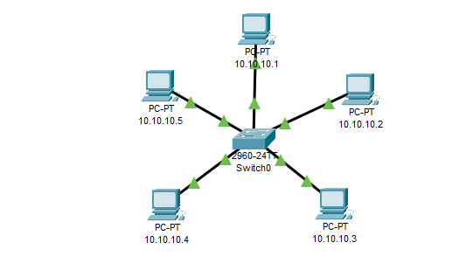

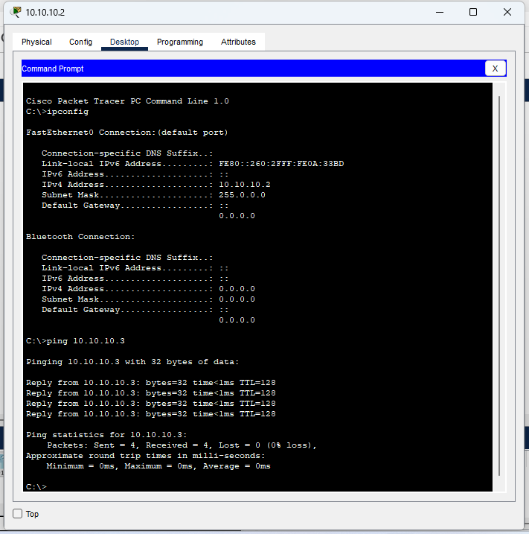

**Ring Topology**

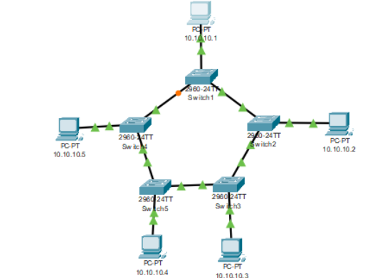

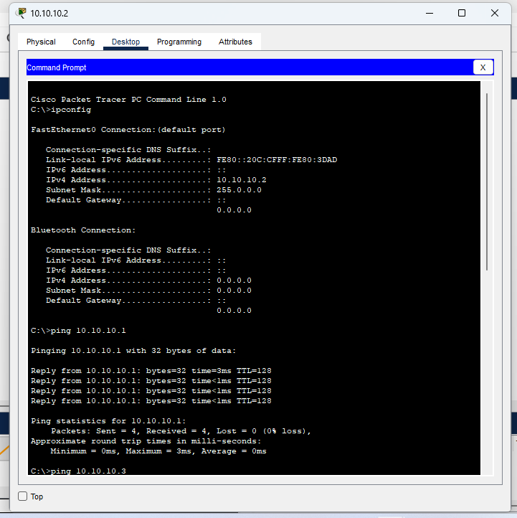

**Conclusion:**

In this experiment, we have successfully built a simple network topology in Cisco Packet Tracer and configured static routing. The routers were manually configured to route packets between two networks using static routes. We also tested the connectivity between devices using the ping command. This experiment demonstrates how static routing ensures traffic between different subnets, even in the absence of dynamic routing protocols.