

**Experiment No 7**

**Aim: Study and installation of network simulators[NS2/NS3].**

**Theory:**

Network Simulator 3 (NS3) is a popular open-source network simulation tool used for researching and developing network protocols, algorithms, and applications. It provides a comprehensive platform for simulating complex network scenarios and evaluating network performance. Here's an overview of studying and installing NS3:

**System Requirements:**

Check the system requirements for NS3 to ensure your computer meets the necessary specifications. NS3 is primarily developed for Linux-based systems, but it can also be installed on Windows or macOS using virtual machines or subsystems like Cygwin or WSL.

**Installation:**

Choose the appropriate installation method based on your operating system and preferences. **For Linux:**

Download the NS3 source code from the official website or clone the Git repository. Follow the detailed installation instructions provided in the NS3 documentation to set up the necessary dependencies and compile NS3.

**For Windows or macOS:**

Set up a Linux virtual machine (e.g., using VirtualBox) or use a subsystem like Cygwin or WSL to emulate a Linux environment.

Follow the Linux installation instructions within the virtual machine or subsystem. Configuration and Building:

After installing NS3, configure the build options based on your requirements. NS3 provides several configuration parameters that allow you to enable or disable specific features.

Use the waf build system (provided with NS3) to build the NS3 libraries and executables.

**Output:**

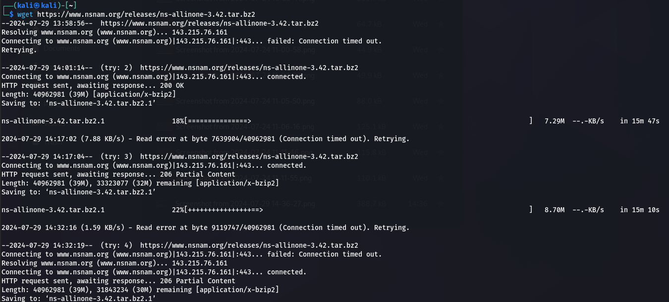

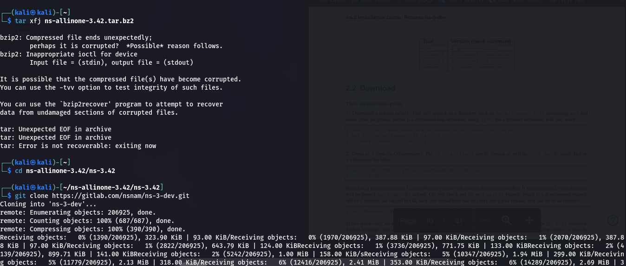

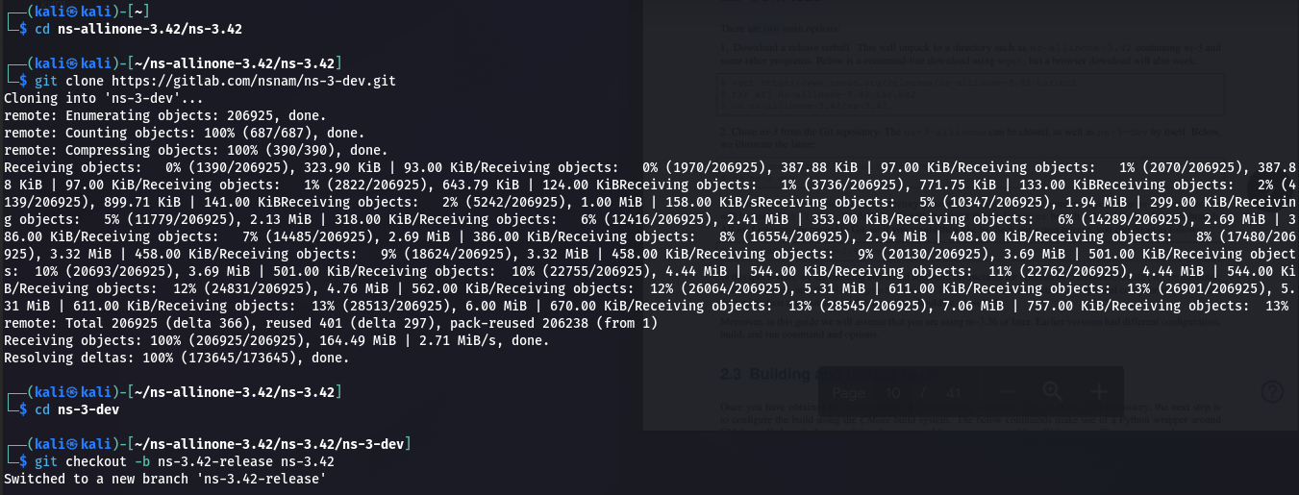

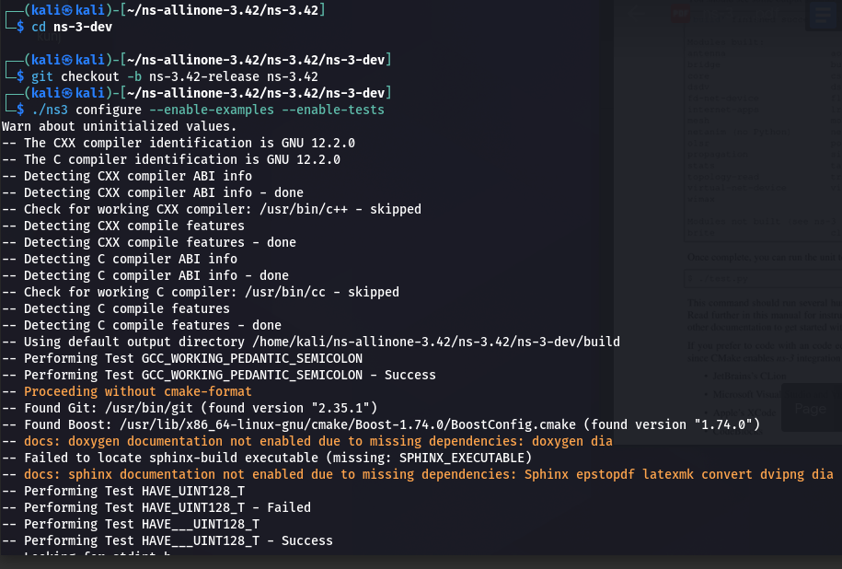

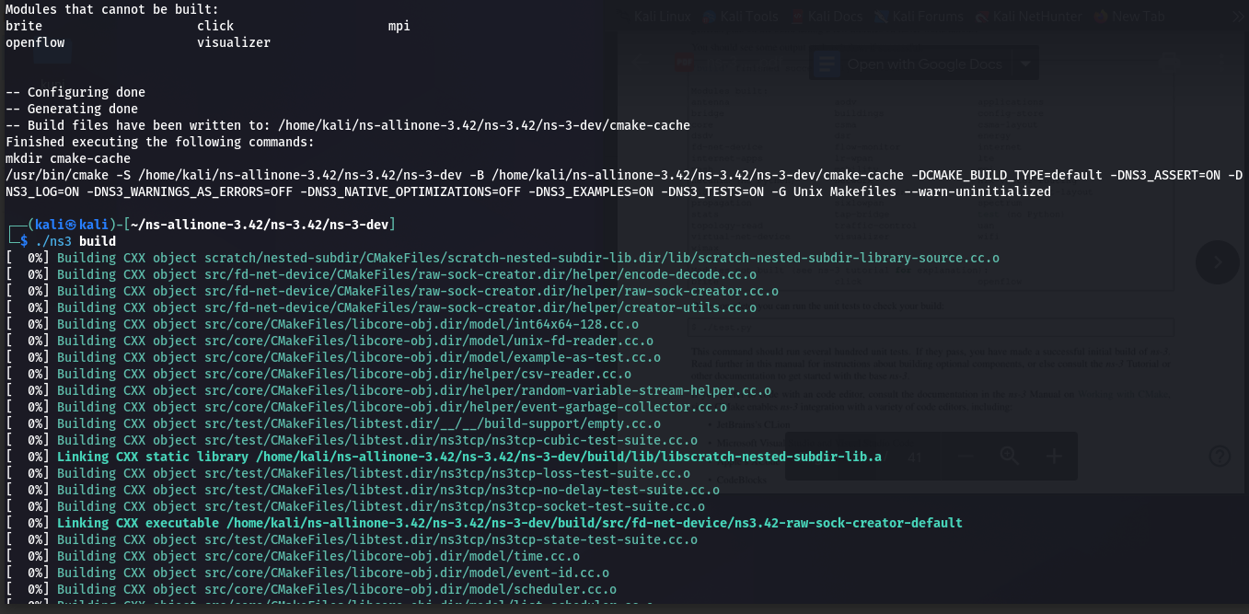

**Conclusion:** We have studied and installed Network Simulator (NS3).