**Experiment No 9**

**Aim: Perform File Transfer and access using FTP.**

**Theory:**

File Transfer Protocol(FTP) is an application layer protocol which moves files between local and remote file systems. It runs on the top of TCP, like HTTP. To transfer a file, 2 TCP connections are used by FTP in parallel: control connection and data connection.

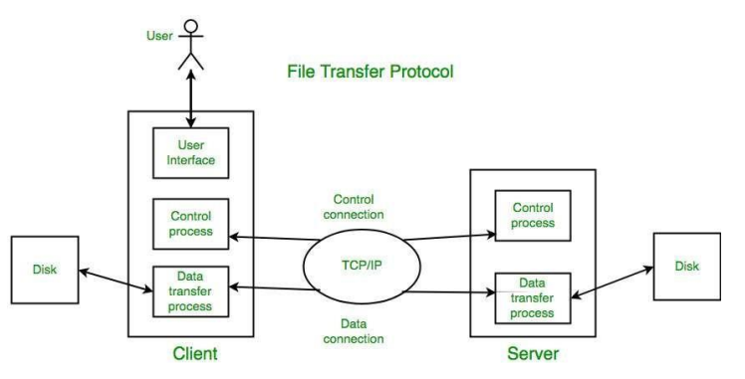

Objectives of FTP:

* It provides the sharing of files.
* It is used to encourage the use of remote computers. O
* It transfers the data more reliably and efficiently.

Advantages of FTP:

* Speed: One of the biggest advantages of FTP is speed. The FTP is one of the fastest way to transfer the files from one computer to another computer.
* Efficient: It is more efficient as we do not need to complete all the operations to get the entire file.
* Security: To access the FTP server, we need to login with the username and password. Therefore, we can say that FTP is more secure.

Active and Passive mode:

In the active mode, the client starts listening on a random port for incoming data connections from the server (the client sends the FTP command PORT to inform the server on which port it is listening). Nowadays, it is typical that the client is behind a firewall (e.g. built-in Windows firewall) or NAT router (e.g. ADSL modem), unable to accept incoming TCP connections.

In the passive mode, the client uses the control connection to send a PASV command to the server and then receives a server IP address and server port number from the server, which the client then uses to open a data connection to the server IP address and server port number received.

**Output:**

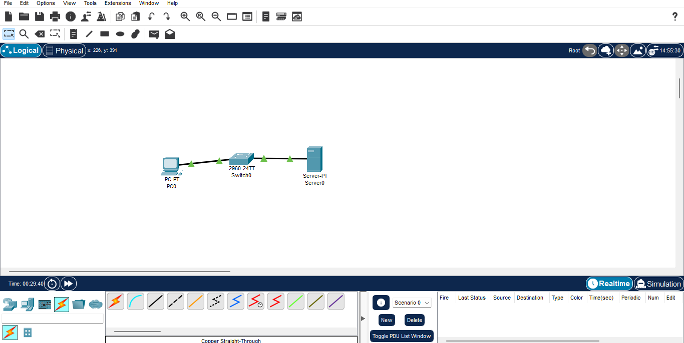

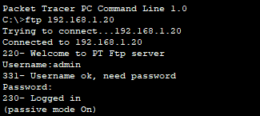

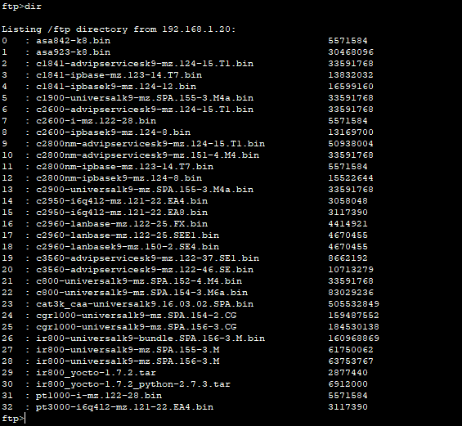

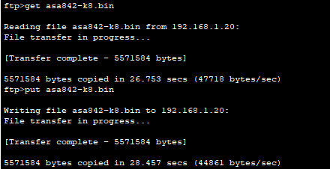



**Conclusion:** We have accessed and transferred files during FTP.