**Experiment No 10**

**Aim: Design VPN and Configure RIP/OSPF using Packet tracer. Theory:**

RIP has a default administrative distance of 120. It uses the hop count (the number of routers between the source and destination network) as the metric. The hop count limit is 15. Any route with a higher hop count will be marked as unreachable.

RIP implements the split horizon, route poisoning, and hold down mechanisms to prevent incorrect routing information from being propagated.

In most networking environments, RIP is not the preferred choice of routing protocol, as its time to converge and scalability are poor as compared to EIGRP, OSPF, or IS-IS. However, it is easy to configure, because RIP does not require any parameters, unlike other protocols.

**Output:**

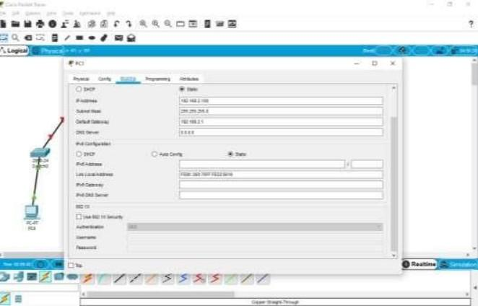

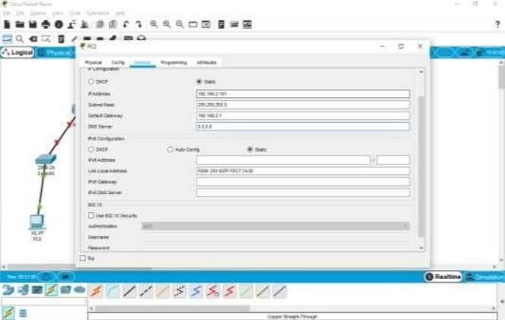

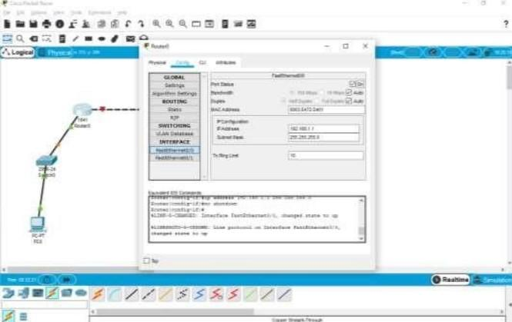

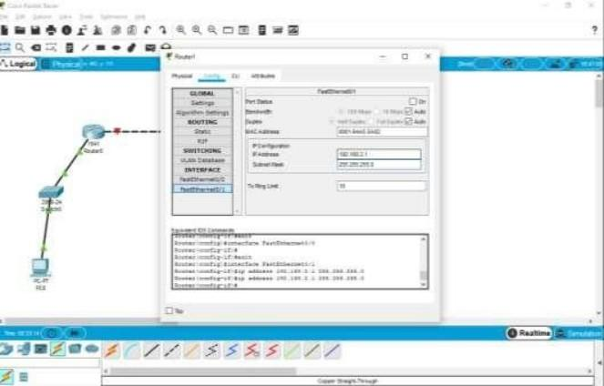

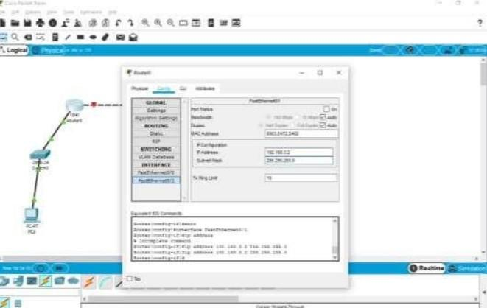

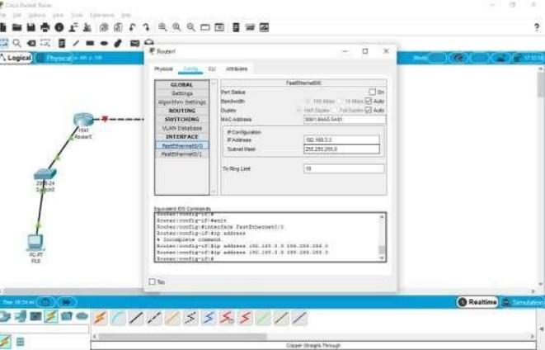

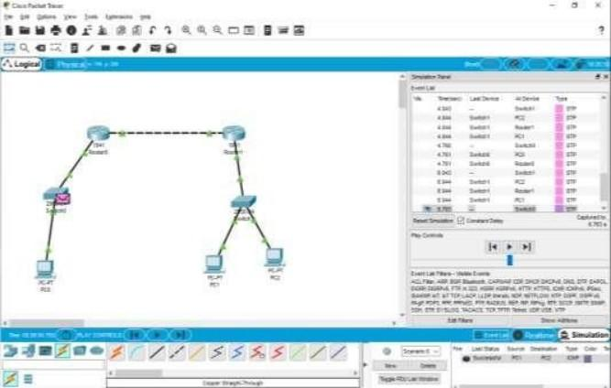

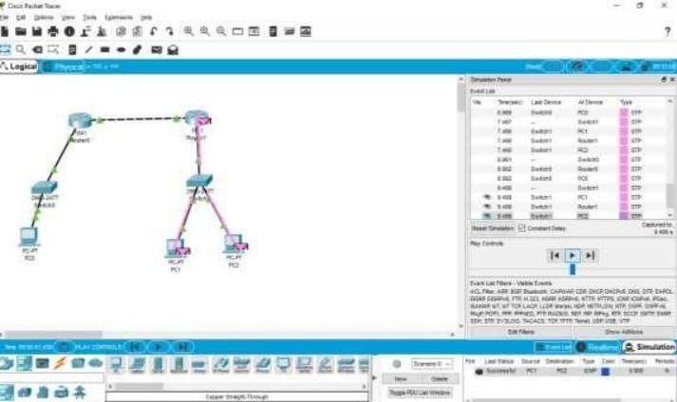

**Conclusion:** Thus in this practical we have successfully Designed VPN and configured RIP using Cisco packet tracer.