**Class:** Final Year (Computer Science and Engineering)

**Year:** 2024-25 **Semester:** 1

**Course:** High Performance Computing Lab

**Practical No. 4**

**Exam Seat No: 21510013**

**Title of practical:**

Study and Implementation of Synchronization

**Problem Statement 1:**

# Analyse and implement a Parallel code for below programs using OpenMP considering synchronization requirements. (Demonstrate the use of different clauses and constructs wherever applicable)

# Fibonacci Computation:

**Screenshots:**

**#include** <omp.h>

**#include** <stdio.h>

**#include** <stdlib.h>

**int** fibonacci(**int** *n*)

{

**int** i, j;

**if** (*n* **<** 2)

**return** *n*;

**else**

    {

**#pragma** **omp** **task** **shared**(**i**)

        i **=** fibonacci(*n* **-** 1);

**#pragma** **omp** **task** **shared**(**j**)

        j **=** fibonacci(*n* **-** 2);

**#pragma** **omp** **taskwait**

**return** i **+** j;

    }

}

**int** main(**int** *argc*, **char** **\*\****argv*)

{

**char** **\***a **=** *argv*[1];

**int** n **=** atoi(a), result;

**#pragma** **omp** **parallel**

    {

**#pragma** **omp** **single**

        result **=** fibonacci(n);

    }

    printf("Result is %d\n", result);

}

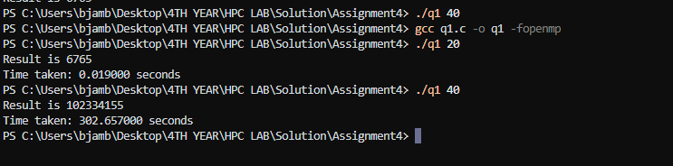

**Information:**

**Problem Statement 2:**

# Analyse and implement a Parallel code for below programs using OpenMP considering synchronization requirements. (Demonstrate the use of different clauses and constructs wherever applicable)

## Producer Consumer Problem

**Screenshots:**

**#include** <stdio.h>

**#include** <stdlib.h>

*// Initialize a mutex to 1*

**int** mutex **=** 1;

*// Number of full slots as 0a*

**int** full **=** 0;

*// Number of empty slots as size*

*// of buffer*

**int** empty **=** 10, x **=** 0;

*// Function to produce an item and*

*// add it to the buffer*

**void** producer() {

*// Decrease mutex value by 1*

**--**mutex;

*// Increase the number of full*

*// slots by 1*

**++**full;

*// Decrease the number of empty*

*// slots by 1*

**--**empty;

*// Item produced*

    x**++**;

    printf("\nProducer produces "

           "item %d",

           x);

*// Increase mutex value by 1*

**++**mutex;

}

*// Function to consume an item and*

*// remove it from buffer*

**void** consumer() {

*// Decrease mutex value by 1*

**--**mutex;

*// Decrease the number of full*

*// slots by 1*

**--**full;

*// Increase the number of empty*

*// slots by 1*

**++**empty;

    printf("\nConsumer consumes "

           "item %d",

           x);

    x**--**;

*// Increase mutex value by 1*

**++**mutex;

}

*// Driver Code*

**int** main() {

**int** n, i;

    printf("\n1. Press 1 for Producer"

           "\n2. Press 2 for Consumer"

           "\n3. Press 3 for Exit");

*// Using '#pragma omp parallel for'*

*// can give wrong value due to*

*// synchronization issues.*

*// 'critical' specifies that code is*

*// executed by only one thread at a*

*// time i.e., only one thread enters*

*// the critical section at a given time*

**#pragma** **omp** **critical**

**for** (i **=** 1; i **>** 0; i**++**) {

        printf("\nEnter your choice:");

        scanf("%d", **&**n);

*// Switch Cases*

**switch** (n) {

**case** 1:

*// If mutex is 1 and empty*

*// is non-zero, then it is*

*// possible to produce*

**if** ((mutex **==** 1) **&&** (empty **!=** 0)) {

                producer();

            }

*// Otherwise, print buffer*

*// is full*

**else** {

                printf("Buffer is full!");

            }

**break**;

**case** 2:

*// If mutex is 1 and full*

*// is non-zero, then it is*

*// possible to consume*

**if** ((mutex **==** 1) **&&** (full **!=** 0)) {

                consumer();

            }

*// Otherwise, print Buffer*

*// is empty*

**else** {

                printf("Buffer is empty!");

            }

**break**;

*// Exit Condition*

**case** 3:

            exit(0);

**break**;

        }

    }

}

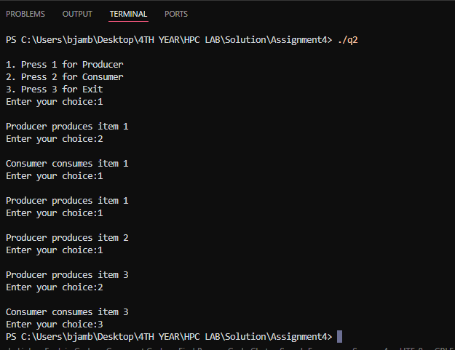

**Information:**

**Github Link:**