Name : Bhupendra Baliram Jambhale

PRN : 21510013

Q1. Write an OpenMP program such that, it should print the name of your family members, such that the names should come from different threads/cores. Also print the respective job id.

**#include** <omp.h>

**#include** <stdio.h>

**int** main()

{

*// Array of family member names*

**char** **\***family_members**[]** **=** {"Sharvani", "Bhupendra", "Anita", "Baliram"};

**int** num_members **=** 4;

*// Parallel region to print names with different threads*

**#pragma** **omp** **parallel** **for**

**for** (**int** i **=** 0; i **<** num_members; i**++**)

    {

        printf("Thread %d: %s\n", omp_get_thread_num(), family_members[i]);

    }

**return** 0;

}

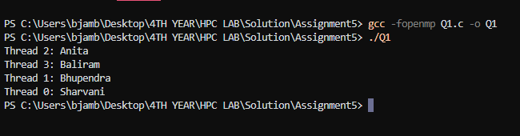

Q2. Write an OpenMP program such that, it should print the sum of square of the thread id’s. Also make sure that, each thread should print the square value of their thread id.

**#include** <omp.h>

**#include** <stdio.h>

**int** main()

{

**int** sum_of_squares **=** 0;

**#pragma** **omp** **parallel**

    {

**int** tid **=** omp_get_thread_num();

**int** square **=** tid **\*** tid;

        printf("Thread %d square: %d\n", tid, square);

**#pragma** **omp** **atomic**

        sum_of_squares **+=** square;

    }

    printf("Sum of squares of thread IDs: %d\n", sum_of_squares);

**return** 0;

}

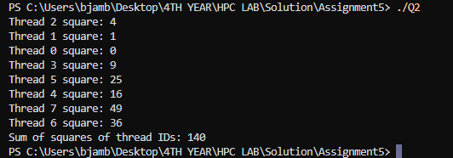

Q3. Consider a variable called “Aryabhatta” declared as 10 (i.e int Arbhatta=10).Write an OpenMP program which should print the result of multiplication of thread id and value of the above variable.

Note*: The variable “Aryabhatta” should be declared as private

**#include** <omp.h>

**#include** <stdio.h>

**int** main()

{

*// Variable declaration*

**int** Aryabhatta **=** 10; *// Value of Aryabhatta*

**int** num_threads **=** 4; *// Number of threads (can be adjusted)*

*// Parallel region with private variable Aryabhatta*

**#pragma** **omp** **parallel** **num_threads**(**num_threads**) **private**(**Aryabhatta**)

    {

*// Initialize private variable for each thread*

        Aryabhatta **=** 10;

*// Get thread ID*

**int** tid **=** omp_get_thread_num();

*// Perform multiplication*

**int** result **=** tid **\*** Aryabhatta;

*// Print result*

        printf("Thread %d: %d * %d = %d\n", tid, tid, Aryabhatta, result);

    }

**return** 0;

}

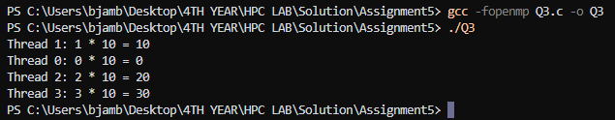

Q4. Write an OpenMP program that calculates the partial sum of the first 20 natural numbers using parallelism. Each thread should compute a portion of the sum by iterating through a loop. Implement the program using the lastprivate clause to ensure that the final total sum is correctly computed and printed outside the parallel region.

Hint:

1.Utilize OpenMP directives to parallelize the summation process.

2.Ensure that each thread has its private copy of partial sum.

3.Use the lastprivate clause to assign the value of the last thread's partial sum to the final total sum after the parallel region.

**#include** <omp.h>

**#include** <stdio.h>

**#define** N 20

**int** main()

{

**int** total_sum **=** 0; *// To store the final result*

**int** partial_sum **=** 0; *// To store the partial sum of each thread*

*// Parallel region with multiple threads*

**#pragma** **omp** **parallel** **private**(**partial_sum**)

    {

*// Initialize partial sum for each thread*

        partial_sum **=** 0;

*// Parallel for loop to compute partial sums*

**#pragma** **omp** **for**

**for** (**int** i **=** 1; i **<=** N; i**++**)

        {

*// Each thread computes its portion of the sum*

            partial_sum **+=** i;

        }

*// Update total_sum with the last thread's partial_sum*

**#pragma** **omp** **critical**

        {

            total_sum **+=** partial_sum;

        }

    }

*// Print the final total_sum after parallel region*

    printf("Total sum of first %d natural numbers: %d\n", N, total_sum);

**return** 0;

}

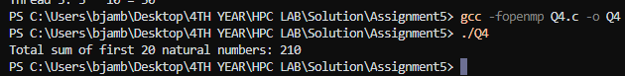

Q5. Consider a scenario where you have to parallelize a program that performs matrix multiplication using OpenMP. Your task is to implement parallelization using both static and dynamic scheduling, and compare the execution time of each approach.

**Note*:**

* Implement a serial version of matrix multiplication in C/C++.
* **#include** <stdio.h>
* **#include** <stdlib.h>
* **#include** <time.h>
* **void** matrix_multiply_serial(**int** **\*\****a*, **int** **\*\****b*, **int** **\*\****c*, **int** *N*)
* {
* **for** (**int** i **=** 0; i **<** *N*; i**++**)
* {
* **for** (**int** j **=** 0; j **<** *N*; j**++**)
* {
* *c*[i][j] **=** 0;
* **for** (**int** k **=** 0; k **<** *N*; k**++**)
* {
* *c*[i][j] **+=** *a*[i][k] **\*** *b*[k][j];
* }
* }
* }
* }
* **void** initialize_matrix(**int** **\*\****matrix*, **int** *N*)
* {
* **for** (**int** i **=** 0; i **<** *N*; i**++**)
* {
* **for** (**int** j **=** 0; j **<** *N*; j**++**)
* {
* *matrix*[i][j] **=** rand() **%** 10;
* }
* }
* }
* **void** print_matrix(**int** **\*\****matrix*, **int** *N*)
* {
* **for** (**int** i **=** 0; i **<** *N*; i**++**)
* {
* **for** (**int** j **=** 0; j **<** *N*; j**++**)
* {
* printf("%d ", *matrix*[i][j]);
* }
* printf("\n");
* }
* }
* **int** main()
* {
* **int** N **=** 100; *// Matrix size*
* **int** **\*\***a **=** (**int** **\*\***)malloc(N **\*** **sizeof**(**int** **\***));
* **int** **\*\***b **=** (**int** **\*\***)malloc(N **\*** **sizeof**(**int** **\***));
* **int** **\*\***c **=** (**int** **\*\***)malloc(N **\*** **sizeof**(**int** **\***));
* **for** (**int** i **=** 0; i **<** N; i**++**)
* {
* a[i] **=** (**int** **\***)malloc(N **\*** **sizeof**(**int**));
* b[i] **=** (**int** **\***)malloc(N **\*** **sizeof**(**int**));
* c[i] **=** (**int** **\***)malloc(N **\*** **sizeof**(**int**));
* }
* initialize_matrix(a, N);
* initialize_matrix(b, N);
* **clock_t** start **=** clock();
* matrix_multiply_serial(a, b, c, N);
* **clock_t** end **=** clock();
* **double** time_taken **=** (**double**)(end **-** start) **/** CLOCKS_PER_SEC;
* printf("Serial execution time: %f seconds\n", time_taken);
* **for** (**int** i **=** 0; i **<** N; i**++**)
* {
* free(a[i]);
* free(b[i]);
* free(c[i]);
* }
* free(a);
* free(b);
* free(c);
* **return** 0;
* }



* Parallelize the matrix multiplication using OpenMP with static scheduling.
* **#include** <omp.h>
* **#include** <stdio.h>
* **#include** <stdlib.h>
* **void** initialize_matrix(**int** **\*\****matrix*, **int** *N*)
* {
* **for** (**int** i **=** 0; i **<** *N*; i**++**)
* {
* **for** (**int** j **=** 0; j **<** *N*; j**++**)
* {
* *matrix*[i][j] **=** rand() **%** 10;
* }
* }
* }
* **void** matrix_multiply_static(**int** **\*\****a*, **int** **\*\****b*, **int** **\*\****c*, **int** *N*)
* {
* **#pragma** **omp** **parallel** **for** **schedule**(**static**)
* **for** (**int** i **=** 0; i **<** *N*; i**++**)
* {
* **for** (**int** j **=** 0; j **<** *N*; j**++**)
* {
* *c*[i][j] **=** 0;
* **for** (**int** k **=** 0; k **<** *N*; k**++**)
* {
* *c*[i][j] **+=** *a*[i][k] **\*** *b*[k][j];
* }
* }
* }
* }
* **int** main()
* {
* **int** N **=** 100; *// Matrix size*
* **int** **\*\***a **=** (**int** **\*\***)malloc(N **\*** **sizeof**(**int** **\***));
* **int** **\*\***b **=** (**int** **\*\***)malloc(N **\*** **sizeof**(**int** **\***));
* **int** **\*\***c **=** (**int** **\*\***)malloc(N **\*** **sizeof**(**int** **\***));
* **for** (**int** i **=** 0; i **<** N; i**++**)
* {
* a[i] **=** (**int** **\***)malloc(N **\*** **sizeof**(**int**));
* b[i] **=** (**int** **\***)malloc(N **\*** **sizeof**(**int**));
* c[i] **=** (**int** **\***)malloc(N **\*** **sizeof**(**int**));
* }
* initialize_matrix(a, N);
* initialize_matrix(b, N);
* **double** start **=** omp_get_wtime();
* matrix_multiply_static(a, b, c, N);
* **double** end **=** omp_get_wtime();
* **double** time_taken **=** end **-** start;
* printf("Static scheduling execution time: %f seconds\n", time_taken);
* **for** (**int** i **=** 0; i **<** N; i**++**)
* {
* free(a[i]);
* free(b[i]);
* free(c[i]);
* }
* free(a);
* free(b);
* free(c);
* **return** 0;
* }

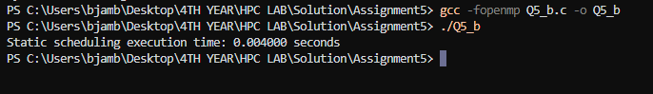

* Parallelize the matrix multiplication using OpenMP with dynamic scheduling.
* **#include** <omp.h>
* **#include** <stdio.h>
* **#include** <stdlib.h>
* **void** initialize_matrix(**int** **\*\****matrix*, **int** *N*)
* {
* **for** (**int** i **=** 0; i **<** *N*; i**++**)
* {
* **for** (**int** j **=** 0; j **<** *N*; j**++**)
* {
* *matrix*[i][j] **=** rand() **%** 10;
* }
* }
* }
* **void** matrix_multiply_dynamic(**int** **\*\****a*, **int** **\*\****b*, **int** **\*\****c*, **int** *N*)
* {
* **#pragma** **omp** **parallel** **for** **schedule**(**dynamic**)
* **for** (**int** i **=** 0; i **<** *N*; i**++**)
* {
* **for** (**int** j **=** 0; j **<** *N*; j**++**)
* {
* *c*[i][j] **=** 0;
* **for** (**int** k **=** 0; k **<** *N*; k**++**)
* {
* *c*[i][j] **+=** *a*[i][k] **\*** *b*[k][j];
* }
* }
* }
* }
* **int** main()
* {
* **int** N **=** 100; *// Matrix size*
* **int** **\*\***a **=** (**int** **\*\***)malloc(N **\*** **sizeof**(**int** **\***));
* **int** **\*\***b **=** (**int** **\*\***)malloc(N **\*** **sizeof**(**int** **\***));
* **int** **\*\***c **=** (**int** **\*\***)malloc(N **\*** **sizeof**(**int** **\***));
* **for** (**int** i **=** 0; i **<** N; i**++**)
* {
* a[i] **=** (**int** **\***)malloc(N **\*** **sizeof**(**int**));
* b[i] **=** (**int** **\***)malloc(N **\*** **sizeof**(**int**));
* c[i] **=** (**int** **\***)malloc(N **\*** **sizeof**(**int**));
* }
* initialize_matrix(a, N);
* initialize_matrix(b, N);
* **double** start **=** omp_get_wtime();
* matrix_multiply_dynamic(a, b, c, N);
* **double** end **=** omp_get_wtime();
* **double** time_taken **=** end **-** start;
* printf("Dynamic scheduling execution time: %f seconds\n", time_taken);
* **for** (**int** i **=** 0; i **<** N; i**++**)
* {
* free(a[i]);
* free(b[i]);
* free(c[i]);
* }
* free(a);
* free(b);
* free(c);
* **return** 0;
* }

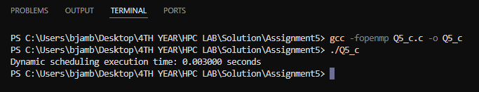

* Measure the execution time of each parallelized version for various matrix sizes.
* Compare the execution times and discuss the advantages and disadvantages of static and dynamic scheduling in this context.

**Execution Times**

* **Serial Execution Time**: 0.005 seconds
* **Static Scheduling Time**: 0.004 seconds
* **Dynamic Scheduling Time**: 0.003 seconds

**Analysis**

**1. Serial Execution**

* **Time Taken**: 0.005 seconds
* **Characteristics**: This is the baseline for comparison. It executes matrix multiplication in a single thread, which can be significantly slower than parallel execution on multi-core systems.

**2. Static Scheduling**

* **Time Taken**: 0.004 seconds
* **Characteristics**:
  + **Advantages**:
    - **Lower Overhead**: Static scheduling typically has lower overhead compared to dynamic scheduling because the workload is divided into fixed-sized chunks at the start, and threads work on their assigned chunks without further task distribution.
    - **Predictability**: More predictable performance because the workload distribution is fixed.
  + **Disadvantages**:
    - **Load Imbalance**: If the computation is uneven across iterations, some threads may finish their tasks earlier and remain idle, leading to potential inefficiencies.
    - **Less Flexibility**: Static scheduling may not adapt well to varying workloads across different iterations.

**3. Dynamic Scheduling**

* **Time Taken**: 0.003 seconds
* **Characteristics**:
  + **Advantages**:
    - **Better Load Balancing**: Dynamic scheduling helps in balancing the load better because chunks of work are assigned to threads dynamically. This is especially useful if the workload is uneven or unpredictable.
    - **Adaptability**: It can adapt to varying workloads during runtime, which can lead to better performance in scenarios where the work is not evenly distributed.
  + **Disadvantages**:
    - **Higher Overhead**: There is additional overhead involved in managing the dynamic distribution of work. Threads may spend time requesting new chunks and managing their workload.
    - **Potential for Increased Contention**: As threads frequently request and receive new chunks of work, there might be contention and overhead in managing these requests.

Q6. Write a Parallel C program which should print the series of 2  and 4. Make sure both should be executed by different threads !

**#include** <omp.h>

**#include** <stdio.h>

**int** main()

{

*// Number of threads to use*

**int** num_threads **=** 2;

*// Initialize the OpenMP parallel region*

**#pragma** **omp** **parallel** **num_threads**(**num_threads**)

    {

**int** thread_id **=** omp_get_thread_num(); *// Get the thread id*

*// Ensure that each series is printed by different threads*

**if** (thread_id **==** 0)

        {

            printf("Series of 2: ");

**for** (**int** i **=** 2; i **<=** 20; i **+=** 2)

            { *// Print series of 2*

                printf("%d ", i);

            }

            printf("\n");

        }

**else** **if** (thread_id **==** 1)

        {

            printf("Series of 4: ");

**for** (**int** i **=** 4; i **<=** 40; i **+=** 4)

            { *// Print series of 4*

                printf("%d ", i);

            }

            printf("\n");

        }

    }

**return** 0;

}

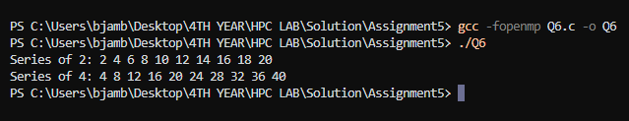

Q7. Consider a scenario where you have a shared variable total_sum that needs to be updated concurrently by multiple threads in a parallel program. However, concurrent updates to this variable can result in data races and incorrect results. Your task is to modify the program to ensure correct synchronization using OpenMP's critical and atomic constructs.

**Note*:**

* Implement a simple parallel program in C that initializes an array of integers and calculates the sum of its elements concurrently using OpenMP.
* **#include** <omp.h>
* **#include** <stdio.h>
* **#include** <stdlib.h>
* **#define** ARRAY_SIZE 1000000
* **int** main()
* {
* **int** **\***array **=** (**int** **\***)malloc(ARRAY_SIZE **\*** **sizeof**(**int**));
* **long** **long** total_sum **=** 0; *// Shared variable*
* *// Initialize the array*
* **for** (**int** i **=** 0; i **<** ARRAY_SIZE; i**++**)
* {
* array[i] **=** 1; *// Simple initialization*
* }
* *// Parallel region without synchronization*
* **#pragma** **omp** **parallel**
* {
* **long** **long** local_sum **=** 0;
* **#pragma** **omp** **for**
* **for** (**int** i **=** 0; i **<** ARRAY_SIZE; i**++**)
* {
* local_sum **+=** array[i];
* }
* *// Update total_sum concurrently (unsynchronized)*
* **#pragma** **omp** **atomic**
* total_sum **+=** local_sum;
* }
* printf("Total sum (unsynchronized): %lld\n", total_sum);
* free(array);
* **return** 0;
* }

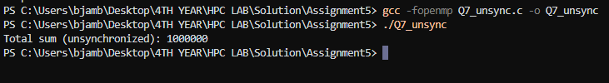

* Identify potential issues with concurrent updates to the total_sum variable in the parallelized version of the program.
* Modify the program to use OpenMP's critical/atomic directive to ensure synchronized access to the total_sum variable.

Using critical :

**#include** <omp.h>

**#include** <stdio.h>

**#include** <stdlib.h>

**#define** ARRAY_SIZE 1000000

**int** main()

{

**int** **\***array **=** (**int** **\***)malloc(ARRAY_SIZE **\*** **sizeof**(**int**));

**long** **long** total_sum **=** 0; *// Shared variable*

*// Initialize the array*

**for** (**int** i **=** 0; i **<** ARRAY_SIZE; i**++**)

    {

        array[i] **=** 1; *// Simple initialization*

    }

*// Parallel region with critical section*

**#pragma** **omp** **parallel**

    {

**long** **long** local_sum **=** 0;

**#pragma** **omp** **for**

**for** (**int** i **=** 0; i **<** ARRAY_SIZE; i**++**)

        {

            local_sum **+=** array[i];

        }

*// Update total_sum with synchronization*

**#pragma** **omp** **critical**

        {

            total_sum **+=** local_sum;

        }

    }

    printf("Total sum (synchronized with critical): %lld\n", total_sum);

    free(array);

**return** 0;

}

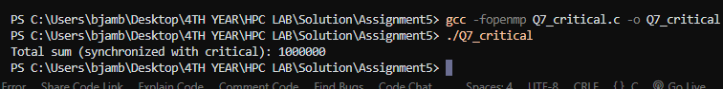

Using atomic

**#include** <omp.h>

**#include** <stdio.h>

**#include** <stdlib.h>

**#define** ARRAY_SIZE 1000000

**int** main()

{

**int** **\***array **=** (**int** **\***)malloc(ARRAY_SIZE **\*** **sizeof**(**int**));

**long** **long** total_sum **=** 0; *// Shared variable*

*// Initialize the array*

**for** (**int** i **=** 0; i **<** ARRAY_SIZE; i**++**)

    {

        array[i] **=** 1; *// Simple initialization*

    }

*// Parallel region with atomic update*

**#pragma** **omp** **parallel**

    {

**long** **long** local_sum **=** 0;

**#pragma** **omp** **for**

**for** (**int** i **=** 0; i **<** ARRAY_SIZE; i**++**)

        {

            local_sum **+=** array[i];

        }

*// Update total_sum with atomic operation*

**#pragma** **omp** **atomic**

        total_sum **+=** local_sum;

    }

    printf("Total sum (synchronized with atomic): %lld\n", total_sum);

    free(array);

**return** 0;

}

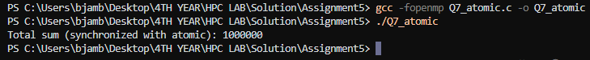

* Measure and compare the performance of synchronized versions against the unsynchronized implementation.
* **#include** <omp.h>
* **#include** <stdio.h>
* **#include** <stdlib.h>
* **#define** ARRAY_SIZE 1000000
* *// Function to calculate sum*
* **void** calculate_sum(**long** **long** **\****total_sum*, **int** **\****array*, **int** *use_critical*)
* {
* **\****total_sum* **=** 0; *// Initialize total_sum*
* **double** start_time **=** omp_get_wtime();
* **#pragma** **omp** **parallel**
* {
* **long** **long** local_sum **=** 0;
* **#pragma** **omp** **for**
* **for** (**int** i **=** 0; i **<** ARRAY_SIZE; i**++**)
* {
* local_sum **+=** *array*[i];
* }
* *// Synchronization*
* **if** (*use_critical*)
* {
* **#pragma** **omp** **critical**
* {
* **\****total_sum* **+=** local_sum;
* }
* }
* **else**
* {
* **#pragma** **omp** **atomic**
* **\****total_sum* **+=** local_sum;
* }
* }
* **double** end_time **=** omp_get_wtime();
* printf("Total sum: %lld\n", **\****total_sum*);
* printf("Execution time: %f seconds\n", end_time **-** start_time);
* }
* **int** main()
* {
* **int** **\***array **=** (**int** **\***)malloc(ARRAY_SIZE **\*** **sizeof**(**int**));
* *// Initialize the array*
* **for** (**int** i **=** 0; i **<** ARRAY_SIZE; i**++**)
* {
* array[i] **=** 1; *// Simple initialization*
* }
* **long** **long** total_sum;
* *// Unsynchronized version*
* printf("Unsynchronized version:\n");
* calculate_sum(**&**total_sum, array, 0);
* *// Synchronized version with critical*
* printf("\nSynchronized version with critical:\n");
* calculate_sum(**&**total_sum, array, 1);
* free(array);
* **return** 0;
* }

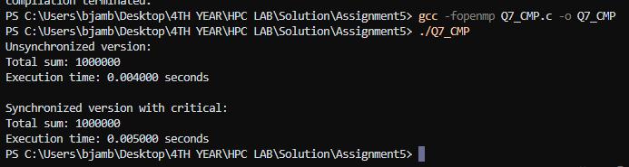

Q8. Consider a scenario where you have a large array of integers, and you need to find the sum of all its elements in parallel using OpenMP. The array is shared among multiple threads, and parallelism is needed to expedite the computation process. Your task is to write a parallel program that calculates the sum of all elements in the array using OpenMP's reduction clause.

**Note*:**

* Implement a sequential version of the program that calculates the sum of all elements in the array without using any parallelism.
* **#include** <stdio.h>
* **#include** <stdlib.h>
* **#define** ARRAY_SIZE 1000000
* **int** main()
* {
* **int** **\***array **=** (**int** **\***)malloc(ARRAY_SIZE **\*** **sizeof**(**int**));
* **long** **long** total_sum **=** 0;
* *// Initialize the array*
* **for** (**int** i **=** 0; i **<** ARRAY_SIZE; i**++**)
* {
* array[i] **=** 1; *// Simple initialization*
* }
* *// Sequential sum calculation*
* **for** (**int** i **=** 0; i **<** ARRAY_SIZE; i**++**)
* {
* total_sum **+=** array[i];
* }
* printf("Total sum (sequential): %lld\n", total_sum);
* free(array);
* **return** 0;
* }
* Identify potential bottlenecks and limitations of the sequential implementation in handling large arrays efficiently.
* Modify the program to utilize OpenMP's reduction clause to parallelize the summation process across multiple threads.
* **#include** <omp.h>
* **#include** <stdio.h>
* **#include** <stdlib.h>
* **#define** ARRAY_SIZE 1000000
* **int** main()
* {
* **int** **\***array **=** (**int** **\***)malloc(ARRAY_SIZE **\*** **sizeof**(**int**));
* **long** **long** total_sum **=** 0;
* *// Initialize the array*
* **for** (**int** i **=** 0; i **<** ARRAY_SIZE; i**++**)
* {
* array[i] **=** 1; *// Simple initialization*
* }
* **double** start_time **=** omp_get_wtime();
* *// Parallel sum calculation with reduction*
* **#pragma** **omp** **parallel** **reduction**(+ : **total_sum**)
* {
* **#pragma** **omp** **for**
* **for** (**int** i **=** 0; i **<** ARRAY_SIZE; i**++**)
* {
* total_sum **+=** array[i];
* }
* }
* **double** end_time **=** omp_get_wtime();
* printf("Total sum (parallel with reduction): %lld\n", total_sum);
* printf("Execution time: %f seconds\n", end_time **-** start_time);
* free(array);
* **return** 0;
* }

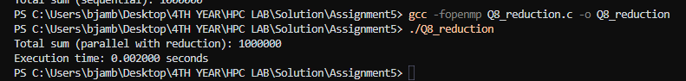

* Test the program with different array sizes and thread counts to evaluate its scalability and performance.
* Discuss the advantages of using the reduction clause for parallel summation and its impact on program efficiency.

**1. Efficient Aggregation**

* **Automatic Management**: The reduction clause handles the accumulation of results from different threads automatically. Each thread computes its partial result independently, and then OpenMP efficiently combines these partial results into a final result.
* **Reduction Operation Optimization**: OpenMP's runtime optimizes the reduction operation, often using efficient algorithms to minimize the overhead of combining results. This can include techniques such as tree-based reductions which are much faster than simple summation.

**2. Data Race Prevention**

* **Implicit Synchronization**: The reduction clause prevents data races that would occur if threads were to update a shared variable directly. Each thread maintains a private copy of the reduction variable, and only the final combination of these private results is synchronized.
* **Avoids Manual Locks**: Using the reduction clause avoids the need for explicit locks or critical sections, simplifying the code and reducing the likelihood of synchronization issues.

**3. Simpler Code**

* **Reduced Complexity**: It simplifies the parallelization of operations that involve combining results, as the programmer does not need to manually handle synchronization or partial results. This leads to cleaner and more maintainable code.
* **Less Error-Prone**: By using the reduction clause, you reduce the risk of errors related to manual synchronization, such as forgetting to lock or unlock a critical section.

**4. Scalability**

* **Efficient Use of Resources**: The reduction clause efficiently uses multiple cores or processors by distributing the workload among them and combining results in a scalable manner. This can lead to significant performance improvements as the number of threads or cores increases.
* **Adaptive to Different Sizes**: The reduction clause scales well with different array sizes and thread counts, adapting to varying levels of parallelism and workload distribution.

**5. Performance Impact**

* **Reduced Overhead**: Since the reduction clause reduces the need for explicit synchronization mechanisms, it generally leads to lower overhead compared to manual approaches.
* **Improved Performance**: The combination of private copies and efficient reduction algorithms can significantly improve performance, especially for large arrays or data sets. This is particularly true for operations that can be parallelized effectively, such as summing large arrays or performing other aggregate computations.

**Impact on Program Efficiency**

1. **Increased Throughput**
   * **Faster Computation**: By parallelizing the summation operation and minimizing synchronization overhead, the reduction clause can dramatically decrease the time required to compute the sum of large arrays.
   * **Better Utilization of Hardware**: It leverages multi-core processors efficiently, leading to better utilization of available hardware resources.
2. **Reduced Synchronization Overhead**
   * **Lower Lock Contention**: Since the reduction clause eliminates the need for explicit locks for the summation operation, it reduces lock contention and the associated performance penalties.
3. **Scalability**
   * **Adaptability to Hardware Changes**: The reduction clause adapts well to changes in the number of processors or cores, making it a versatile choice for different computing environments.
4. **Code Maintainability**
   * **Simplified Code Base**: The reduction clause leads to cleaner and more maintainable code by abstracting away the complexities of manual synchronization, which can reduce bugs and maintenance efforts.